December 29, 2022

IFB-22-402
Translations and Interpretation Contract
Addendum 1

The purpose of this addendum is to notify potential applicants of changes that have been made to IFB-22-402. The addendum includes the following revisions to the Solicitation Manual. Added language appears in bold underline, and deleted language appears in [strikethrough] and within square brackets.

Solicitation Manual
- Page 1, Section I. Key Activity And Dates:

Deadline to submit bid for IFB-22-402 has been extended to January 5, 2023
The Public Bid Opening date as been changed to January 12, 2023 at 10 a.m. PST

ACTIVITY | ACTION DATE
IFB Release | 12/7/2022
Deadline to Submit Written Question by 5:00 p.m.* | 12/14/2022
Distribute Questions/Answers and Addenda (if any) | 12/20/2022
Deadline to Submit Bid by 5:00 p.m.* | 1/5/2023
Public Bid Opening | 1/12/2023 at 10:00 a.m. PST
Notice of Proposed Award | 1/13/2023
Contract Start Date | 2/1/2023
Contract Termination Date | 1/31/2025
Potential one-year contract extension termination date | 1/31/2026

- Page 2, Section I “Public Bid Opening – IFB-22-402” link provided:

Public Bid Opening – IFB-22-402
Meeting ID: 288 052 941 13
Passcode: DsJQTz
Or call in (audio only)
+1 916-306-7589,,361494683# United States, Sacramento
Phone Conference ID: 361 494 683#

3. Attachment 6 Cost Bid
Addition of tables to include rates for expedited and standard requests for one audio technician as part of the cost bid.

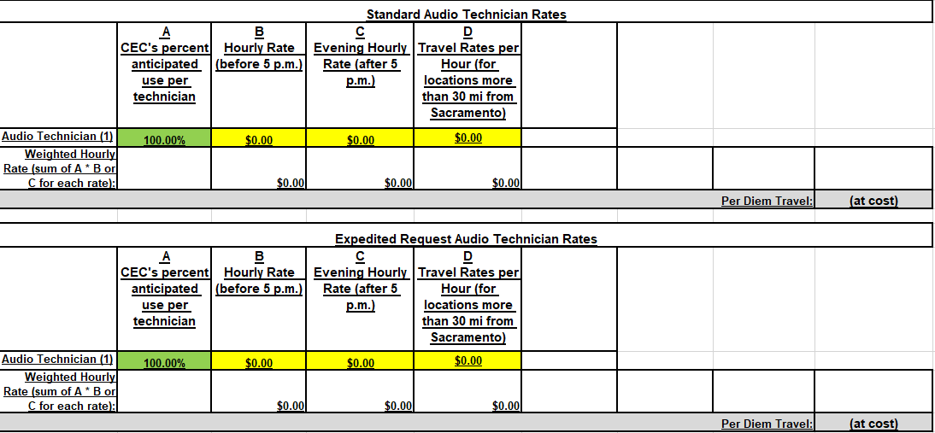

The instructions to fill out the interpretation rate columns have been updated to specify that all fees should include the appearance of two (2) interpreters and the equipment necessary to perform simultaneous interpretation services.

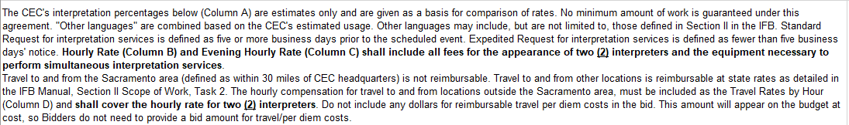

4. Q&A Addendum
Updates to response for question 38:

Q: It is the industry standard to charge for interpreting equipment such as transmitters, headsets, etc. separately from the interpreting. Can vendors list the pricing for interpreting equipment separately from the hourly charge for interpreting?
A: No, the hourly interpretation and audio technician rates should include any equipment costs. Our current contract’s audio technician rate is $100/hour. We are updating our cost bid sheet to include a section for bidders to list the hourly rate for an audio technician.

Phil Dyer,
Commission Agreement Officer

