GFO-22-304
Addendum 1: Cover Letter
December 27, 2022

Assessing the Role of Hydrogen in California’s Decarbonizing Electric System
The purpose of this addendum is to remove Attachment 13 (References for Calculating Energy End-Use and GHG Emissions) from the solicitation and to revise the Solicitation Manual and Attachment 3 (Project Narrative Form). The revisions to the Solicitation Manual include the following:
(1) removal of text related to Attachment 13,
(2) revising language for completeness within the Project Focus section,
(3) replacing the bullet points on the Project Focus questions with numbers and letters,
(4) revising language for clarity and consistency within the Project Focus questions,
(5) revising dates within Section I.E. (Key Activities Schedule),
(6) modifying template language in Section I.J.1. (Electric Program Investment Charge (EPIC) Program) with the updated text from the EPIC Solicitation Manual template,
(7) modifying language in Section II.B.2 (Ratepayer Benefits, Technological Advancements, and Breakthroughs) with the updated text from the EPIC Solicitation Manual template reflecting the CPUC’s revised definition for ratepayer benefits, and
(8) correcting the table of contents to include subheadings I.H to I.L.

The revisions to Attachment 3 (Project Narrative Form) include (1) replacing the bullet points on the Project Focus questions with numbers and letters, and (2) revising language for clarity and consistency within the Project Focus questions and the “Impacts and Benefits to California IOU Ratepayers” section.

The addendum includes the revisions to the Solicitation Manual, to Attachment 3, and to Attachment 13, described in detail below.
Note: Added language appears in bold underlined font and deleted language appears in strikethrough within brackets. When modifications are not formatted in the manner just described, screenshots of the modified section are provided of the section both before and after the modification was made.

Solicitation Manual:

Modification #1: Removal of text related to Attachment 13

Page 3, ATTACHMENTS table was amended as follows:

Attachments
Attachment Number | Title of Section
1 | Application Form (requires signature)
2 | Executive Summary
3 | Project Narrative
4 | Project Team
5 | Scope of Work
6 | Project Schedule
7 | Budget
8 | CEQA Compliance Form
9 | References and Work Product
10 | Commitment and Support Letters (require signature)
11 | Project Performance Metrics
12 | Applicant Declaration (require signature)
[13] | [References for Calculating Energy End-Use and GHG Emissions]

Page 22, Part of Section II.B.2. was amended as follows:

Any estimates of energy and water savings or GHG impacts must include citations to the data sources used to calculate the estimates. [be calculated using the References for Calculating Electricity End-Use, Electricity Demand, and GHG Emissions (Attachment.]

Page 29, Section III.C.13. was removed as follows:

[13. References for Calculating Energy End-Use and GHG Emissions (Attachment 13)
Any estimates of energy savings or GHG impacts described in the application should be calculated as specified on this form, to the extent that the references apply to the proposed project.]

Page 36, Part of Section IV.F. was amended as follows:

The Project Narrative (Attachment) must respond to each criterion below. The responses must directly relate to the solicitation requirements and focus as stated in the solicitation. Any estimates of energy savings or GHG impacts must include citations to the data sources used to calculate the estimates. [should be calculated as specified in the References for Calculating Energy End-Use and GHG Emissions (Attachment), to the extent that the references apply to the proposed project.]

Modification #2: Revising language for completeness within the Project Focus section

Page 7 , Part of Section I.C. was amended as follows:

Projects must evaluate the role of hydrogen in California's decarbonizing electric sector through technology, economic, and environmental assessment(s) focused on 1) production, transmission, and distribution of hydrogen from renewable electricity for any end-use and 2) specific end-use applications in the electric sector such as zero carbon firm dispatchable generation.

Modification #3: Replacing the bullet points on the Project Focus questions with numbers and letters

Pages 8 – 9, Part of Section I.C. was amended as follows:

Before modification screenshots: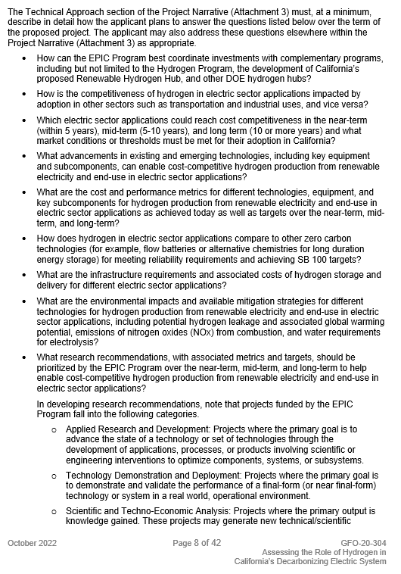
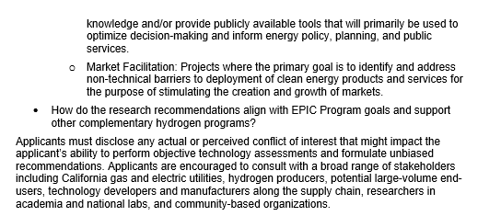

After modification screenshots:

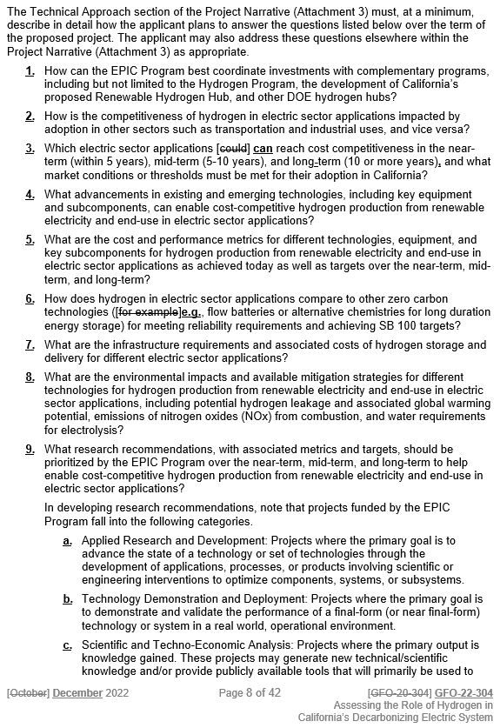

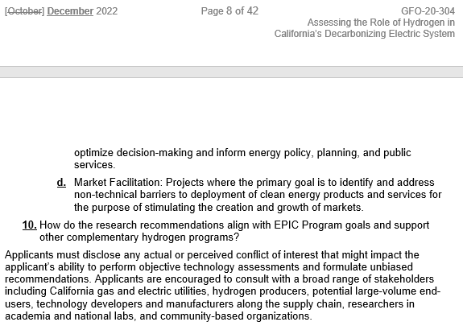

Modification #4: Revising language for clarity and consistency within the Project Focus questions (specifically questions 3 and 6 were revised)

Page 8 , Part of Section I.C. was amended as follows:

- How can the EPIC Program best coordinate investments with complementary programs, including but not limited to the Hydrogen Program, the development of California’s proposed Renewable Hydrogen Hub, and other DOE hydrogen hubs?
- How is the competitiveness of hydrogen in electric sector applications impacted by adoption in other sectors such as transportation and industrial uses, and vice versa?
- Which electric sector applications [could] can reach cost competitiveness in the near-term (within 5 years), mid-term (5-10 years), and long-term (10 or more years), and what market conditions or thresholds must be met for their adoption in California?
- What advancements in existing and emerging technologies, including key equipment and subcomponents, can enable cost-competitive hydrogen production from renewable electricity and end-use in electric sector applications?
- What are the cost and performance metrics for different technologies, equipment, and key subcomponents for hydrogen production from renewable electricity and end-use in electric sector applications as achieved today as well as targets over the near-term, mid-term, and long-term?
- How does hydrogen in electric sector applications compare to other zero carbon technologies ([for example]e.g., flow batteries or alternative chemistries for long duration energy storage) for meeting reliability requirements and achieving SB 100 targets?

Modification #5: Revising dates within Section I.E. (Key Activities Schedule)

Page 10, Part of Section I.E. was amended as follows:

ACTIVITY | DATE | TIME
Solicitation Release | October 27, 2022
Pre-Application Workshop | November 7, 2022 | 9:00 a.m.
Deadline for Written Questions | November 14, 2022 | 5:00 p.m.
Anticipated Distribution of Questions and Answers | Week of December [12] 26, 2022
Deadline to Submit Applications | [January 23] February 7, 2023 | 11:59 p.m.
Anticipated Notice of Proposed Award Posting Date | Week of [March 13] April 17, 2023
Anticipated Energy Commission Business Meeting Date | [June] July 2023
Anticipated Agreement Start Date | [July] August 2023
Anticipated Agreement End Date | [July] August 2025

Modification #6: Modifying template language in Section I.J.1. (Electric Program Investment Charge (EPIC) Program) with the updated text from the EPIC Solicitation Manual template

Page 13, Part of Section I.J.1. was amended as follows:

This solicitation will award projects funded by the EPIC, an electricity ratepayer surcharge established by the California Public Utilities Commission (CPUC) in December 2011. The purpose of the EPIC program is to benefit the ratepayers of three investor-owned utilities (IOUs), including Pacific Gas and Electric Co., San Diego Gas and Electric Co., and Southern California Edison Co. The EPIC funds clean energy technology projects that meet the guiding principles of (1) improving safety, (2) increasing reliability, (3) increasing affordability, (4) improving environmental sustainability, and (5) improving equity, all as related to California's electric system. [promote greater electricity reliability, lower costs, and increased safety.] In addition to providing IOU ratepayer benefits, funded projects must lead to technological advancement and breakthroughs to overcome the barriers that prevent the achievement of the state’s statutory energy goals. The EPIC program is administered by the CEC and the IOUs.

Modification #7: Modifying template language in Section II.B.2 (Ratepayer Benefits, Technological Advancements, and Breakthroughs) with the updated text from the EPIC Solicitation Manual template reflecting the CPUC’s revised definition for ratepayer benefits

Pages 21 – 22, Part of Section II.B.2. was amended as follows:

- Ratepayer Benefits, Technological Advancements, and Breakthroughs
California Public Resources Code Section 25711.5(a) requires EPIC-funded projects to:
- Benefit electricity ratepayers; and
- Lead to technological advancement and breakthroughs to overcome the barriers that prevent the achievement of the state’s statutory energy goals.
EPIC's mandatory guiding principle is to provide ratepayer benefits, which is defined as (1) improving safety, (2) increasing reliability, (3) increasing affordability, (4) improving environmental sustainability, and (5) improving equity, all as related to California's electric system. [The CPUC defines “ratepayer benefits” as greater reliability, lower costs, and increased safety. The CPUC has also adopted the following guiding principles as complements to the key principle of electricity ratepayer benefits: societal benefits; GHG emissions mitigation and adaptation in the electricity sector at the lowest possible cost; the loading order; low-emission vehicles/transportation; economic development; and efficient use of ratepayer monies.]
Accordingly, the Project Narrative Form (Attachment) and the “Goals and Objectives” section of the Scope of Work Template (Attachment) must describe how the project will: (1) benefit California IOU ratepayers by improving safety, increasing reliability, increasing affordability, improving environmental sustainability, and improving equity, all as related to California's electric system [increasing reliability, lowering costs, and/or increasing safety]; and (2) lead to technological advancement and breakthroughs to overcome barriers to achieving the state’s statutory energy goals.

Modification #8: Correcting the table of contents to include subheadings I.H to I.L

Page i, Table of Contents was amended as follows:

Before modification screenshot:

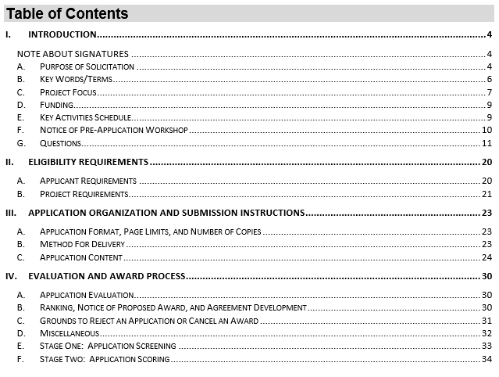

After modification screenshot:

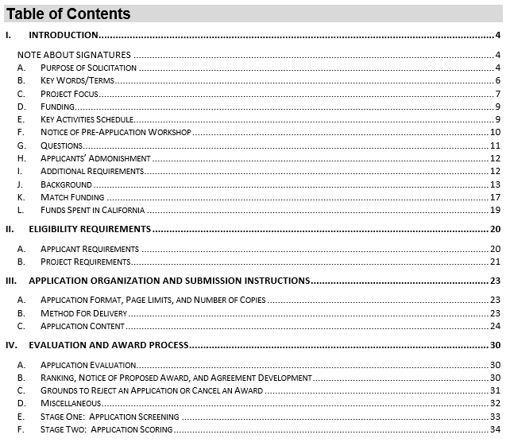

Attachment 3 (Project Narrative Form):

Modification #1: Replacing the bullet points on the Project Focus questions with numbers and letters

Pages 1 – 3, Part of the Technical Approach section was amended as follows:

Before modification screenshots:

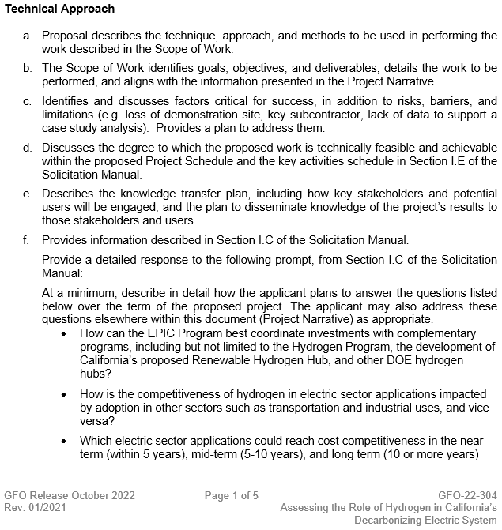
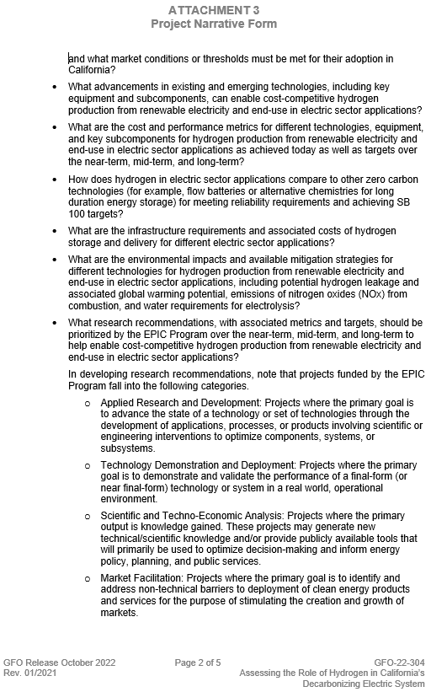
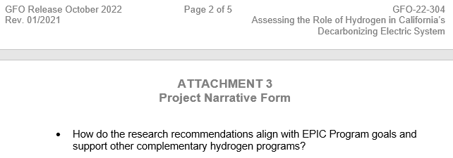

After modification screenshots:

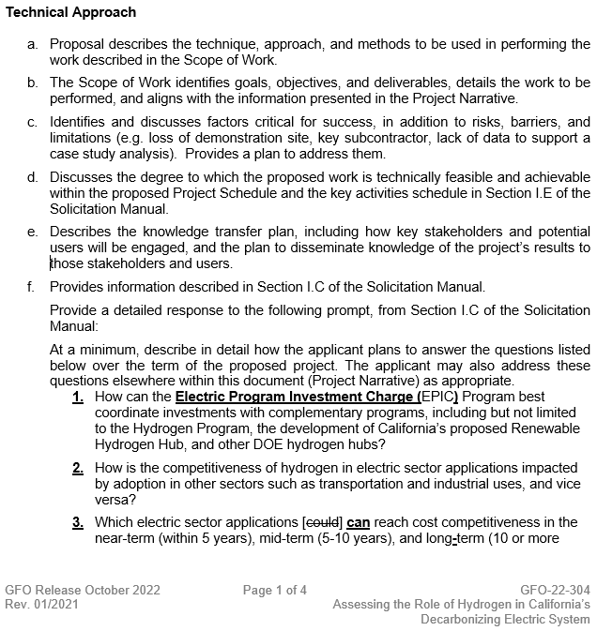
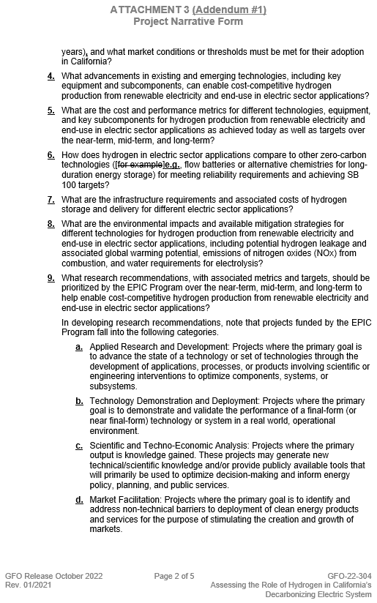
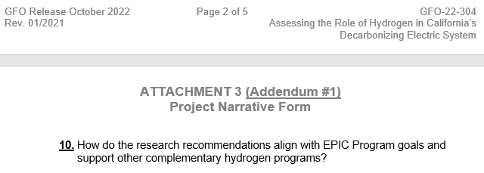

Modification #2: Revising language for clarity and consistency within the Project Focus questions (specifically questions 1, 3 and 6 were revised) and the “Impacts and Benefits to California IOU Ratepayers” section.

Pages 1 – 2, Part of the Technical Approach section was amended as follows (specifically Project Focus questions 1, 3 and 6 were revised):

- How can the Electric Program Investment Charge (EPIC) Program best coordinate investments with complementary programs, including but not limited to the Hydrogen Program, the development of California’s proposed Renewable Hydrogen Hub, and other DOE hydrogen hubs?
- How is the competitiveness of hydrogen in electric sector applications impacted by adoption in other sectors such as transportation and industrial uses, and vice versa?
- Which electric sector applications [could] can reach cost competitiveness in the near-term (within 5 years), mid-term (5-10 years), and long-term (10 or more years), and what market conditions or thresholds must be met for their adoption in California?
- What advancements in existing and emerging technologies, including key equipment and subcomponents, can enable cost-competitive hydrogen production from renewable electricity and end-use in electric sector applications?
- What are the cost and performance metrics for different technologies, equipment, and key subcomponents for hydrogen production from renewable electricity and end-use in electric sector applications as achieved today as well as targets over the near-term, mid-term, and long-term?
- How does hydrogen in electric sector applications compare to other zero-carbon technologies ([for example]e.g., flow batteries or alternative chemistries for long-duration energy storage) for meeting reliability requirements and achieving SB 100 targets?

Page 3, Part of sub-section a. of the Impacts and Benefits to California IOU Ratepayers section was amended as follows:

- Explains how the proposed project will benefit California Investor-Owned Utility (IOU) ratepayers and provides clear, plausible, and justifiable (quantitative preferred) potential benefits. Estimates the energy benefits including:
  - annual electricity (EPIC) and thermal savings (Public Interest Energy Research Natural Gas program) [(PIER NG)] (kilowatt-hour and therms), energy cost reductions, peak load reduction and/or shifting, infrastructure resiliency, infrastructure reliability.
In addition, estimates the non-energy benefits including:
- greenhouse gas emission reductions, air emission reductions (e.g. NOx), water savings and cost reduction, and/or increased safety.

Attachment 13 (References for Calculating Energy End-Use and GHG Emissions):

Modification:
Attachment 13 was removed from this solicitation’s list of attachments, which includes the removal of Attachment 13 from the solicitation’s website (https://www.energy.ca.gov/solicitations/2022-10/gfo-22-304-assessing-role-hydrogen-californias-decarbonizing-electric-system).

Eilene Cary,
Commission Agreement Officer

Pacific Standard Time or Pacific Daylight Time, whichever is being observed.
This deadline does not apply to non-technical questions (e.g., questions concerning application format requirements or attachment instructions) or to questions that address an ambiguity, conflict, discrepancy, omission, or other error in the solicitation. Such questions may be submitted to the Commission Agreement Officer listed in Section G at any time prior to the application deadline. Please see Section G for additional information.
See CPUC “Phase 1” Decision 11-12-035, December 15, 2011, http://docs.cpuc.ca.gov/PublishedDocs/WORD_PDF/FINAL_DECISION/156050.PDF.
CPUC Decision 21-11-028, Appendix A https://docs.cpuc.ca.gov/PublishedDocs/Published/G000/M425/K515/425515575.PDF (revising former guiding principles within CPUC “Phase 2” Decision 12-05-037, Ordering Paragraph 2 http://docs.cpuc.ca.gov/PublishedDocs/WORD_PDF/FINAL_DECISION/167664.PDF.).
[See CPUC “Phase 2” Decision 12-05-037, May 24, 2012, http://docs.cpuc.ca.gov/PublishedDocs/WORD_PDF/FINAL_DECISION/167664.PDF.]
California Public Resources Code, Section 25711.5(a), http://www.leginfo.ca.gov/cgi-bin/displaycode?section=prc&group=25001-26000&file=25710-25712.
CPUC Decision 21-11-028, Appendix A https://docs.cpuc.ca.gov/PublishedDocs/Published/G000/M425/K515/425515575.PDF (revising former guiding principles within CPUC “Phase 2” Decision 12-05-037, Ordering Paragraph 2 http://docs.cpuc.ca.gov/PublishedDocs/WORD_PDF/FINAL_DECISION/167664.PDF.).
[Id. at p. 19.]
[Id. at pp. 19-20.]

