RFP-22-803
January 20, 2023
QUESTIONS AND ANSWERS
Demand Scenarios Project
The purpose of this document is to provide answers to questions for the above solicitation. The following answers are based on the California Energy Commission (CEC) staff’s interpretation of the questions received.
Q1: Is the 120 expected total hours for Task 5 correct?
A1: Yes, these are the expected total hours for Task 5. As will be discussed in the Pre-Bid Conference, Staff anticipates it to be a relatively simple model designed to take input total fuel demand and split into fuel types.
Q2: With respect to the following paragraph on page 5:
“This contract will have a ceiling value of $1.5M; however, CEC commits to initial funding of only $500K to support analysis in the scope of this contract. CEC may add funding beyond the current $500K, and up to $1.5M, as funding becomes available.”
i: When will the decision be made to add funding beyond the initial $500k?

A2i: The decision could be made as early as the end of the year 2023 if additional funding is necessary for tasks to be completed

ii: Is staff’s intention that the award will be made based on satisfying the written scope using the initial $500k only and then be able to modify the contract to add scope to spend any budget it may add beyond the initial $500k?

A2ii: The contract amount can be modified if Staff foresee additional work that needs to be completed, and the specific task descriptions for this additional work would be specified in a revised or new work authorization.

Q3: Should the bidder assume that only $500k is available for the written scope of work?
A3: Yes, that is correct.

Questions asked during the workshop:
Q4: Should the form, which is attachment 7 be limited to a maximum of $500k, or 1.5 million when bidders submit their response?
A4: Yes, the funding is limited to $500k and the bidder should submit responses for the scope of work not to exceed that amount.
Q5: Is the scope as written, expected to be delivered within that $500k? Because the RFP mentions, you know additional funds may be available? What changes about the scope or the timeline if those additional funds are made available, is there a longer contract period, or are you expecting more in-depth research?
A5: Yes, the scope is written for the funding not to exceed $500k. However, there could be changes in scope as we start developing these scenarios. If additional work needs to be completed, then the task descriptions for this additional work would be specified in a revised or new work authorization. The deliverable due dates in the scope of work are linked to CEC proceedings and can only be changed if revisions do not affect these proceedings.
Q6: The RFP mentions the Adapted Pathways Model. Is that available for bidders to review and look at right now? Or will it be made available? And in future points just about maybe who owns that model? Is it the CEC or is it license from another contractor?
A6: The Adapted Pathways Model is a variation of E3’s PATHWAYS model. It was used in the first round of the Demand Scenario Project. Both the PATHWAYS Model and the Adapted PATHWAYS Model have the code in Analytica. What makes it Adapted from the original PATHWAYS is that we bypassed certain internal computations in the original model and replaced them with the results of the various modeling tools of the California Energy Commission. This product is owned by the California Energy Commission, and we are free to make further modifications to it.
Generally, the Energy Commission does not release the code of its modeling tools. However, the below pictures show the flow of the data to provide an overview of the Adapted PATHWAYS Model.

Sectoral Demand:
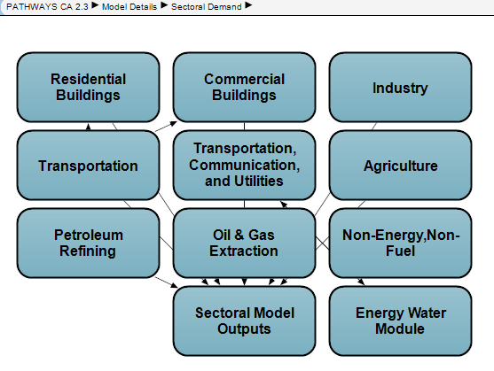
Energy Supply:
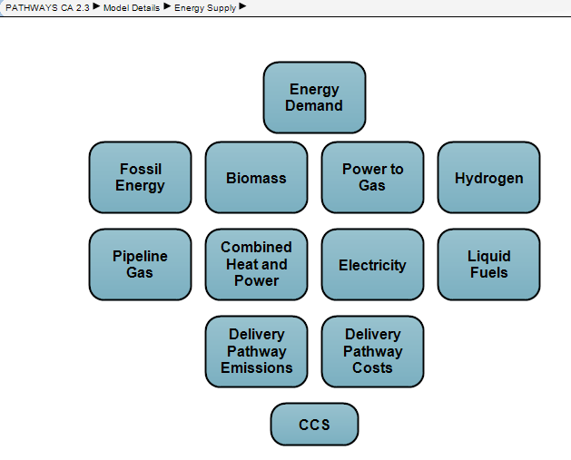

Adapted PATHWAYS Hourly Load Shape Module:
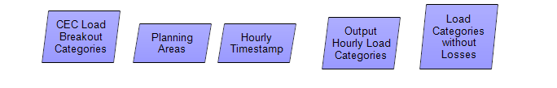
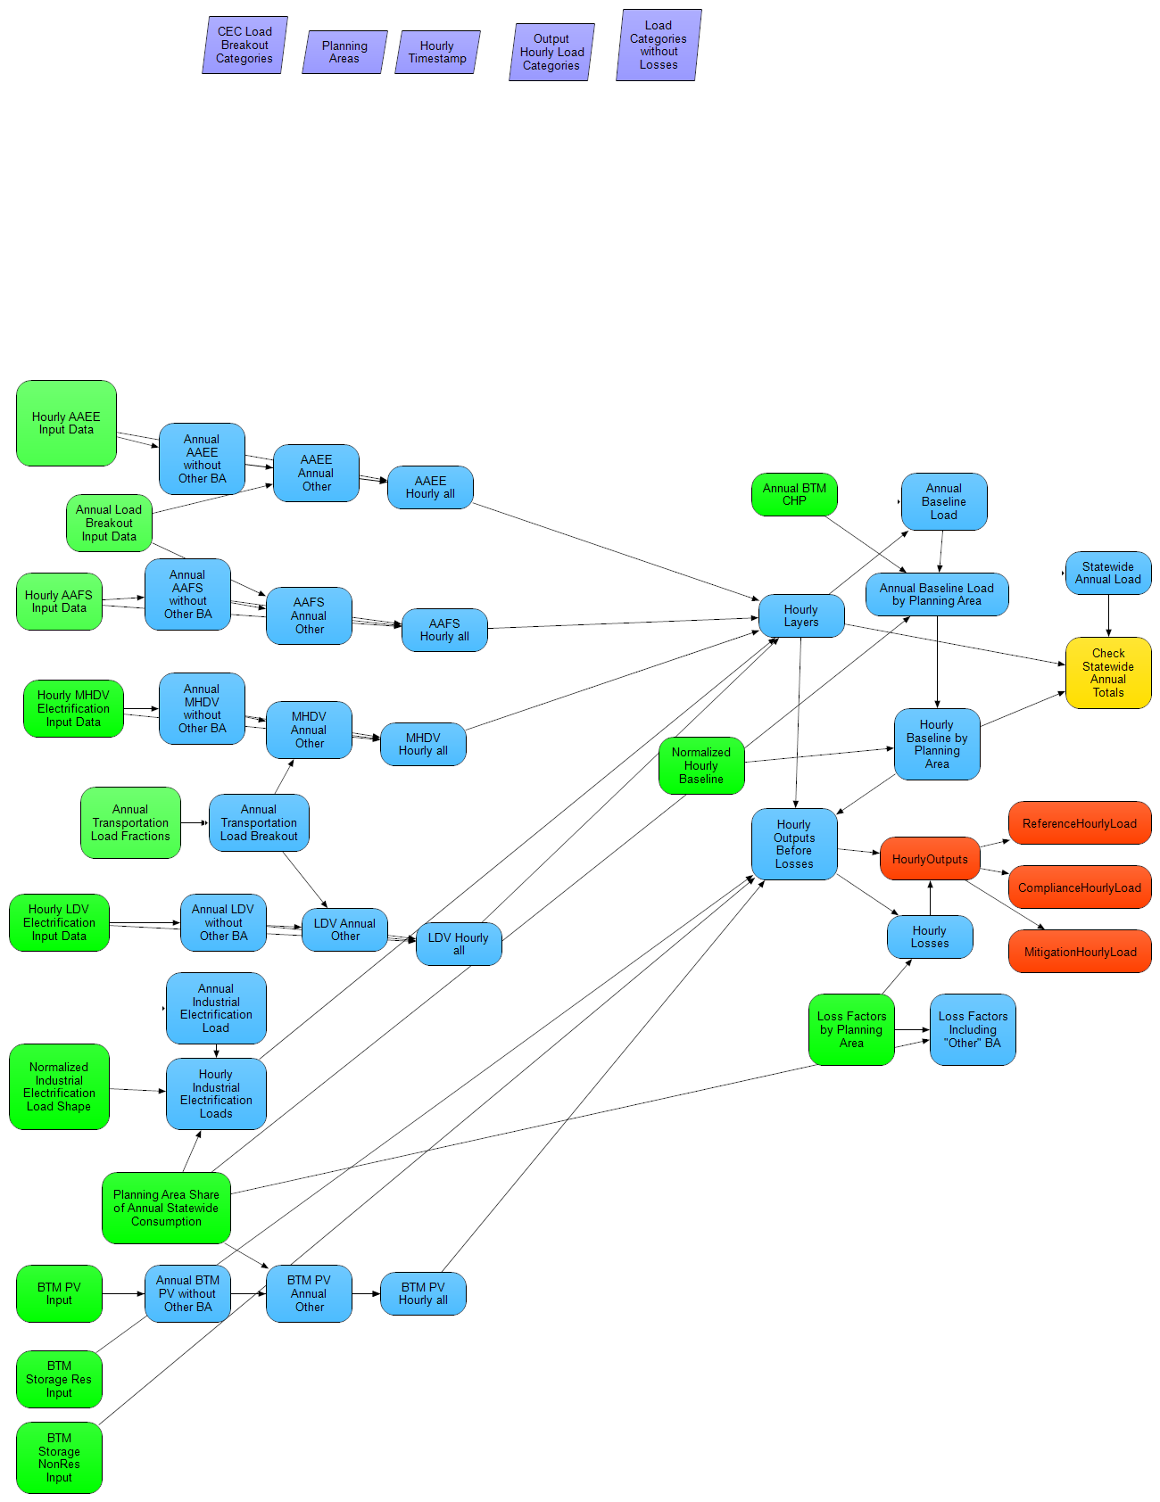

The tables below detail the Sectors and Fuels Staff plan to model for the Demand Scenarios Project.
CEC: The Color Green indicates the sector with CEC Inputs and Turquoise is Fuels of the sector which CEC provides data for.
Contractor: The remaining sectors/fuels data needs to be provided by the contractor.
Agriculture | Commercial | Industrial | Oil & Gas Extraction | Petroleum Refining
Conventional Diesel | Conventional Diesel | Coal | Conventional Diesel | Coke
Conventional Gasoline / Conventional Ethanol | Conventional Gasoline / Conventional Ethanol | Conventional Gasoline / Conventional Ethanol | Natural Gas | Natural Gas
Electricity | Electricity | Electricity | Renewable Diesel | Refinery and Process Gas
Natural Gas | Kerosene | LPG | Waste Heat | Waste Heat
Renewable Diesel | LPG | Natural Gas | Biogas | Biogas
Waste Heat | Natural Gas | Waste Heat | Hydrogen | Hydrogen
Biogas | Renewable Diesel | Hydrogen
Hydrogen | Waste Heat | Biogas
 | Wood
 | Biogas
 | Hydrogen

Residential | TCU | Transportation
Conventional Diesel | Electricity | Conventional Diesel
Electricity | Natural Gas | Conventional Gasoline / Conventional Ethanol
Kerosene | Waste Heat | Conventional Jet Fuel
LPG | Biogas | Electricity
Natural Gas | Hydrogen | Hydrogen
Renewable Diesel |  | Renewable Diesel
Wood
Biogas
Hydrogen
Q7: The RFP mentions the ability to propose a new platform that is not Adapted PATHWAYS. Are they similar requirements around any new Model development that bidders submit that CEC would own/modify it?
A7: There is language in the RFP manual that specifies that the modeling tool developed as a part of this project will be the property of the Energy Commission.

.

