See the formatting recommendations in Part III, Section A.

The Project Narrative must respond to each sub-criterion below.

Technical Merit

- The proposed project provides a clear and concise description of the technological, scientific knowledge advancement, and/or innovation that will overcome barriers to achieving the State’s statutory energy goals.
- Describes the competitive advantages of the proposed technology over state-of-the-art (e.g., efficiency, emissions, durability, cost).
In addition, provide a competition matrix to compare current and competing technologies, such as
Table X: Competition Matrix:
Comparable Attribute | Applicant’s Technology | Current Leading Technology | Competing Technology
Example: Gas efficiency | (1 unit) | (3 units) | (2 units)
Example: Temperature range | (20 units) | (10 units) | (10 units)

- Provides the proposed technical specifications and describe how the project will meet or exceed the technical specifications by the end of the project.
- Describes the technology readiness level (TRL) the proposed technology has achieved and the expected TRL by the end of the project.
- Describes at what scale the technology has been successfully demonstrated, including size or capacity, number of previous installations, location and duration, results, etc.
- Describes how the proposed demonstration will lead to increased adoption of the technology in California.
- Provides information described in Section I.C.

Technical Approach
- Proposal describes the technique, approach, and methods to be used in performing the work described in the Scope of Work
- The Scope of Work identifies goals, objectives, and deliverables, details the work to be performed, and aligns with the information presented in Project Narrative.
- Proposal identifies the reliability that the project and site recommendations as described will be carried out if funds are awarded.
- Identifies and discusses factors critical for success, in addition to risks, barriers, and limitations (e.g. loss of demonstration site, key subrecipient). Provides a plan to address them.
- Discusses the degree to which the proposed work is technically feasible and achievable within the proposed project schedule Attachment, and the key activities schedule in Section I.E.
- Describes the technology transfer plan to assess and advance the commercial viability of the technology.
- Provides a clear and plausible measurement and verification plan that describes how energy savings and other benefits specified in the application will be determined and measured.
- Provides information documenting progress towards achieving compliance with the California Environmental Quality Act (CEQA) by addressing the areas in Section I.I, and Section III.C.7
- Provides information described in Section I.C.

Impacts and Benefits to California IOU Ratepayers
- Explains how the proposed project will benefit California Investor-Owned Utility (IOU) ratepayers and provides clear, plausible, and justifiable (quantitative preferred) potential benefits. Estimates the energy benefits including:
- quantifiable thermal energy savings from reduced gas use in laboratory operations, product development, and projected reduction in gas use from replacing incumbent products with proposed CO₂-based products.
In addition, estimates the non-energy benefits including:
- greenhouse gas emission reductions, air emission reductions (e.g. NOx), water savings and cost reduction, and/or increased safety.
- States the timeframe, assumptions with sources, and calculations for the estimated benefits, and explains their reasonableness. Include baseline or “business as usual” over timeframe.
- Explains the path-to-market strategy including near-term (i.e. initial target markets), mid-term, and long-term markets for the technology, size and penetration or deployment rates, and underlying assumptions.
- Identifies the expected financial performance (e.g. payback period, ROI) of the demonstration at scale.
- Identifies the specific programs which the technology intends to leverage (e.g. feed-in tariffs, IOU rebates, demand response, storage procurement) and extent to which technology meets program requirements.
- Provides information described in Section I.C.

Team Qualifications, Capabilities and Resources

- Identifies credentials of applicant and any subrecipient core personnel, including the project manager and principal investigator (include this information in Project Team Form Attachment).
- Demonstrates that the project team (TDD only) including Community Based Organization has appropriate qualifications, experience, financial stability and capability to complete the project.
- Explains the team structure and how various tasks will be managed and coordinated.
Include an organization chart similar to the one below
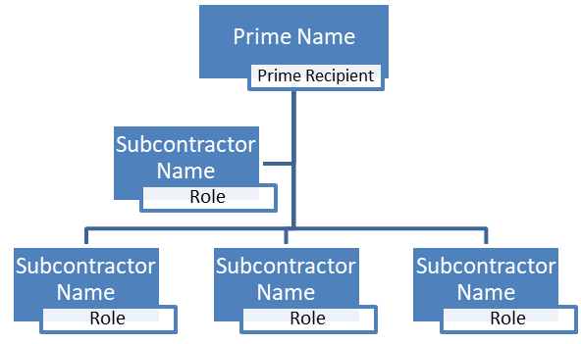
Figure X: Organization Chart

- Describes the facilities, infrastructure, and resources available that directly support the project.
- Describes the team’s history of successfully completing projects in the past 10 years including subsequent deployments and commercialization.

Budget and Cost Effectiveness
Budget forms are complete for the applicant and all subrecipients, as instructed in Budget Attachment.
Provide a budget by tasks, such as:
Table X: Task Budget
Task (by major task) | Energy Commission Funds | Match Share | Total
Task 1: General Project Tasks
Task 2:
Task [TBD-1]: Evaluation of Project Benefits
Task [TBD-2]: Technology/ Knowledge Transfer Activities *
* Requires at least 5% of total CEC funds

- Justifies the reasonableness of the requested funds relative to the project goals, objectives, and tasks.
- Justifies the reasonableness of direct costs (e.g., labor, fringe benefits, equipment, materials & misc. travel, and subrecipients).
- Justifies the reasonableness of indirect costs (e.g., overhead, facility charges (e.g., rent, utilities), burdens, subrecipient profit, and other like costs).

Funds Spent in California

This project proposes to spend $_________ of Energy Commission funds in California.

Funds Spent on California Based Entities

This project proposes to spend $_________ of Energy Commission funds on California Based Entities.

Disadvantaged Communities / Tribes
- Proposal identifies how the target market(s) will benefit disadvantaged and low-income communities and/or tribes.
- Identifies economic impact on low-income and disadvantaged communities and/or tribal communities including customer bill savings, job creation, partnering and contracting with micro- and small-businesses, and economic development.
- Describes how the project will increase access to clean energy or sustainability technologies within disadvantaged or low-income communities and/or tribes and how the development will benefit the communities.
- Applicants have letters of support from technology partners, community based organizations, environmental justice organizations, or other partners that demonstrate equity, feasibility, and commercial viability in low-income and disadvantaged communities and/or tribes.
- Provides information described in Section I.C.

