Limit the fact sheet to two pages. See the formatting requirements in Part III, Section A.

Title of Project

Brief Highlight Statement

The Issue
This section should be about one paragraph, 4-5 sentences, describing the issues or critical need being addressed.

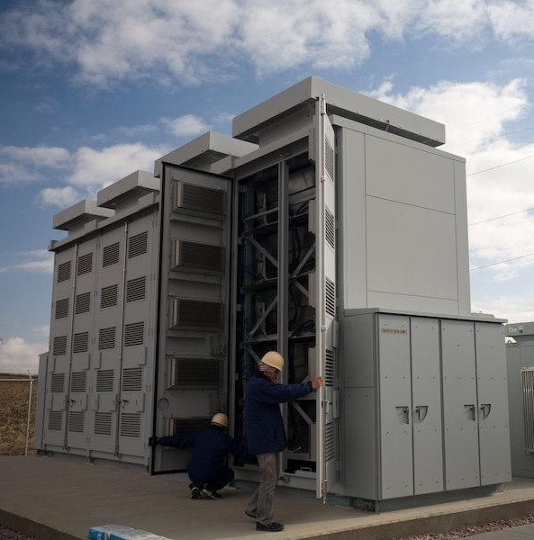
Example: Energy storage technologies have the potential to increase the reliability of California’s energy supply, and the ability to dispatch energy sources. While wind and solar power plants help California to generate energy with little detriment to the environment, the intermittent nature of these sources requires special attention when connecting them to the grid. Building a portfolio of energy storage options could help address these system challenges and balance the development of newer, distributed energy technologies with the continued development of well-established generation technologies. While energy storage has the potential to serve multiple valuable functions in the electric grid, it is currently very expensive, primarily due to it being in the early stages of development. The lack of large-scale production and mature mechanisms for energy storage in the electricity markets further adds to the high cost of available technologies.

Project Description

This section should be about one or two paragraphs, 8-10 sentences, describing the project.

Example: The sodium-sulfur (NaS) battery energy storage system (BESS) is one of the most advanced battery storage technologies on the market, with more than six hours of energy storage, a high efficiency of about 80 percent, and a long life span of 15 years. Pacific Gas & Electric Co. (PG&E) is installing a 2 megawatt (MW), 14 megawatt-hour (MWh) system at its Vaca-Dixon substation and a 4 MW, 28 MWh system at the end of a distribution line that is connected to the Hitachi Global Storage Solutions facility in San Jose, CA.
2 MW / 14 MWh sodium sulfur battery installation at PG&E’s Vaca-Dixon substation. Source: PG&E

The BESS installation at the Hitachi facility will serve to enhance power reliability for customers on the distribution line by mitigating fluctuations. Multiple hours of backup power provided by the BESS will reduce emissions from the facility’s diesel backup generator normally used during power outages. The BESS has the capacity to fully power the Hitachi facility powered by the battery – known as “islanding” – in the event of an outage. In addition to these functions, additional battery capacity is allocated to provide ancillary services, such as peak load shaving and voltage regulation, helping to support grid stability. The system will further be used to supply energy in times of high demand and store energy in times of oversupply.

PG&E’s Vaca-Dixon substation is close to, and on the same distribution feeder as, the Vaca-Dixon solar plant. The solar plant is capable of generating approximately 2 MW of peak power. Installation of a 2 MW energy storage battery will test the use of energy storage at the substation level to manage this intermittent resource, and will also provide the grid ancillary services depending on customer demand.
Anticipated Benefits for California
This section should be about one or two paragraphs, 6-8 sentences, describing how the proposed project will help overcome barriers to achieving the state’s energy goals and provides ratepayer benefits of greater electricity reliability, lower costs, and/or increased safety.

Example: Energy storage may contribute multiple benefits to California’s electricity ratepayers by helping to stabilize the grid, improve service reliability, and reduce financial losses associated with power outages. Storage can offset the need to purchase and install new generation, as well as reduce the use of highly polluting peaking power plants during periods of high demand. When compared to the slower response rates of traditionally dispatched conventional fossil fuel powered plants, the fast ramp rates of NaS batteries are particularly suited to support the integration of large amounts of variable renewable energy, helping to meet California’s aggressive renewable energy goals.
However, the magnitude of these benefits is poorly understood because very few advanced storage devices have been deployed. These benefits are not realized primarily due to the emerging nature of many storage technologies, their high cost, and the lack of mature mechanisms for their participation in electricity markets. This project aims to provide critical real-world data on the technical and financial performance of battery energy storage and to determine how market products can be designed to make energy storage economical. It is driven by the mutual vision of the Energy Commission and PG&E to better understand how emerging energy storage technologies can help meet California’s future energy needs, and to share this knowledge with the public.

Project Specifics
Contractor: Pacific Gas and Electric Co.
Partners: San Jose, San Jose County; and Vacaville, Solano County
Amount: $3,300,000
Co-funding: $8,000,000 from Pacific Gas and Electric Co.
Term: June 2010 to December 2014

Contacts
Recipient:
Phone:
Email:

Amount:
Co-funded Amount:
Project Location(s):
Project Term:

