STATE OF CALIFORNIA – NATURAL RESOURCES AGENCY EDMUND G. BROWN JR., Governor

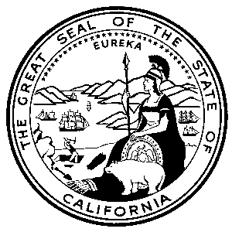
CALIFORNIA ENERGY COMMISSION
1516 NINTH STREET
SACRAMENTO, CA 95814-5512
www.energy.ca.gov

GFO-17-601
Addendum 1
August 2, 2018

Light Duty Vehicle Hydrogen Refueling Infrastructure
Operation and Maintenance (O&M) Support Grants

The purpose of this addendum is to correct an error. The maximum O&M funding award amount in Table 2 on page 7 of the Application Manual should read as follows:

Table 2. Station Address and Maximum O&M Award Amount under this Solicitation

Station Address | Maximum O&M Funding Award under this Solicitation
5314 Topanga Canyon Road, Woodland Hills, CA | $175,000 $165,000

Doug Harvey,
Commission Agreement Officer

