STATE OF CALIFORNIA – NATURAL RESOURCES AGENCY GAVIN NEWSOM., Governor

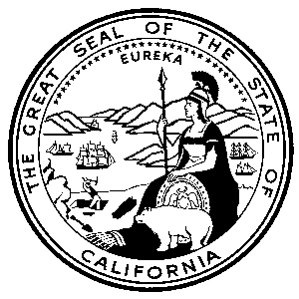
CALIFORNIA ENERGY COMMISSION
1516 NINTH STREET
SACRAMENTO, CA 95814-5512
www.energy.ca.gov

Addendum #2
July 26, 2019

RFQ-18-402

Request for Qualifications for
TECHNICAL ASSISTANCE
to the
Bright Schools Program
Energy Partnership Program

The purpose of this addendum is to make the following revisions to the solicitation document:

RFQ-18-402 Solicitation

Section I, Key Activities and Dates

- Page 6, Key Activities and Dates. The Action Date for the activities as listed below have been changed.

Key activities including dates and times for this RFQ are presented below. An addendum will be released if the dates change for the asterisked (*) activities.
Activities | Action Date
RFQ release | 5/21/2019
Pre-Bid Conference* | 6/3/2019
Written Question Submittal Deadline by 5:00 p.m.* | 6/3/2019
Distribute Questions / Answers and Addenda (if any) | 6/17/19
Deadline to submit SOQ by 5:00 p.m.* | 7/16/2019
SOQ Discussions with Firms* | 8/15/2019-8/16/2019 8/23/2019-8/30/2019
Notice of Selection | 8/19/2019 9/3/2019
Cost Negotiations | 8/20/2019-9/10/2019  9/3/2019-9/24/2019
Notice of Proposed Award | 9/18/2019 10/2/2019
Energy Commission Business Meeting | 12/11/2019
Contract Start Date | 12/31/2019
Contract End Date | 12/31/2022

Section III, STATEMENT OF QUALIFICATIONS (SOQ) Format, Required Documents and Delivery

- Page 21, Organize Your SOQ as Follows: SECTION 1, Administrative Response. Attachment 9 Civil Rights Laws Certification Form has been added to the required forms. This is consistent with Section IV Evaluation Process and Criteria (page 27), which states that the SOQ must include a properly executed Civil Rights Laws Certification Form. This is also consistent with the requirements for the Civil Rights form, described in Section VI, Administration (page 40).

Section IV, ADMINISTRATION

- Page 40, Civil Rights Laws, the attachment number has been changed from Attachment 11 to Attachment 9.

If the bidder has already submitted the signed Civil Rights form in the SOQ package, then no further response is necessary. However, if the bidder did not include the form, please submit the signed form by August 2, 2019, via email, to the Commission Agreement Officer at the following email address:

Angela.Hockaday@energy.ca.gov

If you have previously missed the deadline to submit proposals and your proposal has been rejected, you will not be allowed to resubmit your proposal and no other documents will be accepted.

Angela Hockaday
Commission Agreement Officer

