Limit the fact sheet to two pages. See the formatting requirements in Part III, Section A.

Title of Project

Brief Highlight Statement
The Issue
This section should be about one paragraph, 4-5 sentences, describing the issues or critical need being addressed.

Project Innovation + Advantages
This section should be about one paragraph, 5-6 sentences, providing general description of the project. Summarize the key features and how it will address the issues identified previously.

Anticipated Benefits for California
General benefits: Provide a description of how the proposed project will help overcome barriers to achieving the state’s energy goals.

Specific Benefits (choose from the following benefits that apply to the project, and provide 1-2 sentence descriptions)
- Lower costs: 1-2 sentences
- Greater reliability
- Increase safety
- Economic development
- Environmental benefits
- Public health
- Consumer appeal
- Energy security
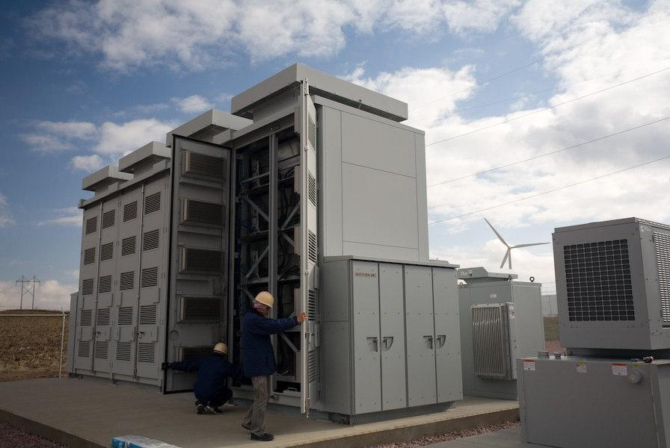
Provide a picture and caption on your project. Only bmp, gif, jpeg, and png file types allowed with 4MB max size.

Contacts
Recipient:
Phone:
Email:

Amount:
Co-funded Amount:
Project Location(s):
Project Term:

