The tables in this attachment provide a basis for applicants to estimate the potential impact and benefits associated with their proposals. Applicants must use these tables when estimating the proposed project’s energy and peak demand savings and greenhouse gas (GHG) impacts, to the extent that the data apply to the proposed project. The tables characterize California’s residential and commercial electricity market in terms of consumption and peak demand for major end use categories and a statewide GHG emissions factor.

Applicants must temper their market impact estimates with realistic assumptions about the timeframe for achieving market penetration as it relates to construction activity and the market connection challenges associated with all technology transfer efforts. Applicants must also discuss the potential for competing technologies, and account for them in their discussion of market impacts assumed for the proposed efforts.

- Residential Data

The following tables have been assembled from source data used by the Energy Commission for assembling the California Energy Demand 2006-2016 Residential Demand Forecast. These standardized end-use data will provide the project evaluation committee with a common reference for comparing residential energy and demand savings estimates. The total number of homes used in the forecast was 12,345,233.

Table 1: Residential Peak Demand and Energy Consumption by End-Use

Residential Sector End Uses | Peak Demand* |  | Annual Energy
 | MW | % of Total MW | Total Energy (GWh/ Year) | % of Total Energy
Air Conditioning | 12,660 | 50% | 7,252 | 8%
Cooking | 1,098 | 4% | 2,888 | 3%
Dishwashers | 502 | 2% | 2,805 | 3%
Domestic Hot Water | 246 | 1% | 1,691 | 2%
Dryers | 805 | 3% | 4,497 | 5%
Freezers | 352 | 1% | 2,251 | 2%
Misc (includes lighting) | 4,955 | 20% | 36,901 | 41%
Pools & Spas | 1,151 | 5% | 5,415 | 6%
Refrigerators | 2,214 | 9% | 15,218 | 17%
Space Heating | - | 0% | 3,662 | 4%
TVs | 1,004 | 4% | 6,409 | 7%
Washers | 279 | 1% | 1,658 | 2%
Waterbeds | - | 0% | - | 0%
Total | 25,266 | 100% | 90,647 | 100%

*Peak demand numbers are estimates based on load factor.

Table 2: Residential Gas Consumption by End-Use
End Use | Millions of Therms/Year | % of Total
Air Conditioning | 52 | 1.0%
Cooking | 304 | 5.7%
Dishwashers (water heating) | 368 | 6.9%
Domestic Hot Water | 1,200 | 22.5%
Dryers | 166 | 3.1%
Miscellaneous | 189 | 3.5%
Pools & Spas | 287 | 5.4%
Space Heating | 2,228 | 41.7%
Washers (water heating) | 543 | 10.2%
Total | 5,336 | 100%

- Commercial End-Use Data
For commercial buildings, use the energy and peak demand tables found in the Energy Commission’s California Commercial End Use Survey (CEUS) Report (March 2006) located at: http://www.energy.ca.gov/2006publications/CEC-400-2006-005/CEC-400-2006-005.PDF. Before using this data, refer to Chapter 7 of the CEUS report. The following are excerpts from the report.

Table 3: Overview of Energy Usage in the Statewide Service Area (Table 8-1 in the CEUS Report)
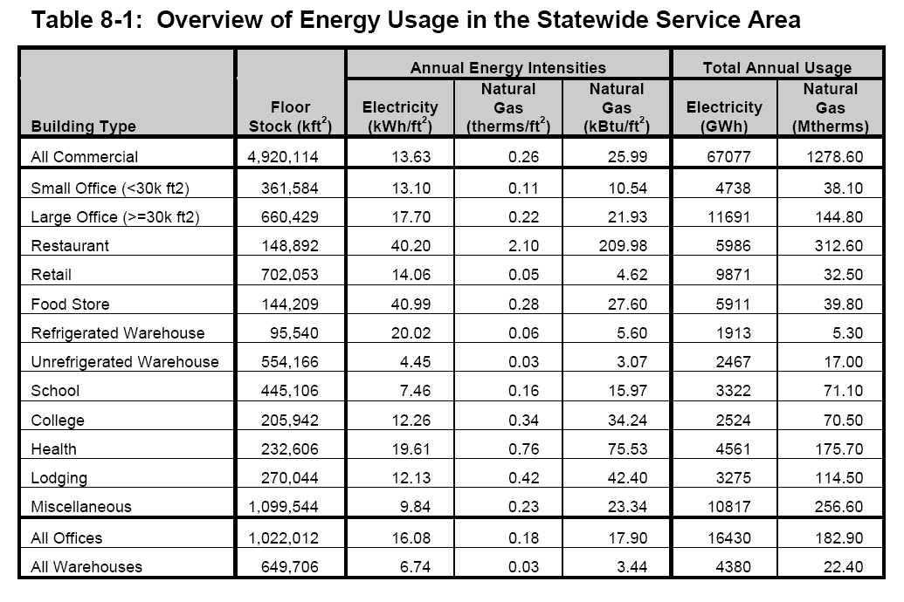

Table 4: Electric Usage (GWh) by Building Type and End Use (Table 8-2 in the CEUS Report)
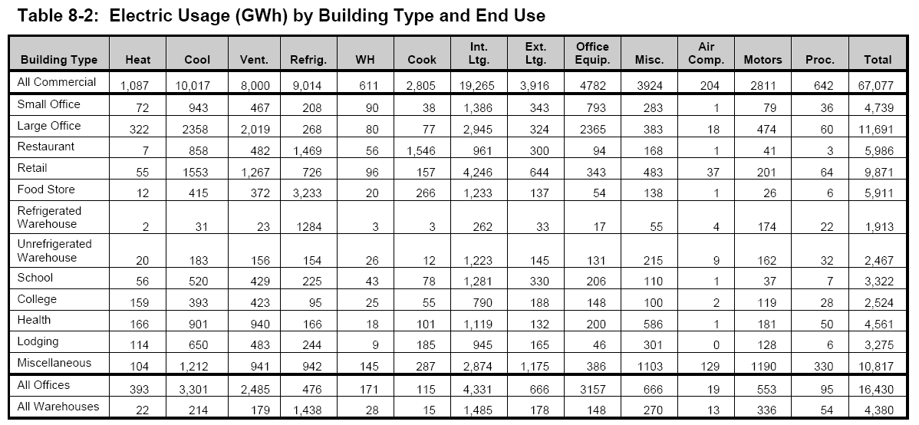

- Greenhouse Gas Emissions
Table 5: Standardized Emission Factors for Electricity and Gas
 | Emissions Factor (CO2e) | Emissions Factor(CO₂e)
Electricity | 0.588 lbs/kWh saved | 0.000283 metric tons/kWh
Gas | 11.7 lbs/therm saved | 0.0053 metric tons/therm

Energy Costs
 | Average Statewide Residential | Average Statewide Commercial | Average Statewide Industrial
Electricity | $ 0.15/kWh | $ 0.1418/kWh | $ 0.1054/kWh
Natural Gas | $ 0.96/therm | $ 0.676/therm | $ 0.565/therm

Energy Commission staff estimates.
California Air Resources Board staff calculations.
U.S. Energy Information Administration (EIA) 2012 summaries, tables 6 through 10. http://www.eia.gov/electricity/sales_revenue_price/.
U.S. Energy Information Administration, www.eia.gov/dnav/ng/ng_pri_sum_dcu_SCA_a.htm.

