STATE OF CALIFORNIA – NATURAL RESOURCES AGENCY EDMUND G. BROWN JR., Governor
CALIFORNIA ENERGY COMMISSION
1516 NINTH STREET
SACRAMENTO, CA 95814-5512
www.energy.ca.gov

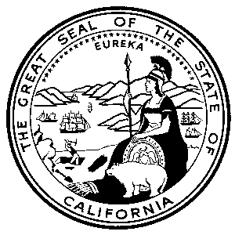

Addendum 6

August 17, 2018

GFO-15-312

The EPIC Challenge: Accelerating the Deployment of Advanced Energy Communities

The purpose of this addendum is to amend the key activities schedule. This addendum includes the following revisions to the Solicitation Manual:

Page 19, Section G. Key Activities Schedule
Deleted: “September 7”
Added: “September 21”
Deleted: “October 15”
Added: “October 29”
Brad Worster
Commission Agreement Officer

