Attachment 7
School Bus Replacement Program Regional Map

Del Norte

Siskiyou

Modoc

Humboldt

Trinity

Shasta

Lassen
North
Average Daily Attendance | 1,514,687.72
# of Counties | 33

Mendocino

Lake
Tehama

Glenn Colusa

Butte

Plumas

Sierra Nevada Placer
Yuba
Central
Average Daily Attendance | 1,583,469.96
# of Counties | 20

Sonoma

Napa
Amador

Yolo

Solano

Sacra- mento

El Dorado
Sutter

Alpine

Marin

San Francisco
San

Contra Costa
Alameda
San Joaquin
Tuolumne

Mariposa
Calaveras
Stanislaus

Mono

Mateo

Santa Cruz
Santa Clara

Merced

Madera

San Benito
Fresno
Inyo

Monterey

Kings
Tulare

San Luis Obispo

Kern

Santa Barbara

Ventura Los Angeles
Los Angeles
Average Daily Attendance | 1,466,193.68
# of Counties | 1

San Bernardino

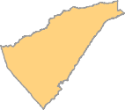
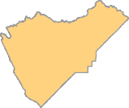
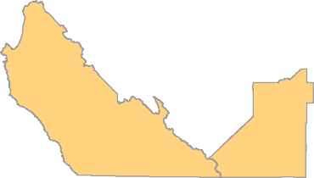
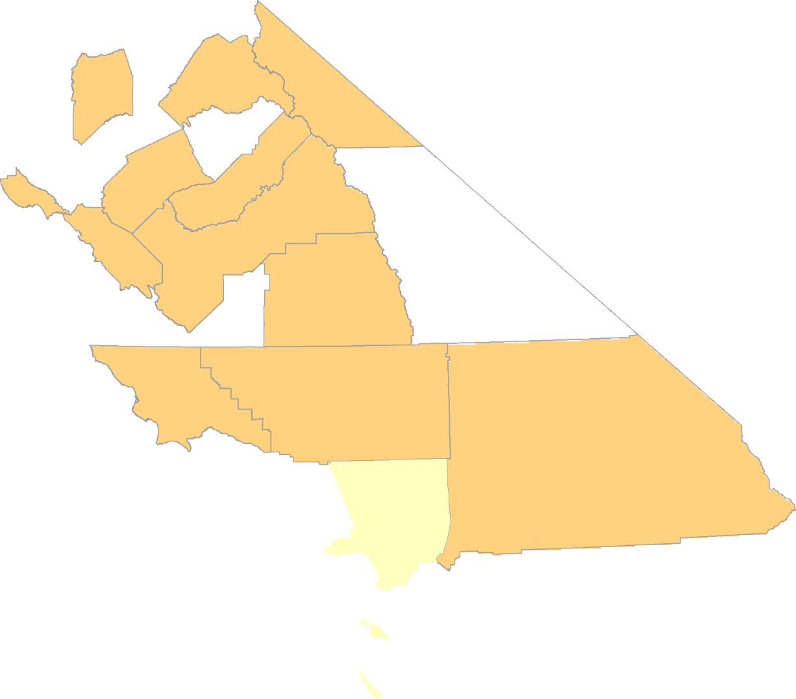
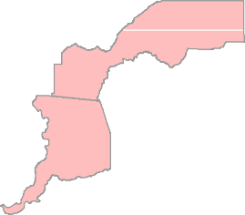
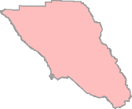
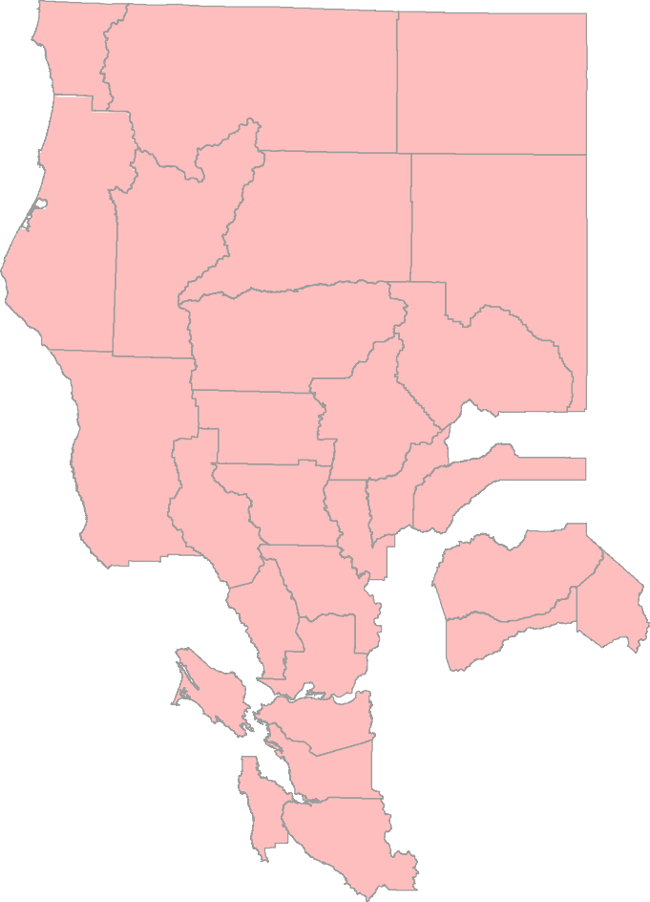

Document Path: T:\Division\Efficiency_Division\Local_Assistance_and_Financing_Office\MapDoc\Attachment 7.mxdDate Saved: 4/25/2018 1:33:13 PM

Orange
Riverside

San Diego
South
Average Daily Attendance | 1,405,604.18
# of Counties | 4

Imperial

