Attachment 9
Instructions for completing the CEC‐24 form

Once recommended for a proposed award, awardees will be required to complete the following worksheet. This document is not required to be completed as part of the application.

The CEC‐24 has fields allowing for the input of 6 sets of utility account information per file. Additional files can be used if necessary to input information for all sites under the jurisdiction of the Local Educational Agency (LEA). If an LEA has one utility for electricity and a different one for natural gas, the LEA must submit a separate CEC‐24 form for each utility.
Select your utility from the pull down menu.
Multiple file identification boxes are used to track submissions requiring multiple files.

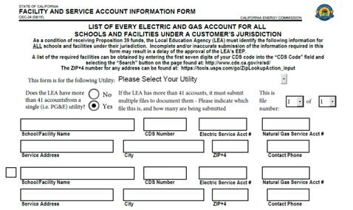
Multiple file selection buttons. This is not needed unless the LEA has more than
6 utility accounts.
Data copy checkbox. This box copies all non‐ utility data from the previous line1.
The fields required for each service account are detailed below:

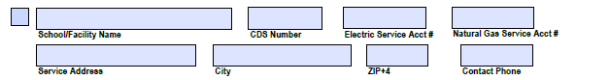

Electricity service account number for this site
Natural gas service account number for this site
Contact telephone number. This should be the direct line for the person completing the form.
The site name and CDS number should match the information on the CDE internet page: http://www.cde.ca.gov/re/sd/
Service location information should match what is on your utility bill.
Once the form is complete, it must be saved in Acrobat (not scanned) and submitted two ways:
- To the Energy Commission, and
- To your utility’s designated recipient. A list of these recipients can be found at: http://energy.ca.gov/efficiency/proposition39/listing_utility_recipients.html. If your utility is not on this list, please contact your account representative for guidance.

1. This must be unchecked in order to be able to edit the non‐utility information

LIST OF EVERY ELECTRIC AND GAS ACCOUNT FOR ALL SCHOOLS AND FACILITIES UNDER A CUSTOMER’S JURISDICTION

As a condition of receiving School Bus Replacement funds, the Local Educational Agency (LEA) must identify the following information for ALL facilities where buses are charged or fueled under their jurisdiction.
Please Select Your Utility
This form is for the following utility:

Does the LEA have more than 6 accounts from a single utility(i.e. PG&E)?

No Yes

Electric Service Acct #

School/Facility Name

CDS Number
Natural Gas Service Acct #

Service Address
City

ZIP+4

Contact Phone

Electric Service Acct #

School/Facility Name

CDS Number
Natural Gas Service Acct #

Service Address City
ZIP+4
Contact Phone

Electric Service Acct #

School/Facility Name

CDS Number
Natural Gas Service Acct #

Service Address
City

ZIP+4

Contact Phone

Electric Service Acct #

School/Facility Name

CDS Number
Natural Gas Service Acct #

Service Address
City

ZIP+4

Contact Phone

Electric Service Acct #

School/Facility Name

CDS Number
Natural Gas Service Acct #

Service Address City
ZIP+4
Contact Phone

Electric Service Acct #

School/Facility Name

CDS Number
Natural Gas Service Acct #

Service Address City
ZIP+4
Contact Phone

