ATTACHMENT 12

Dismantler Certification Form

School District: Agreement Number:

This form is used to satisfy the bus dismantle or scrapping reporting obligation. It must be received by the Energy Commission no later than 12 months after the “new bus” is received. Complete this form in its entirety, obtain the Dismantlers signature, attach applicable photographs, and provide a copy of the Department of Motor Vehicles Dismantlers Notice of Acquisition/Report of Vehicles to be Dismantled (Reg 42).

Photographs required to document destruction:
Vehicle Identification Number Engine Serial Number
□
□
Photo of the method used to “dismantle or scrap” both engine and non-engine portion of the bus (see definition of “dismantle” below and the following page for examples of satisfactory photos)
□

Photographs may be provided by the school district or the dismantler, and may be delivered with this form, or by emailing them to schoolbusprogram@energy.ca.gov.

Dismantler Information:
Dismantler: |  |  | Contact Name:
Address: |  |  | Contact Email:
City: | State: | Zip: |  | Phone:

Engine Dismantle: Vehicle Dismantle:
Engine Make: | Engine Model:
Engine Serial Number:
Describe Method Used for Engine Dismantle:

Vehicle Make: | Vehicle Model:
Vehicle Identification Number:
Final Odometer Reading:
Describe Method Used for Vehicle Dismantle:

The bus and engine identified by the VIN number/Serial number shown above, shall not be returned to the original manufacturer for remanufacture, shall not be resold but shall be dismantled and rendered unfit for further use. To “dismantle” the vehicle chassis means to punch, crush, stamp, hammer, shred, or otherwise render permanently and irreversibly incapable of functioning as originally intended. To “dismantle” the engine portion, a 5 inch hole must be cut into the engine block.

I certify that the information provided on this form is true and correct. Furthermore, the attached photographs are images of the equipment identified on this form. The equipment listed on this form has been dismantled in a manner consistent with the definition listed herein and in accordance with the terms of the Agreement for this Project.

X
Dismantler Authorized Signature | Printed Name | Date

Examples of Acceptable Destruction (“Dismantle”)

The photographs below have been provided below as a guide for acceptable destruction of the engine and non-engine (chassis) portion of the bus.

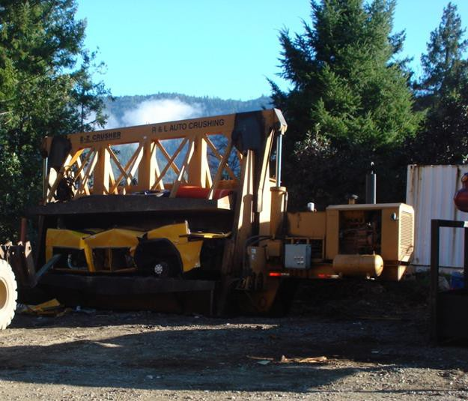
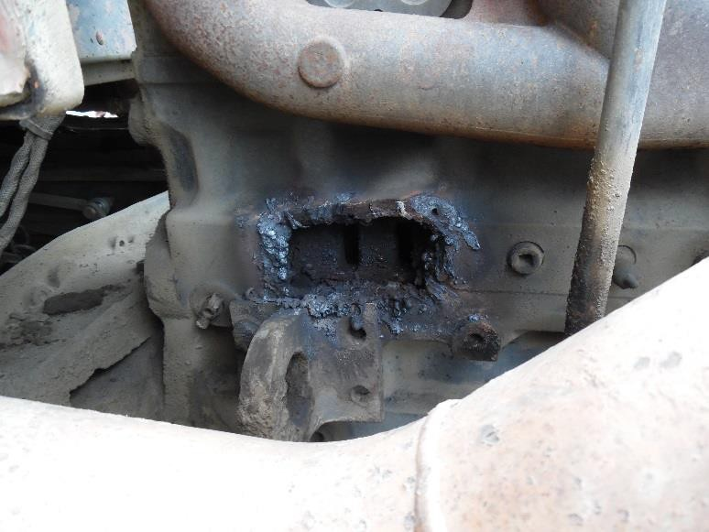
Engine: 5” hole in engine block Example of acceptable destruction of vehicle chassis

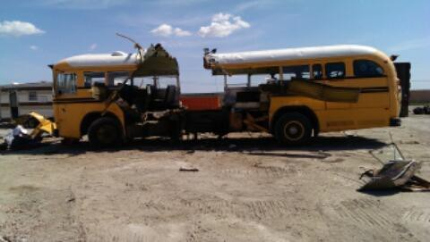
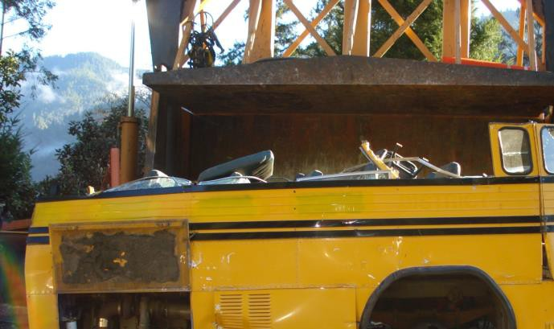

Example of acceptable destruction of vehicle chassis Example of acceptable destruction of vehicle chassis

