WORKSHOP AGENDA

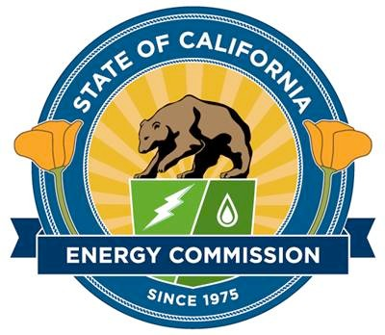
Energy Research Innovations in Water Treatment, Delivery
and Energy Recovery
November 19, 2019
9:30 AM – 4:00 PM PST

CALIFORNIA ENERGY COMMISSION
1516 Ninth Street
1st Floor, Art Rosenfeld Hearing Room Sacramento, California

Web Conference: https://energy.webex.com/ec
Audio Conference: 1-866-469-3239
Access Code: 929 106 078

Workshop Background and Objective: The energy used to extract, treat, convey water and dispose of wastewater currently accounts for nearly 20% of the California’s electricity consumption. Since 1996, there has been a 74% increase in energy use in municipal wastewater treatment and a 39% increase in energy usage for public drinking water systems. This workshop will highlight some of the California Energy Commission’s (CEC) innovative research on water treatment, delivery and energy recovery, seek public input on future research needs and identify potential pathways to commercialization for emerging technologies.

Event | Time
1. Introduction | 9:30 AM
2. Program Overview for the Water Energy R&D - Vice Chair Janea A. Scott | 9:35 AM
3. Advancements in Reducing Energy Use in Wastewater Treatment  Moderator: Christian Fredericks  This panel will discuss promising advancements in wastewater treatment aimed at reducing energy consumption, opportunities to deploy advanced technologies into treatment plants, and future research needs of the industry.  - Onder Caliskaner - Kennedy/Jenks Consultants, Inc., “Raw Wastewater Filtration to Increase Organic Removal Efficiency and Achieve Significant Electrical Savings”  - Sebastian Tilmans – Stanford University, “Maximizing Water and Energy from New Anaerobic Wastewater Treatment Technology”  - Eric Hansen - Silicon Valley Clean Water  - Brian Davis - Linda County Water District  - Phil Ackman - Los Angeles County Sanitation District | 9:45 AM
4. Progress Toward Maximizing Water Resources and Energy Grid Opportunities  Moderator: Kevin Mori  This panel will discuss California’s water infrastructure, and energy and water efficiency advancements, research advancements needed and metrics for determining success.  - Tori Yokoyama – Hazen and Sawyer, “Demonstrating Innovative Leakage Reduction Strategies”  - Nicholas Chow - University of California, Los Angeles, “Water-Energy Impacts of Disaggregated Water System Decision-Making”  - Frank Loge - University of California, Davis, “Advancing DR in the Water Sector”  - Erik Desormeaux - Porifera, Inc., “Testing a Low-Energy Water Treatment System for Fail-Safe Direct Potable Reuse”  - Ben Stanford - Hazen and Sawyer | 10:45 AM
5. Lunch Break | 12:00 PM
6. Innovations in Energy Generation for the Water Sector  Moderator: Katharina Gerber  This panel will discuss several innovative projects for energy recovery and identification of potential research needs.  - Matthew Swindle - San Gabriel Valley Water Company, “In-conduit Demonstration Project”  - Ganesh Rajagopalan - Kennedy Jenks, “Lowering Food-Waste Co-Digestion Costs”  - Paul Stout - Tetra Tech, “Waste Water Treatment Plant Biogas to Beneficial Use”  - Diego Rosso - University of California, Irvine  - Juliet Homer - Pacific Northwest National Laboratory  - Thomas Mosier – U.S. Department of Energy | 1:00 PM
7. Pathways to Create Markets for Innovative Technologies  Moderator: Virginia Lew  This panel will discuss different programs and opportunities available for water agencies to implement innovative technologies, challenges and potential for collaborative efforts.  - Kim Hanagan - California State Water Resources Control Board  - Shahid Chaudhry - CEC: Efficiency Division - ECAA Loan Program  - Peter Fiske - Lawrence Berkeley National Laboratory  - Jon Wells - West Yost Associates  - Diana Bauer – U.S. Department of Energy  - William McDonnell - Metropolitan Water District  - Phil Ackman - Los Angeles County Sanitation District | 2:00 PM
- Q&A Session | 3:30 PM
- Closing Remarks | 3:55 PM
- Adjourn | 4:00 PM

