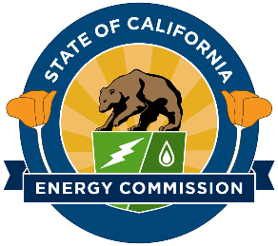

Information on Funding Opportunities for Native American Tribes for Energy Programs and Climate Change Resiliency

Electric Program Investment Charge
Program webpage: https://www.energy.ca.gov/programs-and-topics/programs/electric-program-investment-charge-epic-program

Natural Gas Research Program
Program webpage: https://www.energy.ca.gov/programs-and-topics/programs/natural-gas-program

Clean Transportation Program
Program Webpage: https://www.energy.ca.gov/programs-and-topics/programs/clean-transportation-program

California Electric Vehicle Infrastructure Program
Program webpage: www.calevip.org

Renewable Energy Agriculture Program
Program webpage: https://www.energy.ca.gov/programs-and-topics/programs/renewable-energy-agriculture-program

Geothermal Grant and Loan Program
Program webpage: https://www.energy.ca.gov/data-reports/california-power-generation-and-power-sources/geothermal-grant-and-loan-program

Tribal Government Challenge
Tribal webpage: https://www.energy.ca.gov/programs-and-topics/programs/tribal-program

Solicitation Cycle, Award, and Post Award Process
Webpage: https://www.energy.ca.gov/programs-and-topics/topics/research-and-development

List Servers:
Sign up for list servers: https://www.energy.ca.gov/listservers/index_cms.html

CPUC Initiative to Subsidize Phone & Broadband Services in Tribal Areas
(Proceeding Number R.11-11-007)
Interested entities are encouraged to become parties to the proceeding at the webpage: https://www.cpuc.ca.gov/party_to_a_proceeding/.
To receive electronic updates on this proceeding: http://subscribecpuc.cpuc.ca.gov.

Empower Innovation
A searchable directory of public and private funding opportunities curated for Empower Innovation users. Empower Innovation website: https://www.empowerinnovation.net/

