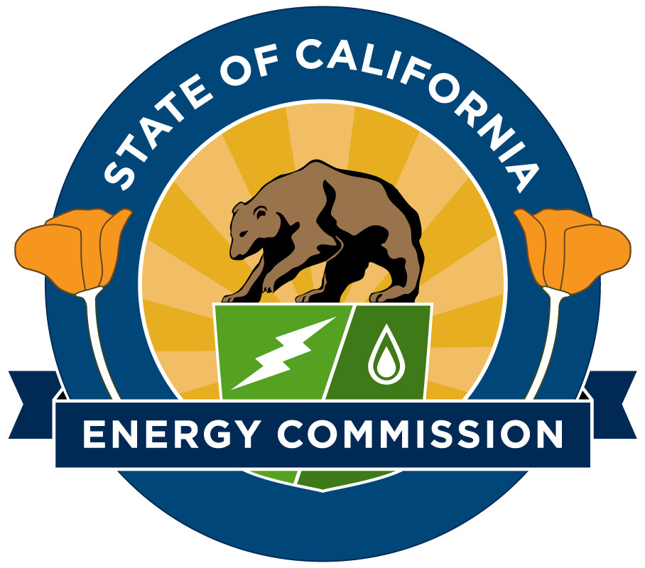 CALIFORNIA ENERGY COMMISSION
DEMAND ANALYSIS WORKING GROUP (DAWG)
2021 CPUC Efficiency Potential and Goals
Study-Measure Characterization & Data Collection Studies

Tuesday, June 2, 2020 – 10:30 AM-1:00 PM
Via Zoom
Zoom website
Password: dawg@10

Time | Topic | Lead
10:30-10:40 | Introduction | Coby Rudolph, CPUC
10:40-11:20 | Measure Characterization | Rebecca Legett, Guidehouse
11:20-11:40 | Q&A/discussion | Coby Rudolph, CPUC
11:40-11:45 | 5 minute break
11:45-12:05 | Market Adoption Study | Melanie Munroe, ODC
12:05-12:15 | Q&A/discussion | Coby Rudolph, CPUC
12:15-12:35 | Industrial/Agricultural Characterization | Christopher Dyson, DNV GL
12:35-12:45 | Q&A/discussion | Coby Rudolph, CPUC
12:45-1:00 | Closing & discussion | Coby Rudolph, CPUC

