This document provides the California Energy Commission (CEC) with basic information about the Applicant and Proposed Project. Each Applicant must complete and include this Application Form in its application.

Applicant’s Legal Name | Federal ID Number
 | -

Title of Proposed Project

Proposed Term
Start Date | End Date
/ / | / /

Proposed Project Funding
Amount of Funds Requested | $
Total Match Funding  Cash Match $  In-kind Match $ | $
Total Project Cost (sum of two previous rows) | $
Match Funding Percentage (Total Match Funding/Total Project Cost) | %

Proposed Project Location
Project city
Project area central point (does not necessarily need to be a site identified for installation). Please indicate cross streets.
Ex: Cesar Chavez Plaza on J & 10th in Downtown Sacramento
Project radius (miles) | miles
Image of project area showing radius
Ex: 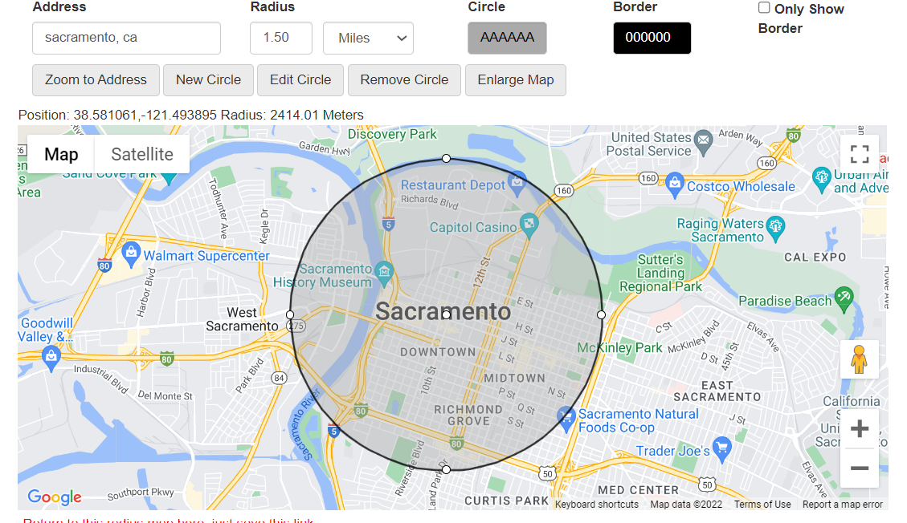
Source: https://www.mapdevelopers.com/draw-circle-tool.php

Number of Chargers
Number of Level 2 chargers project will install

Application Project Type (Check box as required by the solicitation.)
Larger City (population 200,000+)
Smaller City (population between 50,000 and 200,000) or Tribal Lands
Project Description (brief summary)

California Environmental Quality Act (CEQA) Compliance
- Would the proposed project be considered a “Project” under CEQA (PRC 21065 and 14 CCR 15378)?
Yes: skip to question 2
No: Explain why proposed project is not considered a “Project” and complete the following:
Proposed project will not cause direct physical change in the environment or a reasonably foreseeable indirect physical change in the environment because .
- If proposed project is considered a “Project” under CEQA, has environmental review been completed?
Yes (if so, provide documentation in application)
No

Applicant’s Project | Manager (serves as point of contact for all communications)
Name:
Company Address:
City, State, Zip:
Phone/ Fax:
E-Mail:

Key Project Partners(s)
List any key project partners, including subcontractors, vendors, or funding providers, that will perform work under the project, if applicable. Insert the legal name of each entity below and briefly describe their role.
Insert Key Project Partner Legal Name, Describe Role/Duties
Insert Key Project Partner Legal Name, Describe Role/Duties
Insert Key Project Partner Legal Name, Describe Role/Duties
Insert Key Project Partner Legal Name, Describe Role/Duties

Certifications
I hereby authorize the California Energy Commission (CEC) to make any inquiries necessary to verify the information I have presented in my application.
I hereby authorize the CEC to obtain business credit reports and make any inquiries necessary to verify and evaluate the financial condition of the Applicant.
I hereby certify that this application does not contain any confidential or proprietary information.
I hereby certify to the best of my knowledge and belief that I have read, understand, and do hereby accept the terms and conditions contained in this solicitation, including the provisions of the Agreement Terms and Conditions and, further, I am willing to enter into an agreement with the CEC to conduct the proposed project according to the terms and conditions without negotiation.
I hereby certify any required licenses (such as copyrights or trademarks) applicable to the submitted application are in place.
I hereby certify to the best of my knowledge, and under penalty of perjury, that the information contained in this application is correct and complete.
I hereby certify that I am authorized to complete and sign this form on behalf of the Applicant.

Printed Name of Authorized Representative:
Signature of Authorized Representative:
Date: | / /

Note About Signatures
The CEC may have waived the requirement for a signature on application materials for this solicitation. If a notice regarding CEC’s waiver of the signature requirement appears here: https://www.energy.ca.gov/funding-opportunities/solicitations, the waiver applies to this solicitation. In the event of a conflict between the notice and any language in this solicitation regarding signatures, the notice will govern.

Even if the requirement for signatures has been waived, applicants are still expected to adhere to the requirements of this solicitation as if they had signed. If you are an awardee, the CEC will require wet or certified electronic signatures for this attachment within 30 days after posting of the Notice of Proposed Award.

