PROGRAM OPPORTUNITY NOTICE

Energy Conservation Assistance Act-Education Subaccount (ECAA-Ed) Zero-Interest Loan Program
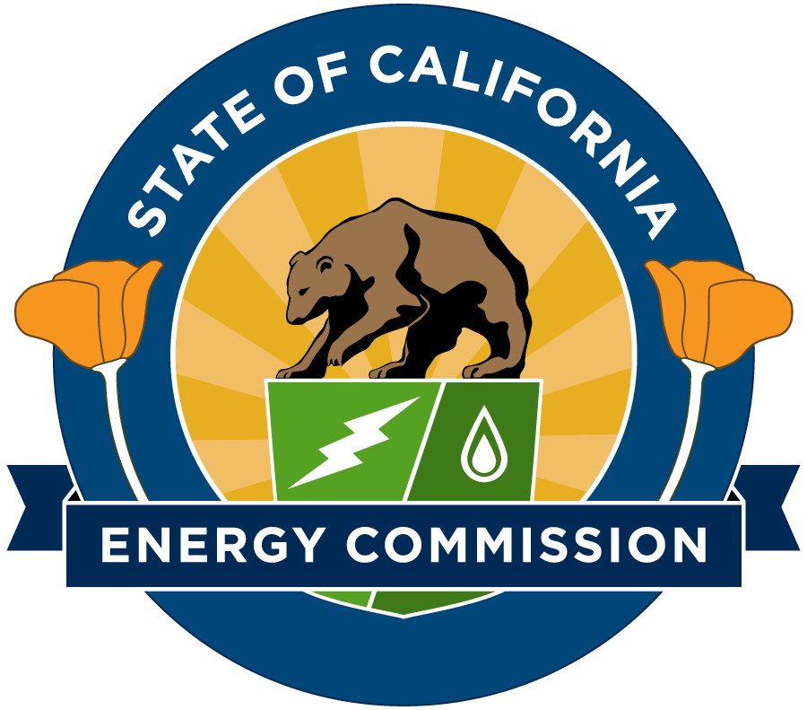

PON-22-001
State of California
California Energy Commission
January 2023

ELIGIBLE APPLICANTS
Applicants must be a local educational agency (LEA). Examples include:
- School districts
- Charter schools (additional terms apply-See Attachments 5, 6, and 7)
- County offices of education
- State special schools

ELIGIBLE PROJECTS
Examples of Eligible Projects:
- Lighting systems
- Heating, ventilation, and air conditioning equipment
- Energy management systems and equipment controls
- Pumps and motors
- Building envelope and insulation
- Energy generation, including renewable energy and combined heat and power projects
- Load shifting projects, such as thermal energy storage and battery storage
- Electric vehicle charging infrastructure used to power public fleets
Examples of Ineligible Projects:
- Projects that are already installed
- Equipment that will not be wholly owned by the applicant (that is, power purchase agreements and third-party-owned battery storage systems)
- Projects funded with an existing Energy Conservation Assistance Act Education-Subaccount (ECAA-Ed) loan
- Projects that do not save energy (kWh or therms) as a whole

LOAN INFORMATION
- The maximum loan amount is the lesser of $3 million, total project cost, or total energy cost savings from the project. For projects that incorporate electric vehicle charging infrastructure and/or battery storage, the maximum loan amount is $5 million. See PROJECT CRITERIA for additional information.
- The interest rate is 0% for the term of the loan.
- A loan applicant with an existing ECAA-Ed loan may apply for an additional loan if additional funding becomes available and when the applicant’s existing loan project is complete.
Contact the CEC for current funding information before applying. This is a revolving loan fund and repayments from previously approved loan awards replenish the fund balance.

Funding Source
Funds used in this loan notice originate from the Clean Energy Job Creation Fund.
Loan Security Requirements
A promissory note and a loan agreement between the applicant and the CEC are required to secure the loan.
Disbursement of Loan Funds
Loan funds are available on a reimbursement basis. For each reimbursement request, receipts and invoices for incurred expenses must be submitted with proof of payment. The final 10 percent of the funds will be retained until the project is complete and the applicant submits the project’s final report. Interest is charged on the unpaid principal balance of the loan computed from the date of each disbursement to the borrower.
Repayment Terms
- Loans must be repaid from energy cost savings or other legally available funds within a maximum of 20 years and shall not be repaid with Proposition 39 award funds (money the borrower is allocated pursuant to Public Resources Code section 26233 of the California Clean Energy Jobs Act). Loans with a simple payback period greater than 20 years can be partially funded.
- The amortization of the loan and repayment schedule will be based on the number of years needed to repay the loan using an estimate of the energy cost savings during the first year after project completion. Energy cost savings are based on applicable tariffs and operating schedules at the time the loan application is submitted.
- The loan repayment term cannot exceed the effective useful life of the loan-funded equipment.
- Applicants will be billed twice a year--in June and December--after the project is completed.
Sample Loan Agreement
Applicants should review the sample loan agreement documents posted on the ECAA program website at Energy Conservation Assistance Act | California Energy Commission before submitting an application.
Additional Loan Information
- All documents are public records submitted in response to this program opportunity notice (PON) are public records and will not be kept confidential.
- Loans may require a tax certificate.

PROJECT CRITERIA
Projects with proven energy and/or demand cost savings are eligible, provided they meet ECAA-Ed eligibility requirements. A feasibility study is required to verify the estimated energy savings.
- The maximum loan amount per application is the lesser of:
  - $3 million ($5 million for projects that incorporate EV charging infrastructure and/or battery storage);
  - The estimated total project cost (less any state, local or federal incentives); or
  - The estimated total energy cost savings over the effective useful life (EUL) of the loan-funded equipment, not to exceed 20 years.
There is no minimum loan amount.
If the estimated total project cost is more than the estimated total energy cost savings over the EUL of the loan-funded equipment, the applicant may reduce the estimated total project cost to the estimated total energy cost savings level by using rebates, incentives, loan co-funding, and/or its own funding. Bond funds cannot be used for co-funding.
- The estimated total energy cost savings over the EUL of the loan-funded equipment will be calculated by multiplying each project measure’s annual energy cost savings by that measure’s EUL and then adding up the savings for the entire project.
The applicant must use EULs provided in the Database for Energy Efficiency Resources (DEER), or the equipment manufacturer’s warranty. EULs will be the lesser of the EUL stated in the application or 20 years.
- Energy cost savings shall be determined using the applicant’s energy rates at the time the application is submitted. Escalation of energy rates and soft costs, such as operation and maintenance savings, will not be considered when determining energy cost savings.
- If the project is installed in a leased facility, the term of the lease must exceed the repayment period of the loan.
Project Commencement
A loan agreement must be fully executed (that is, signed by the CEC and the loan applicant) before project work can begin. Only approved project-related costs that are incurred within the term of the executed agreement and that comply with the terms and conditions of the loan agreement are eligible for reimbursement. If the loan is not approved or executed, the CEC is not responsible for reimbursement of any costs.

HOW TO APPLY
Applicants must submit:
- A completed and signed Loan Application (Attachment 1). Certified electronic signatures are acceptable.
- A completed Summary of Measures in Loan Request (Attachment 2). The Summary of Measures in Loan Request is a summary of project measures for which a loan is being requested. It identifies the estimated savings, cost, EUL and payback. Attachment 2 must be in Excel format.
- Governing Body Resolution (Attachment 3).
- California Environmental Quality Act (CEQA) Compliance Documentation (Attachment 4). Include documentation demonstrating compliance with CEQA. Three possible actions may be taken. The applicant may determine that the activity undertaken by the loan is:
- Not a project. Include a statement that all projects to be funded by the loan are not projects under CEQA, and an analysis supporting the conclusion that the activity is not a project.
- A project that is exempt. Include any Notice of Exemption filed.
3. A project that is not exempt. Include any Notice of Determination filed and a copy, web link, or electronic version of environmental documents prepared, such as a negative declaration, a mitigated negative declaration, or an environmental impact report.
- Documentation of Applicant’s Authority.
- Include documentation showing the authority of the applicant to enter into the loan agreement, which could be:
- A copy of a signed resolution, motion, order, etc. from the applicant’s governing board (See Attachment 3). The documentation must include the finding on CEQA compliance. If the CEQA finding is an agenda item, include both the agenda item and the resolution.
- A copy of the law or document showing the applicant’s authority to enter into a loan agreement.
- Include documentation showing the job title of the individual authorized to apply for the loan and execute the loan agreement. In most cases, the title of the individual will be listed in the resolution, motion, or order (See Attachment 3).
3. If there is no resolution, motion, or order, the applicant must include documentation showing the job title of the authorized individual.

Utility Billing Data.
The applicant must electronically submit 12 months of recent baseline utility data records from electric and natural gas utilities, unless the information on utility usage and rate schedules are included in the feasibility study or energy audit report.
- Feasibility Study or energy audit report. The study must have been completed within the past two years and must contain:
1.A detailed description of the proposed project.
2.A description of the buildings/facilities affected by the proposed project.
3.A discussion of baseline energy use for the facilities, including annual energy-related utility bills.
4.All calculations and assumptions to support the technical feasibility and energy savings of the proposed recommended project.
5.A proposed budget detailing all project costs.
6.A proposed schedule for the implementation of the project. If the feasibility study identifies maintenance and operating procedures, the applicant shall include the estimated date of implementation or provide a reason for not implementing.
- FOR CHARTER SCHOOLS ONLY: Charter schools must review the eligibility requirements in Attachment 5 and submit:
- Attachment 6 - Charter Schools Information
- Attachment 7- Certificate of Good Standing for Charter Schools

APPLICATION REVIEW PROCESS
CEC staff will review applications and supporting documents to validate eligibility and the technical and economic feasibility of the proposed project based on the requirements described in this PON. Applications deemed complete will be processed in the order received. Applications are deemed complete when sufficient documentation is submitted to verify eligibility and compliance with all requirements listed in this PON. If funding becomes oversubscribed, applications will be placed on a waiting list in the order they were deemed complete.
A loan applicant with an existing ECAA-Ed loan can apply for an additional loan if additional funding becomes available, and when the applicant’s existing loan project is complete.
WHEN CAN PROJECTS BEGIN?
A loan agreement must be fully executed (that is, signed by the CEC and loan applicant) before project work can begin. Only approved project-related costs that are incurred within the term of the executed agreement and comply with the terms and conditions of the loan agreement are eligible for reimbursement. If the loan is not approved or executed, the CEC is not responsible for reimbursement of any costs

ATTACHMENTS TO THIS PON

Attachment 1: ECAA-Ed Loan Application for CEC Financing

Attachment 2: Summary of Measures in Loan Request

Attachment 3: Sample Resolution

Attachment 4: CEQA Information
Attachment 5: Charter Schools-Additional Eligibility Requirements
Attachment 6: Charter Schools-Information
Attachment 7: Charter Schools-Certificate of Good Standing for Charter Schools

HOW TO SUBMIT AN APPLICATION
Email the loan application and all supporting documentation to PubProg@energy.ca.gov.

Applications may be submitted at any time and this PON will remain posted for a minimum of 90 days from the original release date.
CONTACT INFORMATION
Please email the CEC to discuss available funding or any other information in this loan notice:

Email: PubProg@energy.ca.gov

Loan Notice Documents
A copy of this loan notice, attachments to this loan notice, sample loan agreements, and more are available on the ECAA webpage at Energy Conservation Assistance Act | California Energy Commission.

The CEC reserves the right to close or change this loan notice.

http://cedars.sound-data.com/deer-resources/deer-database/

