September 25, 2023
GFO-22-615
Innovative Charging Solutions for Medium- and Heavy-Duty Electric Vehicles
Addendum 3

The purpose of this addendum is to notify potential applicants of changes that have been made to GFO-22-615.

The addendum includes the following revisions to the Solicitation Manual. Added language appears in bold underline, and deleted language appears in [strikethrough] and within square brackets.

Solicitation Manual
- Page 7, Section I.D Key Activities and Dates

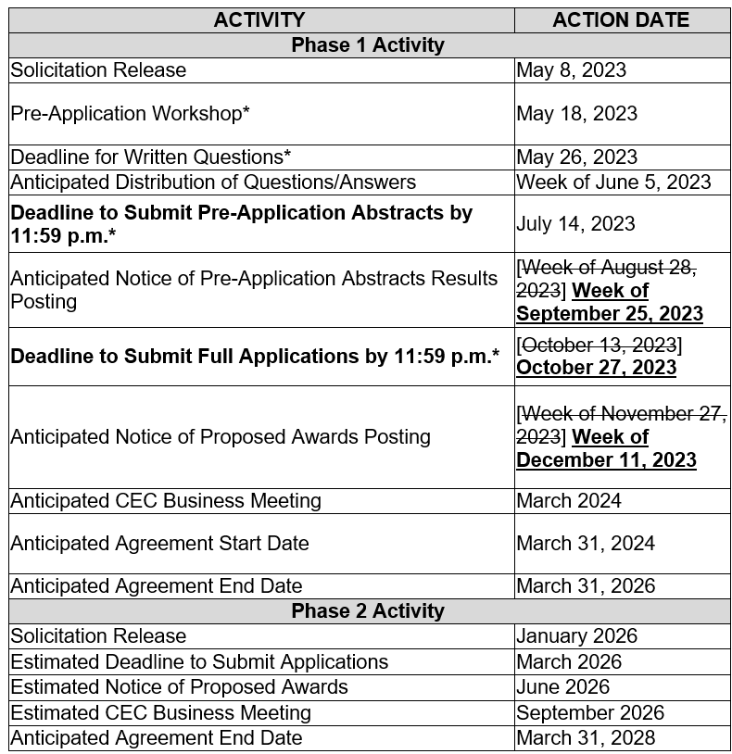

Eunice Lemos-Adair
Commission Agreement Officer

