October 9, 2023
GFO-23-603
Implementation of Medium- and Heavy-Duty
Zero-Emission Vehicle Infrastructure Blueprints

Addendum 01

The purpose of this addendum is to notify potential applicants of changes that have been made to GFO-23-603.

The addendum includes the following revisions to the Solicitation Manual. Added language appears in bold underline, and deleted language appears in [strikethrough] and within square brackets.

Solicitation Manual
- Page 5, Section I.D Key Activities and Dates

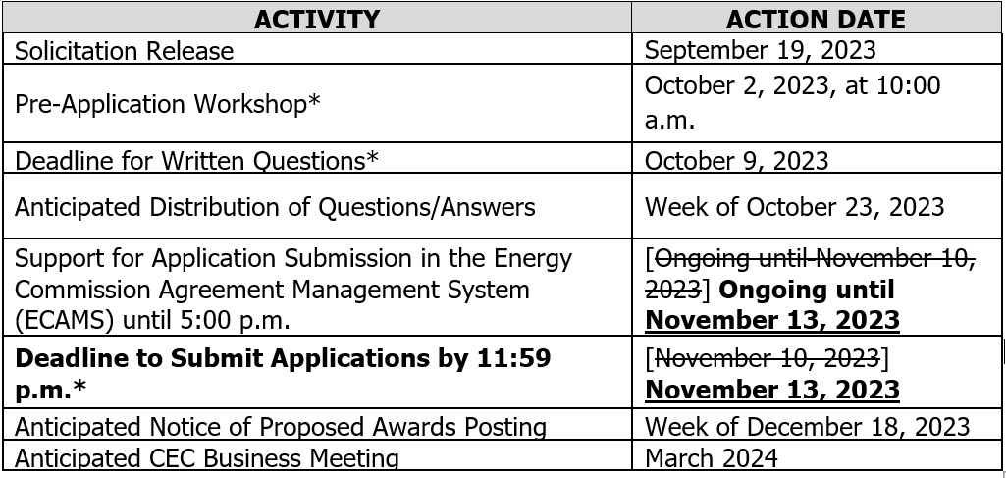

Kevyn Piper
Commission Agreement Officer

