IFB-23-142

Hearing Reporter Services for CEC

Business Meetings, Hearings and Events

QUESTIONS AND ANSWERS

October 6, 2023

The purpose of this document is to provide answers to questions for the above solicitation. The following answers are based on the California Energy Commission (CEC) staff’s interpretation of the questions received.

Q1: Who is presently reporting for you under your current contract?
A1: California Reporting
Q2: What are the rates that are being charged under your current contract?
A2: 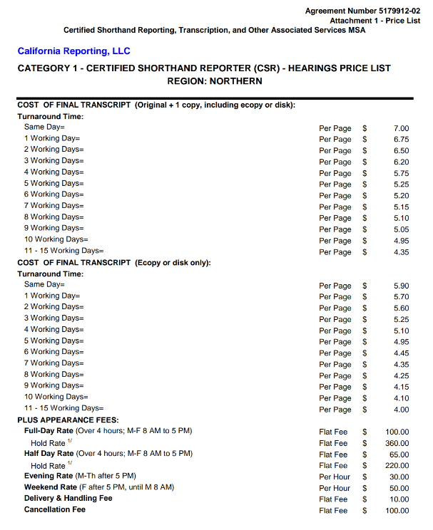
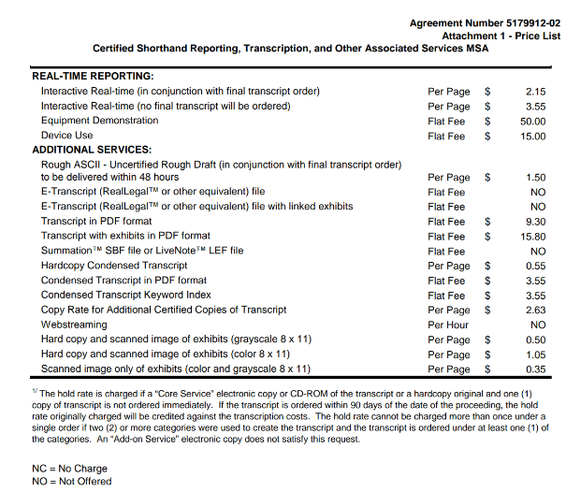
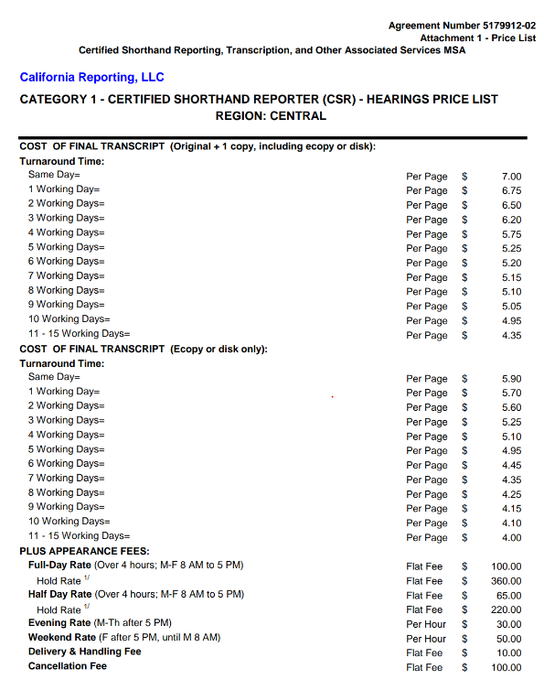
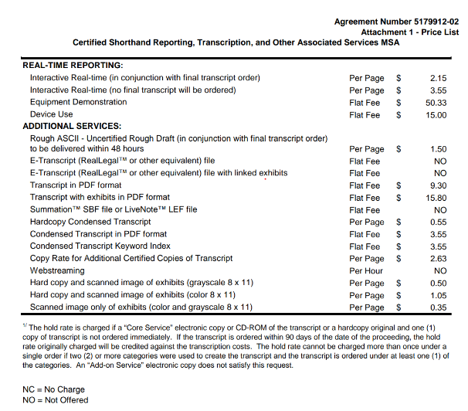
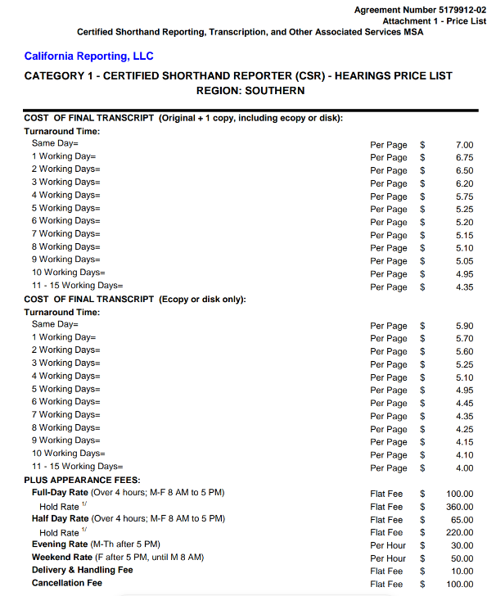
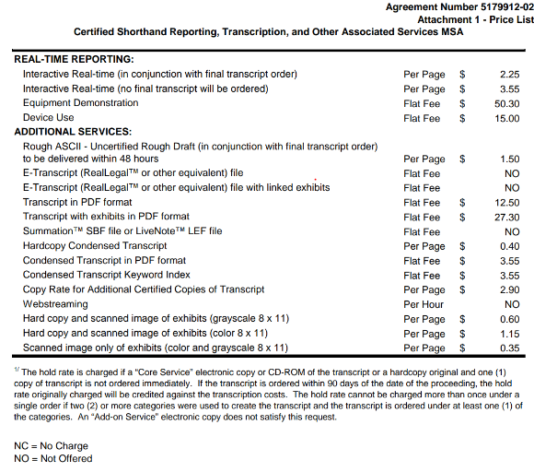
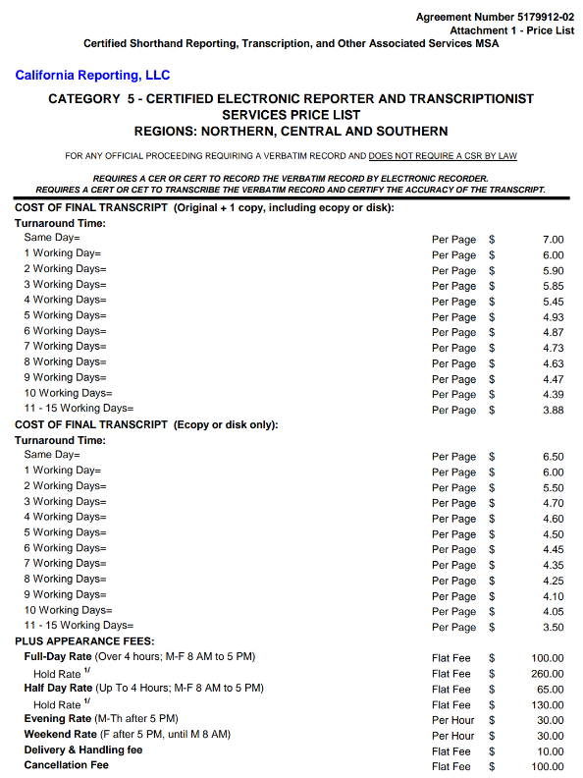
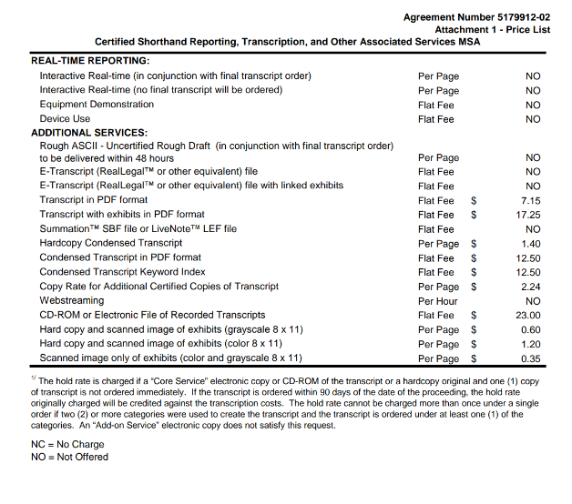
Q3: What percentage of your meetings/hearings where you use a stenotype reporter, do you expect will require a Certified Shorthand Reporter and not just a general reporter?

A3: 100%

Q4: What percentage of your meetings/hearings where you use an electronic reporter, do you expect will require a certified electronic reporter and not just a general electronic reporter?

A4: 100%

