June 10, 2024

**GFO-23-702**

**California Clean Energy Planning Program (CCEPP)**

**Addendum 5**

The purpose of this addendum is to notify potential applicants of a change that has been made to GFO-23-702. The addendum makes changes to the Solicitation Manual, Section I.E. Key Activities Schedule by deleting language that appears in [~~strikethrough~~] and within square brackets and adding language that appears in **bold underline**.

***Solicitation Manual***

**Page 8, Section I.E. Key Activities Schedule**

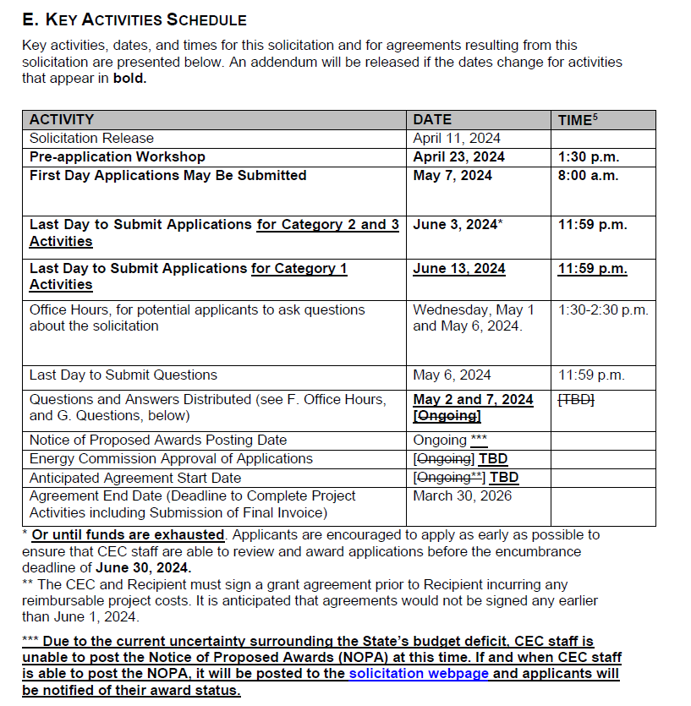

**Eilene Cary**