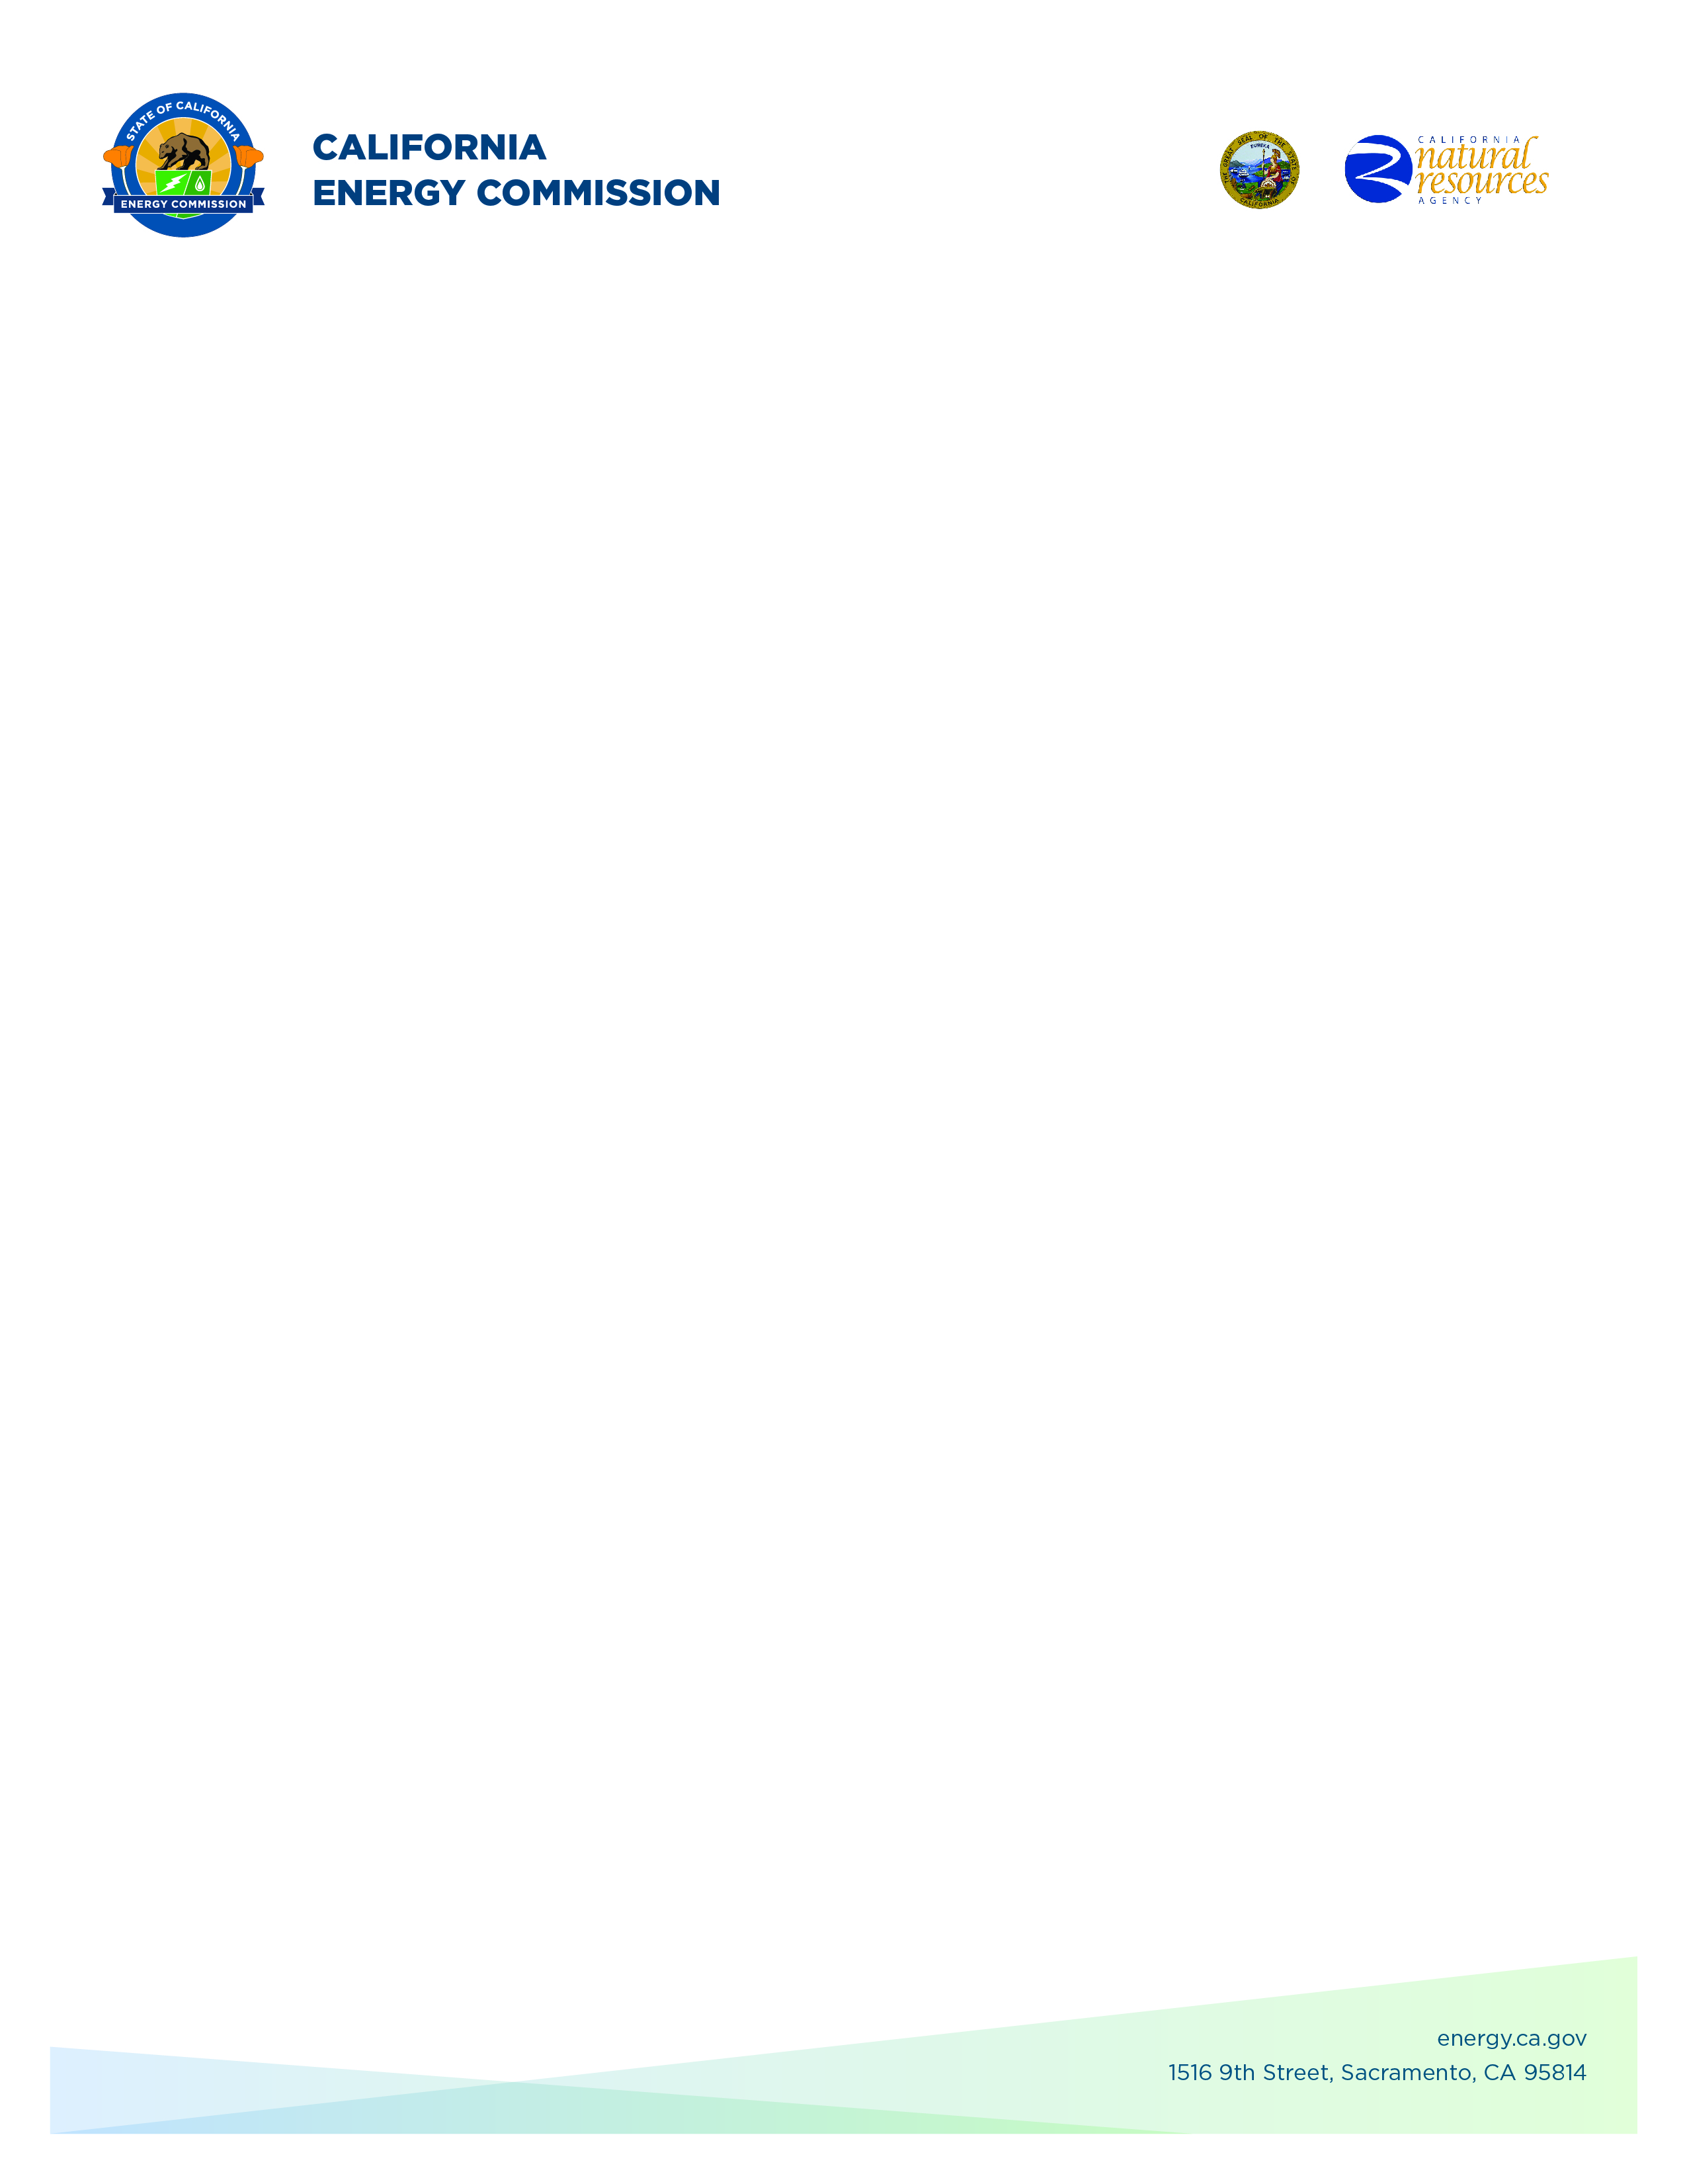**GFO-23-317**

**Energy Storage Innovations to Support Grid Reliability**

**Addendum #1**

**August 6, 2024**

**Please Note:** Added language appears in **bold underlined** font. Deleted language appears in [strikethrough] and within square brackets.

The purpose of this addendum is to make the following revisions to the

Solicitation Manual:

## **Solicitation Manual**

**Page 13, Section I.E.** Under “Key Activities Schedule”

Updated: Anticipated Distribution of Questions and Answers: Week of **August 5,**  **2024**

Updated: Deadline to Submit Applications in ECAMS (Phase 1): **August 19, 2024**

Updated: Anticipated Posting of Phase 1 Results: **Week of September 16, 2024**

Updated: Support for Application Submission in ECAMS (Phase 2): **November 7, 2024**

Updated: Deadline to Submit Application in ECAMS (Phase 2): **November 7, 2024**

Updated: Anticipated Notice of Proposed Award Posting Date): **December 9, 2024**

**Enrico Palo,**

**Commission Agreement Officer**