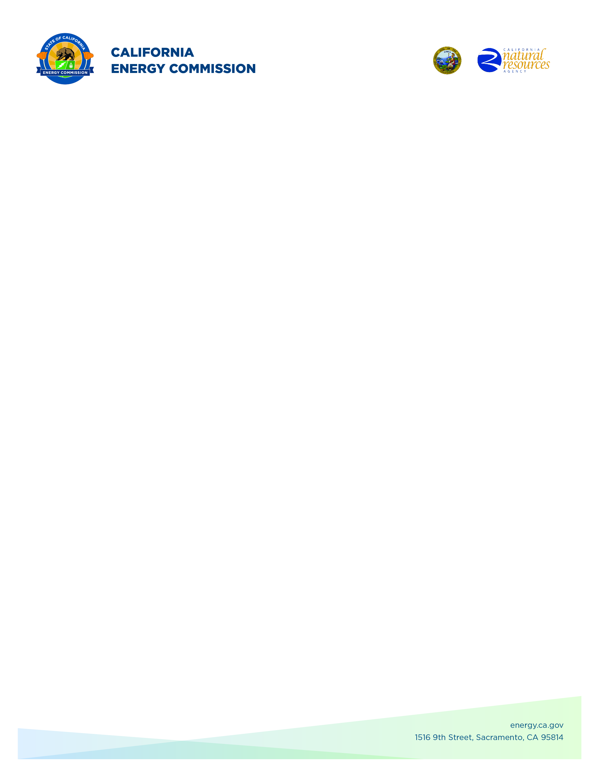**GFO-23-318**

**BRIDGE 2024: Bringing Rapid Innovation Development to Green Energy**

**Addendum # 1**

**August 28, 2024**

Disclaimer: Textual content contained within brackets and with ~~strikethrough~~ was removed, and textual content in **bold underline** was added.

The purpose of this addendum is to make the following revisions to the Solicitation Manual; and the Project Narrative Form (Attachment 2):

## **Solicitation Manual**

### Page i

Updated: **Addendum 1**

Updated: ~~[July 24]~~ **August 28**, 2024

### **Page 2, Section I.A.** Under “Purpose of Solicitation”

Updated: **California state agenc**y [~~California Energy Commission (CEC) program]~~

Updated: Projects must have previously received a funding award from **an** **eligible** [~~the~~] **California state agency** [~~CEC~~] or an eligible U.S. federal agency **with a contract execution date** within five years of the **BRIDGE 2024** application due date (please see Section II.A.1. for the full list of eligible **California and** federal agencies).

### **Page 3, Section I.A.** Under “Purpose of Solicitation”

### 

Updated: The **California Energy Commission** **(**CEC**)** may modify the applicant’s primary technology category at their sole discretion.

### **Page 6, Section I.C.** Under “Project Focus”

Updated: that have [~~successfully~~] **substantially** completed a **California state agency** [~~CEC~~]

### **Page 8, Section I.C.** Under “Project Focus”

Updated: 4. What technical and commercialization milestones have been realized since the technology innovation components of the previous **California state agenc**y ~~[CEC~~]

### **Page 25, Section II.A.1.** Under “Eligibility”

Updated: This solicitation is open to all private entities and individuals that have previously received a funding award from an eligible **California state agency** [~~CEC program~~] or U.S. federal agency that provided funding for applied research of the technology identified in the proposal, and who do not fall within the list of ineligible prime applicants as stated below. **Applicants may include entities that were a subrecipient, a sub-subrecipient, or any tier of subrecipient on the previous award, if the core intellectual property currently resides with the applicant, and the applicant can demonstrate a path forward for commercializing the technology in California**.

Updated: Projects must have previously received a funding award from one of the following **California state agencies** [~~CEC~~] or U.S. federal agencies funding electricity research:

• [~~California Energy Commission’s Public Interest Energy Research (PIER) electric program;~~]

• [~~California Energy Commission’s Electric Program Investment Charge (EPIC) program;~~]

**• California Energy Commission**

**• California Public Utilities Commission**

**• California Air Resources Board**

### **Page 26, Section II.A.1.** Under “Eligibility”

Updated:

• U.S. Department of Defense~~, Defense Advanced Research Projects Agency (DARPA)[;]~~

• U.S. Army Corps of Engineers[~~;]~~

• National Aeronautics and Space Administration (NASA) [~~;]~~

• National Science Foundation (NSF) [~~;]~~

Updated: ***Eligibility for Regional Energy Innovation Clusters Awardees***

**Entities that have received support from one of the Regional Energy Innovation Clusters (REIC) (Southern California Energy Innovation Network, Los Angeles Cleantech Incubator, Activate, and BlueTech Valley) with projects that do not meet the previous funding requirements listed above are eligible for this solicitation. Applicants are required to submit a Previous Project Evaluation Form (Attachment 14) with their proposal. If the funded REIC award does not include technical performance metrics as described in Attachment 14, applicants must provide evidence that their projects met key technical performance targets under their REIC engagement.**

## **Project Narrative Form (Attachment 2)**

### **Page 2,** Under “Technical Merit”

Updated: 4. What technical and commercialization milestones have been realized since the technology innovation components of the previous **California state agency** [~~CEC~~] or U.S. federal agency awards were completed?

**Commission Agreement Officer**

**Angela Hockaday**