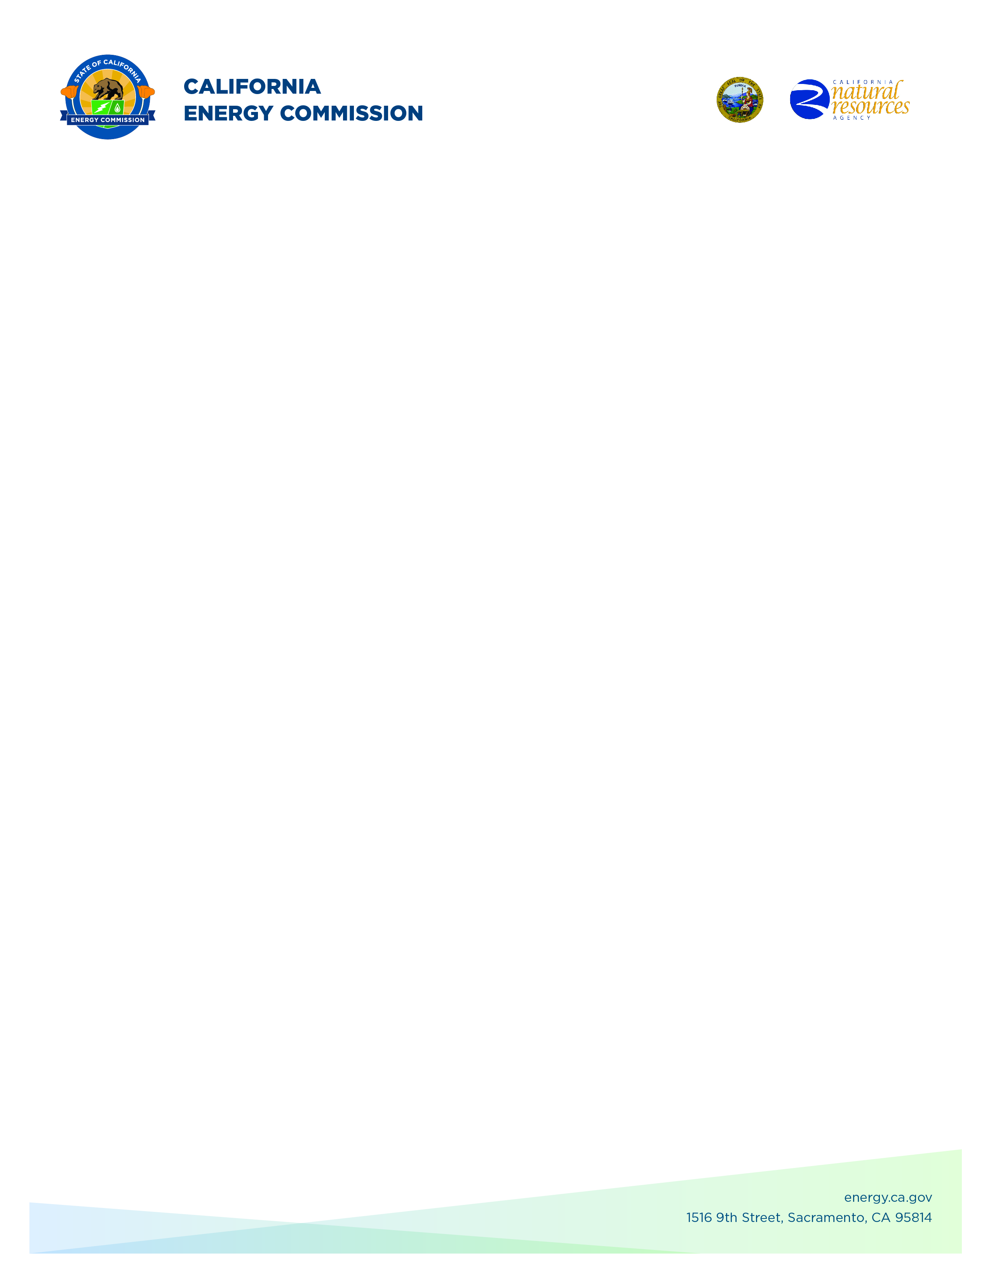**GFO-23-317**

**Energy Storage Innovations to Support Grid Reliability**

**Addendum #3**

**September 24, 2024**

**Please Note:** Added language appears in **bold underlined** font. Deleted language appears in [strikethrough] and within square brackets.

The purpose of this addendum is to make the following revisions to the

Solicitation Manual:

## **Solicitation Manual**

**Page 13, Section I.E.** under “Key Activities Schedule”

Updated: Anticipated Posting of Phase 1 Results: **Week of October 14, 2024**

Updated: Support for Application Submission in ECAMS (Phase 2): **December 4, 2024**

Updated: Deadline to Submit Application in ECAMS (Phase 2): **December 4, 2024**

Updated: Anticipated Notice of Proposed Award Posting Date): **Week of** **January 27, 2025**

Updated: Anticipated Energy Commission Business Meeting Date: **May 8, 2025**

Updated: Anticipated Agreement Start Date: **May 15, 2025**

**Enrico Palo,**

**Commission Agreement Officer**