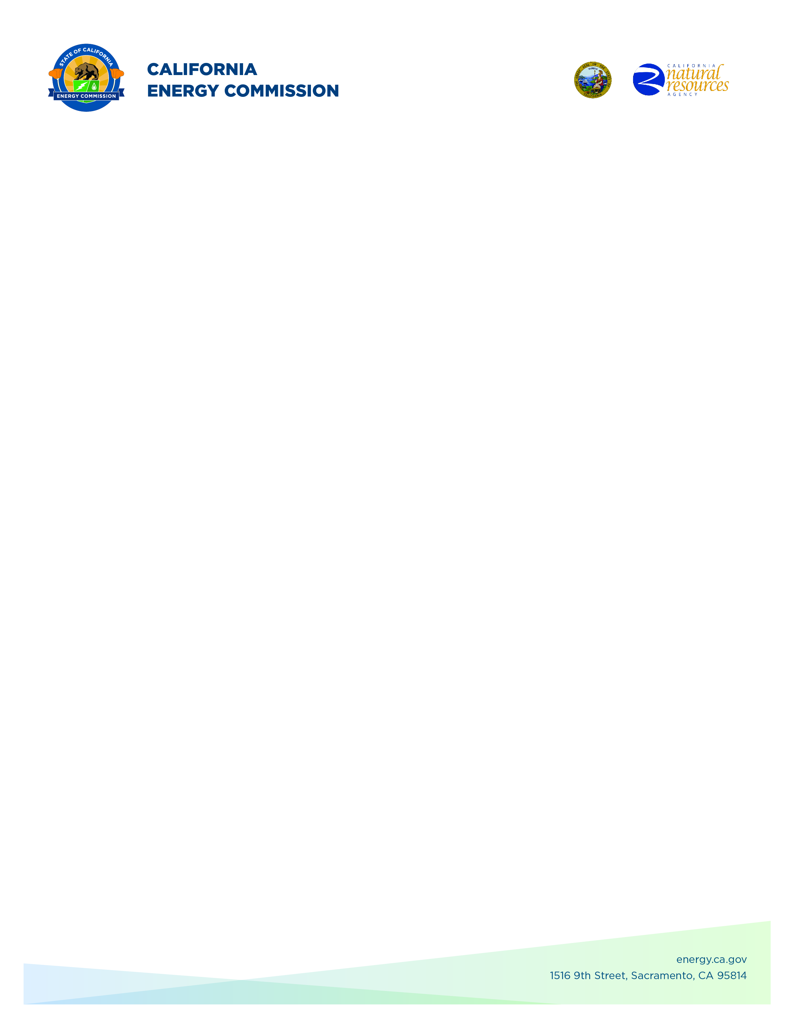**GFO-21-901**

**Cost Share for Federal Clean Energy Funding Opportunities**

**Addendum #33**

**October 30, 2024**

The purpose of this addendum is to notify potential applicants of changes that have been made to GFO-21-901. The addendum includes the following revisions to the Solicitation Manual. Added language appears in **bold underline**, and deleted language appears in ~~strikethrough~~ and within square brackets.

## **Solicitation Manual**

### **Page 27, Project Requirements. Section C.2.** Under “Project Location”

Updated: Projects must be located in California, either partially or in full. Projects involving demonstrations in real-world environments must have the demonstration sites located in a territory served by PG&E, SCE, or SDG&E**, or located offshore and benefitting electric IOU ratepayers**.

### **Page 45, Evaluation and Award Process. Section C. Phase I/Phase III – Stage One: Application Screening.** Under “F. If the project involves technology demonstration/deployment activities.”

Updated:

* All demonstration/ deployment sites are located in a California electric IOU service territory (PG&E, SDG&E, or SCE)**, or located offshore and benefiting electric IOU ratepayers**.

**Marissa Sutton,**

**Commission Agreement Officer**