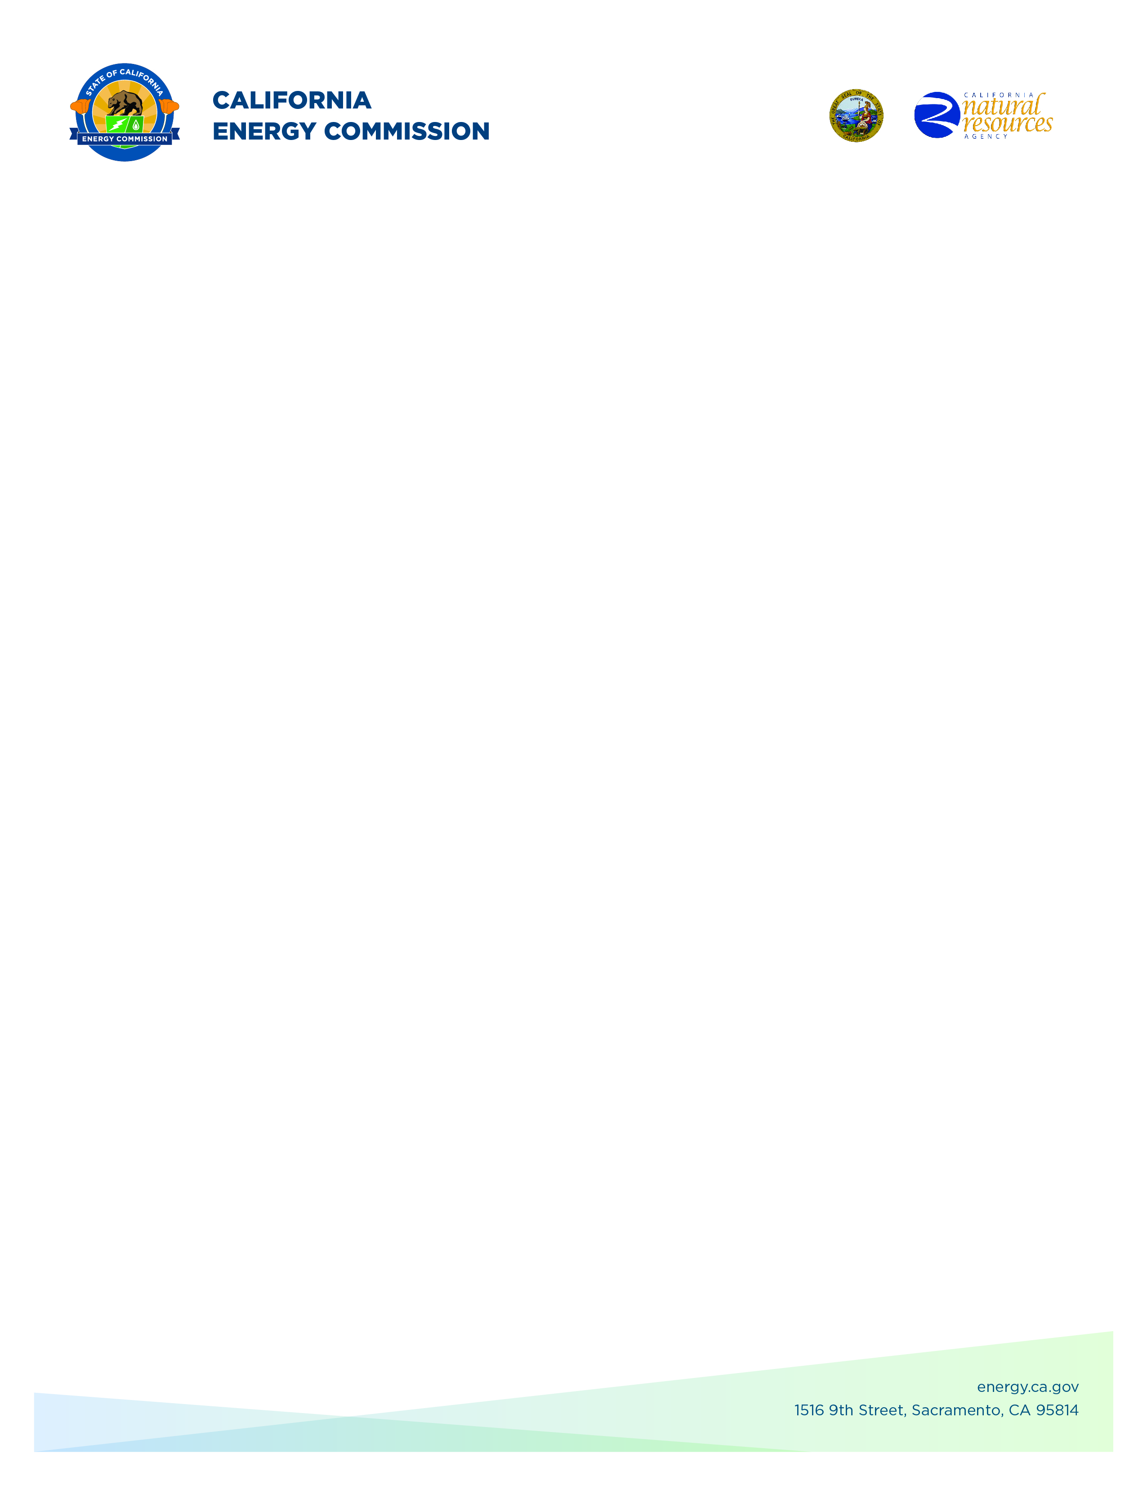**GFO-23-317**

**Energy Storage Innovations to Support Grid Reliability**

**Addendum #4**

**November 19, 2024**

**Please Note:** Added language appears in **bold underlined** font. Deleted language appears in [strikethrough] and within square brackets.

The purpose of this addendum is to make the following revisions to the

Solicitation Manual:

## **Solicitation Manual**

**Page 13, Section I.E.** under “Key Activities Schedule”

Updated: Anticipated Posting of Phase 1 Results: **Week of November 11, 2024**

Updated: Support for Application Submission in ECAMS (Phase 2): **January 6, 2025**

Updated: Deadline to Submit Application in ECAMS (Phase 2): **January 6, 2025**

Updated: Anticipated Notice of Proposed Award Posting Date: **Week of** **March 17, 2025**

Updated: Anticipated Energy Commission Business Meeting Date: **July 9, 2025**

Updated: Anticipated Agreement Start Date: **September 1, 2025**

Updated: Anticipated Agreement End Date: **December 31, 2028 - 2029**

**Enrico Palo,**

**Commission Agreement Officer**