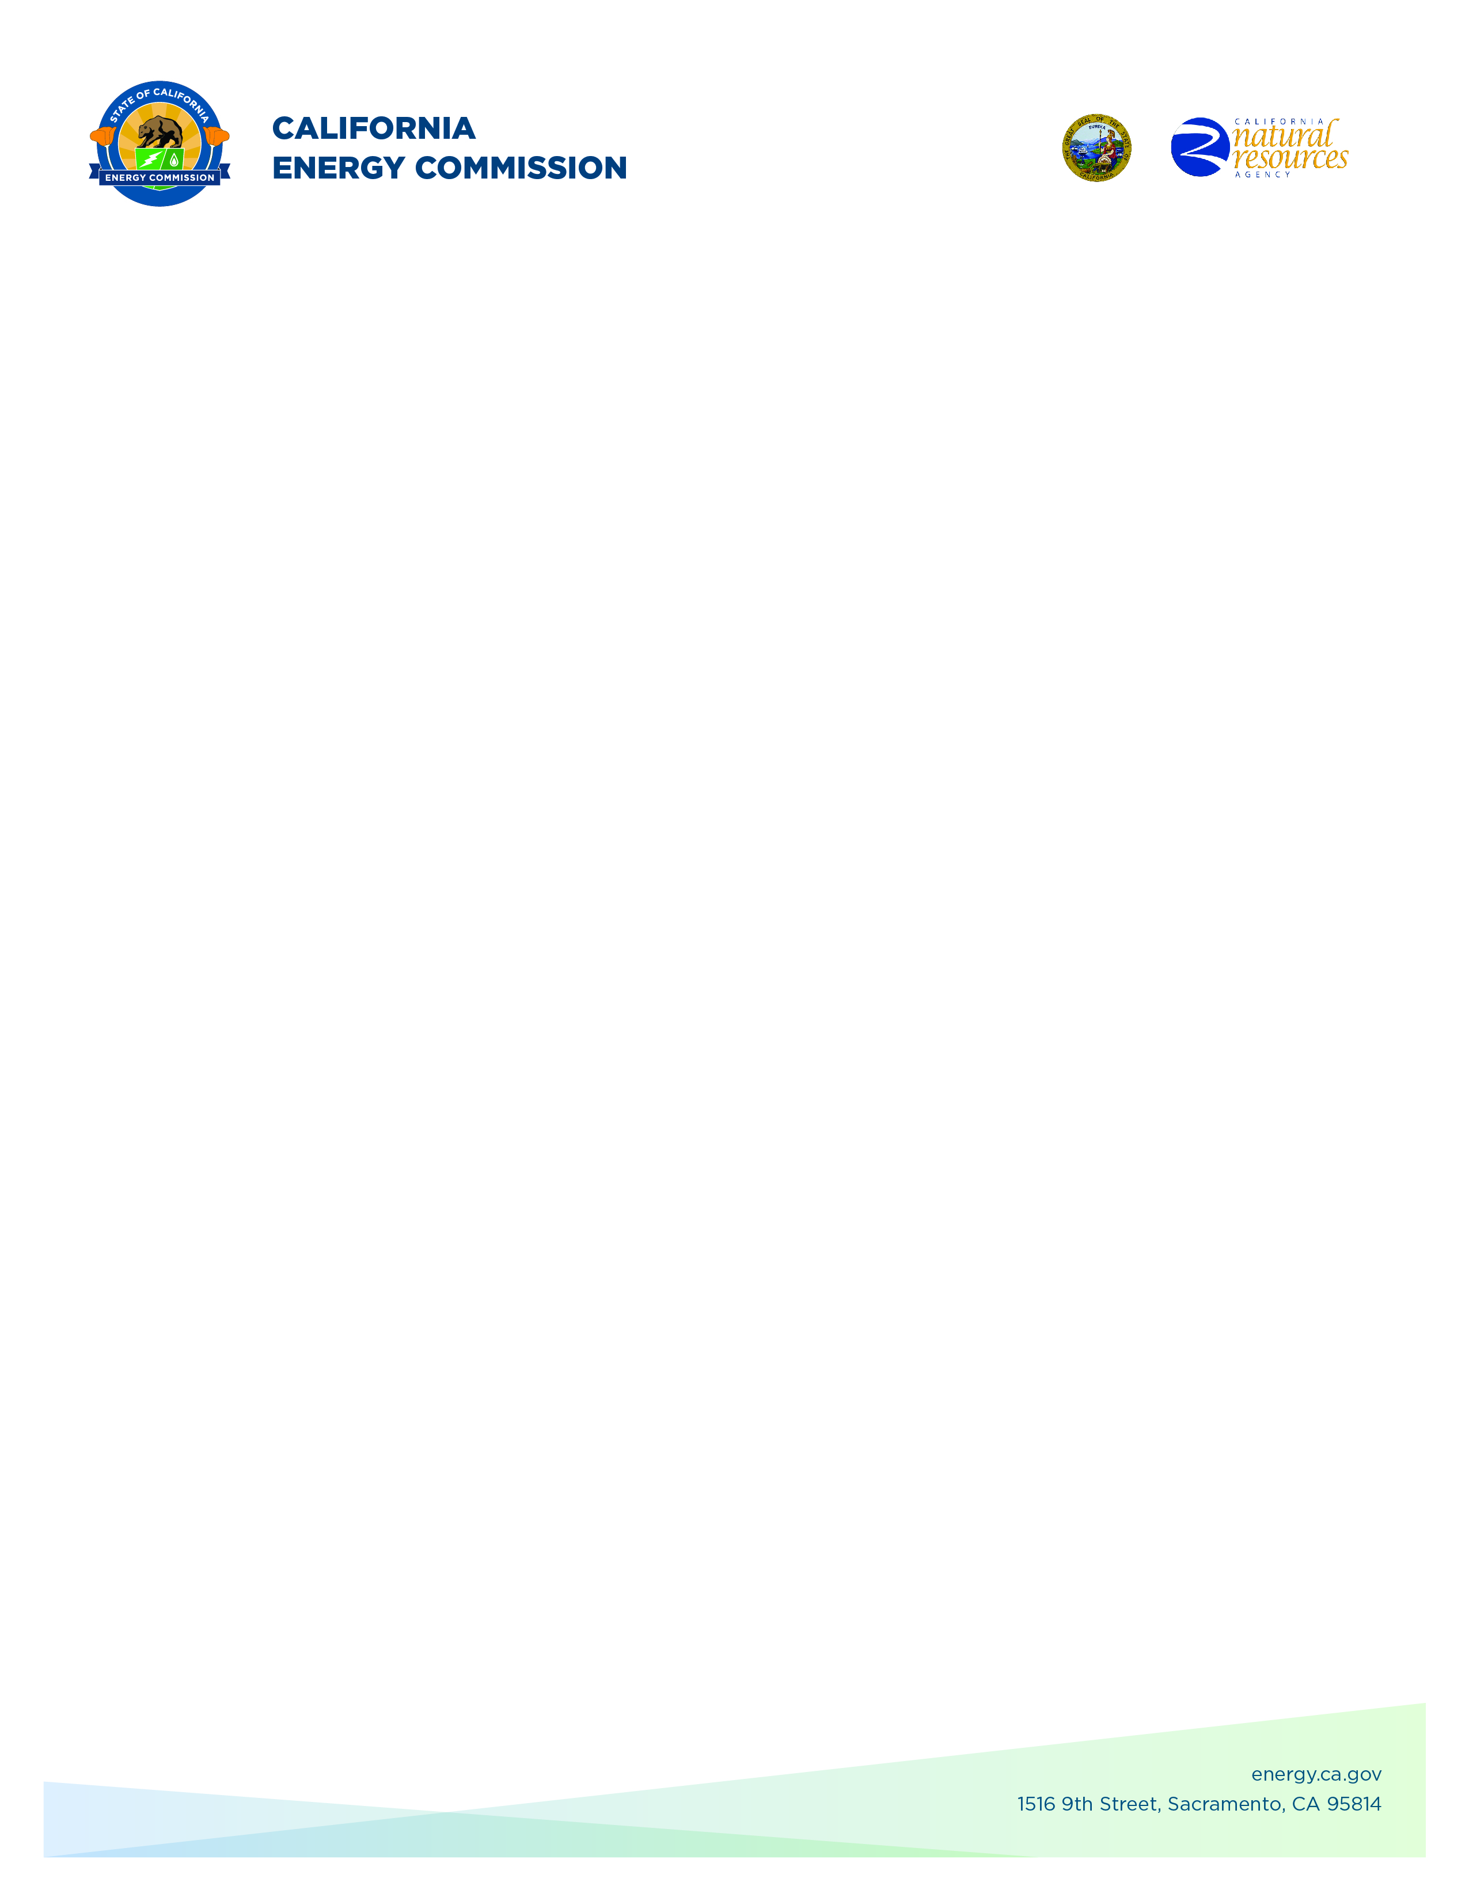**GFO-20-304**

**California Battery Pilot Manufacturing Line**

**Addendum #1**

**March 28, 2025**

The addendum includes the following revisions to the Solicitation Manual. Added language appears in **bold underline**, and deleted language appears in [strikethrough] and within square brackets.

The purpose of this addendum is to make the following revisions to the

Solicitation Manual:

## **Solicitation Manual**

### **Page 8, Section I.D.** Under “Funding”

Updated to reflect larger grant amount:

There is up to [~~$25,000,000]~~ **$28,000,000** available for grants awarded under this solicitation. The minimum funding amount for each project is[~~$25,000,000]~~ **$28,000,000**. The maximum funding amount is [~~$25,000,000]~~ **$28,000,000**.

### **Page 34, Section IV.E.** Under “Stage One: Application Screening”

Updated to remove IOU service territory requirement for project site location from pass/fail screening criteria:

1. If the project involves technology pilot demonstration/ demonstration/ deployment activities

* The application identifies one or more demonstration/ deployment site locations.
* ~~[All demonstration/ deployment sites are located in a California electric IOU service territory (PG&E, SDG&E, or SCE).]~~

### 

**Brad Worster,**

**Commission Agreement Officer**