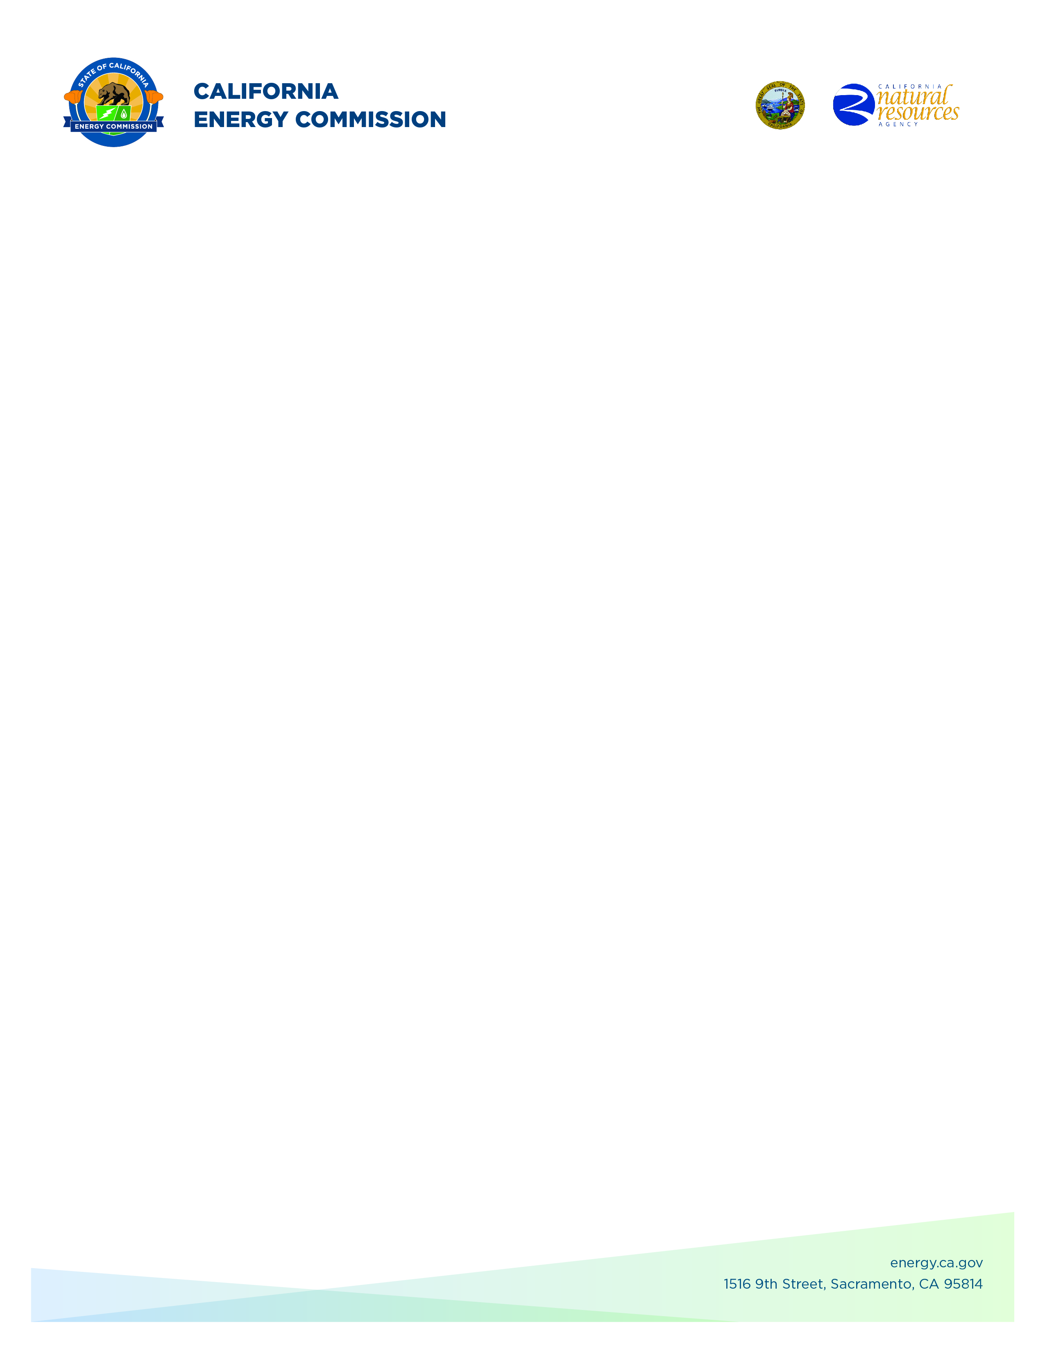**GFO-24-311**

**Food Production Investment Program (FPIP) 2025**

**Addendum 01**

**June 18, 2025**

Disclaimer: Added language appears in **bold underline**, and deleted language appears in [~~strikethrough~~] and within square brackets.

The purpose of this addendum is to make the following revisions to the

Solicitation Manual:

## **Solicitation Manual**

### **Page 9, Section I.E.** Under “KEY ACTIVITIES SCHEDULE”

Updated “Pre-Application Workshop” Date: **June** [~~19~~] **26, 2025**

Updated “Deadline for Written Questions” Date: ~~[June 27]~~ **July 3, 2025**

Updated “Anticipated Distribution of Questions and Answers” Date: Week of **July** [~~21~~] **28, 2025**

### **Page 10, Section I.F** Under “NOTICE OF PRE-APPLICATION WORKSHOP”

Updated “Date and time”: [~~Monday~~] **Thursday**, June [~~19~~] **26**, 2025

### 

**Chester Hong,**

**Commission Agreement Officer**