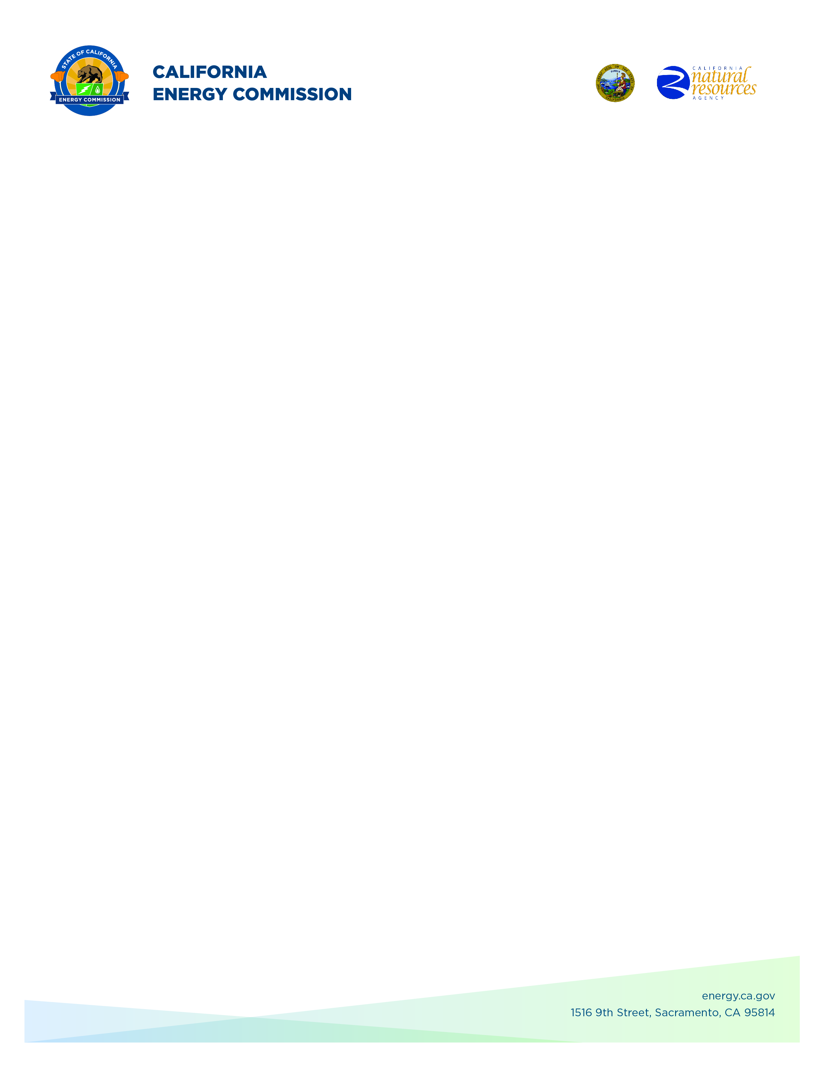**GFO-24-311**

**Food Production Investment Program (FPIP) 2025**

**Addendum 02**

**August 11, 2025**

Disclaimer: Added language appears in **bold underline**, and deleted language appears in [~~strikethrough~~] and within square brackets.

The purpose of this addendum is to make the following revisions to the Solicitation Manual and Budget:

## **Solicitation Manual**

### **Page 8, Section I.D.1** Under “Amount Available and Minimum/Maximum Funding Amounts”

Please note that the grant will reimburse subrecipients' costs up to a maximum of $99,999 **per entity or per task** with FPIP funds, while any remaining subrecipient costs will be eligible to be accounted for under the match fund requirement. Use of the grant recipient’s in-house staff is not reimbursable.

.

### **Page 18, Section II.A.1** Under “Eligibility”

…For this program, food processing facilities are those defined by the North American Industry Classification System (NAICS) codes 311 (Food Manufacturing), 3121 (Beverage Manufacturing), [~~and~~] 493120 (Refrigerated Warehousing and Storage)**, and 115114 (Postharvest Crop Activities [except Cotton Ginning])**….

### **Page 29, Section III.C.5.b** Under “Budget Forms (Attachment 5)”

Subrecipient Budget, which itemizes all M&V and engineering design subrecipient costs. **M&V and/or engineering design subrecipient costs cannot exceed grant funds of $99,999 each per entity or per task**….

## **Budget**

### **Page Subrecipients & Vendors**

### Rows 58–115 have been hidden under the Subrecipients & Vendors tab to remove display of the Vendors section and the Subrecipient & Vendors Grant Totals tables, as these tables are not applicable to the FPIP program.

**Chester Hong,**

**Commission Agreement Officer**