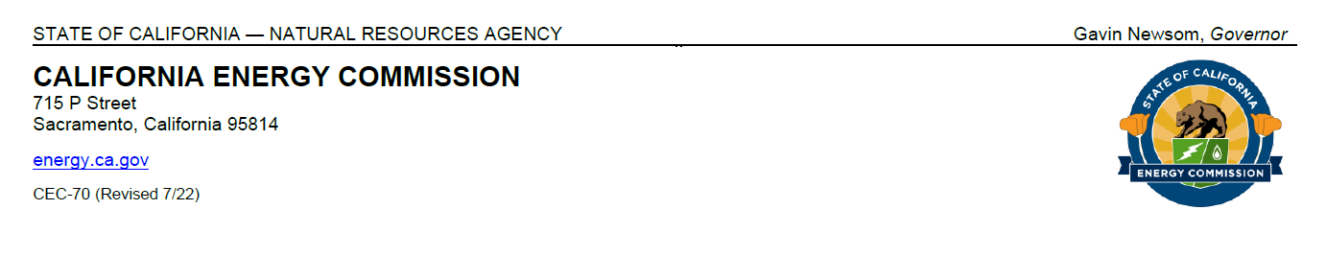

*IN THE MATTER OF:*

*California Energy Commission’s 50th Anniversary Symposium*

NOTICE OF California Energy Commission’s 50th anniversary symposium

# Notice of

# California Energy Commission’s

# 50th Anniversary Symposium

# September 19, 2025

Start Time [9:00 a.m. – End Time [3:00 p.m.]

In-person only at

See Attendance Instructions.

[California Natural Resources Agency

Auditorium

715 P Street

Sacramento, CA 95814.]

Click this link to register: [In-person Attendees’ Guestlist](https://bit.ly/CEC50thAnniversarySymposium)

Join us to celebrate California’s energy leadership at the **California Energy Commission’s (CEC) 50th Anniversary Symposium.** For five decades, the CEC has been a driving force in shaping a vision of a clean energy future for all, setting the standard on efficiency, research, innovation, and renewables. The public is invited to attend the 50th Anniversary Symposium on **Friday, September 19, 2025**, from 9:00 a.m. to 3:00 p.m. at the **California Natural Resources Agency (CNRA)** in Sacramento.

The 50th Anniversary Symposium is **dedicated to the memory of former CEC Chair Robert Weisenmiller,** an enduring champion of California’s clean energy future who recently passed away. [Read his tribute](http://bit.ly/46ZGg8N).

## Agenda

**9:00 a.m. – 10:00 a.m.** | Networking Breakfast & CEC History Showcase in CNRA Lobby

**10:00 a.m. – 1:30 p.m.** | Symposium with Panelists and Guest Speakers in CNRA Auditorium. There will be opportunities for questions and comments by attendees after each panel. Each person will have up to two minutes to speak.

**1:30 p.m. – 3:00 p.m.** | Reception in CNRA Lobby

## Background

The California Energy Commission (CEC) was established in 1975 by the Warren‐Alquist Act to respond to the energy crisis of the early 1970s. With a mission to achieve a 100% clean energy future for all Californians, the CEC has been and is the state’s lead on energy policy and planning. Over the past five decades, the CEC has pioneered energy efficiency advances and diversified the state’s energy portfolio through its research and programs. Today, with a focus on achieving the state’s goal of 100 percent clean energy, the CEC continues to advance innovative and equitable energy solutions.

## Attendance Instructions

**In-person** participants may join the meeting at [715 P Street, Sacramento, CA 95814].

**Public Advisor.** The CEC’s Public Advisor assists the public with participation in CEC events. To request assistance, interpreting services, or reasonable modifications and accommodations, call (916) 957-7910 or email [publicadvisor@energy.ca.gov](mailto:publicadvisor@energy.ca.gov) as soon as possible, but at least five days in advance of this event. The CEC will work diligently to meet all requests based on availability.

Direct media inquiries to [mediaoffice@energy.ca.gov](mailto:mediaoffice@energy.ca.gov) or (916) 654-4989.

Direct general inquiries to Aretha Welch at [aretha.welch@energy.ca.gov](mailto:aretha.welch@energy.ca.gov) or 916-693-5217.

For more information about the 50th Anniversary Symposium, visit the [symposium](https://www.energy.ca.gov/event/outreach/2025-09/california-energy-commissions-50th-anniversary-symposium) webpage, found at <https://www.energy.ca.gov/event/outreach/2025-09/california-energy-commissions-50th-anniversary-symposium>. More information on the evolution of the CEC can be found at [History of the California Energy Commission](https://www.energy.ca.gov/about/50-years-energy-leadership).

**Availability of Documents:** [Documents and presentations](https://www.energy.ca.gov/event/outreach/2025-09/california-energy-commissions-50th-anniversary-symposium) for this meeting will be available at <https://www.energy.ca.gov/event/outreach/2025-09/california-energy-commissions-50th-anniversary-symposium>.

**Dated:** September 3, 2025, at Sacramento, California.

**Approved by:**

Noemí Otilia Osuna Gallardo, CEC Commissioner

Lead Commissioner

## Subscriptions:

[List subscription topics]

Commission News Releases