Chris Kavalec
October 27, 2025
Improved Calibration for End-Use Models
This approach is designed to provide a more accurate backcast (and thus forecast) for the residential and commercial end-use models by adjusting estimated totals at the end-use level for the historical period so that the yearly sums better match QFER consumption. These adjustments would then be continued into the forecast period. The example below uses the residential sector.
In order to provide a reasonable adjustment to the end use totals for each year, including the forecast years, we will require:
- Regressions that tie end use totals to QFER consumption over the historical period, with the regression results used to forecast this relationship into the future.
- A way of allocating the yearly differences, both historical and forecasted, between the regression-based estimates and the totals coming from the residential model among the various end uses.
The most obvious candidate for these regressions is the ordinary least-squares approach for each planning area/forecast zone, where the QFER electricity consumption totals would be regressed on all of the individual electric end-use estimates from the Residential Model, or a smaller set where the end uses are aggregated to some degree, as used in this analysis and shown in Table 1. Unfortunately, high correlation among the end uses, as shown in Table 2 for the PG&E planning area residential sector, precludes use of this simpler approach. Multicollinearity among the independent variables (end uses) severely inflates the coefficient standard errors and yields unreliable “nonsense” coefficients. While the regression provides a good fit for the historical period, projections quickly begin to become unrealistic, even negative in some cases. This means that we need a method to overcome the multicollinearity issue and develop more precise adjustments for the individual end uses. For this purpose, we are using a principal components analysis (PCA).

Table 1: End-Use Aggregations Used in This Analysis

Table 2: End-Use Correlations for 2003-2023, PG&E

Step 1: Principal Components Analysis
A PCA is designed to reduce the number of dimensions (explanatory variables in our case) to a smaller number of variables that retain most of the original information. In other words, a PCA transforms correlated variables into a smaller set of uncorrelated variables, called principal components.
More specifically, a PCA first computes the eigenvalues and eigenvectors of the covariance matrix of the explanatory variables, with the eigenvalues providing a measure of the variance captured by its corresponding eigenvector, or principal component.
A proper PCA requires many data points (more than the 21 we have for each planning area), so we combine all of the planning areas into the analysis. First, the data for each end use must be standardized, that is, the mean of the planning area subtracted off and this quantity divided by the planning area’s standard deviation. Using STATA, the PCA results look like this (with an “s” added to the end use names to denote standardized):
Table 3: Results of PCA Analysis
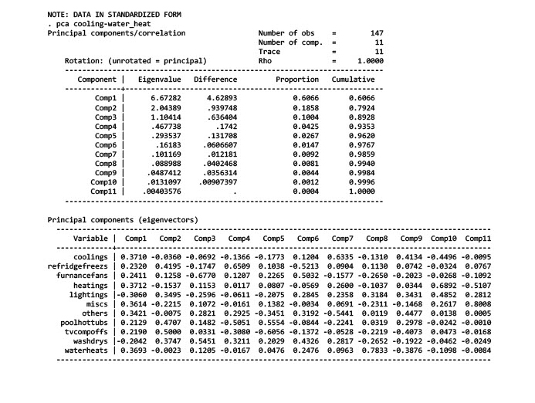
The top part of the table shows the eigenvalues of the covariance matrix (one for each variable), along with the proportion of variance attributed to each component, and the bottom part provides the components, or eigenvectors. The typical “rule of thumb” for a PCA is to choose the number of components that correspond to eigenvalues above one, in this case three.
Step 2: Create Preliminary End-Use Weights
Next, we form three new variables for the three chosen components using the eigenvector values (using the STATA command):
. gen pca1=.3710* coolings+.2320* refridgefreezs`+.2411* furnacefans+.3712* heatings-.3060* lightings+.3614* miscs+.3421* others+.2129* poolhottubs+.2190* tvcompoffs-.2042* washdrys+.3693* waterheats
. gen pca2=-.0360* coolings+.4195* refridgefreezs+.1258* furnacefans-.1537* heatings+.3495* lightings-.2215*miscs-.0075* others+.4707* poolhottubs+.5* tvcompoffs+.3747* washdrys-.0023* waterheats
. gen pca3=-.0692* coolings-.1747* refridgefreezs-.6770* furnacefans+.1153* heatings-.2596* lightings+.1072*miscs+.2821* others+.1482* poolhottubs+.0331* tvcompoffs+.5451* washdrys+.1205* waterheats
We can now use these constructed variables in a regression (with QFER also in standardized form) to create weights for each end use since we have created orthogonal explanatory values:
Table 4: Correlation Among PCA Constructed Variables and Resulting Regression
Table 5: Regression of PCA Components
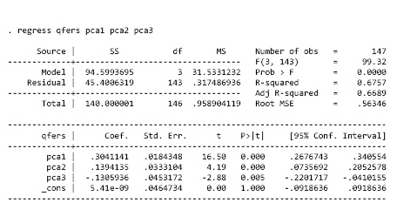
Corresponding coefficients, or unadjusted weights, for each end use are calculated by multiplying the coefficients for pca1, pca2, and pca3 by the corresponding principal component term for each end use. For example, the calculated unadjusted weight for coolings is:
0.3041×0.3710 + 0.1394×-.0360 + -0.1306×-.0692 = 0.1168.
Our goal is to develop weights for each end use to apply to the difference between the econometric prediction described below and the sum of the end use totals from the Residential Model by year for each planning area. Therefore, the preliminary end-use weights need to be normalized to one, as shown in the table below.
Table 6: Preliminary PCA Weights by End Use

Step 3: Use PCA Results to Forecast Adjusted Residential Consumption
Next, we need to develop a forecast for residential consumption upon which to apply to weights from Step 2. We can use the same formulation as shown above for pca1, pca2, and pca3 but substituting the non-standardized (actual) values of the end uses and then regress QFER residential consumption on these newly created variables. That is, regress QFER on the following variables (Using the STATA command):
. gen pca1(ns)=.3710* cooling+.2320* refridgefreez`+.2411* furnacefan+.3712* heating-.3060* lighting+.3614* misc+.3421* other+.2129* poolhottub+.2190* tvcompoff-.2042* washdry+.3693* waterheat
. gen pca2(ns)=-.0360* cooling+.4195* refridgefreez+.1258* furnacefan-.1537* heating+.3495* lighting-.2215*misc-.0075* other+.4707* poolhottub+.5* tvcompoff+.3747* washdry-.0023* waterheat
. gen pca3(ns)=-.0692* cooling-.1747* refridgefreez-.6770* furnacefan+.1153* heating-.2596* lighting+.1072*misc+.2821* other+.1482* poolhottub+.0331* tvcompoff+.5451* washdry+.1205* waterheat
Here, ns denotes the non-standardized version of pca1, pca2, and pca3.
Table 7 shows the results from this regression for the PG&E planning area, and Figure 1 compares historical QFER residential consumption with the sum of the end uses coming from the Residential Model and the new fitted curve developed from the regression results.
Table 7: Non-Standardized Version of PCA Regression for PG&E
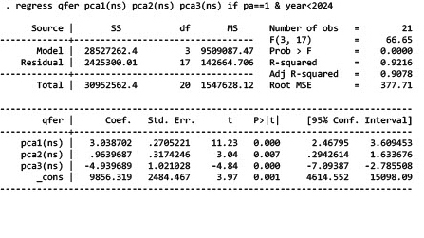
Figure 1: Non-Standardized PCA Regression Results for PG&E
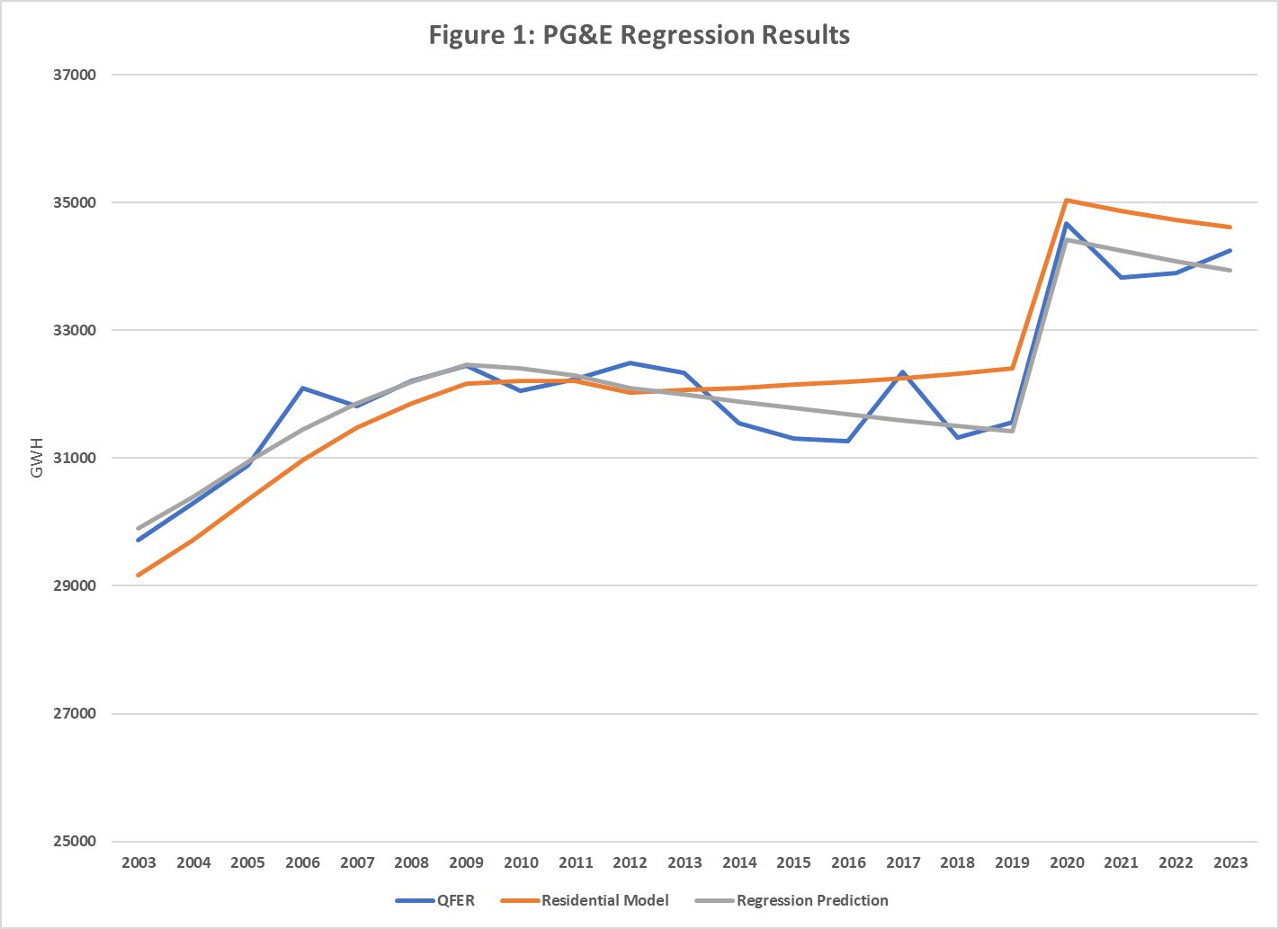

As Figure 1 shows, the regression predictions bring us much closer to QFER compared to the Residential Model output. To develop the final end-use weights for each planning area or forecast zone, we need to account for the relative sizes of the end uses in each region (given the preliminary weights were developed using standardized variables) by multiplying the preliminary weights by the ratio of the region’s standard deviation of electricity use for each end use divided by the standard deviation of total regional residential consumption and then renormalizing the sum to one. Table 8 shows the calculations for the PG&E planning area to derive the final weights.
Table 8: Final Weights for the PG&E Planning Area

Step 4: Adjust End Uses for Improved Backcast
Table 9 shows the differences between the regression predictions for PG&E and the Residential Model output for 2003-2023. End-use totals would then be adjusted in each year by multiplying the appropriate final weight by the difference shown in Table 9. Table 10 shows the weight applied to the PG&E cooling end use for 2003-2023, and Figure 2 provides a graph of the results.

Table 9: Regression Predictions, Sum of Modeled End Uses from Residential Model, and Differences for PG&E Planning Area (GWh)

Table 10: Adjustment to PG&E Cooling End Use (GWh)
Figure 2: Model Output and Adjusted Cooling End Use, PG&E

Step 5: Develop Adjusted Forecast and Apply End-Use Weights
The process for adjusting the forecast for each planning area is similar, with the forecast equal to the sum of the projected end-use totals from the Residential Model. Figure 3 shows historical QFER residential consumption for PG&E, Residential Model totals for the historical and forecast period, and an adjusted forecast developed from the results in Table 7.
Figure 3: Historical and Projected Residential Consumption, PG&E

The final end-use weights from Table 8 would then be applied to the differences between the forecast Residential Model output and the regression predictions, as in the historical case above.
Note that this example is illustrative in the sense that the actual application of this method will first require the proper adjustments to the QFER data and the Residential Model output (e.g. EV use, efficiency programs, weather adjustments). Also, the adjusted forecast would still require scaling to the last historical year.

Aggregation to some degree is required since the total number of electric end uses is higher than the number of observations (2003-2023).
Note that these three variables will not be orthogonal as in Table 4, but are not nearly as correlated as for the end uses as shown in Table 2, thus allowing for a reasonable, coherent forecast as we will see below.
Without this step, we could end up with negative amounts of some end use that uses little energy.
This follows because coefficients estimated using standardized variables can be translated to coefficients for unstandardized data by multiplying the former coefficients by the standard deviation of the appropriate variable (unstandardized) divided by the standard deviation of the dependent variable.

