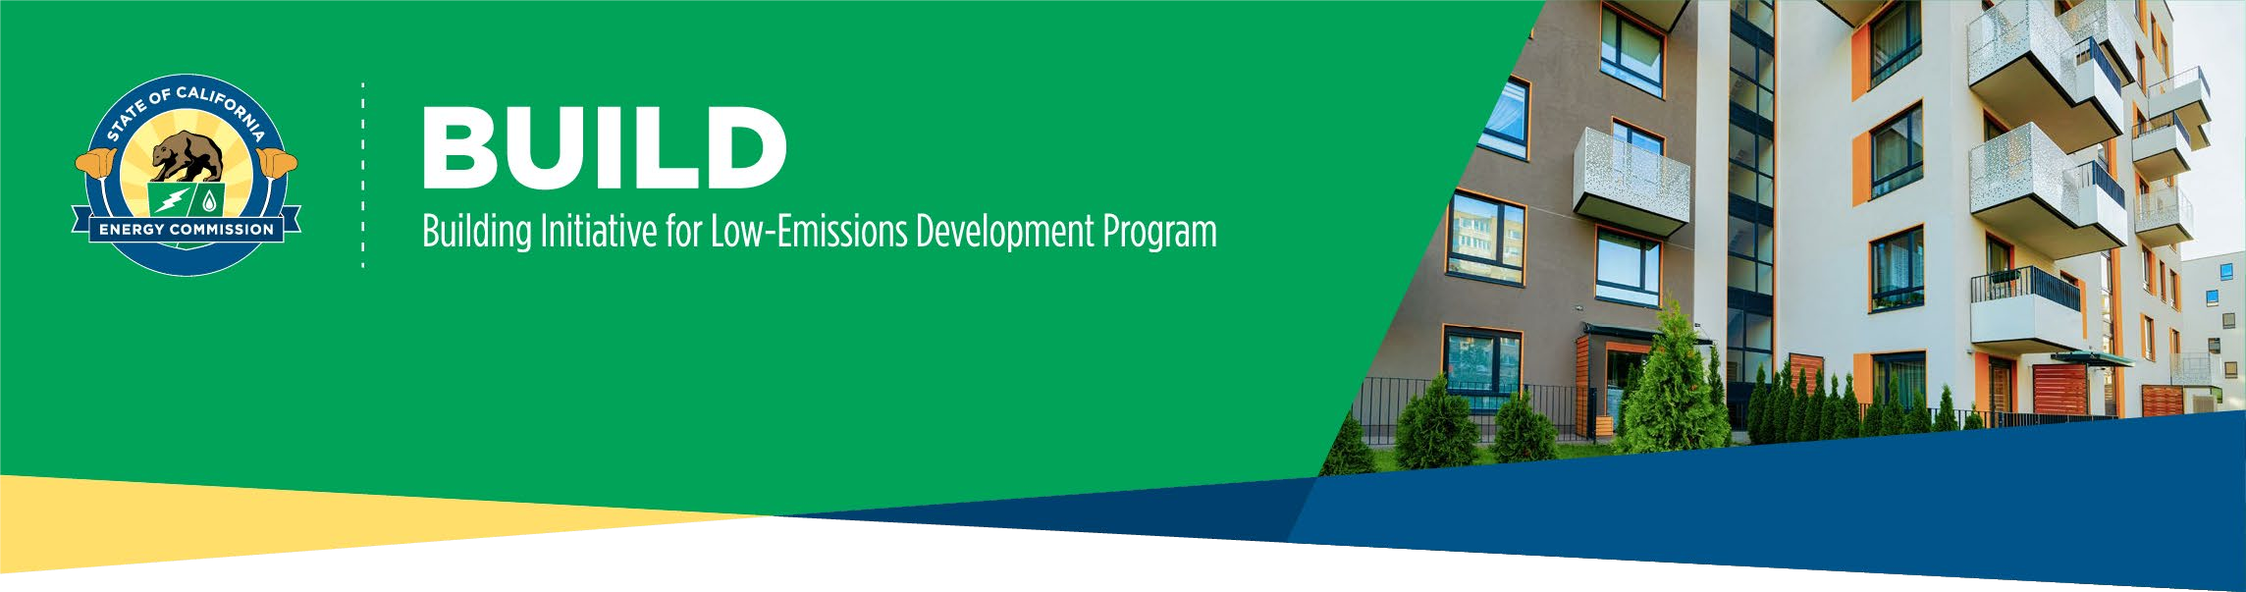

STEP 1: BUILD DESIGN RESERVATION APPLICATION CHECKLIST

Design Reservation Application Eligibility & Term:
Design Reservation Application: If an applicant and the proposed project meet all BUILD Program eligibility requirements and the project has not been issued a building permit, then a BUILD Step 1 Design Reservation is the best place to start.
Projects eligible for Design Reservation must demonstrate the following:
- Ensure all requisite eligibility requirements are met, please see BUILD Program Guidelines | California Energy Commission Chapter 2: Eligibility pgs. 5-10
- No building permits issued from the applicable local agency or tribal government
Design Reservation Term: The initial term of the Design Reservation is 18 months with an optional 6-month extension, by which time eligible applicants must meet the readiness requirements to transition the application to Step 2: Construction.

New Adopter Design Award:
New Adopter Design Award: If applicants are pursuing their first all-electric multifamily building, applicants can apply for the New Adopter Design Award, an optional part of the Design Reservation application, to receive funding based on the initial building designs. The award will reimburse direct costs and paid invoices for architectural, engineering, or energy consultation design services for the project.
If applicable, applicants and projects eligible for the New Adopter Design Award must demonstrate:
- Developer is an eligible applicant who has not yet submitted a permit for the development and construction of an all-electric residential building in California at the time of applying for the award.
- The project is a multifamily residential building of at least 10 units.
- Approval and payment of award is contingent upon approval of the Design Reservation Package.

Design Reservation and New Adopter Award Application Checklist:

Complete the Supplemental Narrative
  - This portion of the application is required to establish an understanding of project status and developer experience. You will need information on the following five topics:
    - Project Schedule
1 Version 3 – 5/30/2025

BUILDING INITIATIVE FOR LOW-EMISSIONS DEVELOPMENT PROGRAM
DESIGN APPLICATION CHECKLIST

    - Project Financing
    - Project’s Affordable Income Restrictions
    - Project’s Modeled Resident Utility Costs Savings
    - Applicant’s Developer Experience (Initial application only)

Complete and provide Custom Path Tool Results (.xlsx) and energy model(s) (.ribd or .bld file) or BUILD Incentive Calculator (New Adopter Applicants Only)
  - The BUILD Calculator & Custom Path Tool are utilized to provide an overview of incentives and ensure project designs will meet the modeled resident bill savings requirement.
  - Access to the calculator and tool and instructions for use are located on the BUILD webpage at the bottom under BUILD CALCULATOR. Please select your specific building type to properly calculate an estimate.
  - BUILD Incentives | California Energy Commission

Provide Preliminary Compliance Certificate(s): CF1R-PRF-01E, LMCC-PRF-01-E, or NRCC-PRF-E (.pdf)
The CF1R-PRF-01E is a Title 24 Part 6 Certificate of Compliance for single family buildings. The LMCC-PRF-01-E is a Title 24 Part 6 Certificate of Compliance for multifamily buildings 3 stories or less. The NRCC-PRF-E is a Title 24 Part 6 Certificate of Compliance for multifamily buildings 4 stories or more. These documents are usually completed by an energy consultant.
Here are links for more information on the CF1R, LMCC, & NRCC Documents:
  - CF1R – 2022 Single Family Residential
  - LMCC – 2022 Low-rise Multifamily
  - NRCC – 2022 Nonresidential & High-rise Multifamily

Complete Payee Data Record (STD-204) (.pdf)
  - An STD-204 is needed to process payments of invoices.
  - Payee Data Record - STD-204 | California Energy Commission
- *If Applicable* Provide your CalEnviroScreen Score for DAC (.jpg, .pdf, .png)
  - CalEnviroScore: A screening method that is used to identify California communities that are disproportionately burdened by multiple sources of pollution.
  - Enter your project’s address and take a screenshot of your project’s location results including overall percentile scores and the map.
  - CalEnviroScreen 4.0

Complete Attestation
This portion at the end of the application is to confirm applicant's intent to develop an eligible project and comply with Program Guidelines.

2 Version 3 – 5/30/2025

