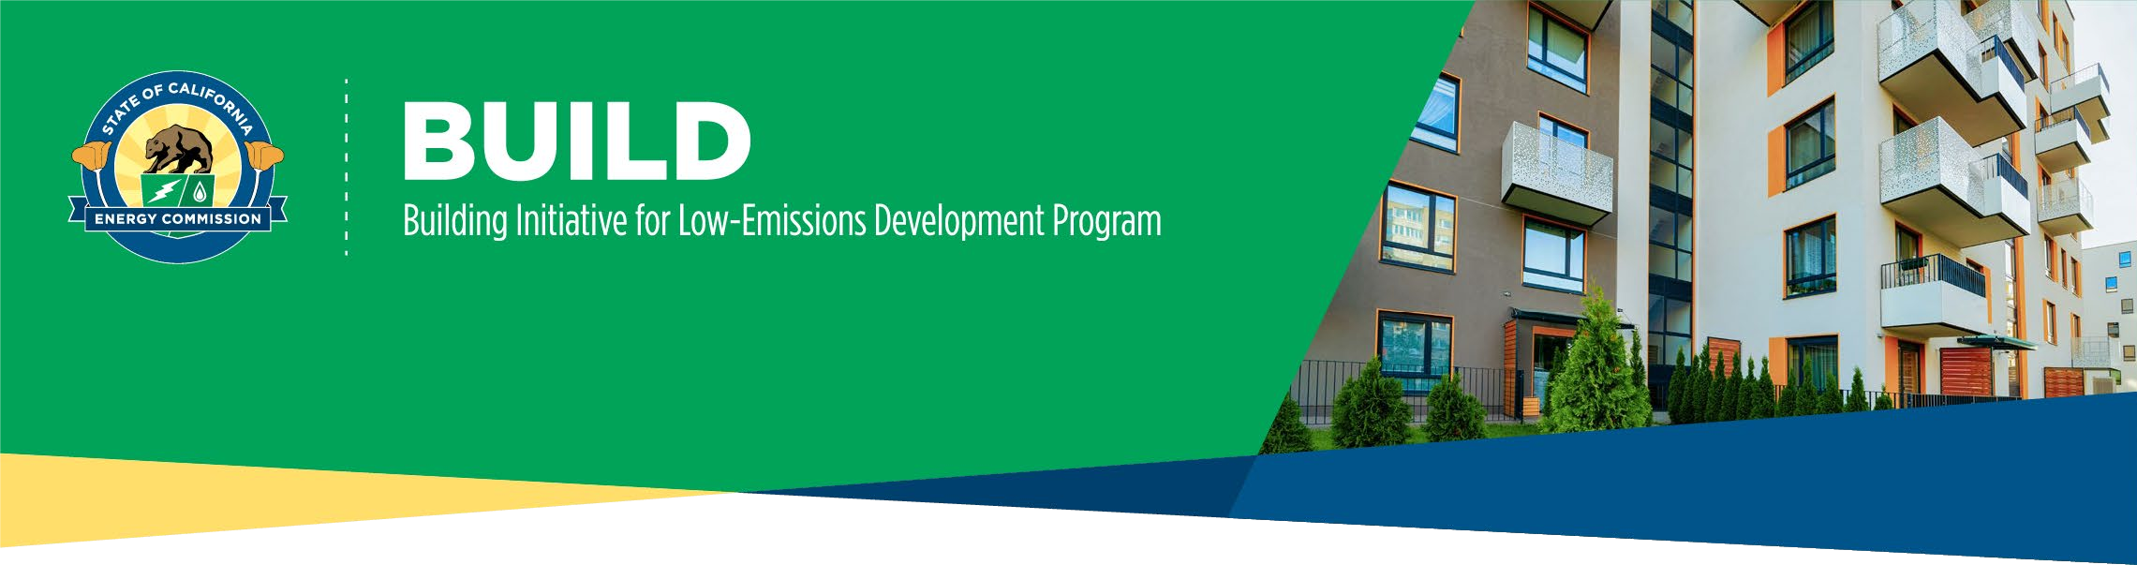

STEP 2: BUILD CONSTRUCTION RESERVATION APPLICATION CHECKLIST

Construction Reservation Application Eligibility & Term:
Construction Reservation Application: If an applicant and the proposed project meet all BUILD Program eligibility requirements and the project has been issued a building permit, then a BUILD Step 2 Construction Reservation is the best place to start.
Projects eligible for Construction Reservation must demonstrate the following:
- All requisite eligibility requirements are met, please see BUILD Program Guidelines | California Energy Commission Chapter 2: Eligibility pgs. 5-10.
- Building permits issued from the applicable local agency or tribal government.
- Evidence of affordable financing source approval.
Construction Reservation Term: The initial term of the Construction Reservation is 36 months with an optional 12- month extension, by which time eligible applicants must meet the readiness requirements to transition the application to Step 3: Completion.

Construction Reservation Application Checklist:

Complete the Supplemental Narrative
  - This portion of the application is required to establish an understanding of project status and developer experience. You will need up to date information on the following five topics:
    - Project Schedule
    - Project Financing
    - Project’s Affordable Income Restrictions
    - Project’s Modeled Resident Utility Costs Savings
    - Applicant’s Developer Experience (Initial application only)

Complete and provide Custom Path Tool Results (.xlsx)
  - Complete the Custom Path Tool (CPT) to determine if your project buildings meet the modeled resident utility cost savings requirement. Modifications to the building design and installation of PV may be considered to comply with the cost savings requirement. The CPT is additionally used to calculate the incentive amount using the building design energy model. The results from the CPT can be submitted with your application.

BUILDING INITIATIVE FOR LOW-EMISSIONS DEVELOPMENT PROGRAM
CONSTRUCTION APPLICATION CHECKLIST

  - Access to our Custom Path Tool which will provide the Custom Energy Model Output is located on the BUILD Incentives webpage under BUILD CUSTOM PATH TOOL.
  - BUILD Incentives | California Energy Commission

Provide Compliance Certificate(s): CF1R-PRF-01E, LMCC-PRF-01-E, or NRCC-PRF-E (.pdf)
  - The CF1R-PRF-01E is a Title 24 Part 6 Certificate of Compliance for single family and multifamily buildings 3 stories or less. The NRCC-PRPF-01-E is a Title 24 Part 6 Certificate of Compliance for multifamily buildings 4 stories or more. These documents are usually completed by an energy consultant.
Here is a link for more information on the CF1R, LMCC, & NRCC Documents.
  - CF1R – 2022 Single Family Residential
  - LMCC – 2022 Low-rise Multifamily
  - NRCC – 2022 Nonresidential & High-rise Multifamily

Provide Energy Model(s) (.ribd or .bld file)
  - Models must be created with CEC approved compliance software (CBECC-Res/Com or Energy Pro), demonstrate compliance with all program requirements and be completed by a certified energy analyst (CEA).

Provide a copy of approved Building Permit(s) (.doc, .pdf)
  - Complete this with the applicable local agency or tribal government.
  - Note that the building permit application date locks the project into the corresponding energy code cycle.

Provide Evidence of Affordable Housing Financing Source Approval (.pdf)
  - Funding details and anticipated date for applying required.
  - This can be provided in the form of letters or similar resolutions evidencing the commitment of construction and permanent financing.
- *If Applicable* Provide your CalEnviroScreen Score for DAC (.jpg, .pdf, .png)
  - CalEnviroScore: A screening method that is used to identify California communities that are disproportionately burdened by multiple sources of pollution.
  - Enter your project’s address and take a screenshot of your project’s location results including overall percentile scores and the map.
  - CalEnviroScreen 4.0

Complete Payee Data Record (STD-204) (.pdf)
  - A Payee Data Record (STD-204) is needed to process payments of invoices.
  - Payee Data Record - STD-204 | California Energy Commission

Complete Attestation
  - This portion at the end of the application is to confirm applicant intent to develop an eligible project and comply with Program Guidelines.

