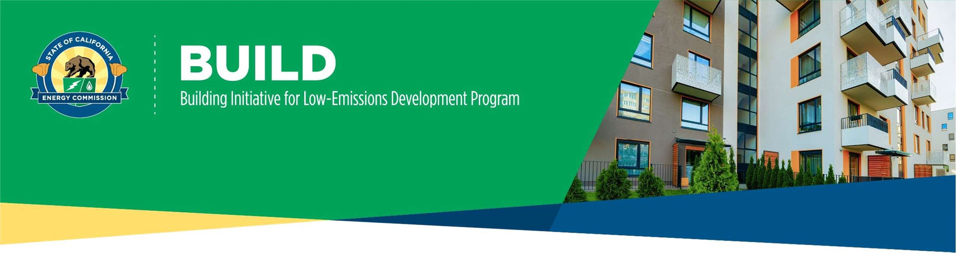

STEP 3: BUILD PROJECT COMPLETION APPLICATION CHECKLIST

Required for ALL application submittals:

Provide copies of Temporary¹ or Final Certificate of Occupancy (.doc, .pdf)
  - Transition from Step 2: Construction Application to Step 3: Completion Application is expected as soon as possible upon receiving a Temporary or Final Certificate of Occupancy

Provide a copy of the Recorded Deed Restriction (MF)/Resale or Equity Sharing Agreement (SF) (.doc, .pdf)
  - Recorded deed restriction or regulatory agreement demonstrating corresponding number of low-income units and bedrooms, or an executed resale restriction or equity-sharing agreement that has been filed with the local county recorder for the property being funded.
- Provide Installation and Verification Compliance Certificates Completed by Installers and HERS Raters (.pdf) Note: All required Certificates of Installation and Verification forms are indicated in the project’s Title 24 Certificate of Compliance
  - Single Family: CF2Rs and CF3Rs completed in HERS Registry
  - Low-Rise Multifamily: completed in HERS Registry
    - 2019 Code: CF2Rs and CF3Rs
    - 2022 Code: LMCIs and LMCVs
  - Mid-Rise and High-Rise Multifamily: NRCIs and NRCVs completed manually
    - All Codes: 2022 Compliance Forms | California Energy Commission

List of Meter IDs (.doc, .pdf)
  - A listing of the Meter ID(s) of the common areas and residential units of the project as provided by the electricity provider of the site, unless indefeasible to obtain by certificate of occupancy issuance.

Provide Final Energy Model(s) (.ribd or .bld file)
  - Model(s) must demonstrate compliance with all program requirements and be created by a certified energy
analyst (CEA).

Provide Final Compliance Certificate(s): CF1R-PRF-01E or NRCC-PRF-01-E
  - Based on final energy model.

Provide Final Custom Path Tool(s)
  - Recalculate incentive values based on final energy model.

Complete Attestation
  - This portion of the application is to confirm applicant developed an eligible project and complied with all
Program Guidelines.

1 A temporary certificate of occupancy will only be accepted at Step 3 if the unfinished portion of the project does not include any of the residential portion of the project or any portion of the project associated with a kicker incentive.
1 Version 4 – 11/20/2025

If building design modifications triggered a Title 24 documentation amendment after the Step 2 Construction application approval:

Provide Description of Design Modifications
  - Description of modifications and any increase or decrease of incentive amount.

If the project includes incremental PV ²:

PV PTO (Permission to Operate) Bundle (Any installed system must be interconnected before construction reservation expiration date) including (.doc, .pdf):
  - Interconnection application
  - System line diagram
  - Copy of final building permit

If the residents pay the utility bills:
- Provide a copy of the VNEM Agreement assigning PV to residents (.doc, .pdf) OR
- Demonstration of individual meters connected to PV systems directly benefitting the tenants OR
Proof of a measure installation and a rental/lease agreement provision/addendum template for all units subject to BUILD affordability requirements. The provision/addendum will provide the Custom Path Tool's monthly modeled resident utility cost difference(s) as a utility rent/lease credit for no less than five (5) years.

Alternatively, if the residents do not pay the utility bills:
- Provide a copy of the deed restriction or a similar legal agreement or covenant

Final or lump sum claims process:

Complete Payee Data Record (STD-204) (.pdf)
  - A Payee Data Record (STD-204) is needed to process payments of invoices.
  - Payee Data Record - STD-204 | California Energy Commission

Completion claim package (processed through BUILD Online) that includes proof of purchase and installation of eligible equipment & PV including kickers (.doc, .pdf):
  - Price & total costs charged for installation or equipment
  - Name, address, contractor’s license
  - Project site address
  - Description of work performed
Quantity, manufacturer, and specific model numbers of equipment installed

Note on Final Incentive Payout
The final incentive amount may:
  - a) Increase if there were changes that improved building design and performance that cause further GHG reduction (if funds are available).
or
  - b) Decrease if there were changes in the project design that triggered a Title 24 documentation amendment after the Step 2 Construction application approval or equipment installed that impact the incentive value. Any progress payments previously paid to the applicant will be assigned to the total final incentive value, so the applicant is not overpaid.

2 Incremental PV is defined as additional PV installed beyond the applicable Energy Code if used to meet the program’s utility cost savings requirement

2 Version 4 - 11/20/2025

