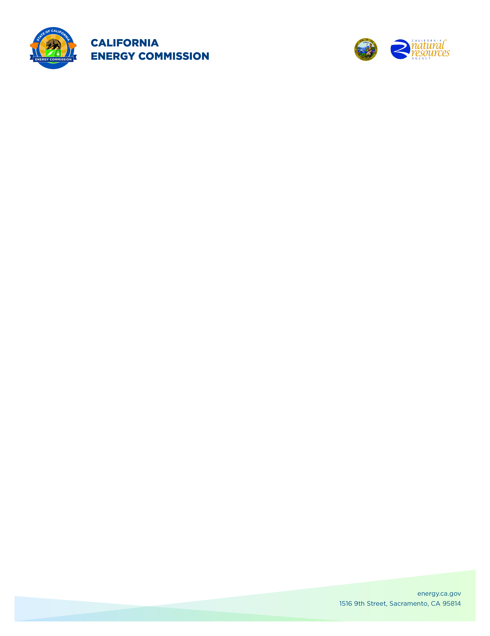
GFO-22-301
Commercializing industrial Decarbonization (2022 CID Program)
Addendum 6
December 12, 2023

The purpose of this addendum is to notify potential applicants of changes that have been made to GFO-22-301.

GFO-22-301 had at most three funding rounds, per the GFO manual, notice is hereby given to:

- Revise Round 2 deadline to submit applications.

The addendum includes the following revisions to the Solicitation Manual. Added language appears in bold underline, and deleted language appears in [strikethrough] and within square brackets.

Solicitation Manual
- GFO manual cover page, revised date
.
- Section 1.E “Key Activities dates”
  - Page 19 – Updated Round 2: Deadline to Submit Application Date.

Crystal Willis,
Commission Agreement Officer

