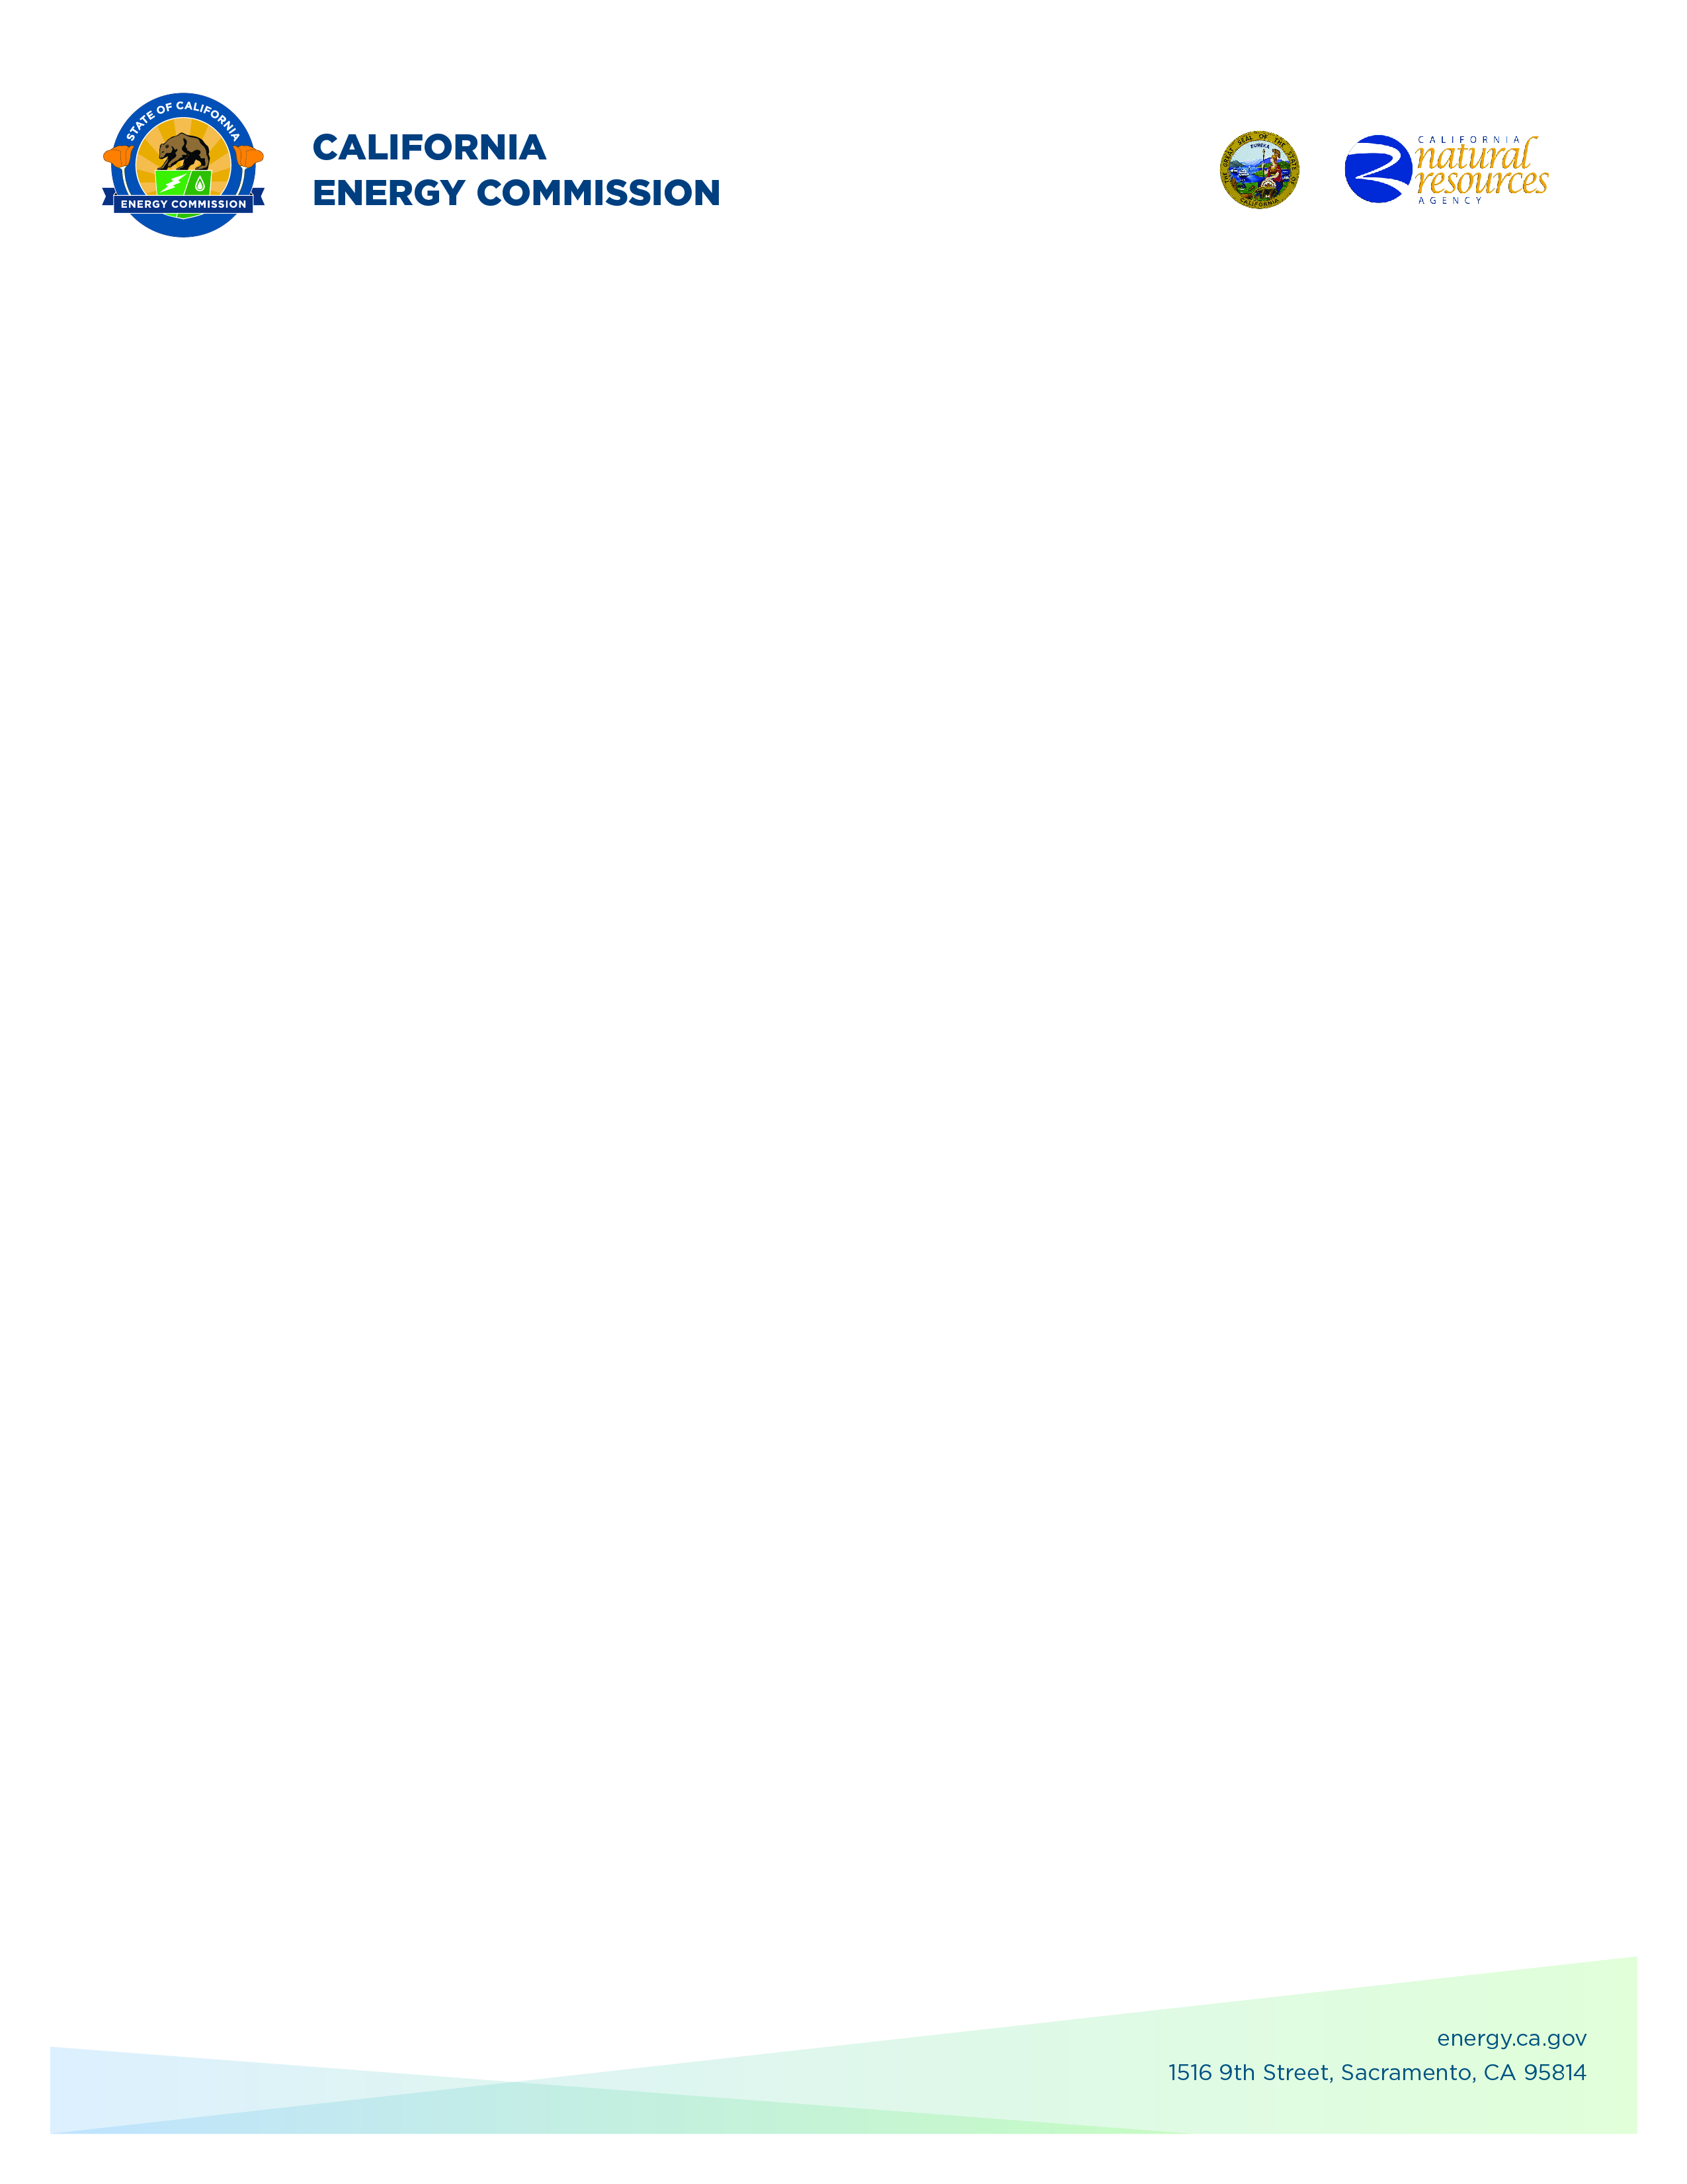
GFO-22-301
Commercializing industrial Decarbonization (2022 CID Program)
Addendum 3
June 8, 2023

The purpose of this addendum is to notify potential applicants of changes that have been made to GFO-22-301.

GFO-22-301 had at most three funding rounds, per the GFO manual, notice is hereby given on the opening for Round 2 funding.

The addendum includes the following revisions to the Solicitation Manual and Questions and Answers document. Added language appears in bold underline, and deleted language appears in [strikethrough] and within square brackets.

Solicitation Manual
- GFO manual cover page
- Section 1.C.2 “Group 2: Energy Efficiency and Decarbonization of Concrete Manufacturing”
  - Page 11 – Added “for” and deleted “at”
  - Page 11 – Added note for Round 2, Group 2 applicants that projects are not required to have the demonstration site(s) located at a cement/concrete manufacturing facility. Applicants are encouraged to have California cement/concrete manufacturers as project partners.
  - Page 11 and 12 – Updated bulleted text describing information to be added “In the Technical Merit section”.
- Section 1.E “Key Activities dates”
  - Page 19 – Added Round 2 Deadline to Submit Application Date, Anticipated Notice of Proposed Awards Posting Date, and Anticipated Energy Commission Business Meeting Date.
  - Page 19 – Revised asterisk notation for Round 2 and 3 Business Meeting dates.
  - Page 19 – Updated Round 1 Anticipated Energy Commission Business Meeting Date

Question and Answers Document
- Updated Q.18 regarding Round 2, Group 2 applicants
- Updated Q.20 regarding Round 2, Group 2 applicants
- Updated Q.54 regarding Round 2, Group 2 applicants

Crystal Willis,
Commission Agreement Officer

