Indices and Sub-indices Design and Development Memorandum

December 2025

- This research is funded by the California Energy Commission (CEC) through the Gas Research and Development Program, which invests in innovations to support the gas sector transition and cost-effective achievement of the state’s clean energy and climate goals.
- The research project, PIR-22-002, aims to provide state agencies, local governments, investor-owned utilities (IOUs), and other stakeholders with a data-driven approach to screen for promising sites for decommissioning specific segments of California’s gas system through a map-based tool that leverages gas system data and publicly available community data.
- This memo and data here within are being shared to support transparent and timely consideration of interim deliverables that are relevant for energy stakeholders and all those interested in California’s public interest gas decommissioning research.

This interim deliverable is submitted to the CEC by DNV GL USA, Inc. The memo meets deliverable requirements under Task 6 of the California Energy Commission’s Project PIR-22-002: Mindful Decommissioning - Development of a Data-Driven Tool to Support Strategic and Equitable Decommissioning of Gas Infrastructure.

Table of Contents
1 Introduction 1
2 Methods of Estimation 3
2.1 Analytical Framework 3
2.2 Value Scaling 3
2.3 Criteria Weighting 5
2.4 Imputation 6
3 Equity Index 8
3.1 Overview 8
3.2 Methodology and Rationale 8
3.3 Data Resources and Sub-Index Detail 8
4 Gas Assets Index 13
4.1 Overview 13
4.2 Methodology and Rationale 13
4.3 Data Resources and Sub-Index Detail 14
5 Non-Residential Decommissioning Readiness Index 18
5.1 Overview 18
5.2 Methodology and Rationale 18
5.3 Weighting Coefficients 19
5.4 Data Resources and Sub-Index Detail 20
6 Residential Decommissioning Readiness Index 22
6.1 Overview 22
6.2 Methodology 22
6.3 Data Resources and Sub-Index Detail 23
7 Combined Indices 27
8 Summary and Conclusion 29
9 References 30
Appendix A. Network Diagram Depicting the Mapping of variables to Sub-indices and indices A-1
Appendix B. Weighting Coefficients – Detailed Tables B-1
Commercial Sectors B-1
Manufacturing, Industrial, and Mining Sectors B-2

Tables

Table 3-1. Variables to Sub-Indices for the Equity Index 9
Table 4-1. Variables to Sub-Indices for the Gas Assets Index 14
Table 5-1. Variables to Sub-Indices for the Non-Residential Readiness Decommissioning Index 20
Table 6-1. Variables to Sub-Indices for the Residential Readiness Decommissioning Index 22

Figures

Figure 1-1. Mapping of Tertiary, Secondary, and Primary Metrics 1
Figure 2-1. Fisher-Jenks Natural Breaks Optimization 5
Figure 4-1. Gas Assets Assessment Factors 13
Figure 7-1. Graphical Illustration of How Different Secondary Metrics (Index Layers) are Additively Combined to Create Combined Index Layers Within the Tool 26

Introduction
In support of the development of a data-driven tool to support strategic and equitable decommissioning of gas infrastructure, the DNV team coordinated closely with the CEC and other stakeholders to develop indices and sub-indices that summarize the metrics collected in the following tasks: Task 2-Gas Assets Assessment; Task 3-Decommissioning Readiness; and Task 4-Community Resources and Equitability Assessment. The sub-indices (secondary metrics) were created to summarize the variables (primary metrics) collected within each of these tasks. The purpose of the index is to effectively aggregate the sub-indices, providing an overall assessment of gas decommissioning risks, costs, and benefits.
In this Indices and Sub-indices Memorandum (also the Secondary and Tertiary Metrics Report in the agreement documentation), we describe the design and development of the indices and sub-indices as well as the methods used for their estimation. Figure 1-1 provides a listing of the indices, sub-indices and variables (respectively the tertiary, secondary, and primary metrics), illustrating the relationship between these metrics. These are also schematically shown in Appendix A: Network Diagram Depicting the Mapping of Variables to Sub-indices and Indices.
Figure 1-1. Mapping of Tertiary, Secondary, and Primary Metrics
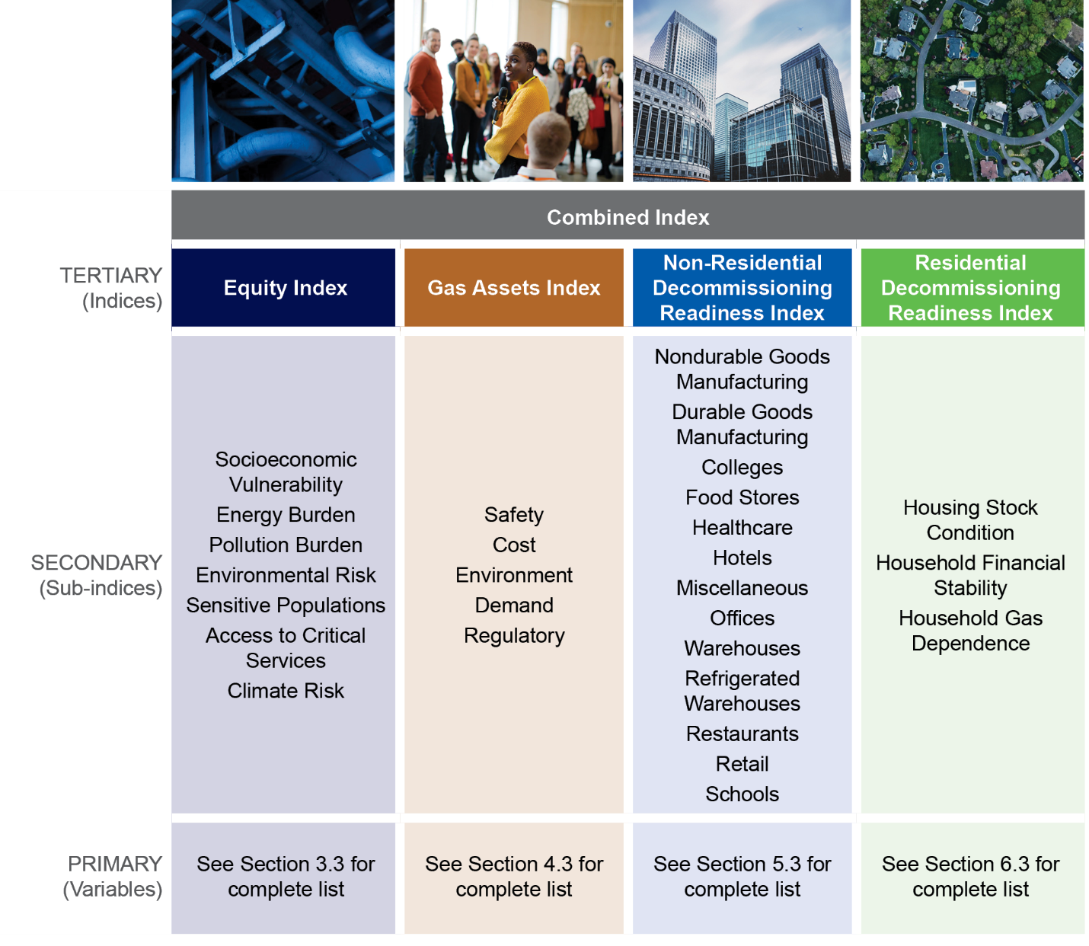
The DNV team created the sub-indices to summarize the variables collected within each of the tasks referenced above. The purpose of the indices is to effectively aggregate the secondary metrics (sub-indices), providing an overall assessment of gas decommissioning risks, costs, and benefits.
Our approach for developing the indices and sub-indices included the following:
- Integrating data from multiple sources that quantify different issues of concern
- Collecting variables that reflect common themes and combining them into index layers (sub-indices)
- Merging these index layers into a single composite index (indices)
Assigning these indices standard numerical scores that were normalized from the different units used in the underlying variables
The report sections are organized as follows:
- Section 2: Methods of Estimation provides a description of the methods of estimation used to determine the analytical framework, value scaling, and criteria weighting.
- Section 3: Equity Index provides an overview, description and rationale for the methodology, and data resources used for the equity index.
- Section 4: Gas Assets Index provides an overview, description and rationale for the methodology, and data resources used for the gas assets index.
- Section 5: Non-Residential Decommissioning Readiness Index provides an overview, description and rationale for the methodology, and data resources used for the non-residential decommissioning readiness index.
- Section 6: Residential Decommissioning Readiness Index provides an overview, description and rationale for the methodology, and data resources used for the residential decommissioning readiness index.
- Section 7: Combined Indices provides a summary of how we combine the four indices into a single layer to provide an overall assessment of gas decommissioning risks, costs, and benefits.
- Section 8: Summary and Conclusion provides a brief summary of benefits of a statewide, data-driven tool with consistent set of data.
- Appendix A: Mapping Variables to Sub-indices provides a complete mapping of variables to sub-indices.
Appendix B: Weighting Coefficients – Detailed Tables provides detailed information for the end-use category based weighting scheme that was developed to quantify the decommissioning readiness of different non-residential customer sectors.

Methods of Estimation

Analytical Framework
The geospatial layers presented in the Tool were developed using a geographic information system multi-criteria decision analysis (GIS-MCDA) approach. This analytical technique combines multiple pieces of quantitative information into a single unified representation, even when they may be naturally represented using diverse units and scales or derived from different and unrelated sources. The layers which have been derived from this approach represent groupings of the primary source variables in ways that signify the various issues or themes of concern relevant to gas decommissioning site exploration. In the Gas Distribution System Screening Tool (the Tool) developed and delivered for this project, with handover completed on October 28, 2025), these groupings include variables related to
- A suite of considerations related to energy equity and environmental justice
- The condition of gas distribution infrastructure assets
- The volume of gas consumed by non-residential gas customers as well as relevant characteristics of their specific end-uses
Potential barriers to gas substitute technology adoption and integration among residential customers
A multi-criteria decision problem involves the evaluation of a set of alternatives relative to various criteria, some of which may be in competition with one another. These evaluations can consider differences in the preferences of individual decision makers, as articulated by the assignment of weights to the different component criteria. The main elements of any multi-criteria decision problem include decision maker(s), alternatives, and criteria. The procedures for tackling multi-criteria decision problems involve three main concepts: value scaling (or standardization), criterion weighting, and a combination (decision) rule. These are fundamental concepts for MCDA in general and GIS-MCDA in particular. They can be considered as the building blocks of spatial decision support procedures.

Value Scaling
As part of a GIS-MCDA analysis, input data needs to be standardized to align observations of varying units and scales. There are several options for value standardization, including min-max scaling, standard error scaling, and ranking/binning, with benefits and drawbacks associated with each approach. For this project, the research team used a ranking/binning approach with 10 bins to discretize the resulting decision index while retaining sufficient information about the variance and underlying distributions of the various input variables.
We calculated indices using a tiered approach, aggregating from primary variables up to the final composite index in stages. First, primary variables were grouped into related topic areas, each corresponding to a sub-index (e.g., the gas assets safety sub-index or the equity energy burden sub-index). Next, with some exceptions, each primary variable was standardized on a 1-10 scale where lower values were assigned a score of 1 and larger values a score of 10—some variables had fewer than 10 distinct values and were standardized on a 1-M scale, where M was the number of distinct values, and other variables, particularly variables relating to year of gas asset construction, were ranked in reverse order with small values being assigned a score of 10 and large values a score of 1. Next, all the standardized scores of variables within a sub-index were summed together, and the resulting sum was standardized using the same 1-10 binning procedure to create a sub-index score. Finally, the values of all sub-indices within an index were summed together and then standardized from 1-10, resulting in our four index values: the Equity Index, the Gas Assets Index, the Non-Residential Decommissioning Readiness Index, and the Residential Decommissioning Readiness Index.
To perform the binning procedure, we used the k-means and Jenks Optimization methods, where choice of method was driven by software availability. Specifically, the Decommissioning Readiness indices were binned using the Jenks Optimization method while the Gas Assets and Equity indices were binned using k-means. Both the k-means and Jenks Optimization methods are unsupervised classification algorithms that assign observations to one of $k$ classes, where $k$ is an integer that is chosen by the user ($k$ is 10 in our use case). The k-means algorithm works by iteratively adjusting the membership of every observation into one of the $k$ classes until within-class variance has been minimized to be below some threshold. The Jenks Optimization algorithm has the same within-class variance minimization goal along with the goal of maximizing between-class variance. As a result, both algorithms should result in very similar classifications, especially in a univariate application, with minor differences arising around class boundaries.
Each algorithm is discussed in more detail below.

Fisher-Jenks Optimization
The Fisher-Jenks optimization method, also known as the goodness of variance fit (GVF), seeks to minimize the variance within a set of defined classes while simultaneously maximizing the variance between them. The method employs the following four steps:
- Step 1: The user selects the attribute, x, to be classified and specifies the number of classes required, k.
- Step 2: A set of k‑1 random or uniform values are generated in the range [min{x}, max{x}]. These are used as initial class boundaries.
- Step 3: The mean values for each initial class are computed and the sum of squared deviations of class members from the mean values is computed. The total sum of squared deviations (TSSD) is recorded.
Step 4: Individual values in each class are assigned to adjacent classes by adjusting the class boundaries to verify that the TSSD can be reduced. This iterative process ends when improvement in TSSD falls below a threshold level, i.e., when the within class variance is as small as possible and between class variance is as large as possible. While true optimization is not assured, the entire process can be optionally repeated from Step 1 or 2 and the TSSD values compared.
The Fisher-Jenks natural breaks optimization procedure shown in Figure 2-1 was used to rescale values for component input variables into a standard 1-10 ordinal ranking scheme. This procedure is a slightly modified version of the one-dimensional k-means cluster binning algorithm.
Figure 2-1. Fisher-Jenks Natural Breaks Optimization
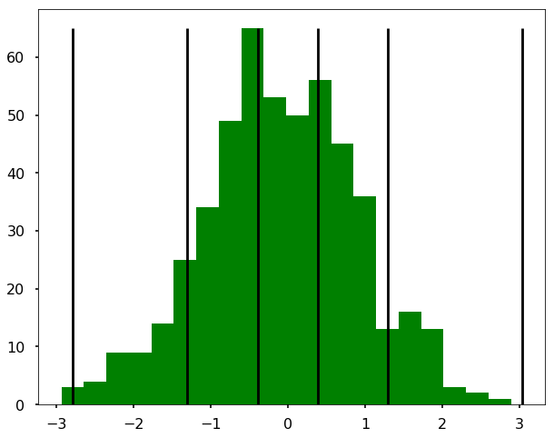

K-Means Clustering
K-means is an unsupervised clustering algorithm that assigns observations of arbitrary dimension into k classes, where the user chooses k. The algorithm works as follows:
- Choose k cluster centers at random from the range[(min{x1}, min{x2}, …, min{xn}), (max{x1}, max{x2}, …, max{xn})].
- Assign every observation in the population to the closest cluster center.
- Recalculate the k cluster centers according to the current assignment of observations.
- Repeat steps 2 and 3 until convergence, or until the WCSS (within cluster sum of squares) falls below a threshold.

Criteria Weighting
Within the scope of this study, the research team did not conduct a comprehensive evaluation of potential variations in outcomes resulting from different weight combinations applied to the secondary criteria (indexes). Accordingly, the default tertiary metric (composite index) presented in the Tool is based on a simple uniform weighting scheme. Recognising the importance of accommodating diverse user preferences within this analytical framework, the Tool has been designed to facilitate the dynamic application of user-defined weights at both the index and sub-index levels. This functionality enables users to dynamically evaluate any possible combination of weights. The development of these capabilities was pursued based on feedback regarding their importance received during engagement with stakeholders in technical advisory committee (TAC) meetings, community workshops, and other meetings with CEC staff, community partners, and interested parties. We expect that proper assessment of metrics-weighting will be an active area for future research and require significant stakeholder engagement. Weighting approaches may vary according to policy objectives, which can differ across regions or IOU districts.

Imputation
Imputation refers to the process of inferring values for a given attribute or data field in instances where data is missing. One of the fundamental limitations of the GIS-MCDA framework, which is the basis of our analytical approach, is that each hierarchy of the index structure inherits the missing data elements of the elements beneath it. In other words, if data is missing for a single variable at a given location, then that will prevent that location from being used in the entire analysis. This is because the mathematical operations which are used to combine component variables into sub-indices, or component sub-indices into indices, do not have any mechanism for coping with missing data values (i.e., 1 + Null = Null). To address this problem within the context of our analyses, different imputation methods were developed and used to infer missing values for different attributes. This approach was taken to leverage unique structural characteristics of each attribute (such as correlations to other known variables) to improve the quality of inference.

Imputing Residential Decommissioning Readiness Variables
In the case of the residential decommissioning readiness index, there are several fields for which missing values were derived using UCLA's private database of IOU customer metered electricity and natural gas consumption. Because the underlying source dataset is limited to IOU customer premises, we determined that imputing missing values for several variables was necessary—this ensured that incorporating the residential decommissioning readiness index did not reduce the geographic coverage of the overall analysis. In accordance with CPUC-mandated customer usage data anonymization and aggregation guidelines, all uses of residential IOU customer usage data involved aggregations that contained a minimum of 100 residential customers. In instances where this threshold could not be achieved for a given census tract, usage related attribute values were treated as NULL and then inferred based upon a geographic proximity-based imputation method that was applied using the remaining available data.
The specific methodology that was used to perform this imputation is known as Kriging. Kriging is a form of spatially weighted interpolation that predicts values for attributes at missing or unobserved locations based upon the spatial correlation structure available observations. It requires fitting a spatial covariance model to each attribute for which missing values must be inferred, since the spatial correlation structures may differ between attributes. These models are then used to generate predictions for the values of each attribute at missing or unobserved locations.
For this analysis we used the centroid locations of each census tracts with missing attribute values for the purpose of computing the pairwise distances that are required to develop these spatial correlation models. The Kriging procedure generates a set of confidence intervals for each imputed value that it produces. An analysis of these confidence intervals indicated that they were suitable for use in this application; however, these confidence intervals have not been retained as variables in the hosted dataset. All variables for which this type of imputation was applied have been documented in the Tool’s documentation pages and associated ArcGIS Online feature metadata.

Imputing Gas Asset Variables
In the case of the gas assets index, imputation was required to calculate the cost sub-index, which was defined based on the “DistAvCost” field. This field, available within the Gas System Census Tract Data as provided by utilities to the R.20-01-007 service list on November 4, 2022, in compliance with the Long-Term Gas Planning Rulemaking, was the best proxy for pipeline replacement cost identified in our review of available data. The column description for DistAvCost describes the field as the average cost per mile to replace distribution pipeline in an Operating District (units: $/mile). The definition of Operating District (field “OpDist”) varies by gas utility as follows: Division (PG&E), Operating District (SoCalGas), Construction and Operations Center serving the census tract (SDG&E), or Jurisdiction (SW Gas). The documentation also noted that since average is calculated across the Operating District, many tracts would have the same value of DistAvCost. Upon examination of this field, we found that only PG&E’s DistAvCost contained data with sufficient variation to include in the model (i.e., SWG submitted data but only two values representing all operating districts; SDG&E submitted a single rate case value; SoCalGas left the field blank).
Using PG&E’s DistAvCost, we were able to impute DistAvCost for the other gas utilities using fields that were more reliably populated for all utilities. We utilized a regression-based approach, fitting a multivariate Ordinary Least Squares (OLS) model on known data and then using this model to predict DistAvCost for census tracts where it was missing. A multivariate OLS model quantifies the relationship between one dependent variable and multiple independent variables, resulting in an equation of the form $y=αX_{1}+ βX_{2}+…+ δX_{n}+C$. The resulting equation can then be used to predict $y$ for different values of $X_{1},X_{2},…, X_{n}$, and will also provide associated prediction errors.
We completed this analysis in several steps: (1) variable selection, (2) model fitting, and (3) imputation.
In step (1), we first created a model that fit DistAvCost against all available variables. Any variable in this initial model that had a statistically significant coefficient—indicating a strong relationship with DistAvCost—formed a preliminary set of predictor variables. We then removed variables from this set that were highly correlated with each other, using 0.75 as a threshold for the absolute value of the correlation score between two predictors. We also removed variables from this set that were mostly or entirely missing for the other IOUs. Next, we fit one more regression model on DistAvCost against the remaining set of variables and then removed any variables that were no longer statistically significant (the statistical significance of independent variables in a multivariate model can change based on the addition or removal of other predictors in the model because of correlation between these variables). Any variables that remained after the selection process became the predictor variables in our OLS imputation model. The final OLS model had an $R^{2}$ value of 0.924, indicating high predictive power.
In step (2), we used the final set of predictor variables from step (1) and created an OLS model, fitting the equation $DistAvCost \sim Diam2OrLess+ Diam2to4+ Diam8to12+DiamOver12+DiamUnk+AvMainPressure+AvMainConsq+AvServiceYear+MainValves+Oldest$. In step (3), we fed these variables from the other IOUs into the OLS model to predict DistAvCost for census tracts where it was missing.

Equity Index

Overview
The Equity Index is comprised of seven sub-indices, each of which is composed of several variables. These variables (primary metrics) were identified and compiled to represent community impacts and to investigate pathways for prioritizing California communities who are identified as disadvantaged, underserved, at-risk, and most vulnerable to costs, burdens and cumulative energy inequities associated with early gas decommissioning. The metrics identified are intended to uplift non-energy impacts and benefits (e.g., health, housing, jobs) that communities view as priorities and analyze ways to quantify them for inclusion in the Tool.
The equity layer was developed with the following data collection goals:
- Comprehensively identify publicly available equity metrics and potential community impacts relevant to gas pipeline decommissioning.
- Research and build case study profiles to apply and test equity metrics identified.
Iteratively refine, prioritize, and select a set of equity metrics most representative of contextual community impacts through feedback from team, subject matter experts, and community input.
Further information on the process for identifying data sources and vetting the indices with community stakeholders is described in the following project deliverable: Community Resources and Equitability Assessment Report. The following sections describe how the equity subindices and index were designed and developed following the estimation methodology presented in Section 2, Methods of Estimation.

Methodology and Rationale
The desktop research process reviewed and identified publicly available equity metrics frameworks and screening tools (see Table 3-1 for a list of metrics and sources). The most relevant and critical equity indicators—used as proxies for community impacts—were then aggregated into a comprehensive list to support the identification of promising gas decommissioning candidate sites statewide.
If a region scores high in sensitive populations, environmental, and climate risk indicators, it may be considered a promising candidate for early gas decommissioning to help address these risks and related inequities sooner rather than later—provided there are no conflicting results in the gas asset and decommissioning readiness criteria. For example, if an area ranks high on the equity index but scores very low in gas asset presence and readiness, it may be deprioritized in favor of a location that scores high across all three categories. Additionally, even within the equity index itself, certain factors may complicate prioritization. An area with high energy burden and frequent grid outages, for instance, may not be a strong candidate for early decommissioning, as the transition to alternative energy sources could increase energy insecurity in the short term.

Data Resources and Sub-Index Detail
The process for using a data-driven scoring system to evaluate and rank different areas (by census tract) was described in Section 2.2 Value Scaling.
In line with the scope of this study, no additional weighting was applied—except for the pre-existing weighting used in the Energy Burden sub-index and Climate Risk Index. Instead, users can apply custom weights to sub-indices and indices in the Analyze tab. This allows weighting to reflect specific policy objectives and community needs, which may vary by region or IOU district. As noted above, the development of these capabilities was pursued based on feedback regarding their importance from stakeholders, including CEC staff and community partners.
The aggregated data in the Tool was reviewed and analyzed to determine clusters or patterns of community impacts. For instance, the Sensitive Populations Index was regressed with other indices to determine clusters and/or patterns that might emerge based on characteristics such as urban vs. rural vs. Indigenous lands. The analysis informed case study profiles that are as representative of regions and areas throughout the state.
This case study approach informed a statewide understanding to assist in determination of the unique environmental justice and energy equity-focused needs and interests for various regions in the state. This case study process and community validation of the respective indexes is described in more detail in the Community Resources and Equitability Assessment Report.
The secondary metrics (sub-indices) and primary metrics (variables) for the Equity Index are shown in Table 3-1 below. Variable descriptions are included below the table.
Table 3-1. Variables to Sub-Indices for the Equity Index
Secondary Metric (Sub-Index) | Primary Metric (Variable) | Data Source
Socioeconomic Vulnerability | Education | U.S. Census Bureau American Community Survey 5-Year (ACS 5-Year 2018-2022), accessed March 11, 2025
 | Linguistic isolation
 | Low income
 | Mobile homes
 | People of color
 | Rent burden
 | Renters
 | Single parent
 | Unemployment rate
Energy Burden | Energy burden ratio | ACS 5-Year 2018-2022
 | Grid outage duration | U.S. DOE Low-income Energy Affordability Data (LEAD) Tool, retrieved July 28, 2023
 | Grid outages county | DOE Lead Tool
 | Non-grid fuels | ACS 5-Year 2018-2022
Pollution Burden | Diesel particulate matter | CalEnviroScreen 4.0, retrieved July 28, 2023
 | Ozone
 | Pesticides use
 | PM2.5 particulate matter
 | Toxic releases to air | U.S. Environmental Protection Agency (EPA) Environmental Justice Mapping and Screening Tool (EJScreen), retrieved July 28, 2023
Environmental Risk | Asbestos risk | ACS 5-Year 2018-2022
 | Lead paint
 | Hazardous waste proximity | EPA EJ Screen
 | RMP proximity
 | Superfund proximity
 | Storage tanks
 | Wastewater discharge
 | Soil contamination | CalEnviroScreen 4.0
Sensitive Populations | Asthma incidence | CalEnviroScreen 4.0
 | Heart disease incidence
 | Low birth weight
 | Cancer incidence | EPA EJ Screen
 | Low life expectancy
Access to Critical Services | Food deserts | U.S. Department of Agriculture (USDA) Food Access Research Atlas, retrieved March 11, 2025
 | Housing burden | CalEnviroScreen 4.0
 | Limited broadband | EPA EJ Screen
 | Health insurance
 | Transportation stops | Inter-university Consortium for Political and Social Research (ICPSR) National Neighborhood Data Archive (NaNDA): Public Transit Stops by Census Tract and ZIP Code Tabulation Area, United States, 2016-2018 and 2024, retrieved March 11, 2025
Climate Risk | Expected annual loss – agriculture | Federal Emergency Management Agency (FEMA) Natural Risk Index Dataset, retrieved July 28, 2023
 | Expected annual loss – buildings
 | Expected annual loss – population
Variable descriptions for the Equity Index include:
- Education: Percentage of households with individuals aged 25 or older who have less than a high school education
- Linguistic isolation: Percent of households that speak English less than "very well"
- Low income: Percent of families below the poverty level
- Mobile homes: Percent of households that live in mobile homes
- People of color: Percent of population that is non-white
- Rent burden: Percent of households paying more than 35% of gross income on rent
- Renters: Percent of households occupied by renters
- Single parent: Percent of households with a single parent
- Unemployment rate: Annual unemployment rate by county
- Energy burden ratio: Household ratio of energy expenditures to gross income by census tract
- Grid outage duration: Average duration of grid outages in this county
- Grid outages county: Number of grid outages in this county
- Non-grid fuels: Percentage of households that use non-grid fuels to heat their home, which include natural gas, propane, liquid gas, wood
- Diesel particulate matter: Percentile of households exposed to diesel particulate matter
- Ozone: Concentration of ozone by census tract
- Pesticides use: Percentile of census tracts affected by pesticide exposure
- PM2.5 particulate matter: Percentile of census tracts affected by PM 2.5 concentration
- Toxic releases to air: a screening-level estimate of relative risk reported as a toxicity-weighted concentration score, normalized for comparison across census tracts, not an actual exposure measurement
- Asbestos risk: Percentage of households in residential buildings older than 1978 who have a higher likelihood of asbestos exposure
- Hazardous waste proximity: Proximity to hazardous waste disposal sites
- Lead paint: Percentage of homes at risk of lead paint exposure using the proxy of 1950s building vintages
- RMP proximity: Proximity to Risk Management Program (RMP) facility
- Soil contamination: Measures potential exposure to hazardous substances in soil by identifying locations of cleanup sites where toxic chemicals have been released and remediation is required. Scores are expressed as percentiles relative to other census tracts statewide.
- Superfund proximity: Proximity to a U.S. EPA Superfund site
- Storage tanks: Proximity of households to underground storage tanks that store petroleum or hazardous substances
- Wastewater discharge: Toxicity weighted concentration of wastewater discharge in nearby waterways
- Asthma incidence: Percentile of households affected by asthma by census tract
- Cancer incidence: Percentile of households affected by cancer by census tract
- Heart disease incidence: Percentile of households with heart disease incidence by census tracts
- Low birth weight: Percentage of babies born with low birth weight
- Low life expectancy: Percentile of households with low life expectancy by census tract
- Food deserts: Limited access to supermarkets, supercenters, grocery stores, or other sources of healthy and affordable food that may make it harder for some people to eat a healthy diet
- Housing burden: Households who are low income and burdened by housing cost.
- Limited broadband: Percentage of homes with limited broadband access
- Health insurance: Percentage of homes without health insurance
- Transportation stops: Transportation stops per square mile by census tract
- Expected annual loss – agriculture: Expected dollar value annual loss of agriculture due to climate impacts by census tract
- Expected annual loss – buildings: Expected dollar value annual loss of buildings due to climate impacts by census tract
- Expected annual loss – population: Expected dollar value annual loss of populations due to climate impacts by census tract

Gas Assets Index

Overview
The Tool aims to identify and prioritize areas where gas distribution pipelines can be decommissioned in a safe, cost-effective, and environmentally beneficial way, while minimizing impacts on customers and communities. The Tool uses Gas System Census Tract Data as provided by utilities to the R.20-01-007 service list on November 4, 2022, in compliance with the Long-Term Gas Planning Rulemaking. The following are the five sub-indices included in the gas assets index, listed with what each is designed to measure:
- Safety: risk of gas leaks, explosions, fires, and other hazards associated with the gas distribution pipelines
- Environment: environmental benefits and impacts associated with gas distribution pipelines, such as greenhouse gas (GHG) emissions that could be avoided through decommissioning
- Cost: cost avoidance associated with gas decommissioning in an area, which would include costs for maintaining or replacing an aging pipeline
- Regulatory Compliance: regulatory compliance and alignment associated with gas decommissioning in an area
Demand: gas demand reduction and customer impact associated with gas decommissioning in an area
Further information on the process for identifying data sources and coordination with relevant stakeholders is described in the following project deliverable: Gas Assets Assessment Data Collection and Analysis Report.
The following sections describe how the gas assets subindices and index were designed and developed following the estimation methodology presented in Section 2, Methods of Estimation.

Methodology and Rationale
The research team began by identifying factors that influence decisions on gas distribution system infrastructure decommissioning. As described above, the gas asset assessment factors identified are safety, environment, cost, regulatory compliance, and demand. These five areas were defined as the sub-indices for the gas assets index.
To identify metrics associated with each of these areas, the research team started the data exploration by reviewing gas system census tract data provided by the four investor-owned gas utilities—PG&E, SoCalGas (SCG), SDG&E, and Southwest Gas (SWG)—in response to the CPUC’s Long-Term Gas Planning Rulemaking R.20-01-007. Data files for each of the four utilities were accessed and downloaded from the CPUC’s website. Using the R-programming language, the files were read and analyzed, with steps taken to validate and clean data to create a single dataset with consistent values across IOUs for each of the fields. For example, data was reviewed and edited where needed to ensure consistent use of variable names and units of measure. After a thorough review of the available data and fields, the research team identified a subset of variables with sufficient data to be used in the analysis. More information on the data validation and selection process is provided in the Gas Assets Assessment Data Collection and Analysis Report.
As a first step in identifying which variables to use in the model, the team identified thematic characteristics of gas infrastructure associated with each of the five sub-indices. Figure 4-1 shows a mapping of gas assets sub-indices (in green) to thematic characteristics (in dark blue).
Figure 4-1. Gas Assets Assessment Factors

Finally, the team determined which of the data variables from the utilities’ gas system data would best represent each thematic characteristic. In some cases, a mapping from the primary data to the thematic characteristics was evident, e.g., the IOUs’ Gas System Census Tract Data included variables for pipeline materials and pipeline age (year). In other cases, the team identified proxy variables to represent the thematic characteristic, e.g., customer counts were proxied by the “Services” field, which is described in the data documentation as “Number of services—Services typically serve one customer each.” In some cases, multiple fields were combined to create a new metric to represent a thematic concept, e.g., “Customers per Mile” is derived by dividing “Services (count)” by the sum of “Medium Pressure Mains (miles)” and “Medium Pressure Services (miles).”
In the case of the pipeline replacement cost, identifying representative variables was more complicated. The IOUs’ Gas System Census Tract Data included only one cost field: “DistAvCost” defined as “Average cost per mile to replace distribution pipeline” in an operating district. As described in Section 2.4.2 Imputing Gas Asset Variables, the research team found that this cost field was consistently populated only in PG&E’s dataset, and therefore, an imputation method was applied to fill in missing data to represent this critical metric for SCG, SDG&E, and SWG. Refer to Section 2.4.2 for more details on the method and data used to derive the cost data metric. See the next section for a complete mapping of gas assets sub-indices to variables, with the variables grouped by the thematic characteristics they represent.

Data Resources and Sub-Index Detail
A mapping of Gas Assets Sub-Indices to characteristics and variables, with definitions, is shown in Table 4-1 below. All variables are sourced from Selected Rulings from the Long-Term Gas Planning Rulemaking (R.20-01-007), with most described in the March 1, 2022, Gas System Data Ruling and supplemental variables described in the September 21, 2022, Revised Gas System Data Ruling.
Table 4-1 shows which variables were used to derive each of the gas assets sub-indices. Most variables were included directly, without transformation, in the k-means value scaling model described in Section 2.2.2. There are several exceptions, noted in the table below, where variables were transformed in some way before being included in the model. These exceptions include:
- Pipe Materials: six pipe material variables in the IOU data were summed to create a single ‘Pipe Materials’ variable, which was included in the k-means value scaling model.
- District Average Cost (DistAvCost): The PG&E DistAvCost field was included directly in the model, but due to data gaps, the DistAvCost field was imputed for SCG, SDG&E, and SWG. The derivation of this cost field is described in detail in Section 2.4.2 Imputing Gas Asset Variables. The table below provides definitions for the variables that were used in the OLS model to impute DistAvCost.
Customers per Mile: a variable derived for input to the Demand sub-index, as described in the preceding section, to represent the number of customers served by a mile of gas distribution system pipeline.
Table 4-1. Variables to Sub-Indices for the Gas Assets Index
Sub-Indices | Characteristic | Variable Descriptions
Safety, Environment, Regulatory | Pipeline Age | - AvMainYear: Year pipeline was installed, averaged across distribution main pipeline miles  - AvServiceYear: Year pipeline was installed, averaged across distribution service pipeline miles  - Oldest: Miles of distribution main and service pipeline older than 1941 or with unknown installation date
Safety, Environment, Regulatory | Pipe Materials | Derived from:  - EarlyAldylA: Miles of distribution main and service pipeline made of Aldyl-A plastic installed in 1965-1972  - LaterAldylA: Miles of distribution main and service pipeline made of Aldyl-A plastic installed in 1973-1985  - UnkDateAldylA: Miles of distribution main and service pipeline made of Aldyl-A plastic with unknown manufacturer or installation year  - NCPSteel: Miles of distribution main and service pipeline made of steel without cathodic protection  - Copper: Miles of distribution service pipeline made of copper  - Iron: Miles of distribution main and service pipeline made of wrought iron  Formula: $(EarlyAldylA+LaterAldylA+UnkDateAldylA+NCPSteel+Copper+Iron)$
Safety, Environment | Pipeline Leaks | - AvMainLeaks: Main leaks identified in leak surveys, excluding repaired or removed leaks, averaged across distribution main pipeline miles  - AvServiceLeaks: Service leaks identified in leak surveys, excluding repaired or removed leaks, averaged across distribution service pipeline miles  - HistAvMainHazLeaks: Main hazardous leaks (grade 1) repaired in 2015-2020, averaged across distribution main pipeline miles  - HistAvServiceHazLeaks: Service hazardous leaks (grade 1) repaired in 2015-2020, averaged across distribution service pipeline miles
Safety, Environment | Pipeline Risk | - AvMainRiskScore: Risk score averaged across distribution main pipeline miles  - AvServiceRiskScore: Risk score averaged across distribution service pipeline miles
Safety | Customer Proximity | - High consequence area (HCA): Overlaps an HCA, which is a populated area near transmission pipelines, where accidents would have higher human consequences  - Moderate consequence area (MCA): Overlaps an MCA, which is moderately populated areas or four-lane road near transmission pipelines
Environment, Demand | Gas Consumption | - TotalLoad: Average annual daily gas consumption in 2021  - LoadChange: Annual gas demand change from 2015 to 2020
Cost | Pipeline Replacement Cost | - DistAvCost: Average cost per mile to replace distribution pipeline in the Division (PG&E)  DistAvCost Imputed for SCG, SDG&E, and SWG based on:  - Diam2OrLess: Miles of distribution main and service pipeline with diameter of 2” or less  - Diam2to4: Miles of distribution main and service pipeline with diameter over 2” through 4”  - Diam8to12: Miles of distribution main and service pipeline with diameter over 8” through 12”  - DiamOver12: Miles of distribution main and service pipeline with diameter over 12”  - DiamUnk: Miles of main or service distribution pipeline with unknown diameter  - AvMainPressure: Set pressure, averaged across distribution main pipeline miles  - AvMainConsq: Calculated probability of serious safety incident given leak, or consequence of failure, averaged across distribution main pipeline miles  • MainValves: Number of valves on distribution main pipelines. Portions of the system can be isolated by closing two or more valves.  Formula: See section 2.4.2 Imputing Gas Asset Variables
Demand | Customer Count | - Services: Number of services—Services typically serve one customer each—used as a proxy for customer count
Demand | Large Customers | - LargeCustomers: Number of large volume customers (count of customers that can receive more than 40,000 cubic feet/hour of gas)
Demand | Customers per Mile | Derived from:  - Services: Number of services—Services typically serve one customer each—used as a proxy for customer count  - MedPressMains: Miles of medium pressure (60 psi or below) distribution main pipeline  - MedPressServices: Miles of medium pressure (60 psi or below) distribution service pipeline  Formula: $Services÷(MedPressMains+MedPressServices)$

Non-Residential Decommissioning Readiness Index

Overview
The Non-Residential Decommissioning Readiness Index is intended to represent the feasibility of non-residential customers disconnecting from gas service based upon the current volume of their gas consumption and the availability of alternative fuel technologies for different end-uses of gas.
Fundamentally, the non-residential decommissioning readiness index seeks to quantify:
- The relative difficulty of substituting specific gas end-use activities with alternative fuels based upon the availability and cost-competitiveness of existing technologies.
The concentration and total volume of gas use among non-residential customers by commercial or industrial sub-sector and corresponding end-use energy service category.

Methodology and Rationale
Decommissioning non-residential gas customers will likely be challenging as there do not currently exist commercially available appliances and equipment offerings that can readily be used as substitutes for all existing gas end-uses within the commercial and industrial sectors. At the present time, the majority of existing commercially available fuel substitution appliance and equipment offerings are based upon electricity. However, in the future, other solutions may emerge, which are similarly technically and economically viable, that are based on alternative energy carriers.
Our approach to developing this index involves the following key steps:
- Quantify the proportions of total gas non-residential consumption being used to provide different end-use services / activities.
- Quantify the relative difficulty / ease with which it would be currently possible to replace existing end-use gas equipment with non-gas-powered alternatives.
Our approach to calculating gas use involved the use of a large private database of non-residential customer account level metered gas consumption for the state’s major investor-owned gas service providers. This database includes billing interval records from the year 2021 for all customers in PG&E, Southern California Gas, and San Diego Gas and Electric (SDG&E) service territories. Unfortunately, data for the Southwestern Gas service territory was not available at this time but could be incorporated into future iterations of the analysis if it becomes available. To protect non-residential IOU customer privacy, no sensitive customer information or usage data are exposed within the Tool in the form of published raw variable inputs. These data were only used in the background calculations that were performed to construct the unitless scores for each of the various non-residential decommissioning readiness sub-indices.
As a starting point in this process each non-residential customer in this database is identified with a six-digit code from the North American Industrial Classification System (NAICS). The NAICS is a nested classification scheme, which provides detailed information about the nature of business or production activities occurring at each customer premise. Furthermore, these NAICS codes can be used to link customer usage records to external published end-use consumption survey results which report the relative proportion of gas consumption for different categories of end-use activity by NAICS sector.
To calculate the relative difficulty / ease of replacing gas equipment, we developed a relative weighting scheme which was used to assign more importance to gas consumption powering end-use categories that were deemed more difficult to substitute using non-gas-powered technologies. This weighting scheme works by multiplying the raw NAICS code level aggregated consumption data for each end-use by a multiplier coefficient which reflected the relative difficulty of gas substitution in that category. Three coefficients were used in this scheme to reflect our qualitative assessment of meaningful differences in the overall technical and economic readiness of available gas-substitution technology alternatives by end-use category: Low Readiness = 3, Medium Readiness = 2, High Readiness = 1. The precise mapping of weighting coefficients to end-use categories within different sectors is described below.
Within this framework, consumption records for groups of NAICS codes which shared end-use gas consumption breakdowns, were aggregated together prior to performing the weighting calculation. These collections of customers map to sectors which constitute the major component sub-indices of the final composite gas decommissioning readiness which is currently presented in the Tool. The detailed decommissioning readiness scores computed for each of these sub-indices are viewed in dedicated map panels at the bottom of this page.
To summarize, the major quantitative steps involved in generating each non-residential decommissioning readiness sub-index involved the following:
- Non-residential customer accounts within our backend account level gas consumption database were assigned standard 6-digit industry classification (NAICS) codes. For each unique NAICS code which appears in the dataset, we assigned a higher-level sectoral designation that we can use to link to published data about the breakdown of gas consumption by end-use category. These approximately map to the first 3-digits of the NAICS codes.
- An aggregated usage table was then computed from our database of non-residential account level consumption data. Consumption values in this table are reported for each census tract and sector.
- Decommissioning readiness weighting coefficients were then assigned for a set of end-use categories that is specific to each sector. Weights ranged from 1-3 (High, Medium, Low). These end-use categories correspond with those variously identified in the CEC’s Commercial Energy Usage Survey (CEUS) and Industrial Energy Usage Survey (IEUS), NREL's county-level industrial energy use database, and the US EIA's Manufacturing End-Use Consumption Survey (MECS).
- Raw decommissioning readiness scores were then computed for each census tract. This was done by computing the scalar product of a vector representing total aggregated gas usage for each sub-sector and another vector representing the fractional breakdowns of gas consumption by end-use category within that sub-sector. This latter vector was additionally transformed by applying a set of weights which reflect our assessment of the relative technical difficulty of substituting gas for each gas end-use within that particular sub-sector.
These raw scores were then binned using a univariate k-means clustering algorithm (Fisher-Jenks Clustering) and reported as ordinal values with a range of 1-10, reflecting low to high decommissioning readiness.

Weighting Coefficients
Below, we have provided a high-level description of the weighting scheme used quantify the decommissioning readiness of different non-residential customer sectors (commercial, industrial, manufacturing, and mining) as well as a summary of the weights chosen. The tables in Appendix B: Weighting Coefficients – Detailed Tables provide detailed information for the end-use category based weighting scheme that was developed to quantify the decommissioning readiness of different non-residential customer sectors. In the tables, the numerical weights that were applied to the consumption within each end-use category are shown along with a narrative justification for why that weight was selected and links to supporting resources.

Overview of the Weighting Scheme
To assess how ready various non-residential customer sectors are for transitioning away from natural gas, a weighting system was developed based on end-use categories. Each category was assigned a weight from 1 to 3, where:
- 1 indicates high readiness for electrification
- 2 indicates moderate readiness with some barriers
3 indicates low readiness due to technological or market limitations
The weights are supported by publicly available data and findings from published studies in both academic and trade specific literature, which provide insight into the availability of electric alternatives, cost considerations, industry norms, and policy incentives.

Commercial Sectors
In commercial settings, most end-use categories received a weight of 1, reflecting strong readiness for electrification:
- Space Heating & Cooling and Water Heating are highly electrifiable with technologies like heat pumps widely available and supported by incentives.
- Miscellaneous Uses also scored a 1, as most equipment is already electric or has viable alternatives.
Cooking and Process Uses received a weight of 2, due to entrenched industry preferences for gas and higher costs of electric alternatives, despite their availability.

Manufacturing, Industrial, and Mining Sectors
This sector presents a more varied landscape:
- Categories like Facility HVAC, Machine Drive, Onsite Transportation, and Other Facility Support were assigned a weight of 1, indicating that electric alternatives are widely adopted or easily implementable.
CHP & Cogeneration and Conventional Boiler Use received a 2, reflecting moderate readiness. While alternatives exist, they often require significant infrastructure changes or face cost barriers.
Other Process Use, Process Heating, and Electro-Chemical Processes were assigned a weight of 3, due to limited technological maturity and the need for further development—especially in high-energy applications and hydrogen-based systems.

Key Takeaways
This weighting scheme helps identify which sectors and end-uses are most prepared for electrification and which require further innovation or policy support. It showcases the potential for near-term transitions in many commercial applications, while highlighting the need for continued research and investment in industrial processes.

Data Resources and Sub-Index Detail
The secondary metrics (sub-indices) and primary metrics (variables) for the Non-Residential Decommissioning Readiness Index are shown in Table 5-1.
Table 5-1. Variables to Sub-Indices for the Non-Residential Readiness Decommissioning Index
Secondary Metric (Sub-Index) | Primary Metrics (Variables) | Data Source
Nondurable Goods Manufacturing | - Facility Level Gas Consumption | - CPUC Disaggregated Investor-Owned Utility Customer Gas Demand Database (UCLA Private Access, 2021 vintage data)
Durable Goods Manufacturing | - Sub-sectoral Level End-Use Gas Consumption Breakdowns | - CEC Commercial End-Use Survey (2019 vintage data)
Colleges | - End-Use Specific Fuel-Substitution Difficulty Weighting Coefficients | - U.S. EIA Manufacturing Energy Consumption Survey (2022 vintage data)
Food Stores |  | - NREL US County Level Industrial Energy Use Database (2014 vintage data)
Healthcare
Hotels
Miscellaneous
Offices
Warehouses
Refrigerated Warehouses
Restaurants
Retail
Schools

Residential Decommissioning Readiness Index

Overview
The Residential Decommissioning Readiness Index represents the relative feasibility for different groups of residential customers to be able to disconnect from gas service. The index's various sub-components are based upon a collection of variables which are known to be correlated with barriers to the adoption of gas substitute technologies (primarily electric), including the integration of those technologies into the electrical and mechanical systems of existing buildings.
Fundamentally, the residential gas decommissioning index seeks to quantify:
- The relative dependence of residential customers on gas as a primary fuel source as well as metrics related to the intensity and overall magnitude of total site energy use (gas + electricity)
- Socio-economic factors that are likely to affect a household's capacity to independently support the financial and logistical burdens associated with purchasing and installing gas substitute technologies
Constraints related to the age and physical condition of the existing building stock that are likely to increase gas substitute technology integration challenges

Methodology

Rationale
When it comes to the potential for residential gas customers to participate in a gas distribution system decommissioning project, we expect that the primary barriers will be different from those facing non-residential customers, as there are already a wide range of commercially available alternative fuel end-use equipment that can immediately be used as substitutes for all existing domestic gas end-uses.
The majority of these existing residential gas-substitute equipment offerings make use of electricity as their primary fuel carrier. In many cases, this is because modern heat pump technologies are ideally suited to efficiently deliver the relatively modest temperatures and pressures that are required for domestic end-use energy services. As a result of this current market landscape, it is worth noting that a significant focus area of the methodology which we have devised for quantifying residential sector decommissioning readiness is oriented around the assessment of different barriers to residential end-use electrification which have previously been identified, both by members of this project team, as well as by other studies.

Approach
Our approach to the development of Residential Decommissioning Readiness Index involves the creation of three sub-indices. Each of these reflect a separate set of challenges or considerations that are distinct from the technological maturity of gas-substitute appliance or equipment offerings. These sub-indices include relevant information about (1) the physical condition of the residential housing stock within each census tract as pertains to the needs of electric appliance integration, (2) the degree to which residential households may or may not have the financial resources necessary to support the early retirement of existing installed gas appliances and their replacement with new substitute equipment, and (3) the degree to which residential customers are currently dependent upon gas for the provisioning of the full suite of end-use energy services that they consume.
The underlying variables which have been assembled to create the three residential gas decommissioning sub-indices are drawn from a combination of public and private sources. The main source of public data is the 2022 American Community Survey (ACS) 5-Year estimates census tract attributes related to housing tenure and costs as well as the physical condition of the residential housing stock and certain classes of installed end-use energy equipment. Census data were access programmatically via a Python API. A coded list of all of the ACS attribute fields used in the analysis is provided in the relevant section below. Alternatively, the main source of private data is a large historical database of account level electricity and natural gas consumption, obtained from California's four major IOU service providers (PG&E, SDG&E, SCE, and SoCalGas) through a data-sharing agreement established between the UCLA team at CCSC and the CPUC's Energy Division. For the purposes of this analysis, account level consumption data for the 2020 calendar year were isolated. Account addresses were geocoded to the parcel level and linked to parcel level building attribute information compiled by county tax assessor offices. These annualized consumption data were then normalized using different parcel attributes to derived needed fields. In accordance with CPUC mandated customer usage data anonymization and aggregation guidelines, all uses of residential IOU customer usage data involved aggregations containing a minimum of 100 residential customers. In instances where this threshold could not be achieved for a given census tract, usage related attribute values were treated as NULL and then inferred based upon a geographic proximity-based imputation method which operate using the remaining available data. These fields were ultimately used as inputs to the Household Gas Dependence sub-index in the Tool as described in the following section.

Data Resources and Sub-Index Detail
The secondary metrics (sub-indices) and primary metrics (variables) for the Residential Decommissioning Readiness Index are shown in Table 6-1 below. Variable descriptions are included below the table.
Table 6-1. Variables to Sub-Indices for the Residential Readiness Decommissioning Index
Secondary Metric (Sub-Index) | Primary Metric (Variable) | Data Source
Housing Stock Condition | Percentage of total housing units that are in 4+ unit multi-family buildings | ACS 5-Year 2018-2022
 | Percentage of total housing units that were built prior to 1978
 | Median home value
Household Financial Stability | Median household income | ACS 5-Year 2018-2022
 | Percentage renter housing units
 | Median gross rent as a percentage of household income
 | Homeowners with mortgage housing costs that are greater than 50% of their household income
 | Homeowners without mortgage housing costs that are greater than 50% of their household income
 | Renter housing costs greater than 50% of their household income
Household Gas Dependence | Percent of total housing units with gas heating equipment | ACS 5-Year 2018-2022
 | SF & MF residential parcel median annual gas consumption as a percentage of total site energy use
 | SF & MF residential parcel median annual gas consumption in therms
 | SF & MF residential parcel median annual gas consumption per square foot of built area
 | SF & MF residential parcel median annual electricity consumption in kilowatt-hours | CPUC Data / anonymized, aggregated, and imputed
 | SF & MF residential parcel median annual electricity consumption per square foot of built area
 | SF & MF residential total annual electricity consumption in kilowatt-hours
 | SF & MF residential total annual gas consumption in therms
Variable descriptions for the Residential Readiness Decommissioning Index include:
- Percentage of total housing units that are in 4+ unit multi-family buildings: The assumption relative to this variable is that census tracts with a larger proportion of inhabitants living within larger multi-family buildings should be considered less ready for gas decommissioning as these types of properties are structurally more difficult to electrify and must content with split incentives (between owners and occupants) in terms of the costs and benefits from doing so.
- Percentage of total housing units that were built prior to 1978: The assumption relative to this variable is that census tracts with a higher proportion of total housing units built before to 1978 (prior to the introduction of California's statewide Title-24 building energy codes) are likely to have been constructed with smaller capacity electrical service panels that are less ready to integrate new electrical appliance loads without the need for costly capacity upgrades or other panel size optimization strategies.
- Median home value: The assumption relative to this variable is that census tracts with higher median home values are likely to have received more extensive and more recent building retrofit measures resulting in the improved thermal shell efficiency, end-use energy appliance efficiency, as well as higher-capacity building electrical system components (service panels, wiring, outlet receptacles, etc.) reducing the effective barriers to gas-substitute end-use electrical appliance integration.
- Median household income: The assumption relative to this variable is that census tracts with higher median household incomes will have greater access to financial resources necessary to facilitate the up-front purchase of gas substitute equipment, as well as to make any necessary property renovations/retrofits necessary to accommodate their installation.
- Percentage renter housing units: The assumption relative to this variable is that census tracts with a higher percentage of renter housing units will have greater challenges in terms of initiating and completing gas-appliance substitution projects, due to the split-incentives between property owners and renters in terms of these types of building energy system alteration projects.
- Median gross rent as a percentage of household income: The assumption relative to this variable is that census tracts with higher median gross rents as a percentage of household income will have a larger population facing financial constraints in terms of the cost of implementing the types of fuel-substitution measures that would likely be required to participate in a decommissioning project.
- Homeowners with mortgage housing costs that are greater than 50% of their household income: The assumption relative to this variable is that census tracts with a larger number of homeowners whose housing costs are greater than 50% of their household income will be more financially constrained in terms of initiating the types of fuel-substitution measures that would likely be required to participate in a decommissioning project.
- Homeowners without mortgage housing costs that are greater than 50% of their household income: The assumption relative to this variable mirrors that of the previous, except as applied to homeowners who may be similarly burdened by non-mortgage related housing costs.
- Renter housing costs greater than 50% of their household income: The assumption relative to this variable mirrors that of the previous, except as applied to renters who may be similarly burdened by housing costs. (NOTE: This variable somewhat overlaps with the median gross rent as a percentage of household income, introduced previously. However, we observe that renters are not the principal agents responsible making property modification decisions. Thus, we determined that it would be appropriate to include both variables in this sub-index as a way of amplifying these concerns relative to census tracts with larger populations of housing cost burdened renter household we consider as having a lower measure of financial stability relative to the potential needs of decommissioning project participation.)
- Percent of total housing units with gas heating equipment: The assumption relative to this variable is that census tracts possessing a larger number of total housing units with gas heating equipment should be considered more dependent upon gas service and thus, less suitable for the immediate siting of gas decommissioning projects.
- SF & MF residential parcel median annual gas consumption as a percentage of total site energy use: The assumption relative to these variables is that census tracts with SF and MF residential parcels whose gas consumption represents a higher proportion of total site energy use are more dependent upon gas service and would likely encounter greater challenges in terms of hosting decommissioning projects. (Note: We observe that this ratio could be skewed if properties had unusually low levels of metered electricity consumption totals for one reason or another. Thus, we additional include the following set of metrics representing the relative magnitude of the consumption of each fuel type, such that they can independently feed into the sub-index.)
- SF & MF residential parcel median annual gas consumption in therms: The assumption relative to these variables is that census tracts with SF and MF residential parcels that have higher median annual gas consumption totals are more dependent upon gas service.
- SF & MF residential parcel median annual gas consumption per square foot of built area: The assumption relative to these variables is that census tracts with SF and MF residential parcels that have higher median gas consumption totals per square foot are more dependent upon gas service.
- SF & MF residential parcel median annual electricity consumption in kilowatt-hours: The assumption relative to these variables is that census tracts with SF and MF residential parcels that have higher median annual electricity consumption totals are less dependent upon gas service.
- SF & MF residential parcel median annual electricity consumption per square foot of built area: The assumption relative to these variables is that census tracts with SF and MF residential parcels that have higher median electricity consumption totals per square foot are less dependent upon gas service.
- SF & MF residential total annual electricity consumption in kilowatt-hours: The assumption relative to these variables is that census tracts with SF and MF residential parcels that have higher total annual electricity consumption levels are less dependent upon gas service.
- SF & MF residential total annual gas consumption in therms: The assumption relative to these variables is that census tracts with SF and MF residential parcels that have higher total annual electricity consumption levels are more dependent upon gas service.

Combined Indices
The purpose of the tertiary metric is to effectively aggregate the four sub-indices to provide an overall assessment of gas decommissioning risks, costs, and benefits. The initial set of tertiary metrics provided in the Tool as the “Combined Index” layer were computed as an evenly weighted summation of the four indices (e.g. “Index” layers) and then renormalized to a 1-10 value range using the same k-means optimization algorithm used elsewhere throughout the analysis. Figure 7-1 provides a graphical illustration of how the four indices (index layers) within the Tool are additively combined to create indices, which are described as combined index layers within the Tool.
Figure 7-1. Graphical Illustration of How Different Secondary Metrics (Index Layers) are Additively Combined to Create Combined Index Layers Within the Tool
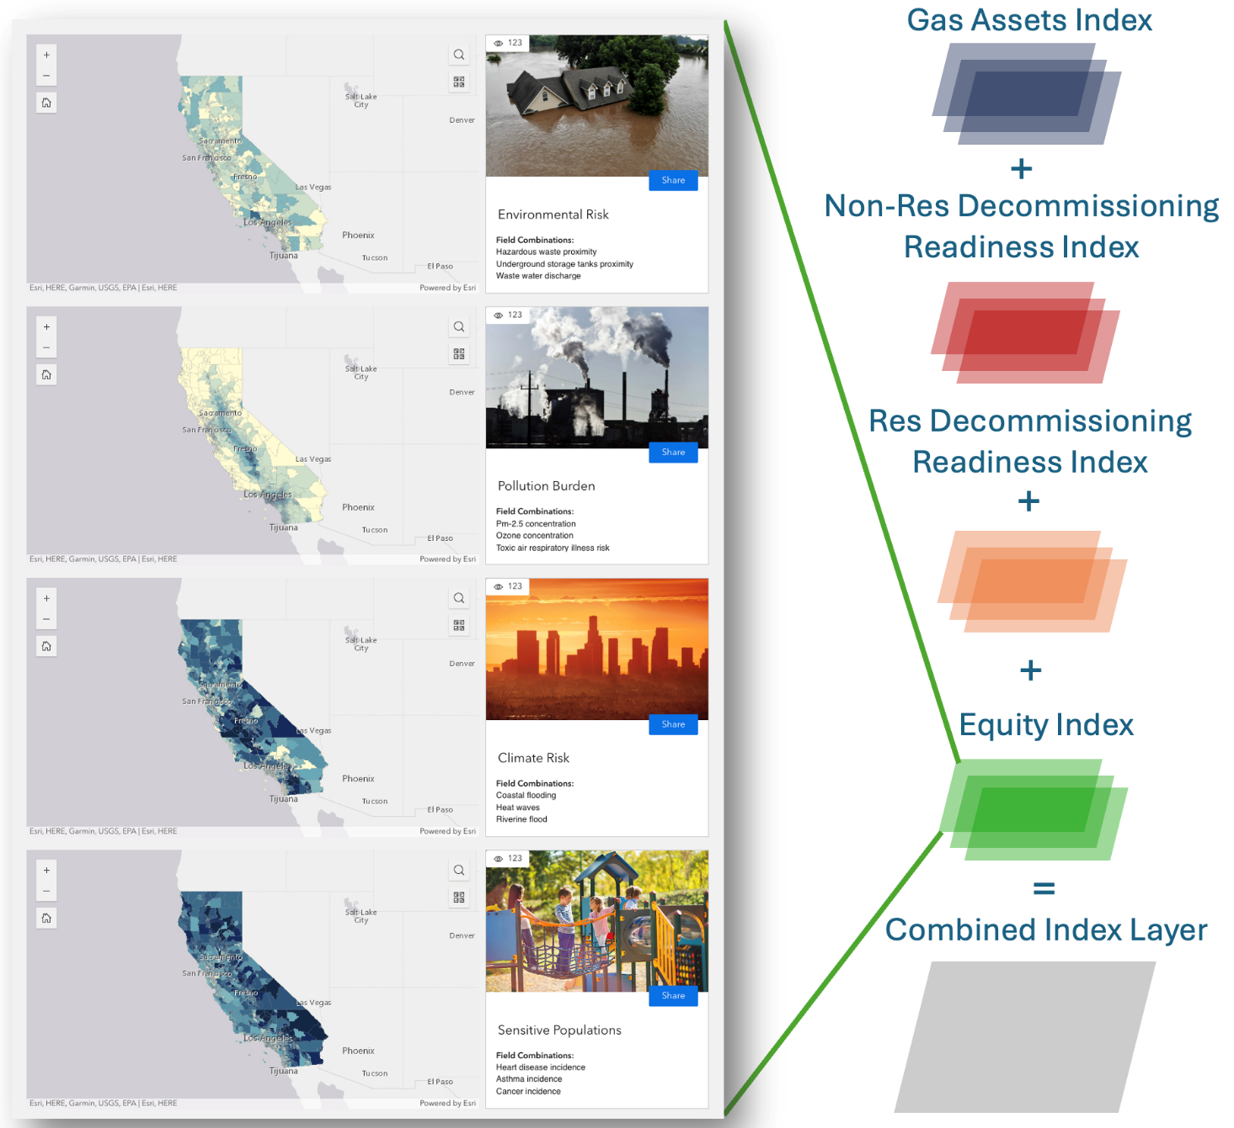
The default approach involves the application of a uniform weight to each index layer. The GIS-MCDA framework also allows stakeholders to assign different weights to secondary metrics to better reflect individual or community perspectives on their relative importance. When designing the structure of the (sub) indices, the team realized that there could be many possible permutations of weighted combinations of sub-indices. Rather than infer preferences for weighting combinations and pre-calculate them, the Tool includes computational tools that allows users to generate their own, bespoke, indices at either the index or sub-index levels based on individual or community preferences. Weights can be adjusted by multiplying the values for each sub-index by any integer value, including negative values. More details about the implementation of this solution are provided in the Data Driven Tool Memorandum, which is another deliverable of this project.
Indices (tertiary metrics) are useful for developing an overall sense of which locations are the most comprehensively suitable for the desired application when simultaneously considering multiple, potentially competing, issues of concern. This is particularly useful when none of the individual criterion involved with the site selection decision can be allowed to strictly dominate any or all other criteria. Having a single layer that provides a comprehensive overview can also be useful as an initial point of entry for stakeholders who may be familiar with some but not all the criteria of concern. These types of site-selection problems draw upon large numbers of heterogenous prioritization criteria and their associated primary data sets. Navigating the combined index layer, as a first experience with the Tool, can provide a useful initial introduction to both the way in which the problem has been framed and the various data sources which have been drawn together to support this framing.

Summary and Conclusion
This report detailed the development and implementation of indices and sub-indices to support the strategic and equitable decommissioning of gas infrastructure. The DNV team, in collaboration with the CEC and other stakeholders, created a comprehensive data-driven tool that integrates multiple sources of information to assess gas decommissioning risks, costs, and benefits.
The sub-indices were designed to summarize the variables collected from various tasks, including gas assets assessment, decommissioning readiness, and community resources and equitability assessment. These sub-indices were then aggregated into indices to provide an overall assessment. The methodology involved integrating data from multiple sources, collecting variables that reflect common themes, and combining them into index layers. These layers were then merged into a single composite index, with numerical scores assigned and normalized.
The Equity Index, was developed to prioritize California communities that are disadvantaged, underserved, at-risk, and most vulnerable to the impacts of early gas decommissioning. The Gas Assets Index focused on safety, environmental benefits, cost, regulatory compliance, and demand. The Non-Residential and Residential Decommissioning Readiness indices assessed the feasibility of disconnecting from gas service based on current consumption and the availability of alternative technologies.
The development of these indices and sub-indices provides a robust framework for evaluating the risks, costs, and benefits associated with gas decommissioning. The Tool offers a consistent set of data that can be used to make informed decisions about where and how to prioritize decommissioning efforts. By considering multiple factors and integrating diverse data sources, this approach ensures that decommissioning strategies are equitable, effective, and aligned with community needs and policy objectives.

References
“Algorithm AS 136: A K-Means Clustering Algorithm.” JSTOR, www.jstor.org/stable/2346830.
California Energy Commission. California Commercial End-Use Survey. 2019 vintage data. https://www.energy.ca.gov/data-reports/surveys/california-commercial-end-use-survey.
California Public Utilities Commission. Disaggregated IOU Customer Gas Demand Database. 2021 vintage data. Accessed via UCLA private database. Private database.
California Public Utilities Commission. “Long-Term Gas Planning Rulemaking (Closed).” CPUC, https://www.cpuc.ca.gov/industries-and-topics/natural-gas/long-term-gas-planning-rulemaking-closed.
California Public Utilities Commission. “Revised Gas System Data Ruling.” CPUC, https://www.cpuc.ca.gov/-/media/cpuc-website/divisions/energy-division/documents/natural-gas/long-term-gas-planning-oir/rulings/revisedgassystemdataruling09212022.pdf.
Federal Emergency Management Agency. National Risk Index: Data Resources. https://hazards.fema.gov/nri/data-resources. [hazards.fema.gov] Retrieved July 28, 2023.
Hartigan, J. A., and M. A. Wong. “Algorithm AS 136: A K-Means Clustering Algorithm.” Journal of the Royal Statistical Society: Series C (Applied Statistics), vol. 28, no. 1, 1979, pp. 100–108. Oxford University Press, doi:10.2307/2346830.
Jenks, George F. “The Data Model Concept in Statistical Mapping.” International Yearbook of Cartography, vol. 7, 1967, pp. 186–190.
Malczewski, Jacek, and Claus Rinner. Introduction to GIS-MCDA. Multicriteria Decision Analysis in Geographic Information Science, Springer, 2015, pp. 23–54.
McMillan, Colin, and Vinayak Narwade. United States County-Level Industrial Energy Use. National Renewable Energy Laboratory, 2018. Updated 22 July 2025. https://data.nrel.gov/submissions/97.
Office of Environmental Health Hazard Assessment. CalEnviroScreen 4.0 Data Dictionary. https://oehha.ca.gov/media/downloads/calenviroscreen/document/calenviroscreen40resultsdatadictionaryf2021.zip. Retrieved July 28, 2023
U.S. Census Bureau. American Community Survey 5-Year Estimates Data Profiles, 2022. https://data.census.gov/table?g=040XX00US06$1400000&y=2022&d=ACS+5-Year+Estimates+Data+Profiles. Accessed March 11, 2025.
U.S. Department of Agriculture, Economic Research Service. Food Access Research Atlas. https://www.ers.usda.gov/data-products/food-access-research-atlas. Retrieved March 11, 2025.
U.S. Department of Energy. Low-Income Energy Affordability Data (LEAD) Tool. Office of State and Community Energy Programs, https://www.energy.gov/scep/slsc/lead-tool. Retrieved July 28, 2023.
U.S. Energy Information Administration. 2022 Manufacturing Energy Consumption Survey: Highlights from Data Releases 1 & 2. U.S. Department of Energy, 2025. https://www.eia.gov/consumption/manufacturing/data/2022/pdf/MECS%202022%20Release%201-2%20Results.pdf.
U.S. Environmental Protection Agency. Download EJSCREEN Data. EJSCREEN: Environmental Justice Screening and Mapping Tool, https://www.epa.gov/ejscreen/download-ejscreen-data. (No longer available). Retrieved July 28, 2023.
University of Michigan Institute for Social Research. National Neighborhood Data Archive (NaNDA). Inter-university Consortium for Political and Social Research, https://www.icpsr.umich.edu/web/ICPSR/studies/38605. Retrieved March 11, 2025.

Network Diagram Depicting the Mapping of Variables to Sub-indices and Indices
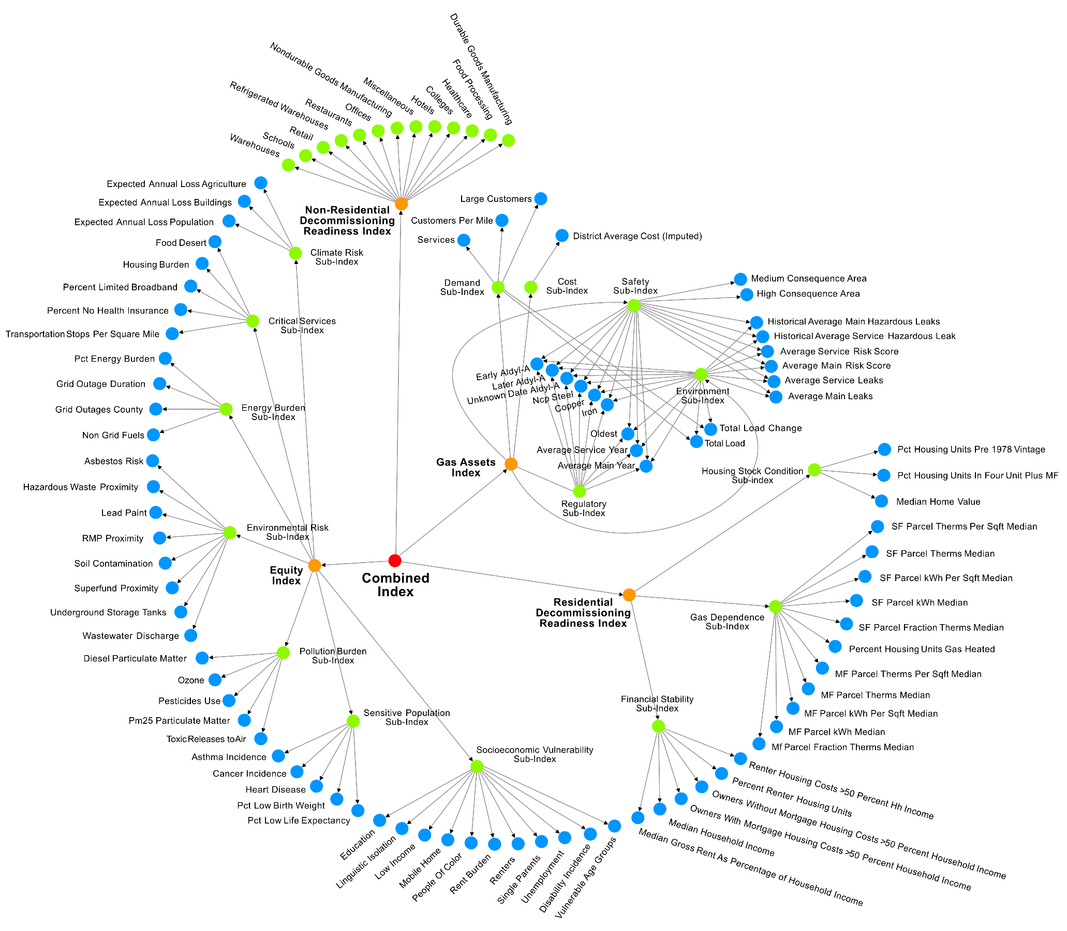
This network diagram depicts the hierarchical structure of the multi-level index dataset developed for use in the tool.
It illustrates the mapping of indices (orange) to sub-indices (green) as well as from sub-indices to component variables (blue).

Weighting Coefficients – Detailed Tables

Commercial Sectors
End-Use Category | Weight | Justification | Sources
Space Heating & Cooling | 1 | Comparable heating technology such as mini split heat pumps and ducted heat pumps are readily available. Costs can be marginally higher for this equipment. Output is the same and can also compensate for cooling technology. There are no restricted industry norms or standard practices. Contractors are offering this, and state policy offers incentives to contractors and business owners. | California Energy Codes and Standards Cost-Effectiveness Studies 2022 Nonresidential New Construction and Existing Building Reports  https://opiniondynamics.com/wp-content/uploads/2022/06/OD-CPUC-Heat-Pump-Market-Study-Report-f.pdf
Water Heating | 1 | Widely available electric-based technology alternatives. Heat pumps can be used for low-temperature water applications, while resistance-based systems can be used for higher temperature water requirements. | California Energy Codes and Standards Cost-Effectiveness Studies 2022 Nonresidential New Construction and Existing Building Reports  https://www.energy.ca.gov/publications/2021/demonstration-high-efficiency-commercial-cooking-equipment-and-kitchen
Cooking | 2 | Commercially ready, offered by contractors, rebates available, and offered in stores. Though the cost of these appliances is significantly higher than natural gas cooking appliances. Industry norms lean towards using natural gas cooking appliances due to perception that they are 'better for cooking' and have more heat control, though manufacturers claim they have comparative performance to gas power cooking equipment. | California Energy Codes and Standards Cost-Effectiveness Studies 2022 Nonresidential New Construction and Existing Building Reports  https://www.energy.ca.gov/publications/2021/demonstration-high-efficiency-commercial-cooking-equipment-and-kitchen  https://caenergywise.com/instant-rebates/
Miscellaneous | 1 | The equipment from four of the six "Miscellaneous" sub-categories are entirely electric by default due to the adaptability and mobility required by the industries in which they are most commonly used. Of the equipment in the remaining two sub-sectors, there are also commercially available electric alternatives for each, however industry norms, cost considerations, and concerns over efficiency are the primary roadblocks to complete electrification. | CEUS 2006 Appendix C
Process | 2 | Though the equipment categorized under "Process" encompasses many industries, much of the equipment is known to be electrifiable, if not already electrified. Process natural gas usage outside of cooking equipment applies to only a small pool of industrial activities that are classified under the commercial sector. The cooking equipment already has commercial alternatives that are readily available, though, as mentioned above, industry norms lean toward using natural gas for certain processes. Most of the remaining equipment borders on industrial process equipment that has been augmented or adapted to operate in mostly electrified commercial office settings. However, there do remaining a few pieces of equipment that are not currently electrifiable, given the energy intensity of said equipment. | CEUS 2006 Appendix C

Manufacturing, Industrial, and Mining Sectors
End-Use Category | Weight | Justification | Sources
CHP & Cogeneration Process | 2 | Combined heat and power (CHP) or cogeneration processes produces electricity and thermal energy generally from natural gas. Alternatives to a CHP plant running off natural gas is an all-electric central heating and cooling plant or potentially replacing the fuel with hydrogen or biofuels as they become more available. The all-electric option requires fundamentally changing the source of electricity for the facility and has consequences to the thermal energy products, but it is generally possible to implement. On-site renewable energy and storage is another option. Hydrogen fuel is not yet available at the scale needed and there are many remaining questions about the distribution of the fuel. | https://alumni.berkeley.edu/california-magazine/2023-spring-summer/berkeley-goes-all-electric-as-part-of-ambitious-clean-energy-campus-plan/
Conventional Boiler Use | 1 | Electric boilers are cheaper than combustion boilers and more efficient. However, higher cost of electricity than gas overcomes the upfront savings and efficiency gains. The primary barrier to electrification for boilers is the cost. | https://www.globalefficiencyintel.com/electrification-of-boilers-in-us-manufacturing
Conventional Electricity Generation | 1 | In conventional power plants that combust natural gas, steam is generated and fed to a turbine, which converts the heat energy to mechanical energy that in turn is converted to electrical energy. Manufacturing facilities would either need to purchase electricity from their utility or develop renewable energy resources, which poses temporal limitations and different land needs. | https://www.sandia.gov/ess-ssl/wp-content/uploads/2018/08/2017_EESAT_Proceeding_Jacobs.pdf
Facility HVAC | 1 | Electric HVAC systems are readily available. Upfront costs are higher for electric systems but come with significant efficiency gains. | https://www.achrnews.com/articles/147247-commercial-hvac-retrofits-can-electrify-the-bottom-line
Machine Drive | 1 | This includes motors, pumps, etc. associated with manufacturing process. Electric motors are widely used in the industrial sector. In total, electricity powers about 89% of motors in manufacturing. | https://www.energy.gov/eere/ammto/articles/get-your-motor-running-next-generation-electric-machines  https://www1.eere.energy.gov/manufacturing/tech_assistance/pdfs/motor.pdf  https://www.eia.gov/todayinenergy/detail.php?id=13431  https://ieeexplore.ieee.org/document/7732552
Onsite Transportation | 1 | Battery electric forklifts and other forms of onsite transportation have been used commercially for decades. | https://dof.ca.gov/wp-content/uploads/sites/352/2023/04/ZE-Forklift-SRIA-to-DOF.pdf
Other Facility Support | 1 | In the MECS survey, the examples of “Other Facility Support” include cooking, water heating, and office equipment, all of which have readily available electric alternatives. | https://www.eia.gov/survey/form/eia_846/proposed/2022/form.pdf
Other Non-Process Use | 1 | Minimal information is provided about what is included in “Other Non-Process Use” in the survey form. The form describes the non-process section as including usage for facility lighting and space-conditioning equipment (HVAC). Electrification is relatively simple and feasible for both.
Other Process Use | 3 | Technologies to electrify process non-heating uses of gas are still being developed and have not achieved a high readiness state at this time. | https://www2.deloitte.com/cn/en/pages/consumer-industrial-products/articles/electrification-in-industrials.html  https://ipu.msu.edu/wp-content/uploads/2018/04/LBNL-Electrification-of-Buildings-2018.pdf  https://betterbuildingssolutioncenter.energy.gov/better-plants/process-cooling-and-hvac
Process Cooling and Refrigeration | 1 | Electric heat-pump based cooling technologies are readily available for a wide variety of Process Cooling and Refrigeration applications. | https://esource.bizenergyadvisor.com/article/electric-chillers
Process Heating | 3 | Technologies to electrify Process Heating uses of gas are still being developed and have not achieved a high readiness state at this time. | https://www.energy.gov/eere/iedo/decarbonizing-process-heat  https://ipu.msu.edu/wp-content/uploads/2018/04/LBNL-Electrification-of-Buildings-2018.pdf
Electro-Chemical Processes | 3 | There are studies citing the transition for gas as feedstock and energy source to recycled hydrogen for Electric-Chemical Processing. However, the technologies are still very early in the stage of development and have not been implemented. Additionally, implementation is contingent on the wide availability of hydrogen. | https://www.sciencedirect.com/science/article/pii/S2211339817300977

Malczewski, Jacek, and Claus Rinner. "Introduction to GIS-MCDA." Multicriteria decision analysis in geographic information science. Berlin, Heidelberg: Springer Berlin Heidelberg, 2015. 23-54.
Hartigan, J. A., & Wong, M. A. (1979). Algorithm AS 136: A K-Means Clustering Algorithm. Journal of the Royal Statistical Society: Series C (Applied Statistics), 28(1), 100–108. Oxford University Press.
Jenks, George F. 1967. "The Data Model Concept in Statistical Mapping", International Yearbook of Cartography 7: 186-190.
Algorithm AS 136: A K-Means Clustering Algorithm on JSTOR
https://www.cpuc.ca.gov/industries-and-topics/natural-gas/long-term-gas-planning-rulemaking-closed
https://www.cpuc.ca.gov/-/media/cpuc-website/divisions/energy-division/documents/natural-gas/long-term-gas-planning-oir/rulings/revisedgassystemdataruling09212022.pdf
https://www.epa.gov/superfund/what-superfund
https://www.cpuc.ca.gov/industries-and-topics/natural-gas/long-term-gas-planning-rulemaking-closed
https://www.cpuc.ca.gov/-/media/cpuc-website/divisions/energy-division/documents/natural-gas/long-term-gas-planning-oir/rulings/gassystemdataruling03012022.pdf
https://www.cpuc.ca.gov/-/media/cpuc-website/divisions/energy-division/documents/natural-gas/long-term-gas-planning-oir/rulings/revisedgassystemdataruling09212022.pdf
SF & MF: single-family and multi-family residential parcels

