Gas Assets Assessment Data Collection and Analysis Memorandum

December 2025

- This research is funded by the California Energy Commission (CEC) through the Gas Research and Development Program, which invests in innovations to support the gas sector transition and cost-effective achievement of the state’s clean energy and climate goals.
- The research project, PIR-22-002, aims to provide state agencies, local governments, investor-owned utilities (IOUs), and other stakeholders with a data-driven approach to screen for promising sites for decommissioning specific segments of California’s gas system through a map-based tool that leverages gas system data and publicly available community data.
- This memo and data here within are being shared to support transparent and timely consideration of interim deliverables that are relevant for energy stakeholders and all those interested in California’s public interest gas decommissioning research.

This interim deliverable is submitted to the CEC by DNV GL USA, Inc. The memo meets deliverable requirements under Task 2 of the California Energy Commission’s Project PIR-22-002: Mindful Decommissioning - Development of a Data-Driven Tool to Support Strategic and Equitable Decommissioning of Gas Infrastructure.

Table of Contents
1 Introduction 1
1.1 Project Timeline 1
1.2 Report Organization 2
2 Data Exploration to Characterize Gas Assets 3
2.1 Planning and Literature Review 3
2.2 Planning Phase: Engagement with Technical Advisors 4
2.3 Stakeholder Engagement Log 6
2.4 Data Requests and Outcomes 7
3 Data Development and Index Construction 8
3.1 Gas Assets Characteristics 8
3.2 Data Preparation and Imputation 9
3.3 Index and Sub-Index Construction 11
3.4 Tool Refinement Phase: Engagement with Technical Advisors 13
3.5 Finalizing the Gas Assets Index Scores 15
3.6 Gas Index and Sub-Index Data Summaries 16
4 Summary and Conclusions 22
4.1 Approach to Gas Assets 22
4.2 Areas for Future Research 22
Appendix A. Literature Review A-1
Appendix B. Gas Assets Assessment Coordination Log B-1
Appendix C. Box Plots C-1

Figures

Figure 1-1. Mindful Gas Decommissioning Project Timeline 1
Figure 2-1. Characteristics Considered for Gas Assets Assessment 6
Figure 3-1. Gas Assets Sub-Indices in Gas Distribution System Decommissioning Screening Tool 8
Figure 3-2. Gas Assets Decommissioning Characteristics Grouped by Sub-Index 9
Figure 3-3. Gas Assets Safety Sub-Index Map and Distribution 17
Figure 3-4. Gas Assets Environment Sub-Index Map and Distribution 18
Figure 3-5. Gas Assets Cost Sub-Index Map and Distribution 19
Figure 3-6. Gas Assets Regulatory Sub-Index Map and Distribution 20
Figure 3-7. Gas Assets Demand Sub-Index Map and Distribution 21

Tables
Table 2-1. Gas Assets Decommissioning Literature Review 3
Table 2-2. August 2023 TAC Attendees 5
Table 3-1. Variables to Sub-Indices Mapping for the Gas Assets Index 11
Table 3-2. July 2024 TAC Attendees 13
Table 3-3. Influence of TAC on Tool Design 13
Table 3-4. Gas Assets Change Log 15

Introduction
Decarbonization of the State of California’s energy system requires the drawdown of emissions from the use of natural gas, promoting behavioral shifts in energy usage, and expanding access to carbon-free energy. Technological barriers to decarbonizing energy resources have been largely overcome. Data-driven tools can assist policymakers and stakeholders with strategically prioritizing decommissioning natural gas assets to address remaining political, social and techno-economic barriers. This project’s goal was to develop such a tool using data collected through CEC’s existing programs, public data sources, and data collected in partnership with IOUs, municipalities, and other stakeholders.
The Gas Distribution System Decommissioning Screening Tool (“the Tool”) developed through this project provides a powerful means to assess the statewide impact of policy decisions on risks and benefits of natural gas decommissioning. The Tool was designed to readily prioritize locations for more detailed analysis, whether to target geographies of interest that provide the most immediate benefit or understand risk factors for those more challenging to decarbonize. The purpose of this Gas Assets Assessment Data Collection and Analysis Memo is to describe and summarize results and lessons learned from the tasks performed to collect, assess and analyze the data that were used to develop the Gas Assets Index and sub-Indices that are integrated into the Tool.

Project Timeline
This project started in Q4 of 2022 and, as shown in Figure 1-1, was completed in the following three phases:
- Planning & Data Collection
- Beta Tool Development & Refinement
- Case Study Engagement, Resource Hub & Feedback
The dark blue bar at the bottom of the figure shows that the project team elicited community and stakeholder feedback throughout the project. The team also integrated the emerging policy context related to Long-Term Gas Planning (R. 20-01-007, R. 24-09-012, and SB-1221 implementation) into planning, data collection, and Tool development where relevant and feasible. This report identifies the various ways in which stakeholder input was sought and incorporated into the development of the Gas Assets Index and sub-indices.
Figure 1-1. Mindful Gas Decommissioning Project Timeline
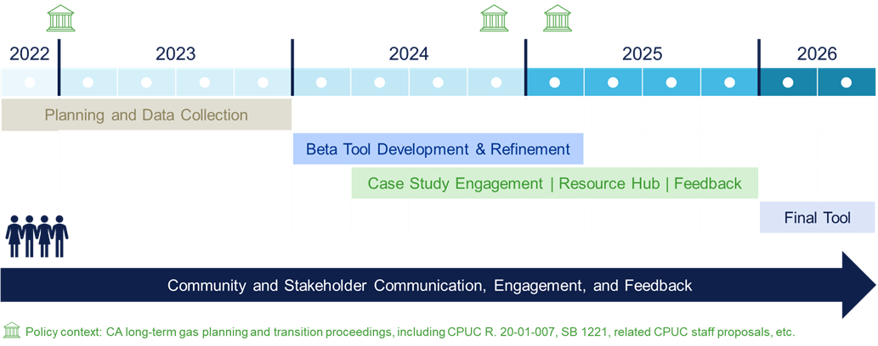

Report Organization
The report is organized as follows:
- Section 2: Data Exploration to Characterize Gas Assets describes the process undertaken to identify the characteristics for inclusion in the Gas Assets Index and sub-indices, including tasks undertaken to engage stakeholders in sourcing data and validating the approach.
- Section 3: Data Development and Index Construction describes the tasks undertaken to work with the sourced data to define the Gas Assets Index and sub-indices and to validate the Tool with stakeholders.
- Section 4: Summary and Conclusions summarizes results and lessons learned in developing the Gas Assets Index and sub-indices, including recommendations for future Tool development.

Data Exploration to Characterize Gas Assets
This section provides an overview of the process undertaken to identify the characteristics for inclusion in the gas assets index, including activities undertaken to engage stakeholders in sourcing data and validating the approach. The section is organized as follows:
- Section 2.1 Planning and Literature Review
- Section 2.2 Planning Phase: Engagement with Technical Advisors
- Section 2.3 Stakeholder Engagement Log
- Section 2.4 Data Requests and Outcomes

Planning and Literature Review
During the several months of the project, the Gas Assets Research Team (“Gas Asset Team”) completed a review of literature relating to gas assets infrastructure and decommissioning. Table 2-1 lists the studies that were reviewed, indicating who authored the study and in what year, with a brief description of the study. A more comprehensive description of the studies is included in Appendix A: Literature Review.
Table 2-1. Gas Assets Decommissioning Literature Review
Study Name | Authors | Study Description
Gas Decarbonization in California – Building Electrification’s Expected Impacts on Gas System Throughput and Hydraulic Analysis Methodologies | R. Brown and K. Lee, Pipeline Simulation Interest Group, Paper No. 2220 (2022) | Documents one of the first data-driven approaches to assessing the suitability of portions of the gas pipeline infrastructure for decommissioning based on operational concerns, ratepayer impacts, and hydraulic feasibility. At the time of publication in 2022, most discussions on gas transition were conceptual or policy-oriented. This paper stands out because it applies engineering-based hydraulic modeling and cost criteria to identify candidate areas for decommissioning, rather than relying solely on qualitative frameworks.
Strategic Pathways and Analytics for Tactical Decommissioning of Portions of Gas Infrastructure for Northern California: Pilot Site Selection Framework and Preliminary Results | Energy and Environmental Economics (E3), (November 2022) | Development of a pilot site selection framework for identifying priority geographies that could be feasibly and beneficially decommissioned in the near-term time frame of 3-15 years.
Natural Gas Ratepayer Impact Memo | RAND (September 2022) | Study demonstrating the need for long-term decommissioning planning and analysis of system hydraulics to minimize downstream impacts.
Pipeline Abandonment Assumptions – Technical and Environmental Considerations for Development of Pipeline Abandonment Strategies | Canadian Energy Pipeline Association (2007) | Summary pipeline abandonment matrix, that assesses the most appropriate methods for abandoning pipelines based on their size and features of their location
Pipeline abandonment: a discussion paper on technical and environmental issues | Issued jointly by the Canadian Association of Petroleum Producers, Canadian Energy Pipeline Association and the Alberta Energy and Utilities Board (1996) | Reviews the technical and environmental issues associated with pipeline abandonment and is intended to provide a basis for further discussion on the issue.... This paper is intended to assist a company in the development of an abandonment plan through the recognition of the general issues which result from the abandonment of a pipeline and by providing the means to address those issues.
Pipeline Abandonment Scoping Study | Prepared by DNV for the National Energy Board (NEB), in collaboration with TERA Environmental Consultants and BCG Engineering (November 2010) | Data and guidance as well as local ordinances, codes, and regulations regarding pipeline abandonment costs and risks.
Future Regulatory Decisions on Natural Gas Networks: Repurposing, Decommissioning and Reinvestments | Prepared by DNV for the European Union Agency for the Cooperation of Energy Regulators (ACER), (October 2022) | Focuses on decommissioning options and alternatives that may be pursued as a consequence of energy decarbonization in Europe.
In addition to the literature review, the Gas Assets Team completed a review of data sources and models available through regulatory proceedings, government agencies, and the utilities’ asset management tools. Sources reviewed include:
- CPUC Long-term Gas Planning Rulemaking (R.20-01-007 – closed). Resources include Gas System Census Tract Data from four Gas IOUs.
- Future Natural Gas Consumption and Price Forecasts. Forecasting of potential changes in energy costs, as well as projections of population growth, across the different localities within the state of California. Sourced from literature as well as public documents produced by state and/or energy agencies.
- Greenhouse Gas Emissions (including Methane). GHG emissions data pertaining to natural gas consumption (on-site combustion) and methane emissions. Sourced from publicly available datasets (CPUC, EPA, CARB, IOUs, local municipalities).
- Hydraulic Feasibility Scoring for Synergi Models (DNV-developed model). In Q3 of 2023, the Gas Assets Team collected and cleaned data and completed some test projects to assess how to use Synergi Gas (DNV’s software system that many gas utilities use for asset management) to evaluate and model the gas network system and score it according to how easily it could be decommissioned based on hydraulic analyses.

Planning Phase: Engagement with Technical Advisors
In August 2023, the DNV and UCLA teams hosted the first of two meetings with the project’s Technical Advisory Committee (TAC). Attendees and project team members present at this TAC meeting are listed in Table 2-2.
Table 2-2. August 2023 TAC Attendees
TAC Member Attendees | CEC Attendees | DNV and UCLA Team
Jacques de Chalendar (Stanford Univ.)  Ari Gold-Parker (E3  Eileen Hlavka (CPUC)  Narasi Sridhar (Ohio State Univ.)  Kiki Velez (NRDC) | Martine Schmidt Poolman (CAM)  Mithra Moezzi  Jason Orta | DNV:  Chris Taylor  Cici Vu  Jacob Moul  Steven Chang  Alex Brust  UCLA:  Stephanie Pincetl  Eric Fournier
The discussion of gas assets at the first TAC covered the following areas:
- Evaluating the state of the gas network. This involved looking at the risks, benefits, and costs associated with decommissioning the gas network. For example, financial risks from reduced ratepayer base due to fuel switching, and intersectionality of decommissioning with local ordinances and obligations. A benefit from decommissioning a segment of pipeline would be a reduction of burden of operations, replacement, and repair. Furthermore, decommissioning can reduce risks from failures, not only health and safety risks, but also the greenhouse gas emission risks associated with pipe leaks and maintenance operations.
- Categorizing the data. Costs that the team considered included costs to de-inventory assets and manage waste, recycling, reuse, and disposal. Potential data sources, identified from planning and literature review, were categorized to address considerations including hydraulic feasibility, avoided costs, reduction in revenue, pipeline integrity, and environmental benefits.
- Tackling hydraulic feasibility. The team developed metrics based on analysis of a portion of the gas network using DNV’s Synergi Gas pipeline network modeling software. The hydraulic model of a gas network is based on the pressure and velocity of gas, the diameters and materials of construction of the pipes, and flow control systems (like regulators and valves). Decommissioning the network requires an understanding of how gas moves through the system. While gas is still serving some number of customers on a network, it is necessary for the IOUs to ensure that, on a peak usage day, all the customers can get the gas that they need. For example, gas-delivery networks often have “dead ends”, think of a residential street, for example, and this may suggest that it could be an integral unit that could be shut off and decommissioned without significantly affecting other areas nearby. Assessing hydraulic feasibility statewide requires access to gas network models which are private data owned by the state’s Gas IOUs.
Reviewing gas system census tract data. The team reviewed the census tract data provided by the IOUs through the CPUC Long-term Gas Planning Rulemaking. The data was reviewed for format and completeness and then analyzed to determine which fields would be useful for decommissioning, such as presence of significant quantities of Aldyl A (which is a type of pipe that is being replaced over time), or areas where there are significant leaks.
At the TAC meeting, the team presented Figure 2-1 showing a cluster of gas system characteristics that were being considered and pursued for inclusion in the Gas Assets Index to assess risks, benefits, and costs of decommissioning. These included:
- Avoided costs: facilities, planned replacements, integrity risks
- Revenue reduction: customer data, natural gas prices, population growth
- Abandonment costs: alternative use cases, land use/ownership, process costs, maintenance
- Stranded assets: amortization, policy
- Pipeline integrity forecasts: threats, historical data
- Environmental benefits: GHGs, pollutants, methane releases
Hydraulic feasibility analysis: hydraulically independent system (HIS) analysis
Figure 2-1. Characteristics Considered for Gas Assets Assessment
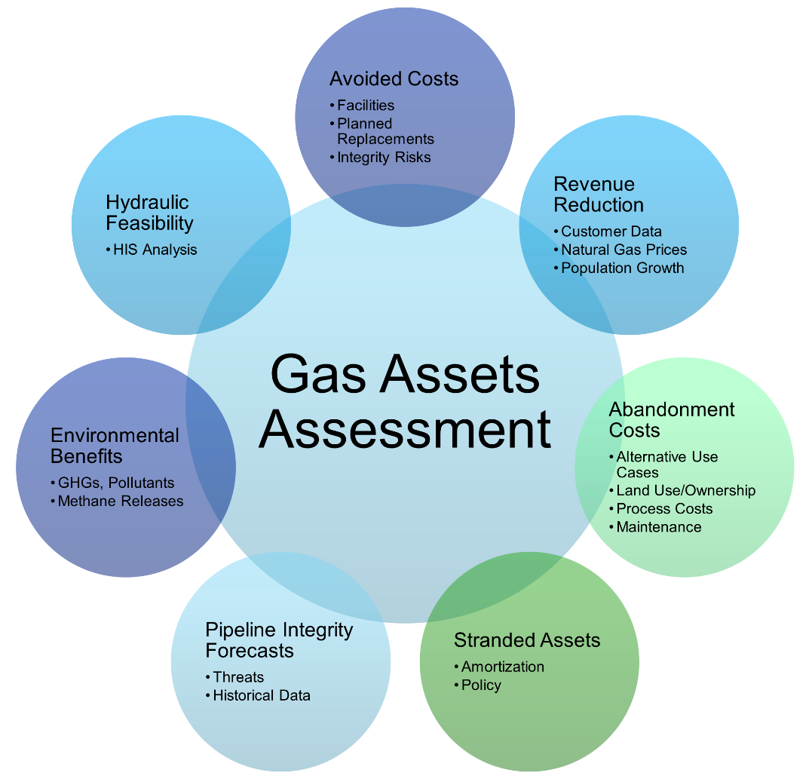

Stakeholder Engagement Log
In the Planning and Data Collection project phase, in addition to hosting the first TAC in August 2023, the research team held meetings and project briefing sessions with other stakeholders including gas IOUs, renewable energy networks (RENs), and community choice aggregators (CCAs). The agenda and goal for all meetings were to provide an overview of the project, introduce the project team, and to discuss opportunities for collaboration, with focus on data sourcing and future engagement opportunities. The conversations were used to inform a request for asset-level data described in the following section. The research team also compiled an outreach database with names and contact information which was used for inviting stakeholders to the two community workshops and the public showcase webinar. More information on these project activities is available in the Community Resources and Equitability Assessment Deliverable. Appendix B. Gas Assets Assessment Coordination Log includes a log of stakeholders with whom meetings were held in the Planning and Data Collection project phase, which is shared to provide the CEC with awareness of stakeholders who were informed of the project activities.

Data Development and Index Construction
This section identifies the data included in the Gas Assets Index in the Tool, and the data development activities over the second year of the project. It is organized as follows:
- Section 3.1 Gas Assets Characteristics
- Section 3.2 Data Preparation and Imputation
- Section 3.3 Index and Sub-Index Construction
- Section 3.4 Tool Refinement Phase: Engagement with Technical Advisors
- Section 3.5 Finalizing the Gas Assets Index Scores
Section 3.6 Gas Index and Sub-Index Data Summaries

Gas Assets Characteristics
The Tool uses Gas System Census Tract Data as provided by utilities to the R.20-01-007 service list on November 4, 2022, in compliance with the Long-Term Gas Planning Rulemaking. Building on the characteristics considered for gas assets assessment that were identified through literature review and exploration of available data, the gas system data were mapped to five gas assets sub-indices, shown in Figure 3-1, and listed here with what each is designed to measure:
- Safety: risk of gas leaks, explosions, fires, and other hazards associated with the gas distribution pipelines
- Environment: environmental benefits and impacts associated with gas distribution pipelines, such as greenhouse gas (GHG) emissions that could be avoided through decommissioning
- Cost: cost avoidance associated with gas decommissioning in an area, which would include costs for maintaining or replacing an aging pipeline
- Regulatory Compliance: regulatory compliance and alignment associated with gas decommissioning in an area
Demand: gas demand reduction and customer impact associated with gas decommissioning in an area
Figure 3-1. Gas Assets Sub-Indices in Gas Distribution System Decommissioning Screening Tool
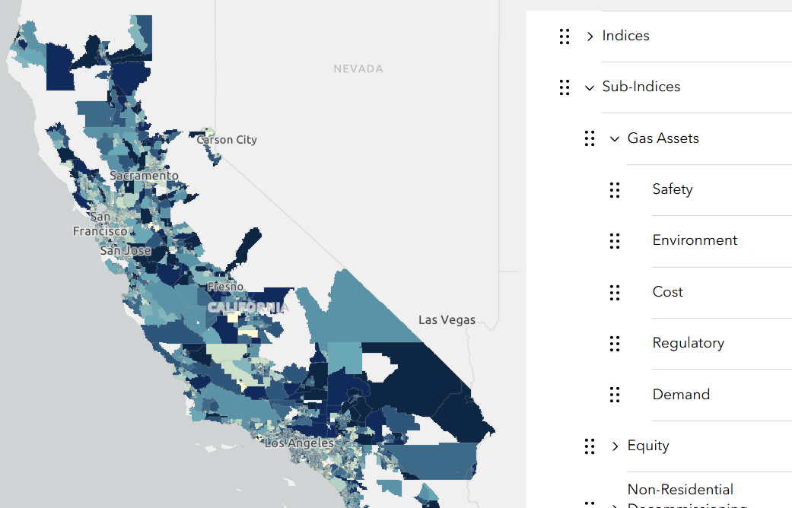
The five sub-indices were selected based on an iterative process, which started with the literature review, engagement with stakeholders, and summary of characteristics for gas assets assessment (see Figure 2-1), which were described earlier in Section 2: Data Exploration to Characterize Gas Assets.
The final structure for the indices is shown in Figure 3-1, which shows a mapping of gas assets sub-indices (in green) to characteristics (in dark blue). For example, the Gas Assets Safety sub-index shows five characteristics that influence pipeline safety and associated decommissioning benefits and risks: Pipeline Leaks, Pipeline Risk, Pipeline Age, Pipe Materials, and Customer Proximity. In simple terms, pipes that are likely to leak can endanger people's safety, and this danger grows when there are more customers nearby.
Figure 3-2 evolved over the course of the project. The figure was revised over the course of the Tool Development and Refinement phase of the project, as it became apparent the full range of data available to develop the Gas Assets Index. The next section describes more about the available data, decisions on which data to use, and actions taken to fill gaps where possible.
Figure 3-2. Gas Assets Decommissioning Characteristics Grouped by Sub-Index

Data Preparation and Imputation
As previously noted, gas system census tract data were downloaded from the four gas utilities the Long-Term Gas Planning Rulemaking R.20-01-007 website (Long-Term Gas Planning Rulemaking (ca.gov)). Each IOU provided the data in a tabular format, typically as a comma-separated value file or Excel workbook. Data among the four IOUs are all somewhat different from one another, requiring some basic data cleaning to apply consistent column formats across all four IOUs. For example, two IOUs reported Load Change with the “%” sign while the other two did not (“32%” vs “32”). Similarly, PG&E’s file has a column called “PeakLoad” whereas SCG’s file had a column called “Peak Load”.
The next step involved standardising all representations of missing values to ensure consistency in the dataset. Specifically, the team encountered values such as "REDACTED" or "DataUnavailable" throughout all four IOUs' data and replaced such values with an empty value. Next, SDG&E’s data contained census tract IDs in a short-hand format that was inconsistent with other IOUs, so the team converted those values to the standard census tract format. Finally, the team ensured all common columns were the same data type to concatenate all four data files into a single table. This way, the team could ensure consistency when importing the data into analytical tools (e.g., R, Python, ArcGIS).
After cleaning and normalizing the data, the research team created box plots and summary tables for all variables. Box plots are powerful tools for visually summarizing and comparing the distribution of many variables at once. Using this visualization approach, the research team could quickly see discrepancies between IOUs. Box plots for the compiled dataset are included in Appendix C. As one example of a finding from review of the box plots: PG&E calculates the Consequence of Failure in terms of per 100,000 leaks whereas the other IOUs do not. The Consequence of Failure is used to calculate other fields such as the Average Service Risk Score, leading to different scales of the same field for different IOUs. The research team could also quickly see which IOUs did not provide data for a particular field. For example, only PG&E provided data for Average Service Risk and as a result, that field is not used in the MCDA model. After completing this process, the team identified a subset of fields to potentially incorporate in the analysis. The types of data available span:
- General geographic based gas system data
- Non-geographic based gas system data (e.g., miles of pipe)
- Customer data (e.g., customer counts, customer types, usage)
- Integrity management and facility integrity risks
- Future planned replacements
Rate case proposed or approved programs to replace pipe or other gas facilities
Most variables were included in the model without transformation to build the indices. There are several exceptions in which variables were transformed in some way before being included in the model. These exceptions include:
- Pipe Materials: six pipe material variables in the IOU data were summed to create a single ‘Pipe Materials’ variable, which was included in the K-Means value scaling model.
- Customers per Mile: to represent the number of customers served by a mile of gas distribution system pipeline, the customer count was divided by the number of miles of gas distribution system mains and services.
District Average Cost (DistAvCost): The PG&E DistAvCost field was included directly in the model, but due to data gaps, the DistAvCost field was imputed for SCG, SDG&E, and SWG. The derivation of this cost field is described below.
DistAvCost was the best proxy for pipeline replacement cost identified in our review of available data. The column description for DistAvCost describes the field as the average cost per mile to replace distribution pipeline in an Operating District (units: $/mile). The definition of Operating District (field “OpDist”) varies by gas utility as follows: Division (PG&E), Operating District (SoCalGas), Construction and Operations Center serving the census tract (SDG&E), or Jurisdiction (SW Gas). The documentation also noted that since average is calculated across the Operating District, many tracts would have the same value of DistAvCost. Upon examination of this field, the team found that only PG&E’s DistAvCost contained data with sufficient variation to include in the model (i.e., SWG submitted data but only two values representing all operating districts; SDG&E submitted a single rate case value; SoCalGas left the field blank).
Using PG&E’s DistAvCost, the research team was able to impute DistAvCost for the other gas utilities using fields that were more reliably populated for all utilities. The team utilized a regression-based approach, fitting a multivariate Ordinary Least Squares (OLS) model on known data and then using this model to predict DistAvCost for census tracts where it was missing. A multivariate OLS model quantifies the relationship between one dependent variable and multiple independent variables, resulting in an equation of the form $y=αX_{1}+ βX_{2}+…+ δX_{n}+C$. The resulting equation can then be used to predict $y$ for different values of $X_{1},X_{2},…, X_{n}$, and will also provide associated prediction errors.
The team completed this analysis in several steps: (1) variable selection, (2) model fitting, and (3) imputation. In step (1), the team first created a model that fit DistAvCost against all available variables. Any variable in this initial model that had a statistically significant coefficient—indicating a strong relationship with DistAvCost—formed a preliminary set of predictor variables. The team then removed variables from this set that were highly correlated with each other, using 0.75 as a threshold for the absolute value of the correlation score between two predictors. The research team also removed variables from this set that were mostly or entirely missing for the other IOUs. Next, the team fit one more regression model on DistAvCost against the remaining set of variables and then removed any variables that were no longer statistically significant (the statistical significance of independent variables in a multivariate model can change based on the addition or removal of other predictors in the model because of correlation between these variables). Any variables that remained after the selection process became the predictor variables in our OLS imputation model. The final OLS model had an $R^{2}$ value of 0.924, indicating high predictive power.
In step (2), the team used the final set of predictor variables from step (1) and created an OLS model, fitting the equation $DistAvCost \sim Diam2OrLess+ Diam2to4+ Diam8to12+DiamOver12+DiamUnk+AvMainPressure+AvMainConsq+AvServiceYear+MainValves+Oldest$. In step (3), the team fed these variables from the other IOUs into the OLS model to predict DistAvCost for census tracts where it was missing.

Index and Sub-Index Construction
A mapping of gas assets sub-indices to characteristics and variables, with definitions, is shown in Table 3-1 below. As with the data, all variable definitions are sourced from Selected Rulings from the Long-Term Gas Planning Rulemaking (R.20-01-007), with most described in the March 1, 2022, Gas System Data Ruling and supplemental variables described in the September 21, 2022, Revised Gas System Data Ruling.
Table 3-1. Variables to Sub-Indices Mapping for the Gas Assets Index
Sub-Indices | Characteristic | Variable Descriptions
Safety, Environment, Regulatory | Pipeline Age | - AvMainYear: Year pipeline was installed, averaged across distribution main pipeline miles  - AvServiceYear: Year pipeline was installed, averaged across distribution service pipeline miles  - Oldest: Miles of distribution main and service pipeline older than 1941 or with unknown installation date
Safety, Environment, Regulatory | Pipe Materials | Derived from:  - EarlyAldylA: Miles of distribution main and service pipeline made of Aldyl-A plastic installed in 1965-1972  - LaterAldylA: Miles of distribution main and service pipeline made of Aldyl-A plastic installed in 1973-1985  - UnkDateAldylA: Miles of distribution main and service pipeline made of Aldyl-A plastic with unknown manufacturer or installation year  - NCPSteel: Miles of distribution main and service pipeline made of steel without cathodic protection  - Copper: Miles of distribution service pipeline made of copper  - Iron: Miles of distribution main and service pipeline made of wrought iron  Formula: $(EarlyAldylA+LaterAldylA+UnkDateAldylA+NCPSteel+Copper+Iron)$
Safety, Environment | Pipeline Leaks | - AvMainLeaks: Main leaks identified in leak surveys, excluding repaired or removed leaks, averaged across distribution main pipeline miles  - AvServiceLeaks: Service leaks identified in leak surveys, excluding repaired or removed leaks, averaged across distribution service pipeline miles  - HistAvMainHazLeaks: Main hazardous leaks (grade 1) repaired in 2015-2020, averaged across distribution main pipeline miles  - HistAvServiceHazLeaks: Service hazardous leaks (grade 1) repaired in 2015-2020, averaged across distribution service pipeline miles
Safety, Environment | Pipeline Risk | - AvMainRiskScore: Risk score averaged across distribution main pipeline miles  - AvServiceRiskScore: Risk score averaged across distribution service pipeline miles
Safety | Customer Proximity | - High consequence area (HCA): Overlaps an HCA, which is a populated area near transmission pipelines, where accidents would have higher human consequences  - Moderate consequence area (MCA): Overlaps an MCA, which is moderately populated areas or four-lane road near transmission pipelines
Environment, Demand | Gas Consumption | - TotalLoad: Average annual daily gas consumption in 2021  - LoadChange: Annual gas demand change from 2015 to 2020
Cost | Pipeline Replacement Cost | - DistAvCost: Average cost per mile to replace distribution pipeline in the Division (PG&E)  DistAvCost Imputed for SCG, SDG&E, and SWG based on:  - Diam2OrLess: Miles of distribution main and service pipeline with diameter of 2” or less  - Diam2to4: Miles of distribution main and service pipeline with diameter over 2” through 4”  - Diam8to12: Miles of distribution main and service pipeline with diameter over 8” through 12”  - DiamOver12: Miles of distribution main and service pipeline with diameter over 12”  - DiamUnk: Miles of main or service distribution pipeline with unknown diameter  - AvMainPressure: Set pressure, averaged across distribution main pipeline miles  - AvMainConsq: Calculated probability of serious safety incident given leak, or consequence of failure, averaged across distribution main pipeline miles  • MainValves: Number of valves on distribution main pipelines. Portions of the system can be isolated by closing two or more valves.  Formula: See section 3.2 Data Preparation and Imputation
Demand | Customer Count | - Services: Number of services—Services typically serve one customer each—used as a proxy for customer count
Demand | Large Customers | - LargeCustomers: Number of large volume customers (count of customers that can receive more than 40,000 cubic feet/hour of gas)
Demand | Customers per Mile | Derived from:  - Services: Number of services—Services typically serve one customer each—used as a proxy for customer count  - MedPressMains: Miles of medium pressure (60 psi or below) distribution main pipeline  - MedPressServices: Miles of medium pressure (60 psi or below) distribution service pipeline  Formula: $Services÷(MedPressMains+MedPressServices)$

Tool Refinement Phase: Engagement with Technical Advisors
In July 2024, the DNV and UCLA teams hosted the second of two meetings with the project’s TAC. Attendees and project team members present at this TAC meeting are listed in Table 3-2.
Table 3-2. July 2024 TAC Attendees
TAC Member Attendees | CEC Attendees | Project Team
Jacques de Chalendar (Stanford University)  Ari Gold-Parker (E3)  Eileen Hlavka (CPUC)  Kiki Velez (NRDC)  Kelly Klima (RAND)  Marc Costa (Energy Coalition) | Martine Schmidt Poolman (CAM)  Jason Orta  David Stoms  Abishay Kumar | DNV:  Chris Taylor  Cici Vu  Hari Polaki  Jacob Moul  Steven Chang  Alex Brust  UCLA:  Stephanie Pincetl  Eric Fournier  Maya Ofek  Samantha Smithies  Subcontractor:  Rick Brown
Whereas the first TAC was hosted during the Planning and Data Collection phase, the second TAC was hosted during the Beta Tool Development & Refinement phase of the project. With respect to the gas assets index and tool design, Table 3-3 shows key feedback from the TAC and how it was integrated into design for the Tool, the Gas Assets Index, and other indices.
Table 3-3. Influence of TAC on Tool Design
Topic | TAC Feedback | How Feedback was Addressed
Tranche Concept and Metric Design | TAC members highlighted the importance of aligning the Tool’s metrics with these tranches, ensuring that equity, asset risk, and technology barriers are reflected in the tool’s structure. | The Tool’s ranking system is inspired by the tranches described in the CPUC Staff Proposal on Gas Distribution Infrastructure Decommissioning Framework in Support of Climate Goals. The tranches segment the gas network into five groups based on decommissioning benefits and challenges.
Data Aggregation and Local Context | TAC members emphasized that while most data are aggregated at the census-tract-level, there is a critical need to explore local context for meaningful analysis. The Tool should allow for deeper exploration beyond aggregated metrics, acknowledging that nuances at the local level can significantly impact decommissioning decisions. | The research team engaged in Community Case Study development to ensure integration of local context into Tool design. More information is available in the Community Resources and Equitability Assessment Deliverable and in the Case Study presented in the Public Showcase Webinar on October 8, 2025. As noted previously, the research team could not secure asset-level data for the gas distribution system infrastructure.
Transparency and Documentation | There was strong support for transparency in metric calculation and data organization. TAC members encouraged making all levels of data (raw, primary, secondary, tertiary metrics) available for download and export, enabling researchers and stakeholders to experiment with different weighting schemes and understand the rationale behind the Tool’s outputs. | As implemented, the Tool does expose the variables, sub-index scores, and index scores. Those data can be exported, and users can also implement custom weighting schemes within the Tool interface as well.
Flexibility in Metric Weighting | TAC members suggested future research into more flexible weighting schemes for metrics, such as decision trees or binary constraints, rather than relying solely on straightforward summation. They also discussed the limitations of current tools (e.g., ArcGIS/ESRI) and the potential for integrating platforms like Power BI for more dynamic analysis. | Custom weighting schemes can be implemented within ArcGIS. It is also possible to export the dataset and import into tools like Power BI for further exploration. The idea for integrating some of these decision support tools is noted as an area for future research.
Community Engagement and Equity Metrics | TAC members stressed the importance of socio-economic vulnerability as a key metric and advocated for iterative engagement with stakeholders to refine and prioritize indices. The Tool should be responsive to community input and capable of highlighting non-energy impacts and benefits. | The Tool’s metrics were shaped by feedback from community workshops. More information is available in the Community Resources and Equitability Assessment Deliverable.
Residential vs. Commercial Readiness | TAC members noted the need to balance focus between commercial and residential readiness for decommissioning. While commercial users present technological challenges, residential readiness is top of mind for communities, involving factors like cost, preferences, and grid capacity. | The Tool evolved to address both sectors based on stakeholder feedback.
Spatial Data Limitations | There was concern about the mismatch between census tract polygons and actual gas distribution lines. TAC members advocated for the release of more granular asset-level data to improve the Tool’s spatial accuracy and relevance for case studies and community analysis. | As described in Section 2.4 above, the Research Team pursued release of asset-level data from the utilities but was unable to secure its release within the timeframe of this project. The suggestion is noted as an area for future research.
Ratepayer Impacts and Cost Metrics | TAC members discussed the need for the Tool to better surface metrics related to ratepayer savings and stranded asset costs, suggesting that these should be more prominent in the equity layer and allow for compare-and-contrast analysis across different metrics. | This feedback was incorporated into the design of the Residential Decommissioning Readiness Index, with more information available in the Tool documentation and in the Decommissioning Readiness Assessment deliverable.
Tool Accessibility and Future Vision | There was interest in making the Tool and its documentation publicly available, with phased releases and ongoing stakeholder validation. TAC members encouraged planning for long-term maintenance and dynamic updates to keep the Tool relevant as new data and lessons emerge from actual decommissioning projects. | To facilitate making the Tool pubic, it was designed to avoid exposing sensitive data, either by sourcing data from publicly available sources (for the Gas Assets and Equity Indices) or by aggregating and anonymizing data to comply with CPUC’s data privacy requirements (for the Non-Residential and Residential Readiness Indices). Ensuring up-to-date data in the Tool is a recommendation for future research.
Recommendations for Future Research | TAC members repeatedly suggested areas for future research, including asset-level data integration, regulatory readiness, grid balancing, and expanding the Tool’s applicability beyond California. | The team was able to consider some parts of this feedback in Tool design. The Tool can accommodate user-defined contact layers, which could bring in data on regulatory readiness and grid balancing. The Tool is built on the ArcGIS platform to facilitate data exchanges with IOUs, who have access to asset-level data. Further, in February 2025, the team presented on the research to two gas utilities in the Northeast: National Grid and Eversource, exchanging ideas on how the Tool could have applicability beyond California.
The TAC members’ input was central to shaping the tool’s design, emphasizing transparency, flexibility, community engagement, and the need for more granular data. Their comments highlighted both the strengths of the research team’s approach and areas for future improvement, ensuring the Tool can remain responsive to stakeholder needs and evolving policy landscapes.

Finalizing the Gas Assets Index Scores
In the period after the July 2024 TAC, the research team sought out additional sources of data for gas assets to address modeling for hydraulic feasibility and GHG emissions. In January 2025, the made the decision to work exclusively with the November 2022 gas system census tract data available through the Long-Term Gas Planning Rulemaking R.20-01-007 website described above. With that decision, several steps were taken to finalize the gas assets index and sub-indices calculations. The changes to the gas assets over the course of the project are documented in the Tool’s change log and listed in Table 3-4 in chronological order:
Table 3-4. Gas Assets Change Log
Date | Version | Gas Assets Change Log
11/12/2023 | Version 0.1 – Major Update | Initial version of master data table uploaded to ArcGIS Online and Beta Tool site published to selected users.
4/5/2024 | Version 0.22 – Bug Fix | Fixed an issue with the calculation of gas assets index that was combining raw sub-index values rather than binned values.
5/6/2025 | Version 0.31 – Minor Update | Gas Assets Index changes:  - Developed new imputation methods for infilling missing district average cost values outside of PG&E Service Territory.  - Corrected an error in the directionality that had previously been applied to one of the variables used in the Demand Sub-Index.  - Removed variables that are either not referenced or are no longer used within the Index.
5/27/2025 | Version 0.32 – Minor Update | Gas Assets Index changes:  - Revised imputation methods for infilling district average cost values for census tracts outside of PG&E service territory.  - Corrected errors in the binning procedure for a selection of variables.
9/10/2025 | Version 1.0 – Major Update | Gas Assets Index changes:  - Corrected a minor error in the mapping of variables to the Gas Assets Environment sub-index to include AvMainLeaks and AvServiceLeaks variables.

Gas Index and Sub-Index Data Summaries
The following pages show reports from the Tool showing sub-index scores by census tract where the color scale reflects the relative readiness or priority for decommissioning: darker colors indicate higher readiness or priority, while lighter colors indicate lower readiness or priority. The report also includes a column chart that shows the distribution of the sub-index scores. While there is some variation in the distributions, they largely reflect a normal distribution. The following summarizes again what each of the sub-indices are designed to measure:
- Safety (Figure 3-3): risk of gas leaks, explosions, fires, and other hazards associated with the gas distribution pipelines
- Environment (Figure 3-4): environmental benefits and impacts associated with gas distribution pipelines, such as GHG emissions that could be avoided through decommissioning
- Cost (Figure 3-5): cost avoidance associated with gas decommissioning in an area, which would include costs for maintaining or replacing an aging pipeline
- Regulatory Compliance (Figure 3-6): regulatory compliance and alignment associated with gas decommissioning in an area
Demand (Figure 3-7): gas demand reduction and customer impact associated with gas decommissioning in an area

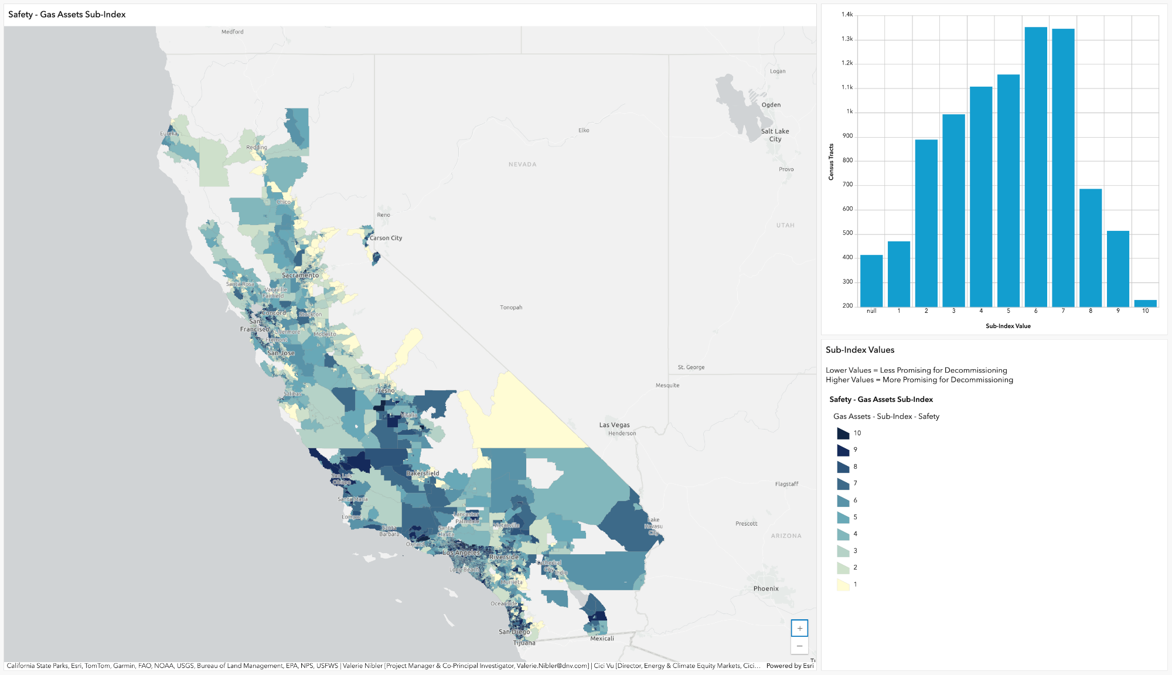
Figure 3-3. Gas Assets Safety Sub-Index Map and Distribution
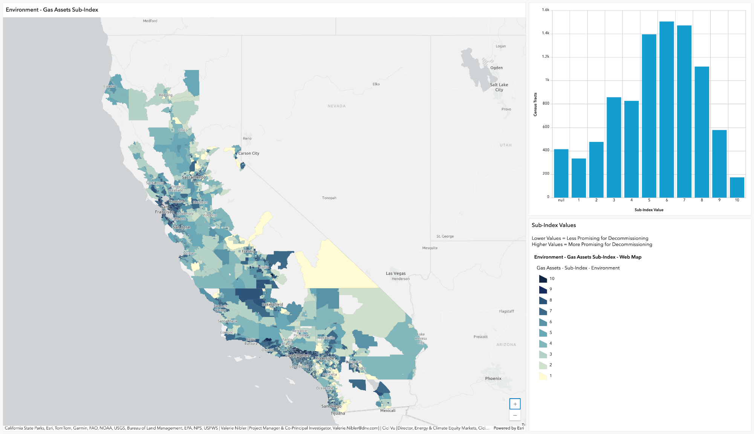
Figure 3-4. Gas Assets Environment Sub-Index Map and Distribution
Figure 3-5. Gas Assets Cost Sub-Index Map and Distribution
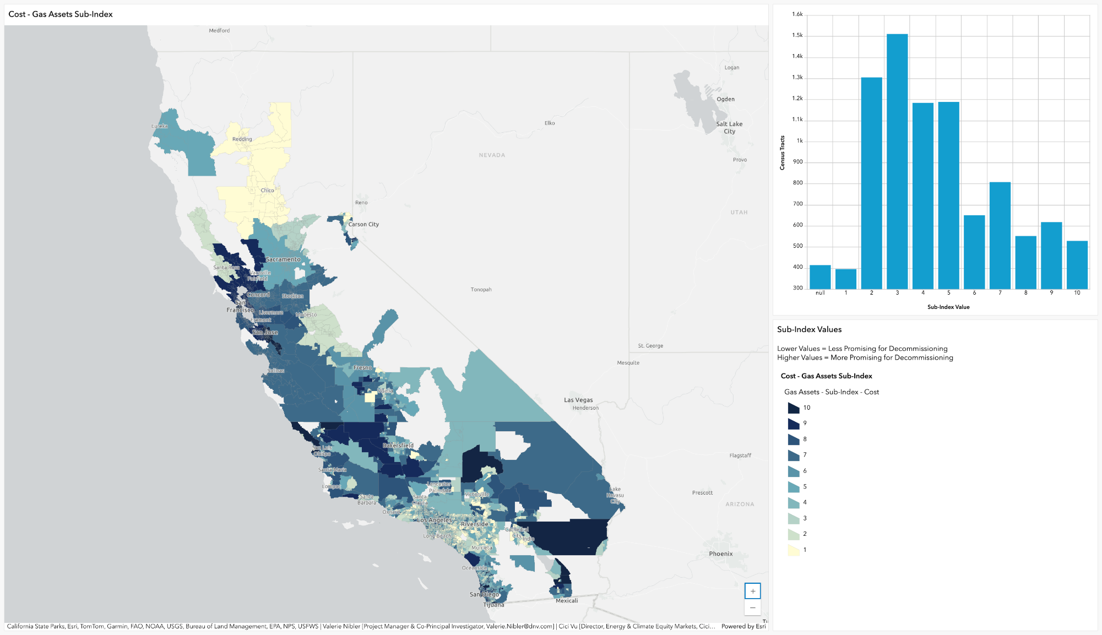
Figure 3-6. Gas Assets Regulatory Sub-Index Map and Distribution
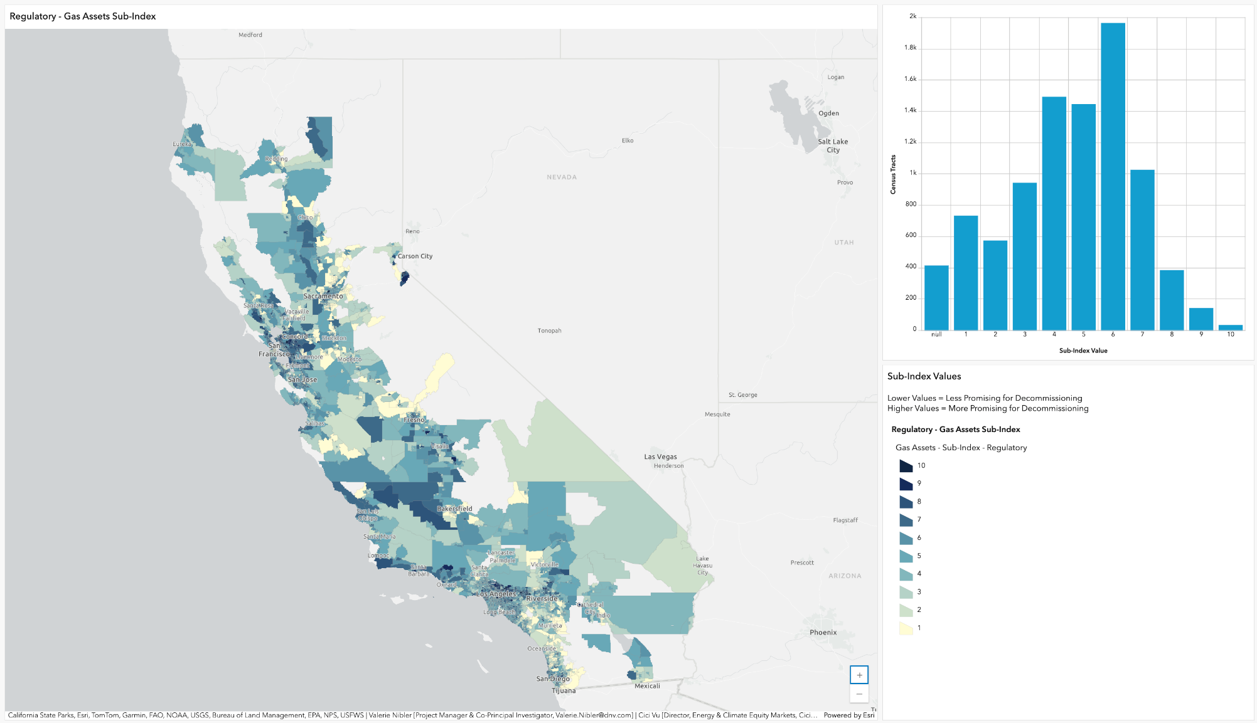
Figure 3-7. Gas Assets Demand Sub-Index Map and Distribution
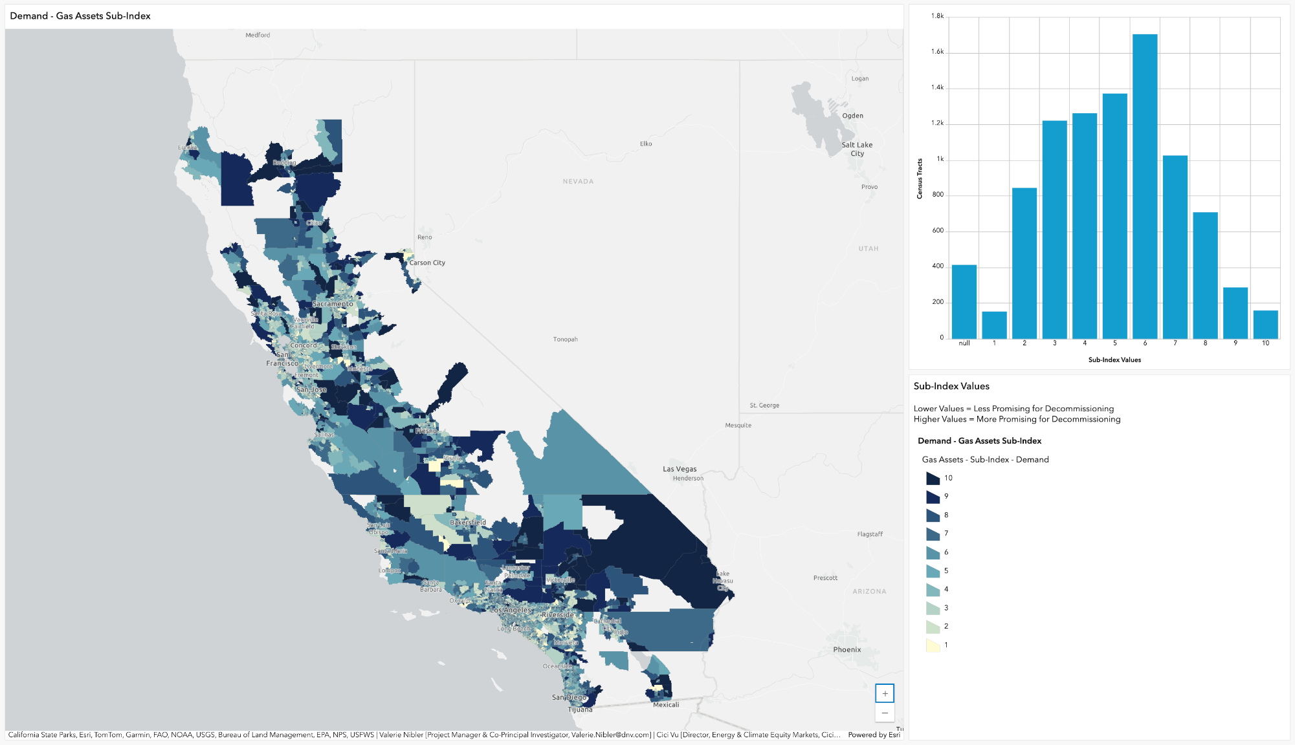

Summary and Conclusions
The Gas Assets Assessment report describes the activities undertaken to develop the gas assets index and five sub-indices to support California’s strategic transition away from natural gas by providing a robust, data-driven foundation for identifying candidate sites for gas system decommissioning. The project’s scope included:
- Comprehensive data collection on gas distribution assets statewide, leveraging utility filings and public datasets.
- Development of a screening tool that integrates data for gas system distribution infrastructure with equity and readiness indices, enabling systematic evaluation of decommissioning opportunities.
Stakeholder engagement to ensure the Tool and findings reflect both technical realities and community perspectives.

Approach to Gas Assets
The assessment focused on mapping and analyzing the physical characteristics, risks, and replacement costs of gas assets across California. Key asset dimensions included safety (e.g., leak-prone pipelines, proximity to population centers), environmental risk, regulatory drivers, pipeline replacement costs, and demand. By aggregating these factors at the census tract level, the Tool provides a standardized, statewide view of where gas infrastructure may pose the greatest risks or offer the most promising opportunities for transition.
When developing the Gas Assets Index, the research team confronted a persistent belief from many stakeholders that gas distribution system asset-level data would be required for prioritizing gas decommissioning projects. The team confronted this belief directly in the Public Showcase webinar in October 2025. The webinar emphasized that while granular, asset-level data is valuable, the statewide screening Tool enables meaningful action now. Waiting for perfect data can stall progress; instead, the Tool leverages available statewide and utility-provided datasets to identify areas for further investigation. The team emphasized the value of the Tool as a starting point:
- Collaboration is key: The Tool is designed to be a starting point for collaboration among utilities, policymakers, and communities. Utilities hold proprietary asset-level data, while the Tool offers a transparent, standardized framework for initial screening.
- Statewide coverage and standardized scoring: The Tool’s value lies in its ability to bridge policy and practice, supporting complex decision-making by integrating multiple criteria—asset risk, equity, and readiness—into a single, actionable framework.
Facilitates iterative improvement: The Tool is a living resource—its statewide perspective and standardized approach allow for ongoing refinement as new data becomes available and as stakeholder feedback is incorporated.

Areas for Future Research
The following summarizes research findings from engagement with stakeholders, including the TAC, for future research and enhancements to the Tool:
- Strategies for long-term Tool maintenance, stakeholder validation, and dynamic updates
- Integration of asset-level data, in collaboration with Gas IOUs, to improve spatial accuracy and relevance for case studies and community analysis
- Incorporation of regulatory readiness data into the Tool
- Inclusion of grid balancing metrics and data for enhanced decision support
- Expanding the tool’s applicability beyond California to other regions
- Research into more flexible and dynamic metric weighting schemes (e.g., decision trees, binary constraints, integration with platforms like Power BI)
- Enhanced metrics related to ratepayer savings and stranded asset costs
- Continued iterative engagement with stakeholders to refine and prioritize indices, highlighting non-energy impacts and benefits

Literature Review
The following sections include summaries from the review of documents completed in the first six months of the project. The descriptions are included to provide background on data that could be used to inform assessment of gas assets for decommissioning. The project team could not source all data described in these sources; refer to the main body of this deliverable to understand what data were used to create the gas assets index for the Tool.
“Gas Decarbonization in California – Building Electrification’s Expected Impacts on Gas System Throughput and Hydraulic Analysis Methodologies”
Authors: R. Brown and K. Lee, Pipeline Simulation Interest Group, Paper No. 2220 (2022)
This conference paper from the Pipeline Simulation Interest Group documents one of the first data-driven approaches to assessing the suitability of portions of the gas pipeline infrastructure for decommissioning based on operational concerns, ratepayer impacts, and hydraulic feasibility. The paper served as an early guide for recommending data sources for the data-driven tool.
Electrification of buildings is considered a key aspect for decarbonization, due to technical feasibility and lower overall costs to mitigate GHGs compared to other strategies. Challenges include customer willingness to electrify, and the upward pressure on gas rates, which requires gas asset retirement to reduce costs, and review of hydraulic analysis to determine the ability to retire gas assets. Essential variables identified by the authors include gas rate, defined as systemwide cost / systemwide gas use, noting that if demand drops (due to California pursuing its decarbonization goals) then rates will by necessity increase, unless system cost reductions can offset the revenue reduction through the retirement of assets.
The study focused on distribution rather than transmission as most buildings are served from distribution system, gas distribution assets are highly networked, and transmission assets would only be retired after a large number of distribution systems come offline. Most transmission customers are not residential and may have technical and feasibility challenges (that could be explored in future versions of data-driven tool).
This paper utilized as proxies for costs the quantity of facilities, such as the miles of pipe, number of regulator stations, number of valves and number of services. The proxy for revenue was measured via gas demand. The paper provides some further refinements of this approach by using IOU obtained values for the unit costs assigned per asset type across different geographical divisions. Therefore, it is possible for such data sets, if IOUs will share cost data, to be made specific to the area proposed for decommissioning. Likewise, gas revenues can be broken down into customer types with different rates assigned to specific customer classes multiplied by the numbers of such customers within the geographic units of interest (census tract, zip code, or hydraulically independent system (HIS)). Combining estimated costs and revenues the area proposed for decommissioning can be assigned a cost/revenue ratio as a direct indicator of the impact on rates if the area is decommissioned.
This paper introduced the concept of dividing gas distribution system geographies into smaller hydraulically independent systems (HIS). A hydraulically independent system (or sub-system) is a portion of a gas pipeline hydraulic model that is fed from a fixed number of regulators and a fixed piping network. While many HIS will be too large to decommission at once, obtaining HIS cost/revenue could be used to direct electrification priorities to HISs with the highest cost/revenue ratio. Smaller subsets of the HIS could be assessed in more detail using a variety of electrification scores, including developing a cost/revenue ratio for these smaller areas. Additional metrics identified in this study for assessing decommissioning suitability include:
- The number and type of customers on a HIS
- Cost factors such as IOU-planned gas projects, proposed but not yet planned gas projects, and facility material, age, and performance which can be indicators of future projects
System utilization
“Strategic Pathways and Analytics for Tactical Decommissioning of Portions of Gas Infrastructure for Northern California: Pilot Site Selection Framework and Preliminary Results”
Authors: Energy and Environmental Economics (E3), (November 2022)
Working with PG&E and local stakeholders, E3 had begun development of a pilot site selection framework for identifying priority geographies that could be feasibly and beneficially decommissioned in the near-term time frame of 3-15 years. To guide the development of their selection framework, it was recognized that building electrification is likely to be the lowest cost and lowest risk option for decarbonizing the building sector, and this conclusion seems consistent with other studies, including those considering colder climates. Other studies that reach this conclusion include the CARB/E3 study, the Princeton Net Zero America study, and the Annual Decarbonization Perspective. Adopting widespread building electrification will have the consequence of challenging the funding and cost recovery mechanisms of the California gas distribution system. As the number of customers decrease on a given gas system, the remaining customers are at risk of rate increases to pay for the fixed costs of maintaining the gas system. Continuing this logic, it should then be recognized that low-income homeowners will be more vulnerable to rate increases.
Consequently, the authors proposed to select sites based on two criteria:
- Potential for scale (focusing on retail customers on distribution systems)
Potential for cost reductions: cost recovery from the distribution system
In a useful table, the authors also summarized the difference in priorities and scope of the current paradigm, potential near-term paradigm and the potential long-term paradigm for decommissioning. This breakdown is useful for the data-driven tool, which should span the mid-term to long-term paradigms and include neighborhoods of scale in the hundreds to thousands of customers and beyond. It should also address challenges pertinent to the long-term avoided costs, and energy equity.
The authors obtained their data and used analysis summarized through the PG&E Gas Asset Analysis Tool. Three criteria were used to make site selection decisions:
- Candidate Screen, which included hydraulic feasibility, the likelihood of near-term capital projects, areas not identified for near-term (imminent) pipeline replacements.
- Engineering Review, which included a Synergi Gas analysis for capacity impacts and hydraulic feasibility.
Site screening and identification, as assessed by the metric of avoided costs / electric costs, community prioritization, and the diversity of building types within a potential geography of prioritization. Avoided costs were defined by the avoided gas asset replacement and/or rebuilding costs, the avoided operations and maintenance costs and subtracting the decommissioning costs. The data provided by IOUs as a result of the CPUC long-term gas planning rulemaking was used to provide the average cost to replace distribution main pipeline and service pipeline, yielding an average avoided cost of $3.38 M / mile. Note, this is a system-wide average which may not be accurate for specific locations. Given importance of reducing costs, the Tool should use a more accurate value when available. These may be requested from the utilities to provide an estimate. Furthermore, for those pipelines that might be planned to be decommissioned but are not scheduled for repair, an estimate should be made for those effective avoided costs per mile based on maintenance and risk, and/or remaining cost in the rate base.
Decommissioning was defined in this work as being disconnected from gas service and those customers being provided with all-electric alternatives. Technical characteristics of the candidate sites included the location, whether or not the location corresponded to a disadvantaged community (DAC), the building types, the number of non-residential buildings, the maximum number of meters, the length of gas mains (ft), the maximum gas avoided costs ($), the maximum avoided costs per customer ($), and the presence of electric upgrades. Electric upgrade information was provided from the PGE Integration Capacity Analysis data set. This particular datapoint marks another toolset that may need to be requested from utilities and is within the scope of the Decommissioning Readiness team that is working in parallel with the Gas Assets Assessment team in the data-driven Tool project.
The technical advisors to the team of authors recommended focusing less on the avoided costs per customer than on other metrics, because focusing on avoided costs per customer would lead to a focus on sparser suburban areas rather than urban regions, which may be more relevant to DACs that may benefit more from decommissioning due to improvements in health, air quality, etc.
“Natural Gas Ratepayer Impact Memo”
Authors: RAND (September 2022)
The scope in this analysis was confined to decommissioning natural gas mains and meters, assuming a decommissioning approach of abandoning pipelines in place in the ground. Summary findings included the recognition that decommissioning can have downstream impacts on customers outside the decommissioning zone and that these should be assessed by hydraulic analysis. Furthermore, it was noted that the costs of pressure betterment or system improvements necessitated by decommissioning would be borne by customers remaining on the system, and that decommissioning may result in only partial repayment of the long amortization time periods typically associated with gas assets by those customers who are decommissioned.
Overall, this study demonstrates the need for long-term planning with regards to decommissioning, and careful analysis of system hydraulics to ensure that downstream impacts are minimized. With regards to pressure betterment, various strategies can be used to minimize the costs of pressure betterment such as careful planning of the quantity of pipeline required to provide betterment and appropriate materials selection in anticipation of future decommissioning activities.
The data sets used in this analysis appeared to consist of hydraulic level models of the distribution systems in specific locales. Specific locations were selected for potential decommissioning in the hydraulic model and the system modifications required to mitigate impact on downstream customers were also evaluated. An assessment of the cost of the gas assets that would be decommissioned (i.e. the contribution of those assets to the rates) versus the additional costs required for pressure betterment for downstream customers was also estimated.
This kind of analysis is highly specific and not immediately suited to implementation in the statewide data-driven tool. On the other hand, some level of decomposition of gas networks into hydraulically independent systems would be useful to the statewide project.
Pipeline Abandonment Studies
Three studies were reviewed:
- Pipeline Abandonment Assumptions – Technical and Environmental Considerations for Development of Pipeline, Abandonment Strategies Authors: Canadian Energy Pipeline Association (2007)
- Pipeline abandonment: a discussion paper on technical and environmental issues, issued jointly by the Canadian Association of Petroleum Producers, Canadian Energy Pipeline Association and the Alberta Energy and Utilities Board (1996)
Pipeline Abandonment Scoping Study, prepared by DNV for the National Energy Board (NEB), in collaboration with TERA Environmental Consultants and BCG Engineering (November 2010)
Beyond the studies previously discussed that are directly associated with the State of California’s decarbonization and decommissioning efforts, it was considered necessary to search for further data and guidance regarding the costs and risks associated with pipeline abandonment from the engineering perspective. The team investigated local ordinances, codes, and regulations that might prescribe methods by which gas facilities are required to be decommissioned, and also considering the policy implications associated with different pipeline decommissioning strategies (such as roles and responsibilities of future landowners with gas assets on their properties versus the former ratepayers and IOUs).
The report provided by the Canadian Energy Pipeline Association “Pipeline Abandonment Assumptions – Technical and Environmental Considerations for Development of Pipeline Abandonment Strategies” provides a summary pipeline abandonment matrix, that assesses the most appropriate methods for abandoning pipelines based on their size and features of their location (agricultural, non-agricultural and other, with sub-categories in each). Given that the focus in this work is on distribution lines, the pipe diameters will most commonly be in the range of 2”-12”, in which case abandon in place is usually considered an appropriate decommissioning strategy, with a few important exceptions: locations that are “Cultivated with special features (re: depth of cover)” or “Prospective future non-agricultural development” are recommended for complete pipeline removal; and locations with roads and railways may be abandoned but require backfill of the pipe with some material such as concrete to prevent soil subsidence. These factors may be relevant for estimating costs of decommissioning given certain geospatial specific concerns.
An earlier discussion paper produced by the Canadian “Pipeline Abandonment Steering Committee” in 1996 highlighted some key issues for assessing abandonment decisions including: land use management; ground subsidence; soil and groundwater contamination; pipe cleanliness; water crossings; erosion; utility and pipeline crossings; creation of water conduits; associated apparatus and cost of abandonment. A flowchart was provided for decision-making regarding abandonment. It includes decision points regarding “Alternate Use or Sale,” “Review of Regulatory Requirements,” “Analysis by Pipeline Segment” for Removal vs Abandon in Place,” “Product Removal and Cleaning,” “Abandonment Activities,” “Monitoring and Management,” “Regulatory Release,” and “Ongoing Public Consultation.” This analysis makes it clear that abandonment decisions, while avoiding system operating and maintenance costs, may have their own costs that could be significant as well as require engagement with the public, landowners, and regulators.
A third report was produced by DNV for the National Energy Board and is a Pipeline Abandonment Scoping study. Pipeline abandonment strategies were reviewed, and several steps were identified as being associated with abandonment in standards set in either Canada or the UK:
- Considerations of alternative uses for the abandoned pipeline
- Land use and legal landowner considerations
- Emptying the pipeline of fluids
- Purging and cleaning
- Filling with inert gas if necessary
- Physical separation from in-service piping
- Capping, plugging, or otherwise sealing
- Future maintenance of the pipeline
- Need for line markers
- Removal of short above ground sections
Record maintenance
With respect to the data-driven screening tool, the research team recognized that an assessment of decommissioning activities with respect to the needs of the State of California needs to be assessed, as well as their impacts on communities and ratepayers, as well as intersection with policy needs.
Future Regulatory Decisions on Natural Gas Networks: Repurposing, Decommissioning and Reinvestments
Authors: Prepared by DNV for the European Union Agency for the Cooperation of Energy Regulators (ACER), (October 2022)
This report produced by DNV in 2022 focuses on decommissioning options and alternatives that may be pursued because of energy decarbonization in Europe. The report outlines the challenges and regulatory approaches that must be taken to address the problem of stranded assets. The same kinds of approaches that examine the residual value or modifying depreciation and cost recovery that were recommended for European assets could apply in the U.S. The approaches will be dictated by the political (state/national policies) and associated regulatory directives. For instance, policies focused on repurposing the pipelines for renewable natural gas or hydrogen will reduce the stranded costs—i.e., reduce the amount needed to be recovered outside of the rate base. The report also includes topics such as asset management approaches (total/operating expenditures vs capital expenditure to incentivize the utilities). This will impact the valuation as the determination that some assets are critical and need to be kept online will influence decommissioning decisions.
The main public source for retrieving the cost information is the FERC Form 2—annual reports submitted by major natural gas companies. The rate case filings would be a good source of information as well but some of the information is redacted in the public online document. These sources may provide information about the unamortized value of the rate base but may not include information on specific segments of the pipeline.
Some other resources related to stranded assets and policy are publications by Payne (2021) and the thesis of Daljevic (2016):
- https://digitalcommons.law.umaryland.edu/cgi/viewcontent.cgi?article=3892&context=mlr Heather Payne, The Natural Gas Paradox: Shutting Down a System Designed to Operate Forever, 80 Md. L. Rev. 693 (2021). Available at: https://digitalcommons.law.umaryland.edu/mlr/vol80/iss3/4
- https://prism.ucalgary.ca/handle/1880/51697 The Regulatory Compact and the Treatment of Stranded Assets, Marko Daljevic, Thesis, University of Calgary

Gas Assets Assessment Coordination Log
In the Planning and Data Collection project phase, in addition to hosting the first TAC in August 2023, the Research Team held meetings and project briefing sessions with other stakeholders including Gas IOUs, renewable energy networks (RENs), and community choice aggregators (CCAs). The agenda and goal for all meetings were to provide an overview of the project, introduce the project team, and to discuss opportunities for collaboration, with focus on data sourcing and future engagement opportunities. The conversations were used to inform a request for asset-level data described in the following section. The research team also compiled an outreach database with names and contact information which was used for inviting stakeholders to the two community workshops and the public showcase webinar. More information on these project activities is available in the Community Resources and Equitability Assessment Deliverable. Table B-1 includes a log of stakeholders with whom meetings were held in the Planning and Data Collection phase, which is shared to provide the CEC with awareness of stakeholders who were informed of the project activities.
Table B-1: Gas Assets Assessment Coordination Log
Date | Organization
5/22/2023 | Clean Energy Alliance
5/22/2023 | Peninsula Clean Energy
6/19/2023 | CleanPowerSF
6/21/2023 | Sonoma Clean Power
7/3/2023 | BayREN
7/10/2023 | SoCalREN (also The Energy Coalition)
7/10/2023 | SoCalREN (also The Energy Coalition)
7/27/2023 | PG&E
7/27/2023 | PG&E
7/27/2023 | PG&E
7/27/2023 | PG&E
7/27/2023 | PG&E
7/27/2023 | PG&E
8/10/2023 | SCG
8/10/2023 | SCG
8/10/2023 | SCG
8/10/2023 | SCG
8/10/2023 | SCG
8/10/2023 | SCG
8/10/2023 | SDG&E
8/10/2023 | SDG&E
8/10/2023 | SDG&E
8/10/2023 | SDG&E
8/10/2023 | SDG&E
8/10/2023 | SDG&E
8/10/2023 | SDG&E
8/10/2023 | SDG&E
8/10/2023 | SDG&E

Box Plots
After cleaning and normalizing the data from the IOUs data as submitted to the CPUC as part of the Long-Term Gas Planning Rulemaking, the research team created box plots and summary tables for all variables. Box plots are powerful tools for visually summarizing and comparing the distribution of many variables at once. Using this visualization approach, the research team could quickly see discrepancies between IOUs. Box plots for the compiled dataset are included below in alphabetical order. Variable definitions are available from Selected Rulings from the Long-Term Gas Planning Rulemaking (R.20-01-007), with most described in the March 1, 2022, Gas System Data Ruling and supplemental variables described in the September 21, 2022, Revised Gas System Data Ruling.
As one example of a finding from review of the box plots: PG&E calculates the Consequence of Failure in terms of per 100,000 leaks whereas the other IOUs do not. The Consequence of Failure is used to calculate other fields such as the Average Service Risk Score, leading to different scales of the same field for different IOUs.
The box plots also show which IOUs did not provide data for a particular field. For example, only PG&E provided data for Average Service Risk and as a result, that field is not used in the MCDA model. After completing this process, the team identified a subset of fields to potentially incorporate in the analysis.

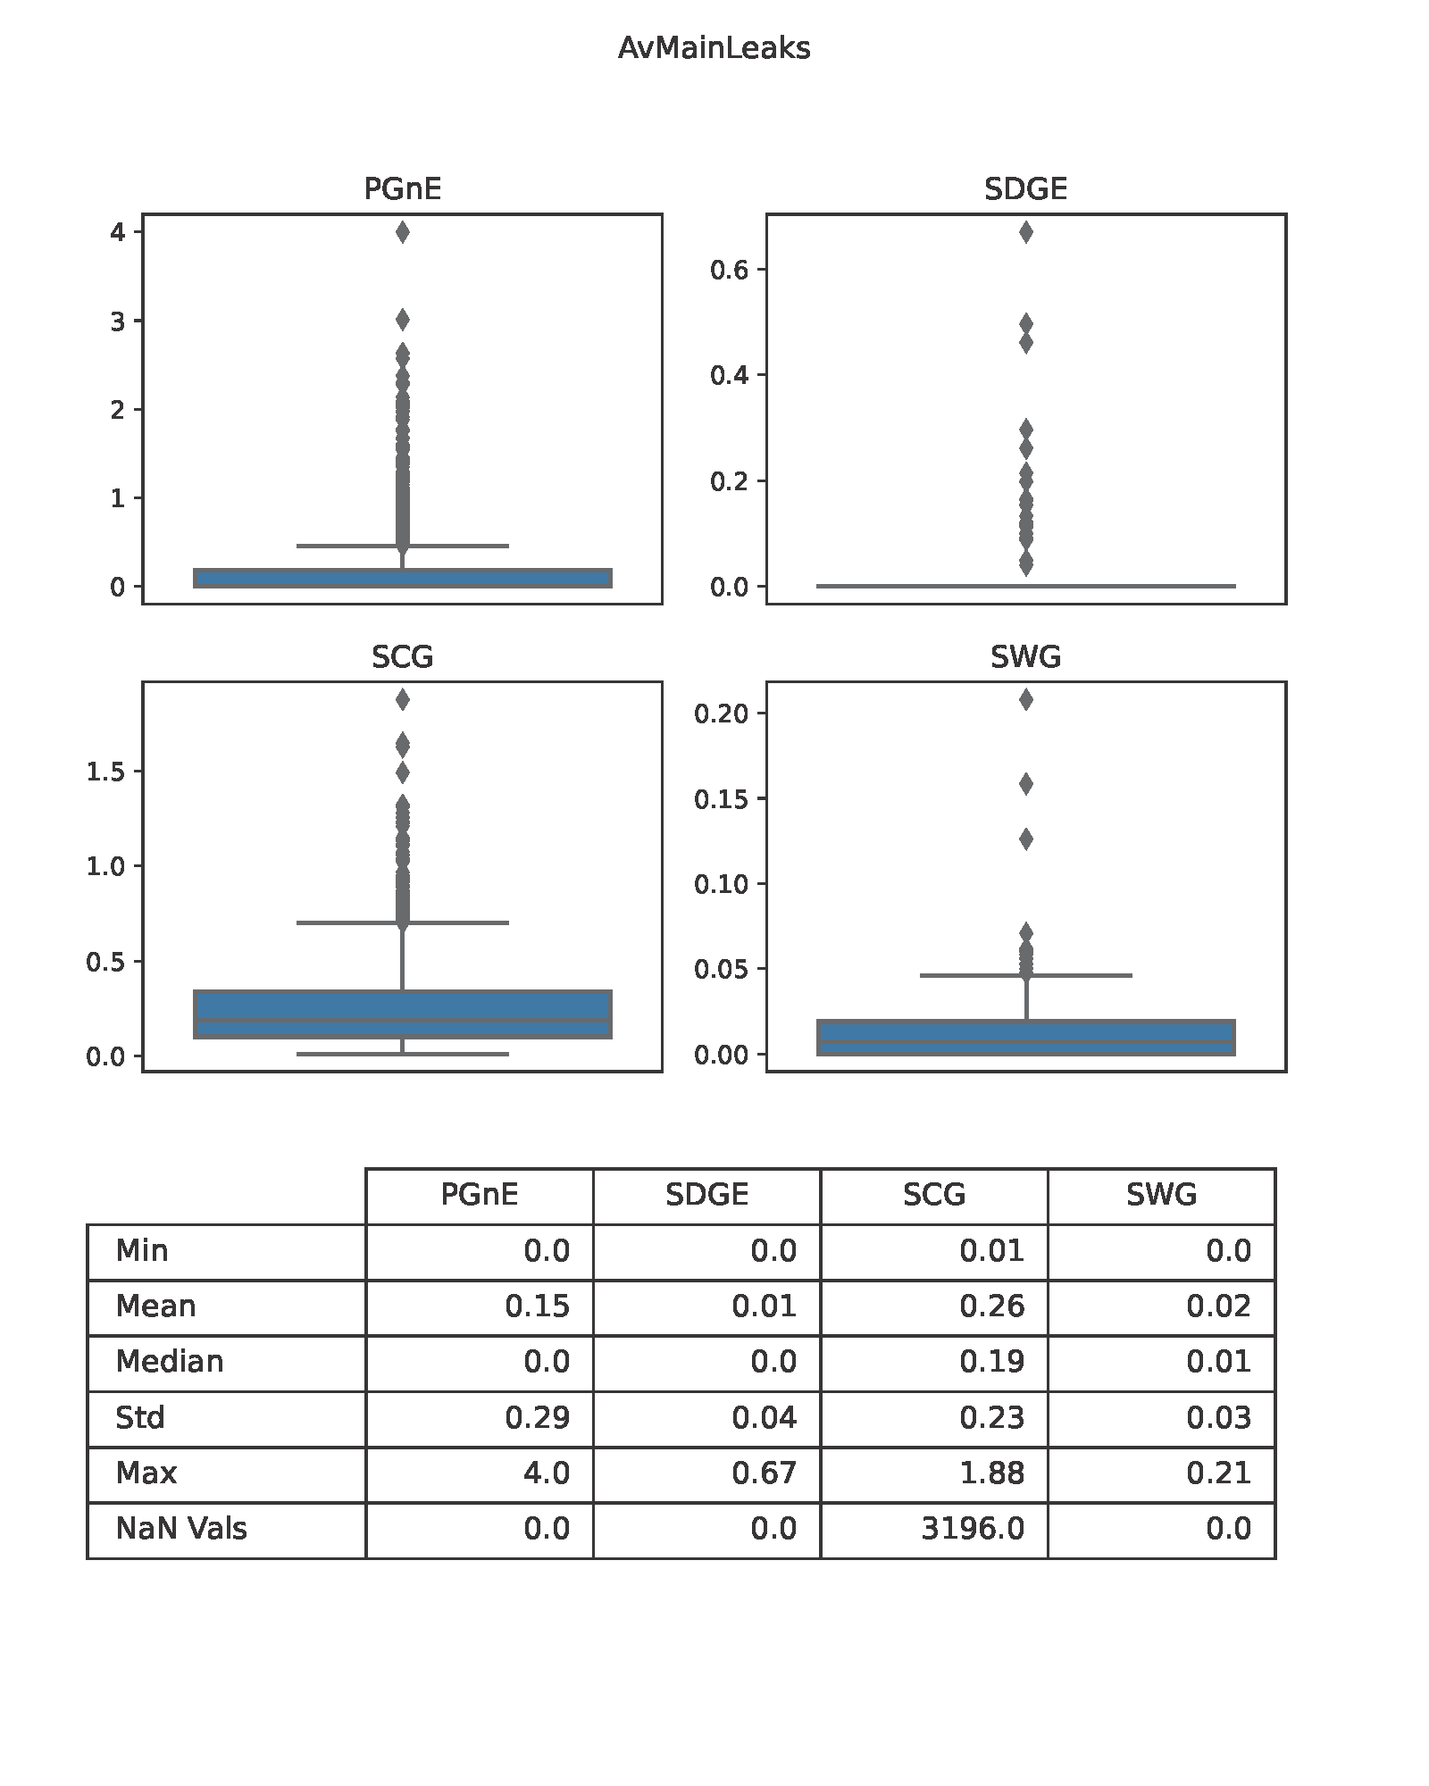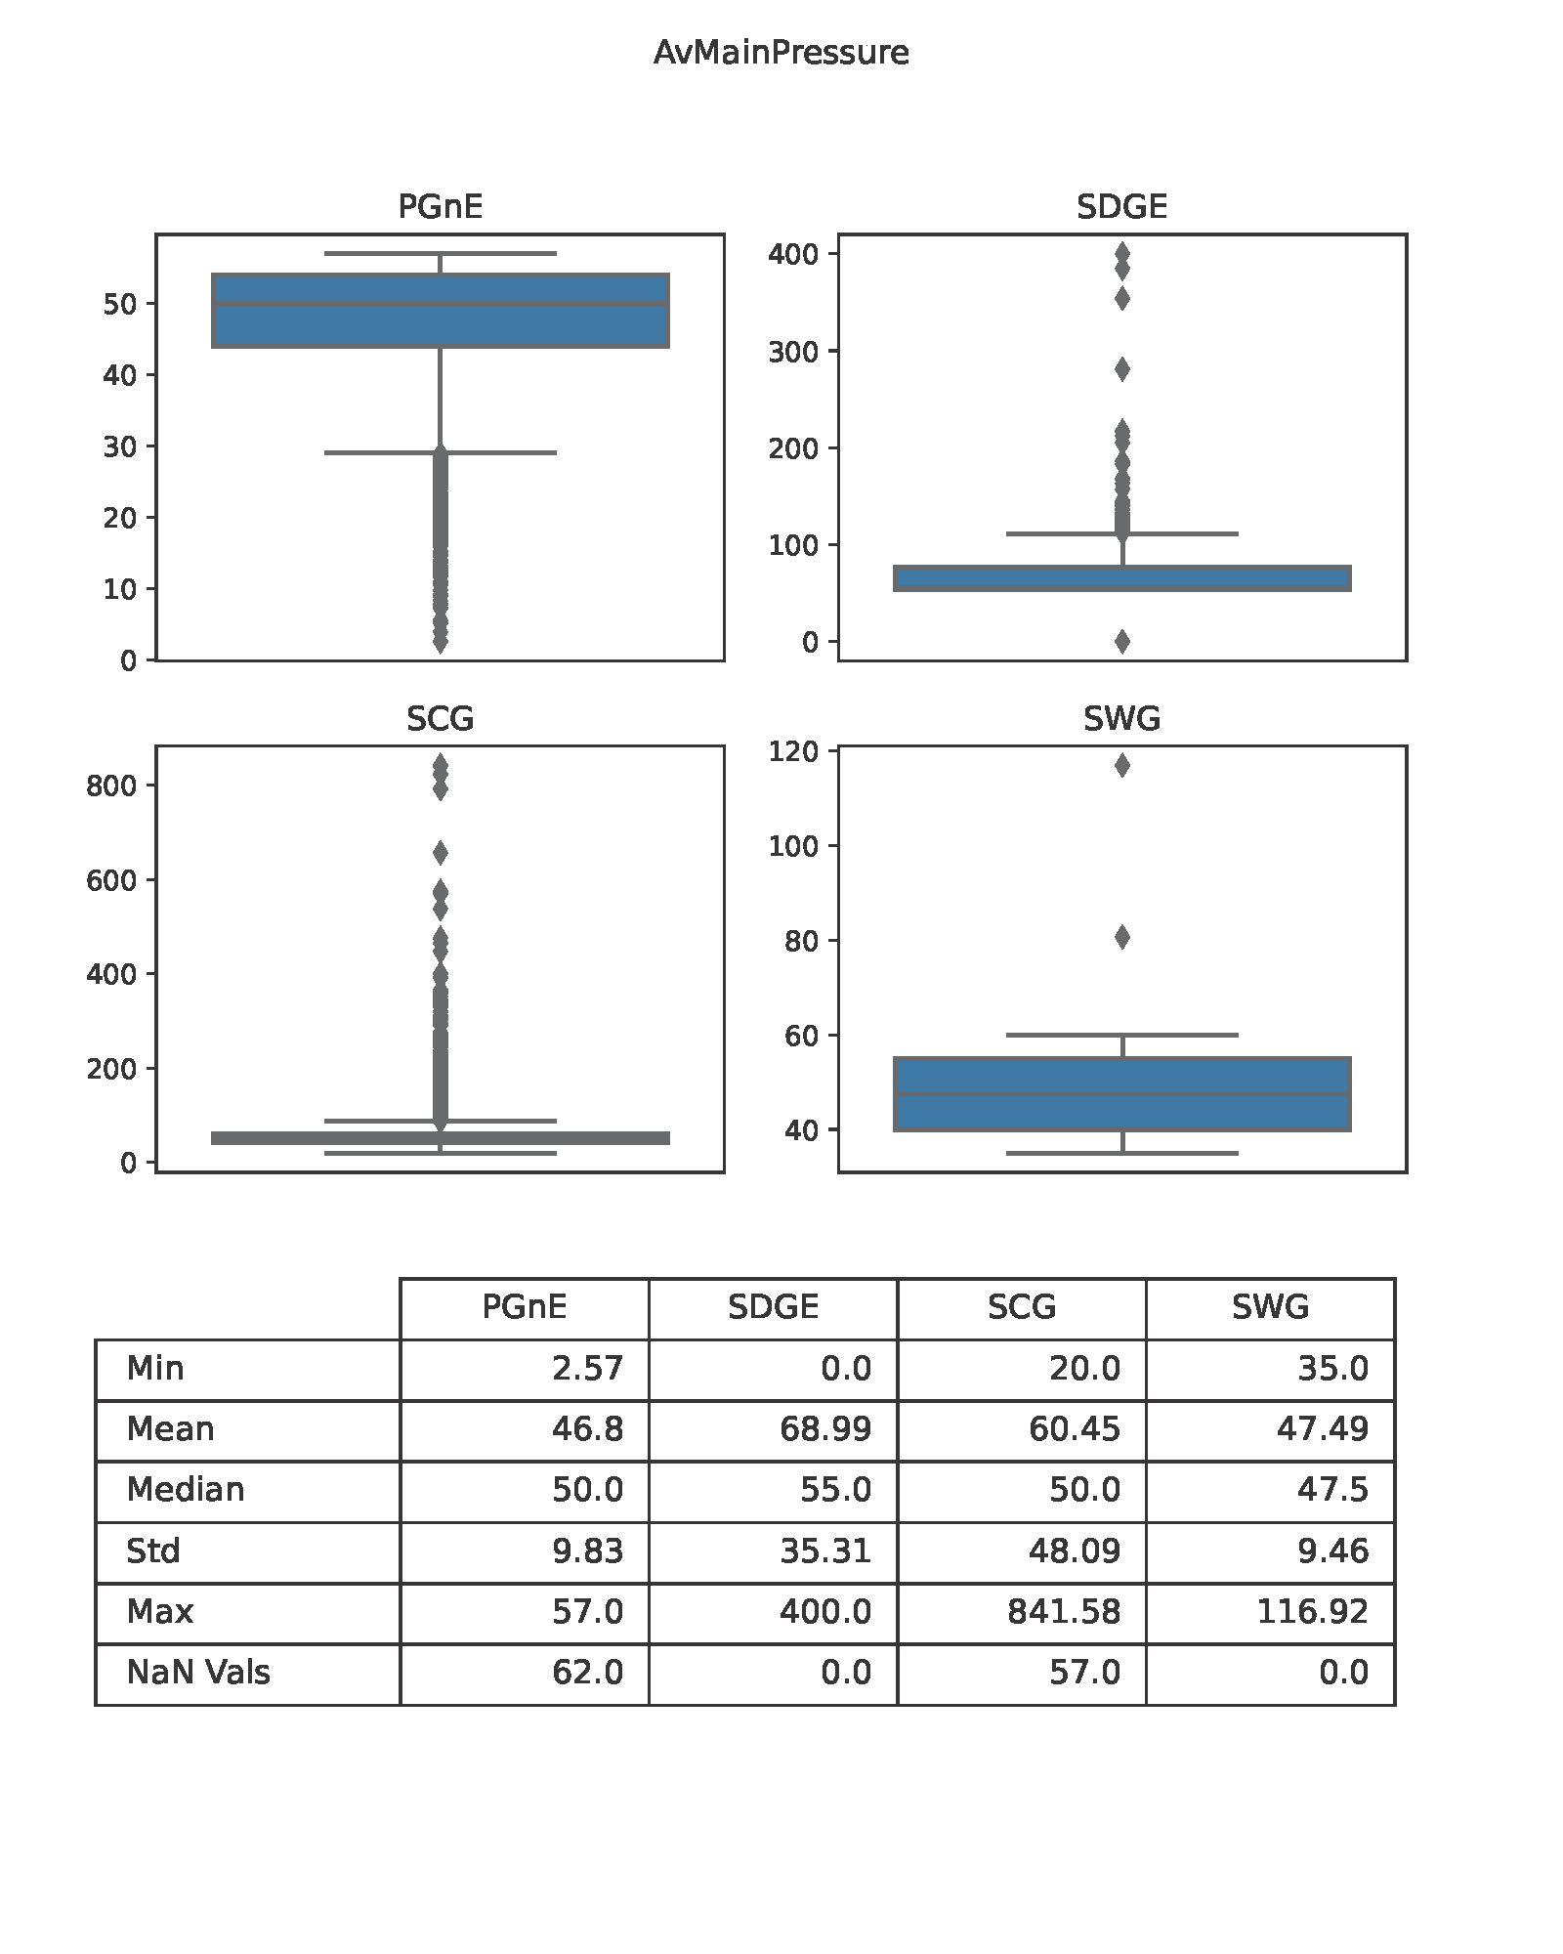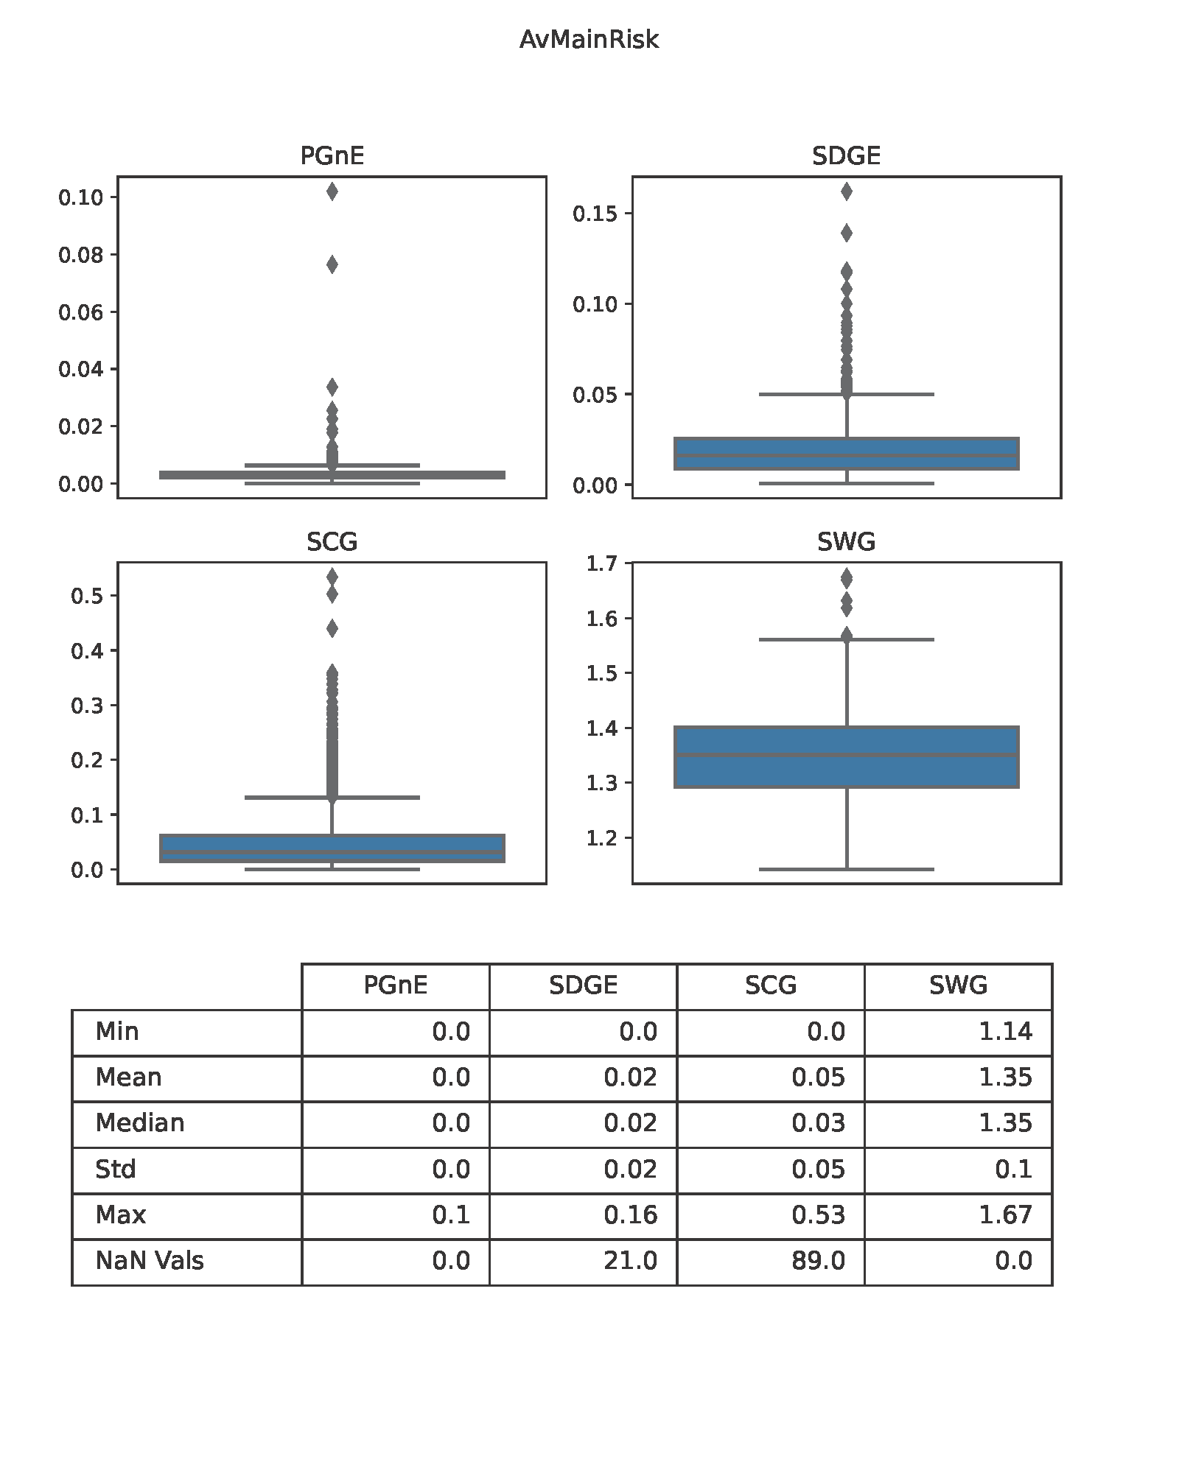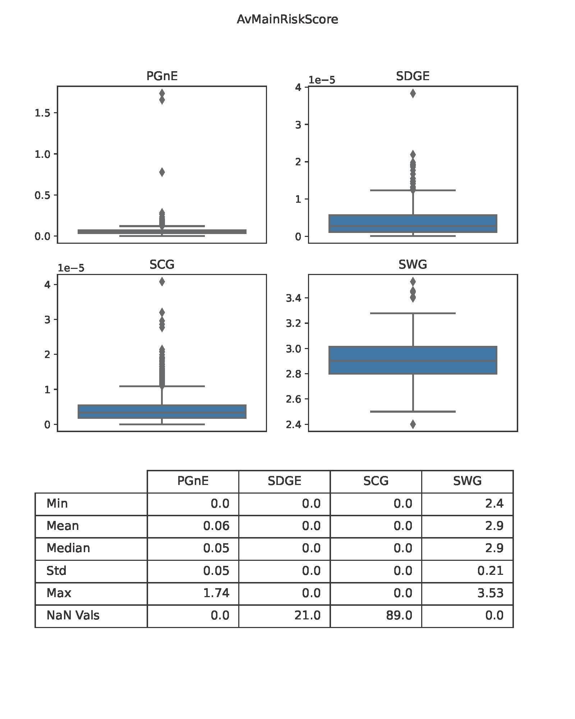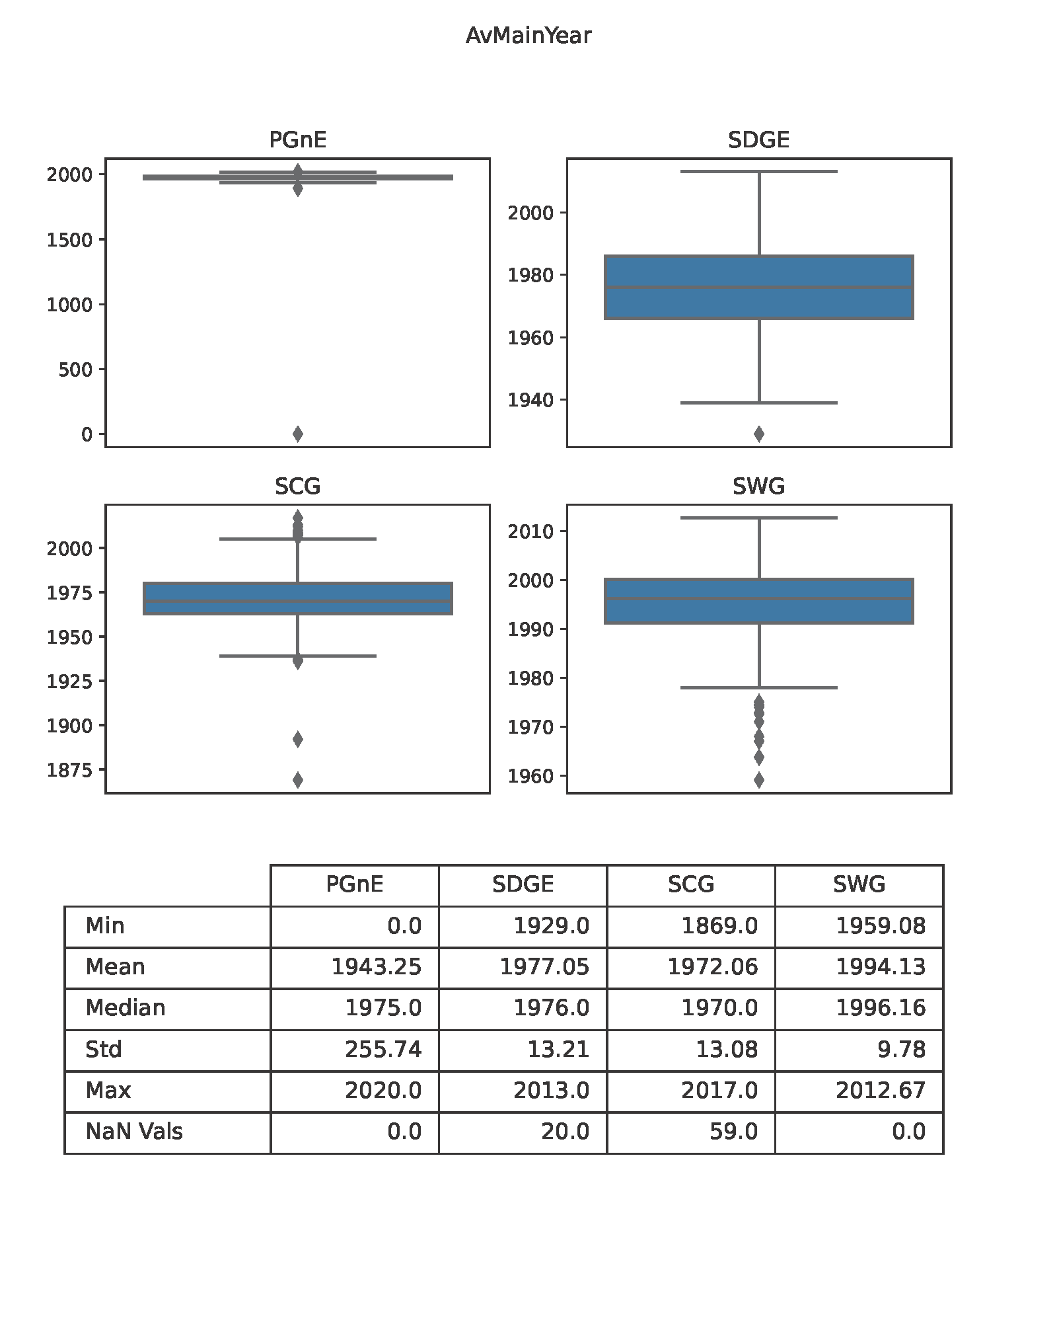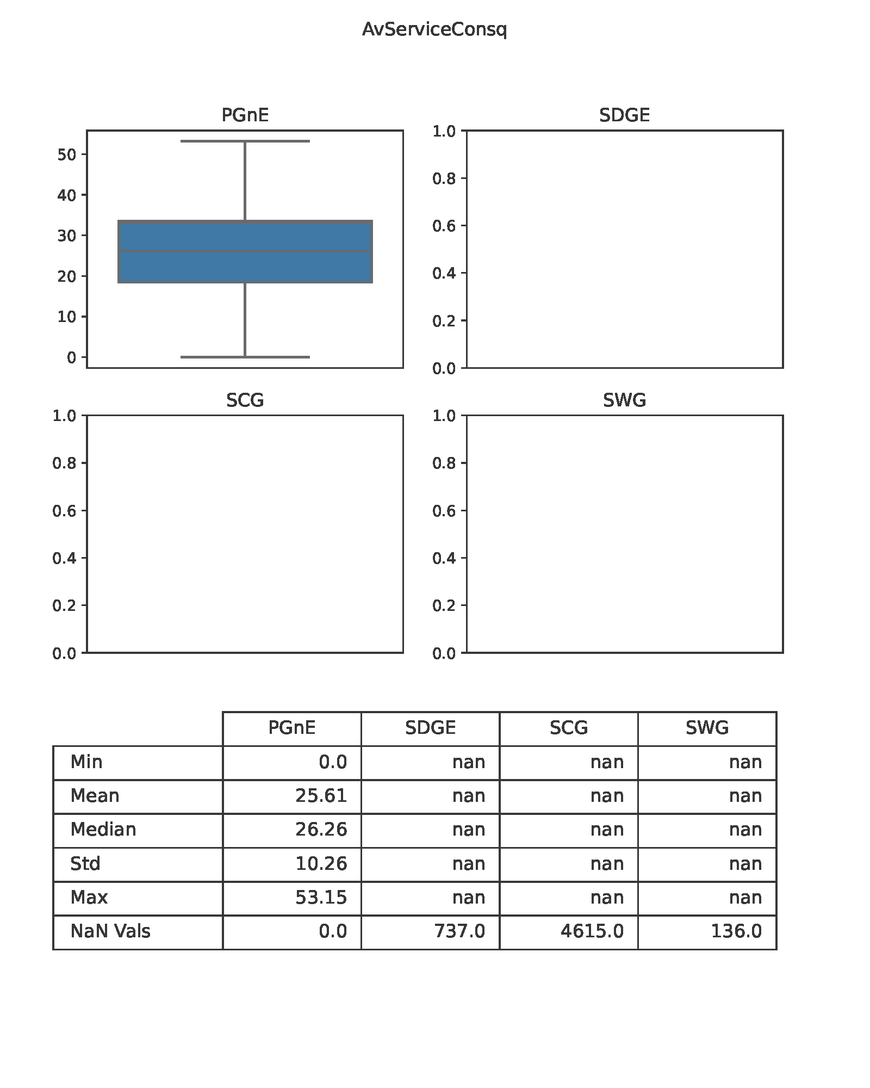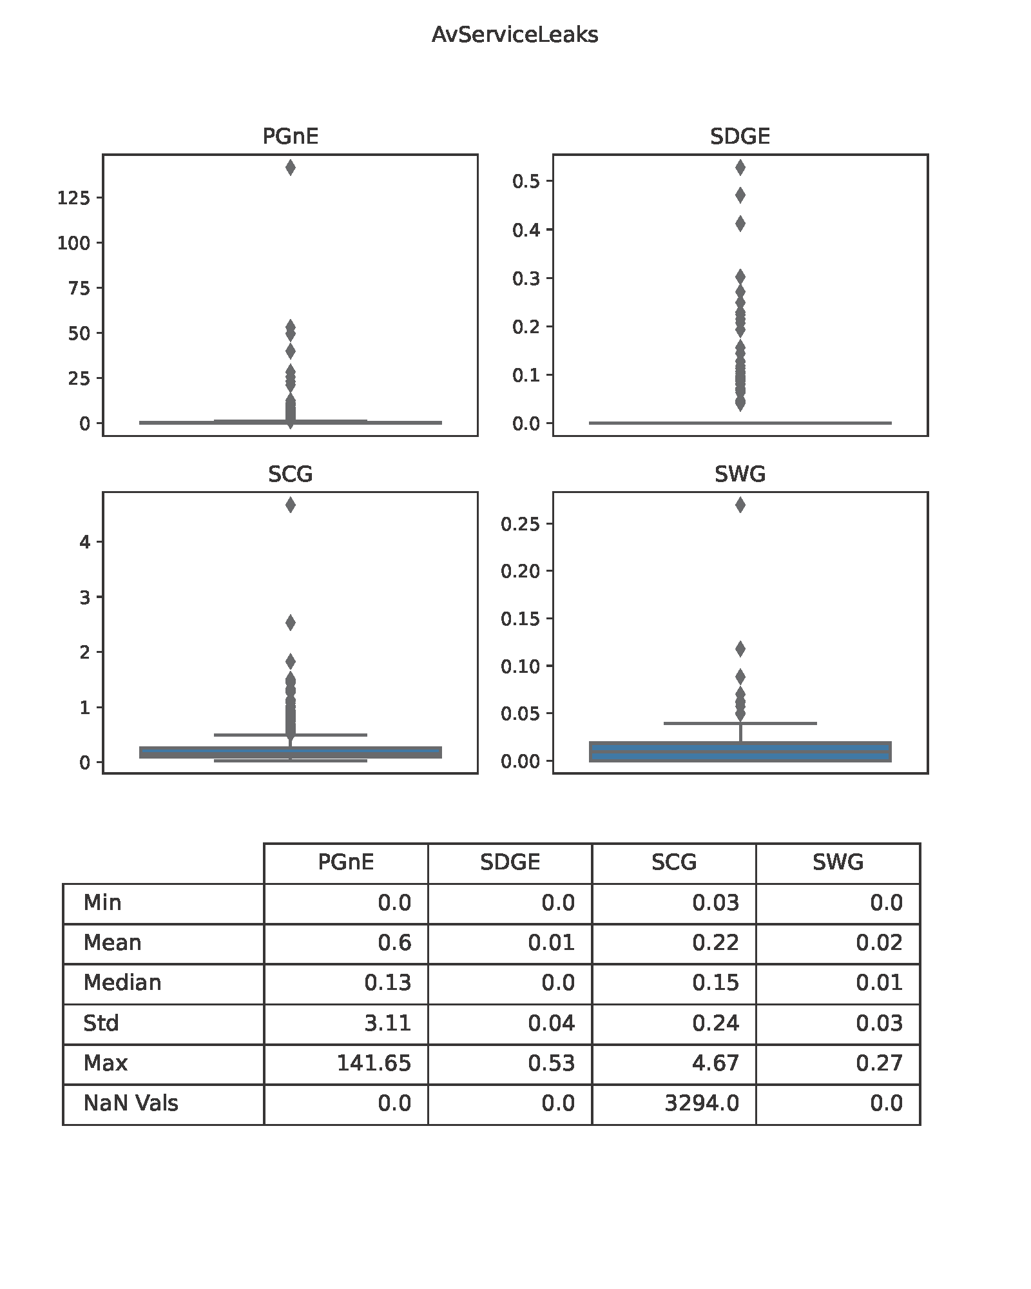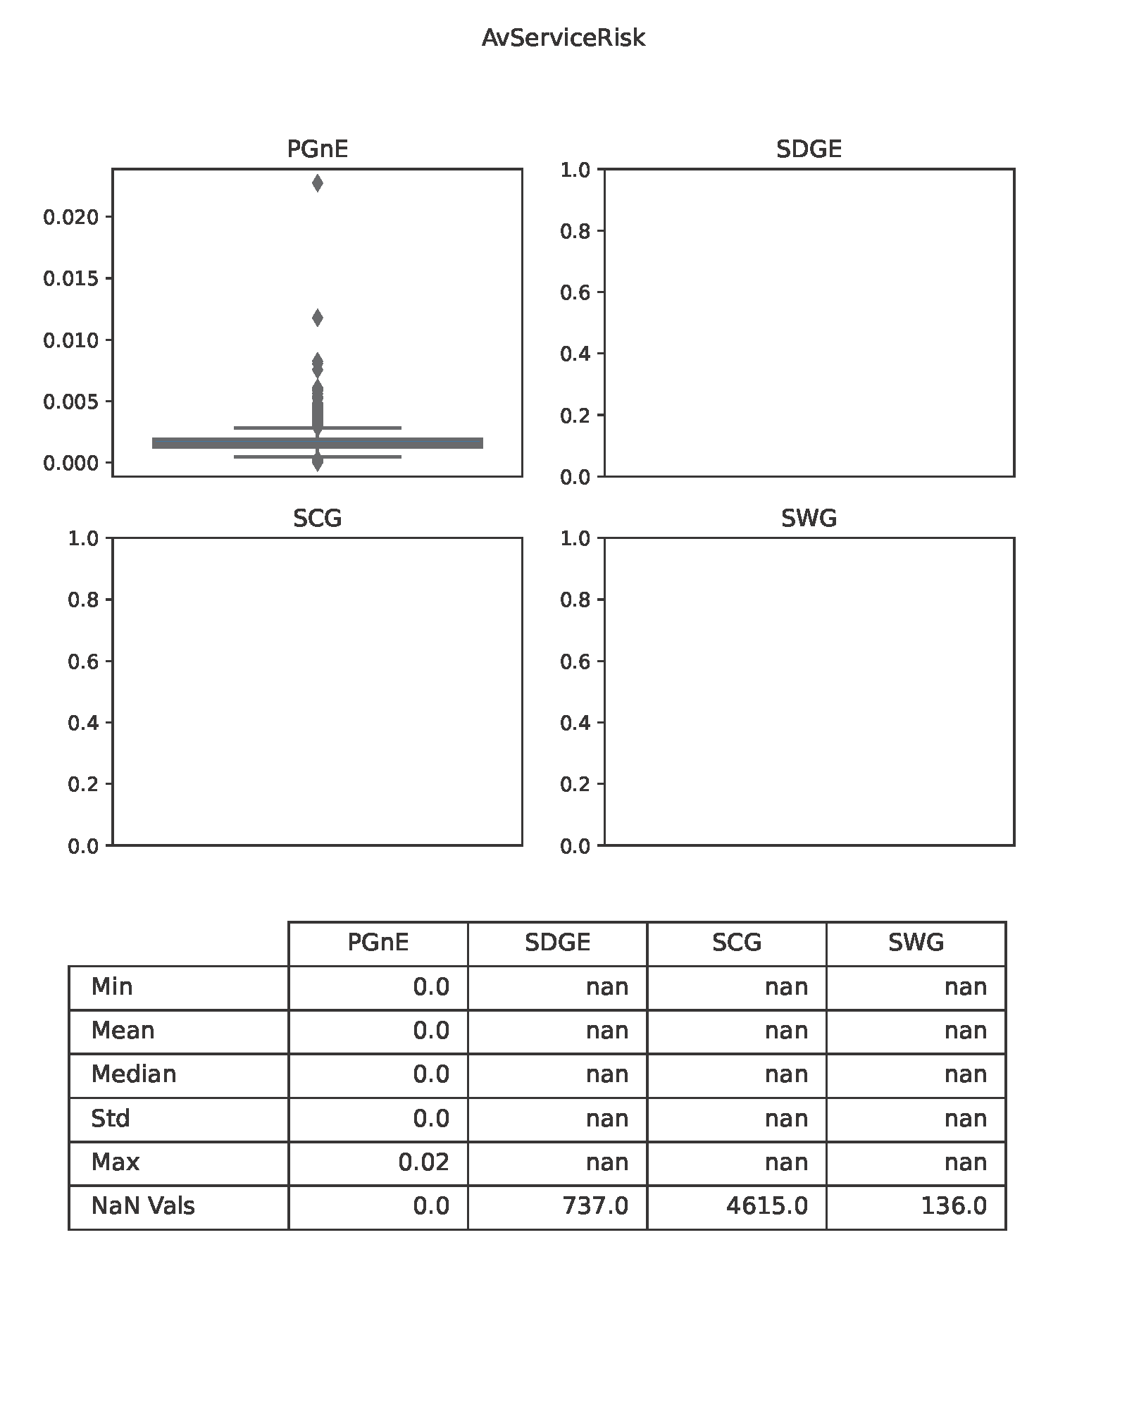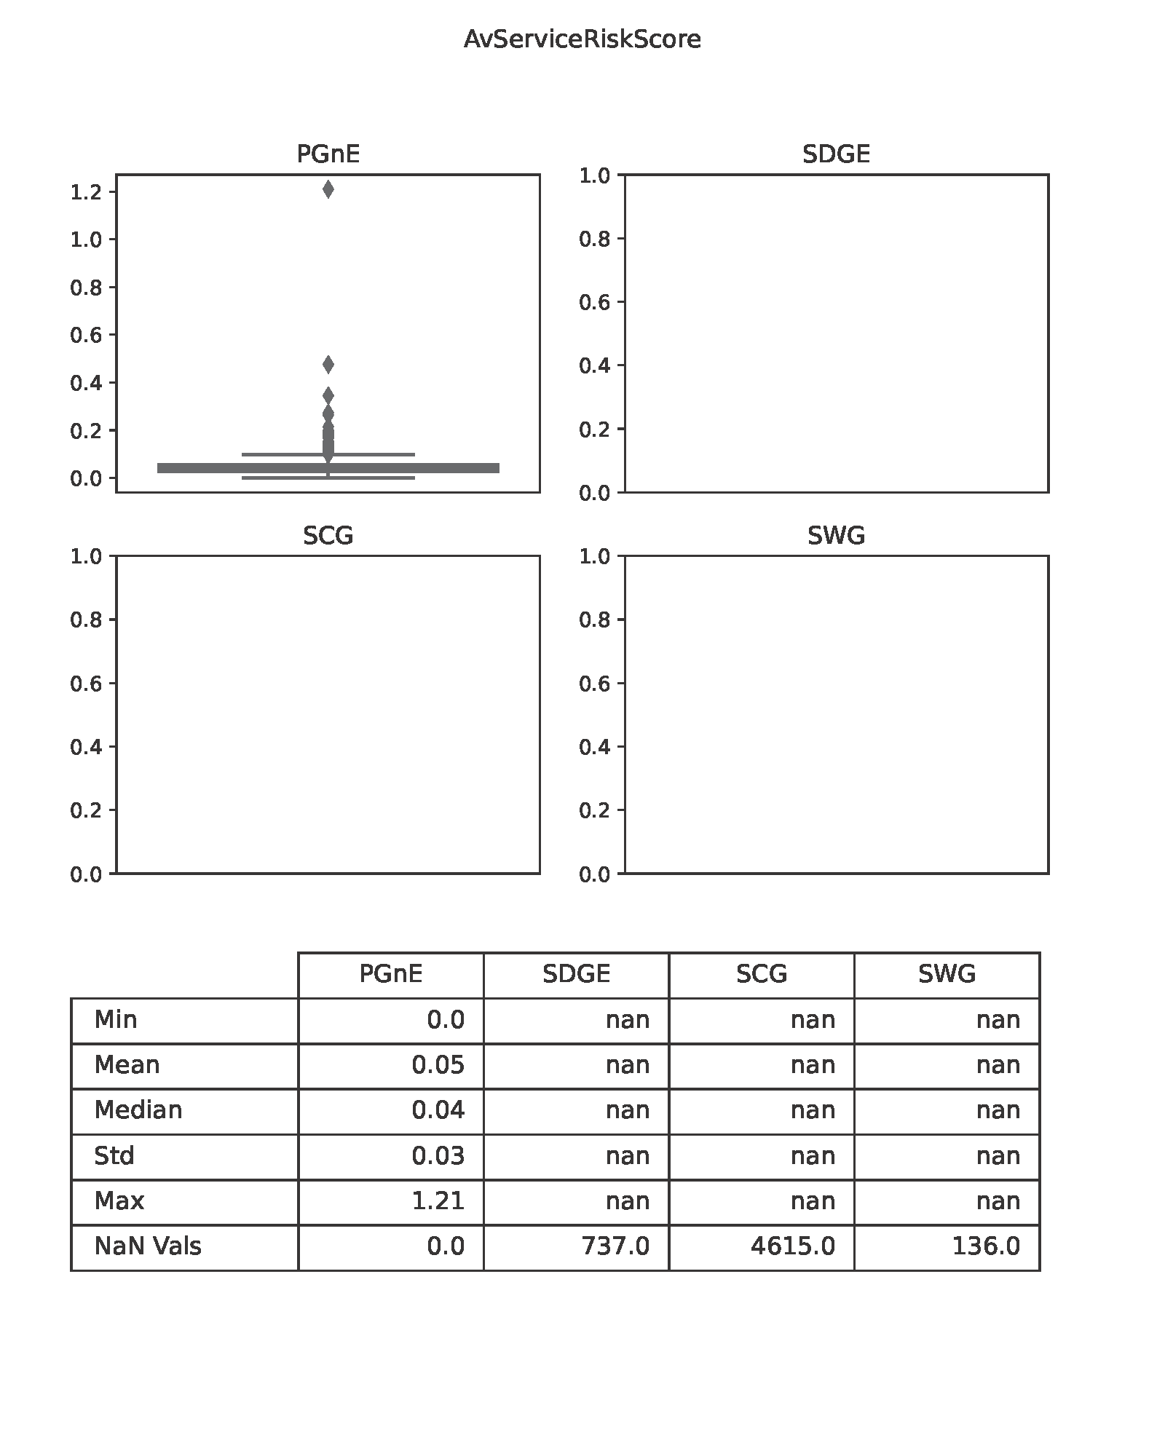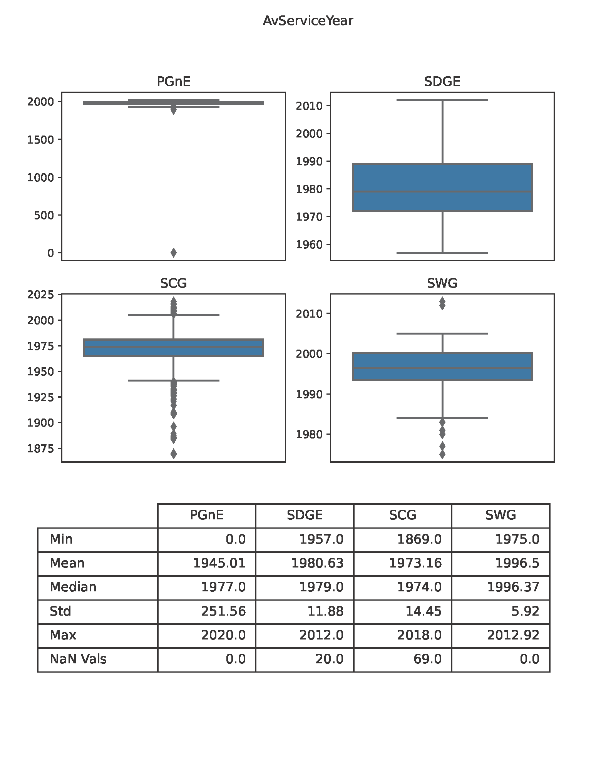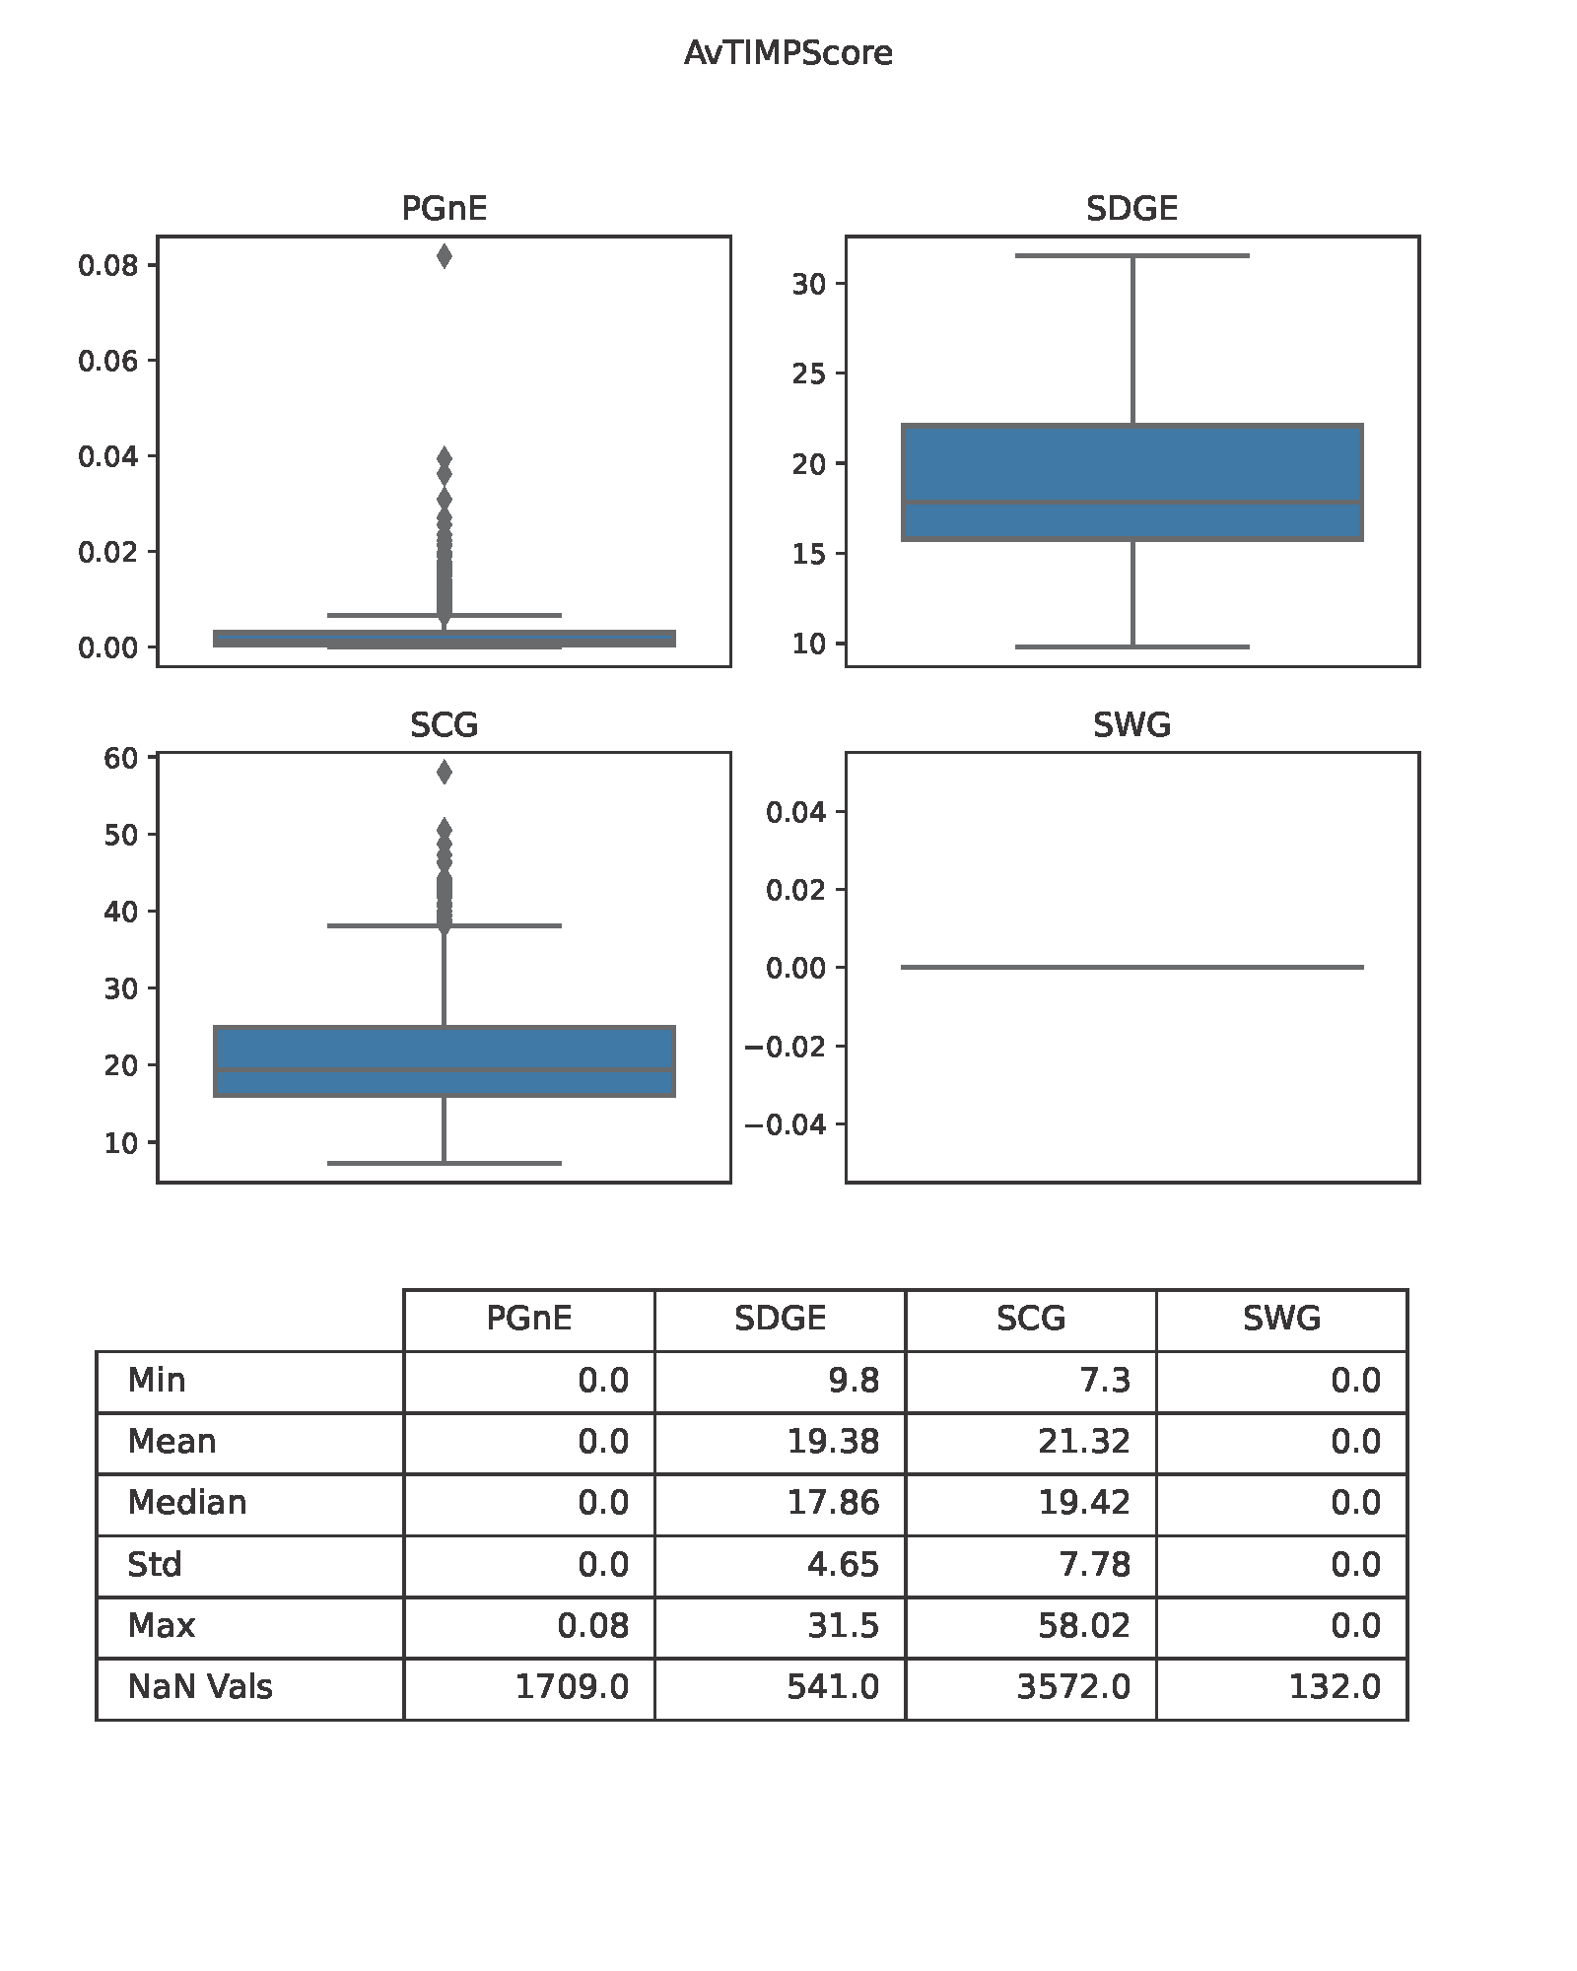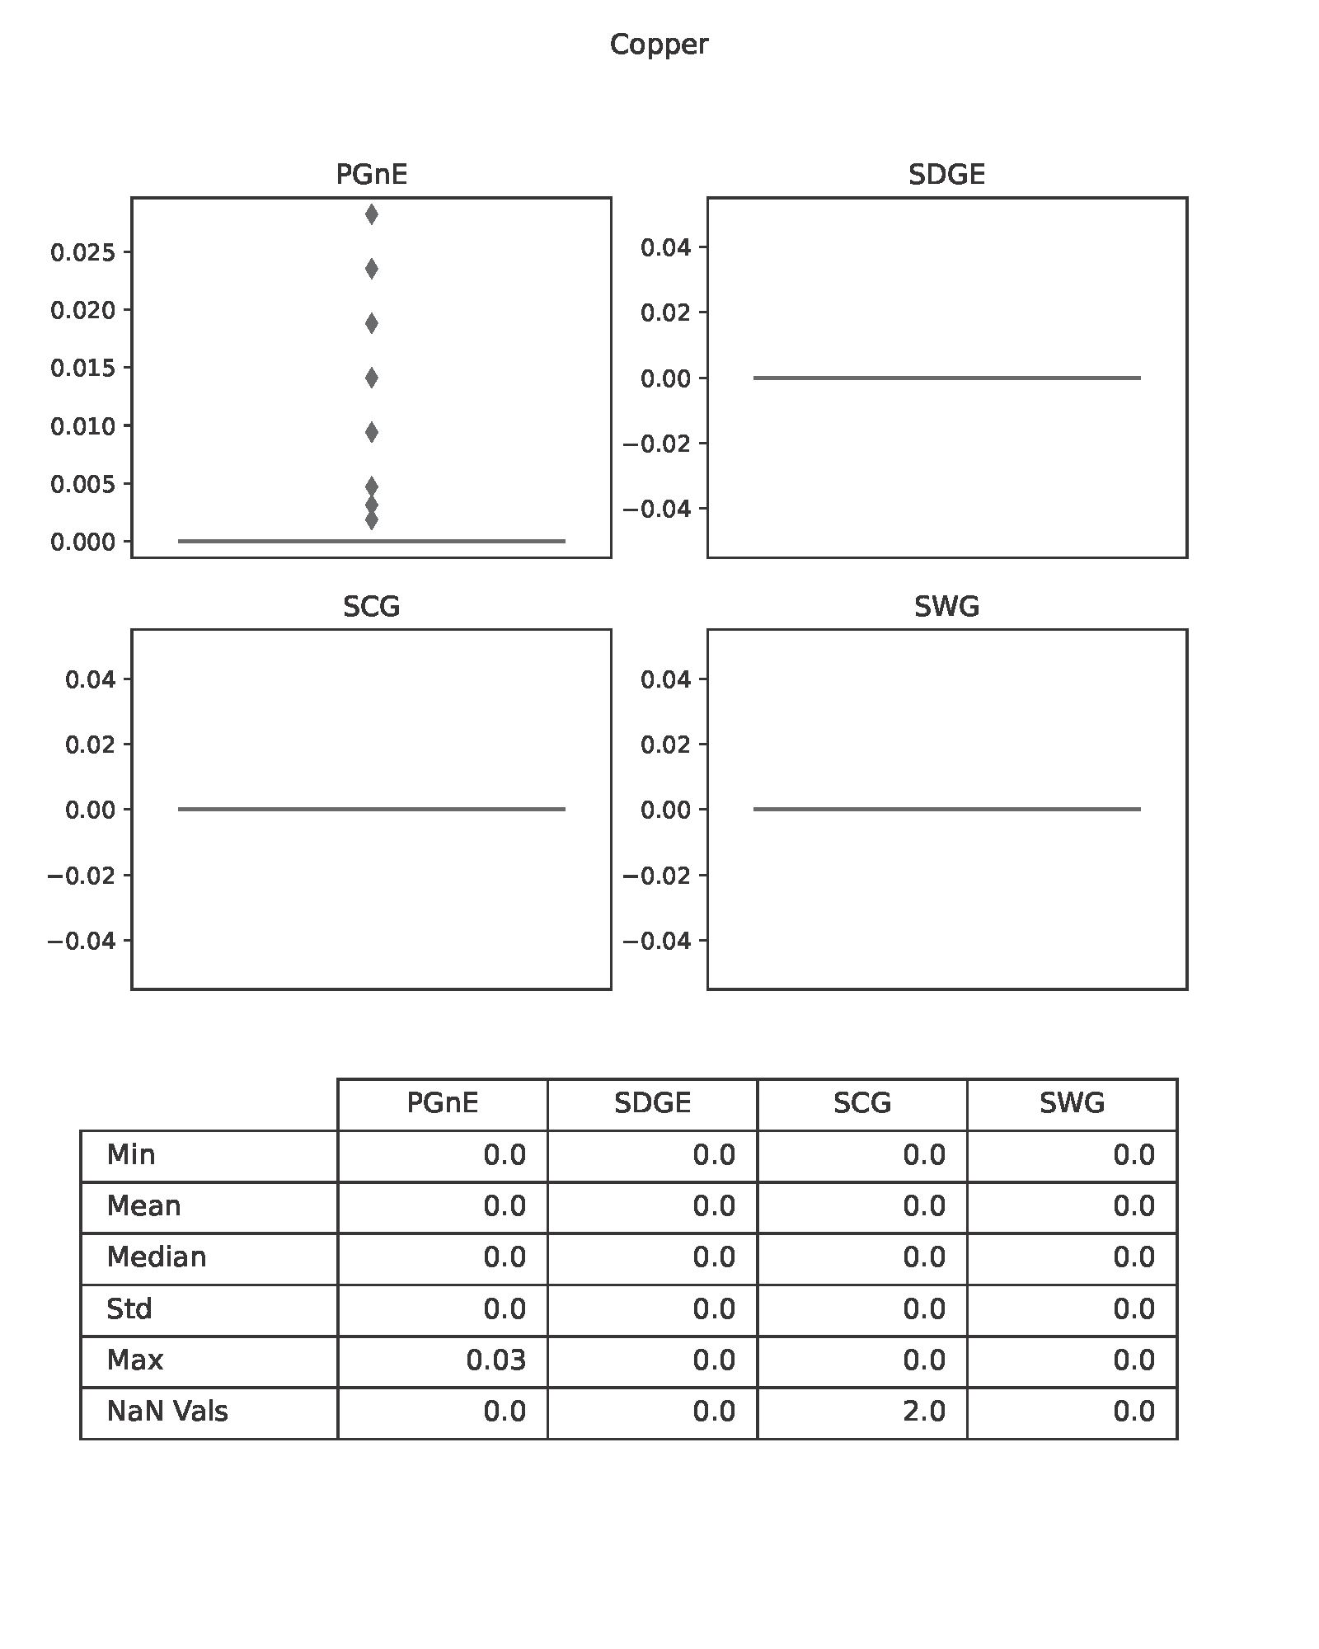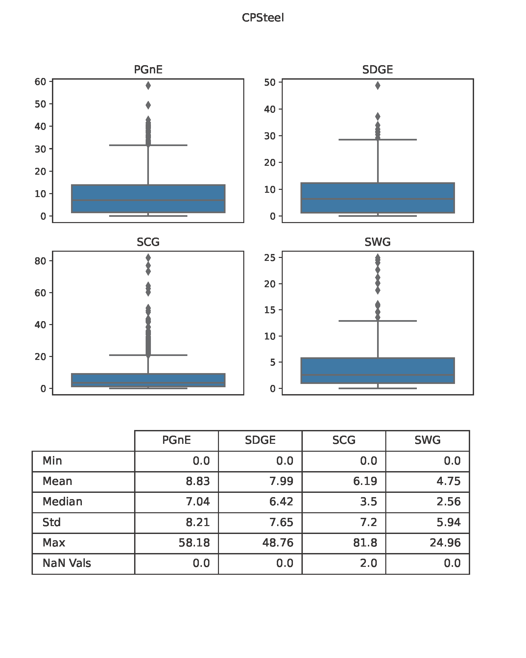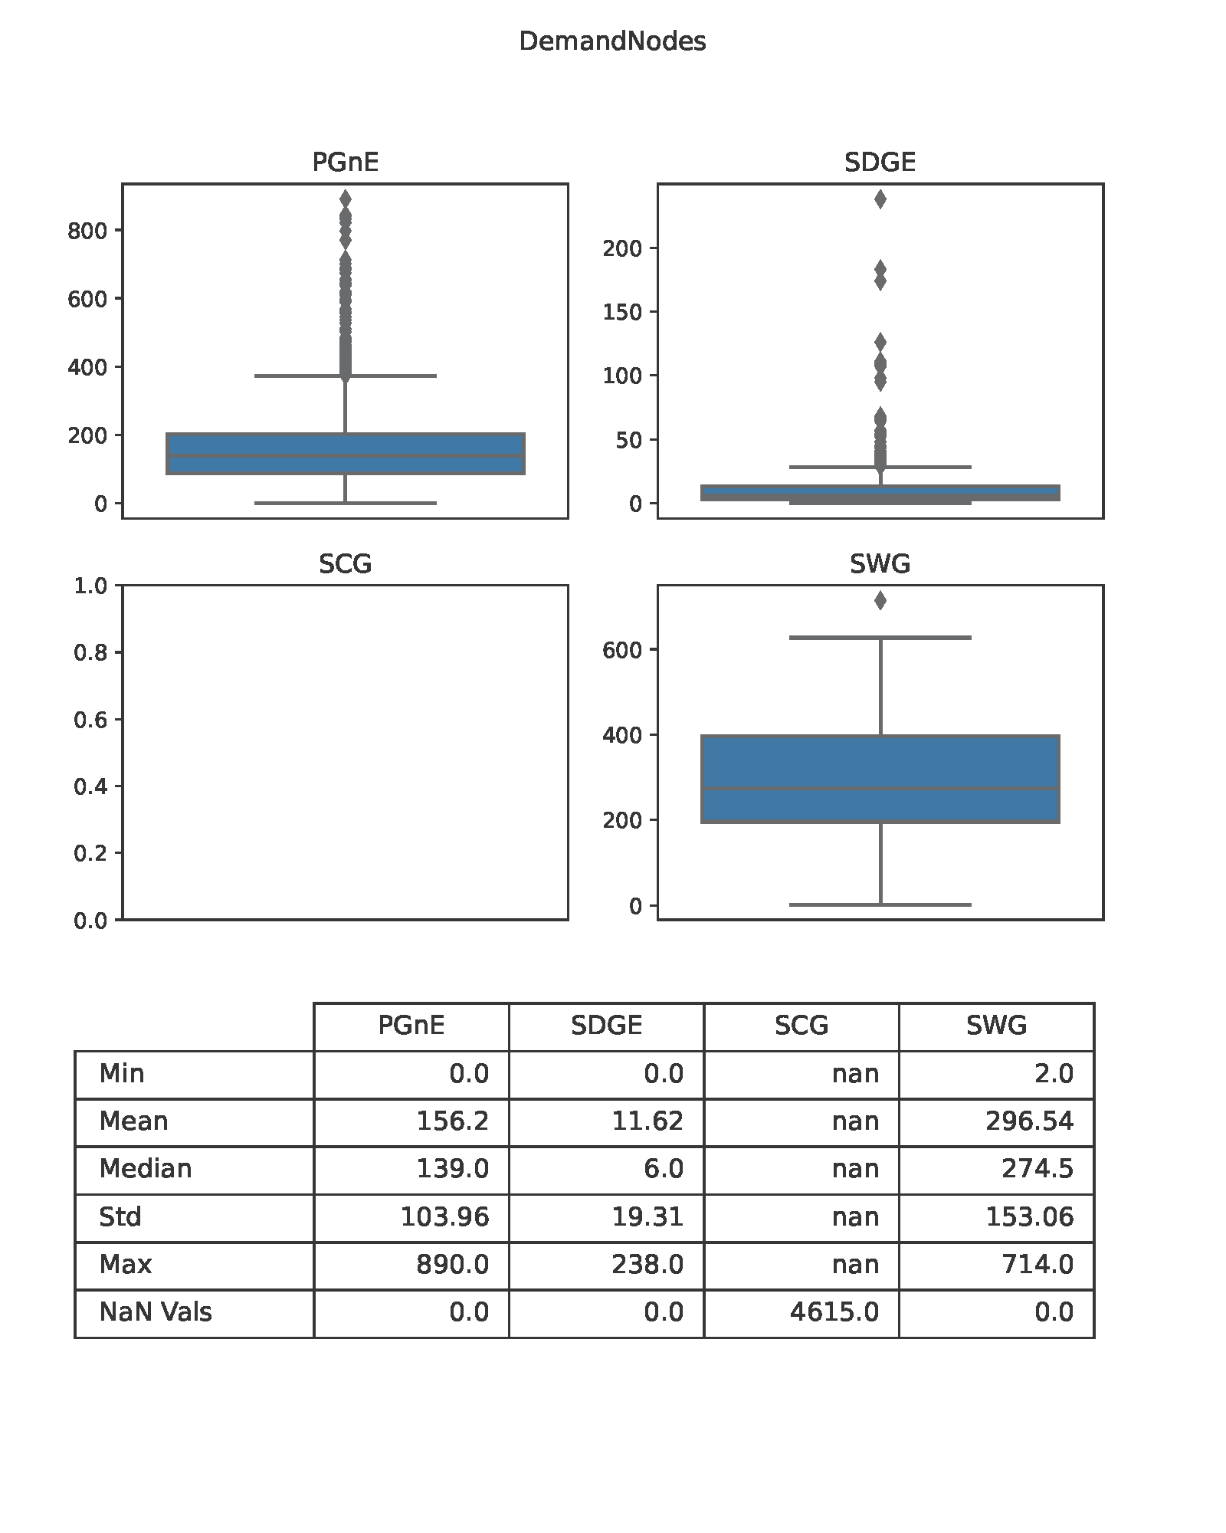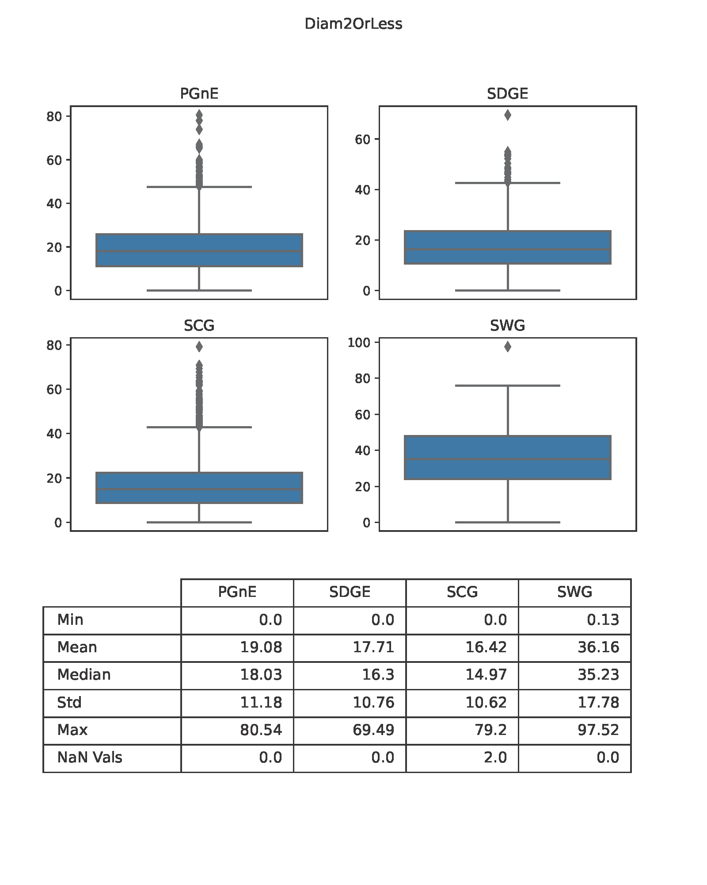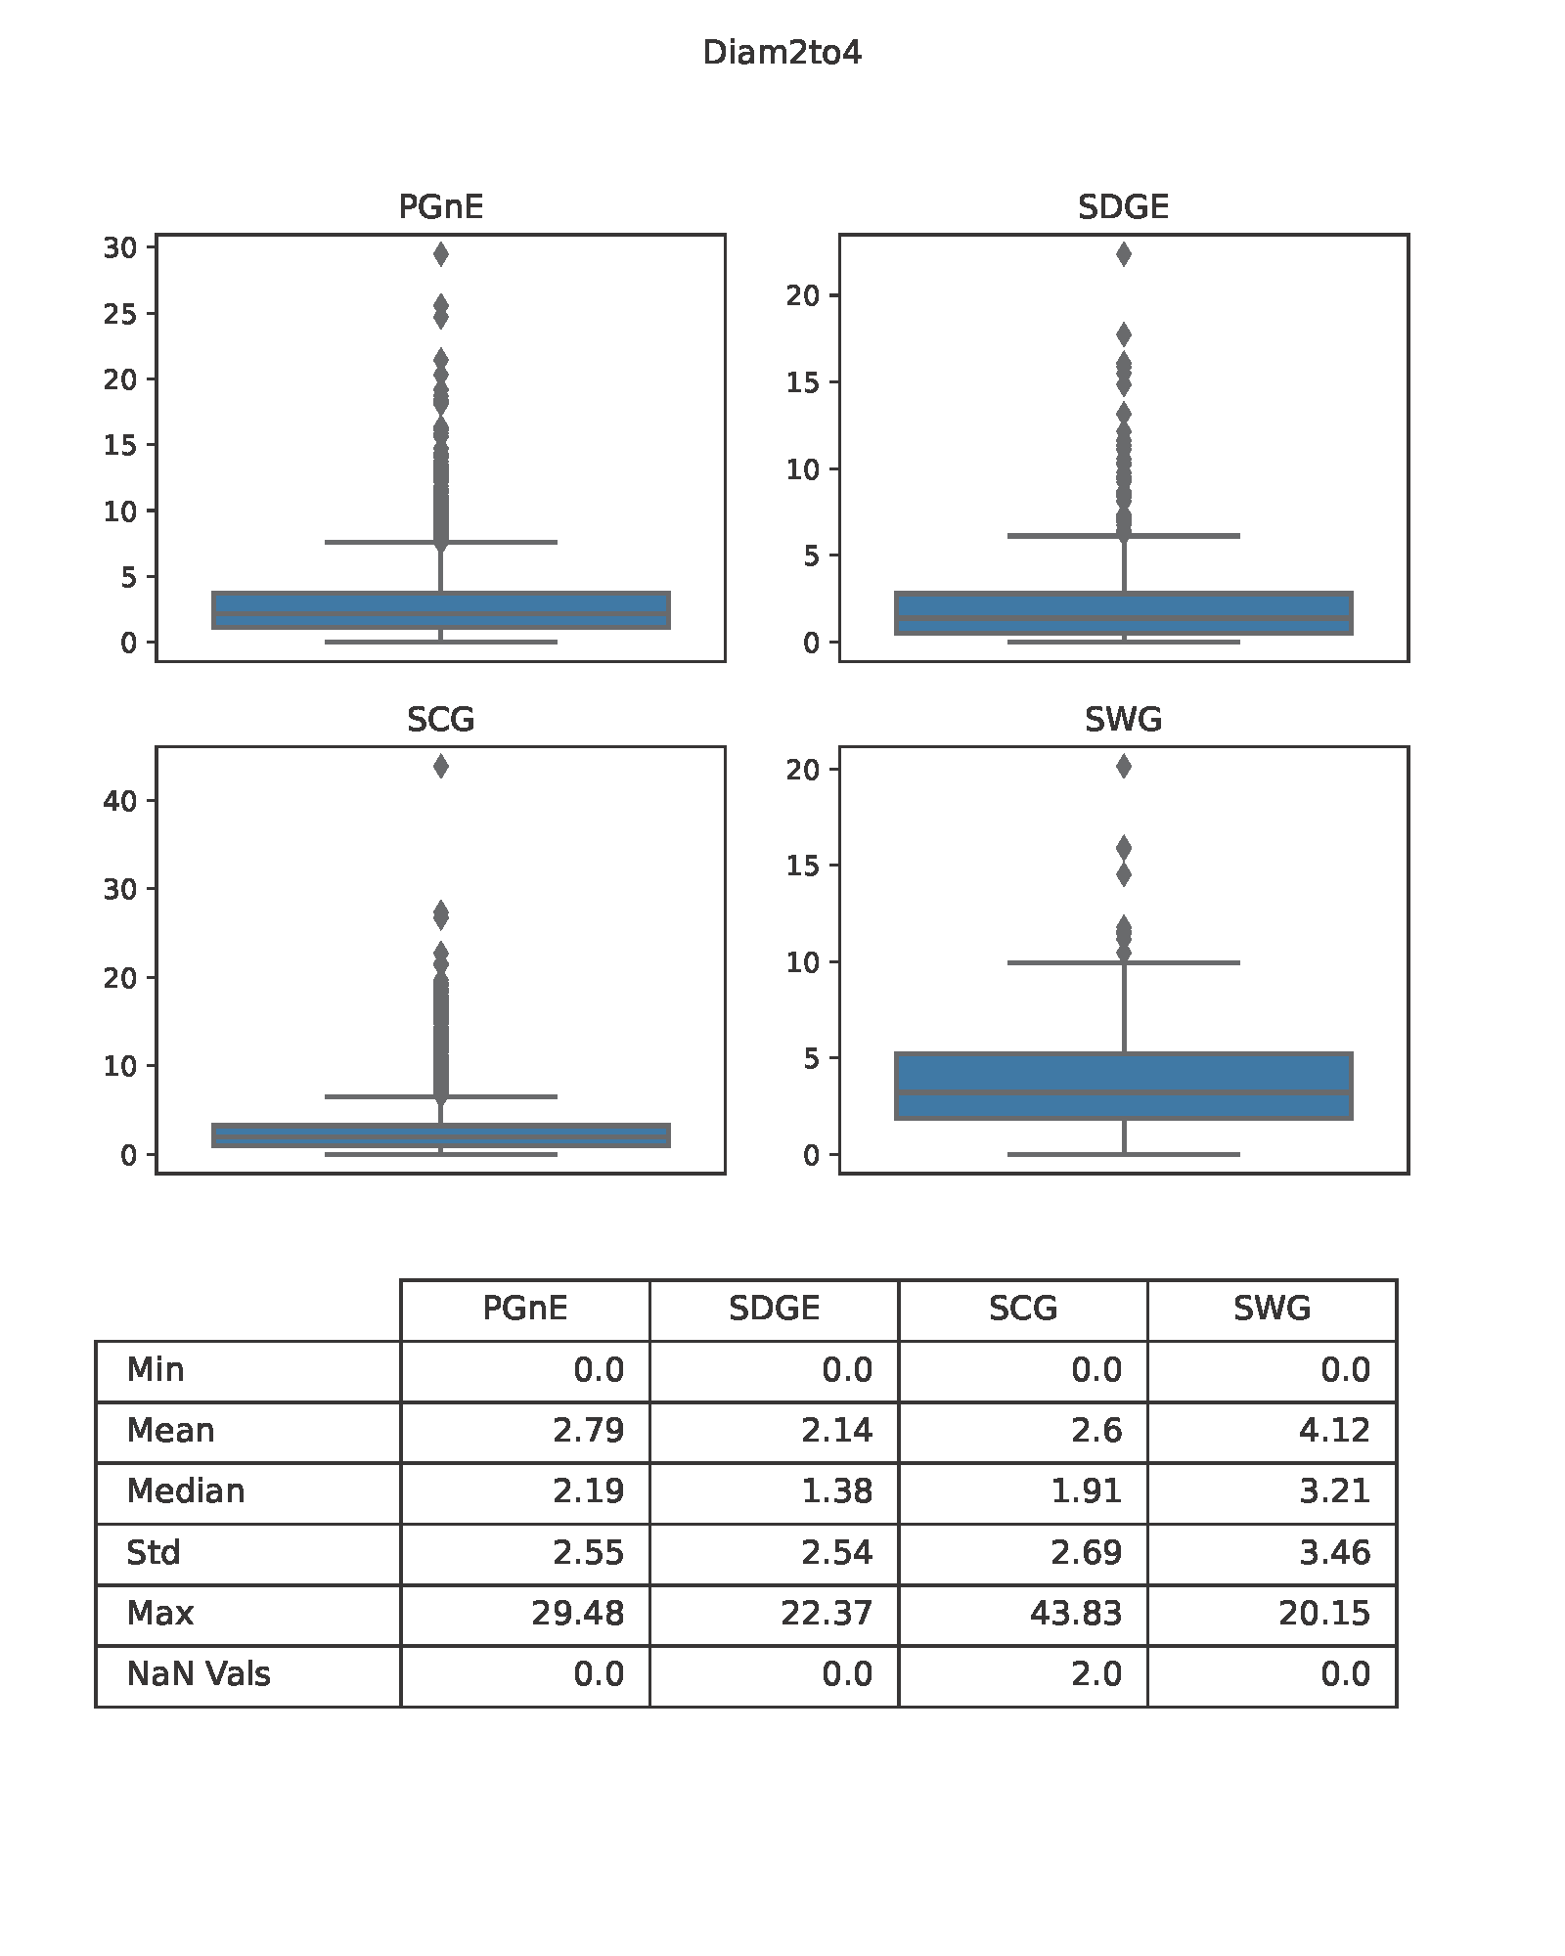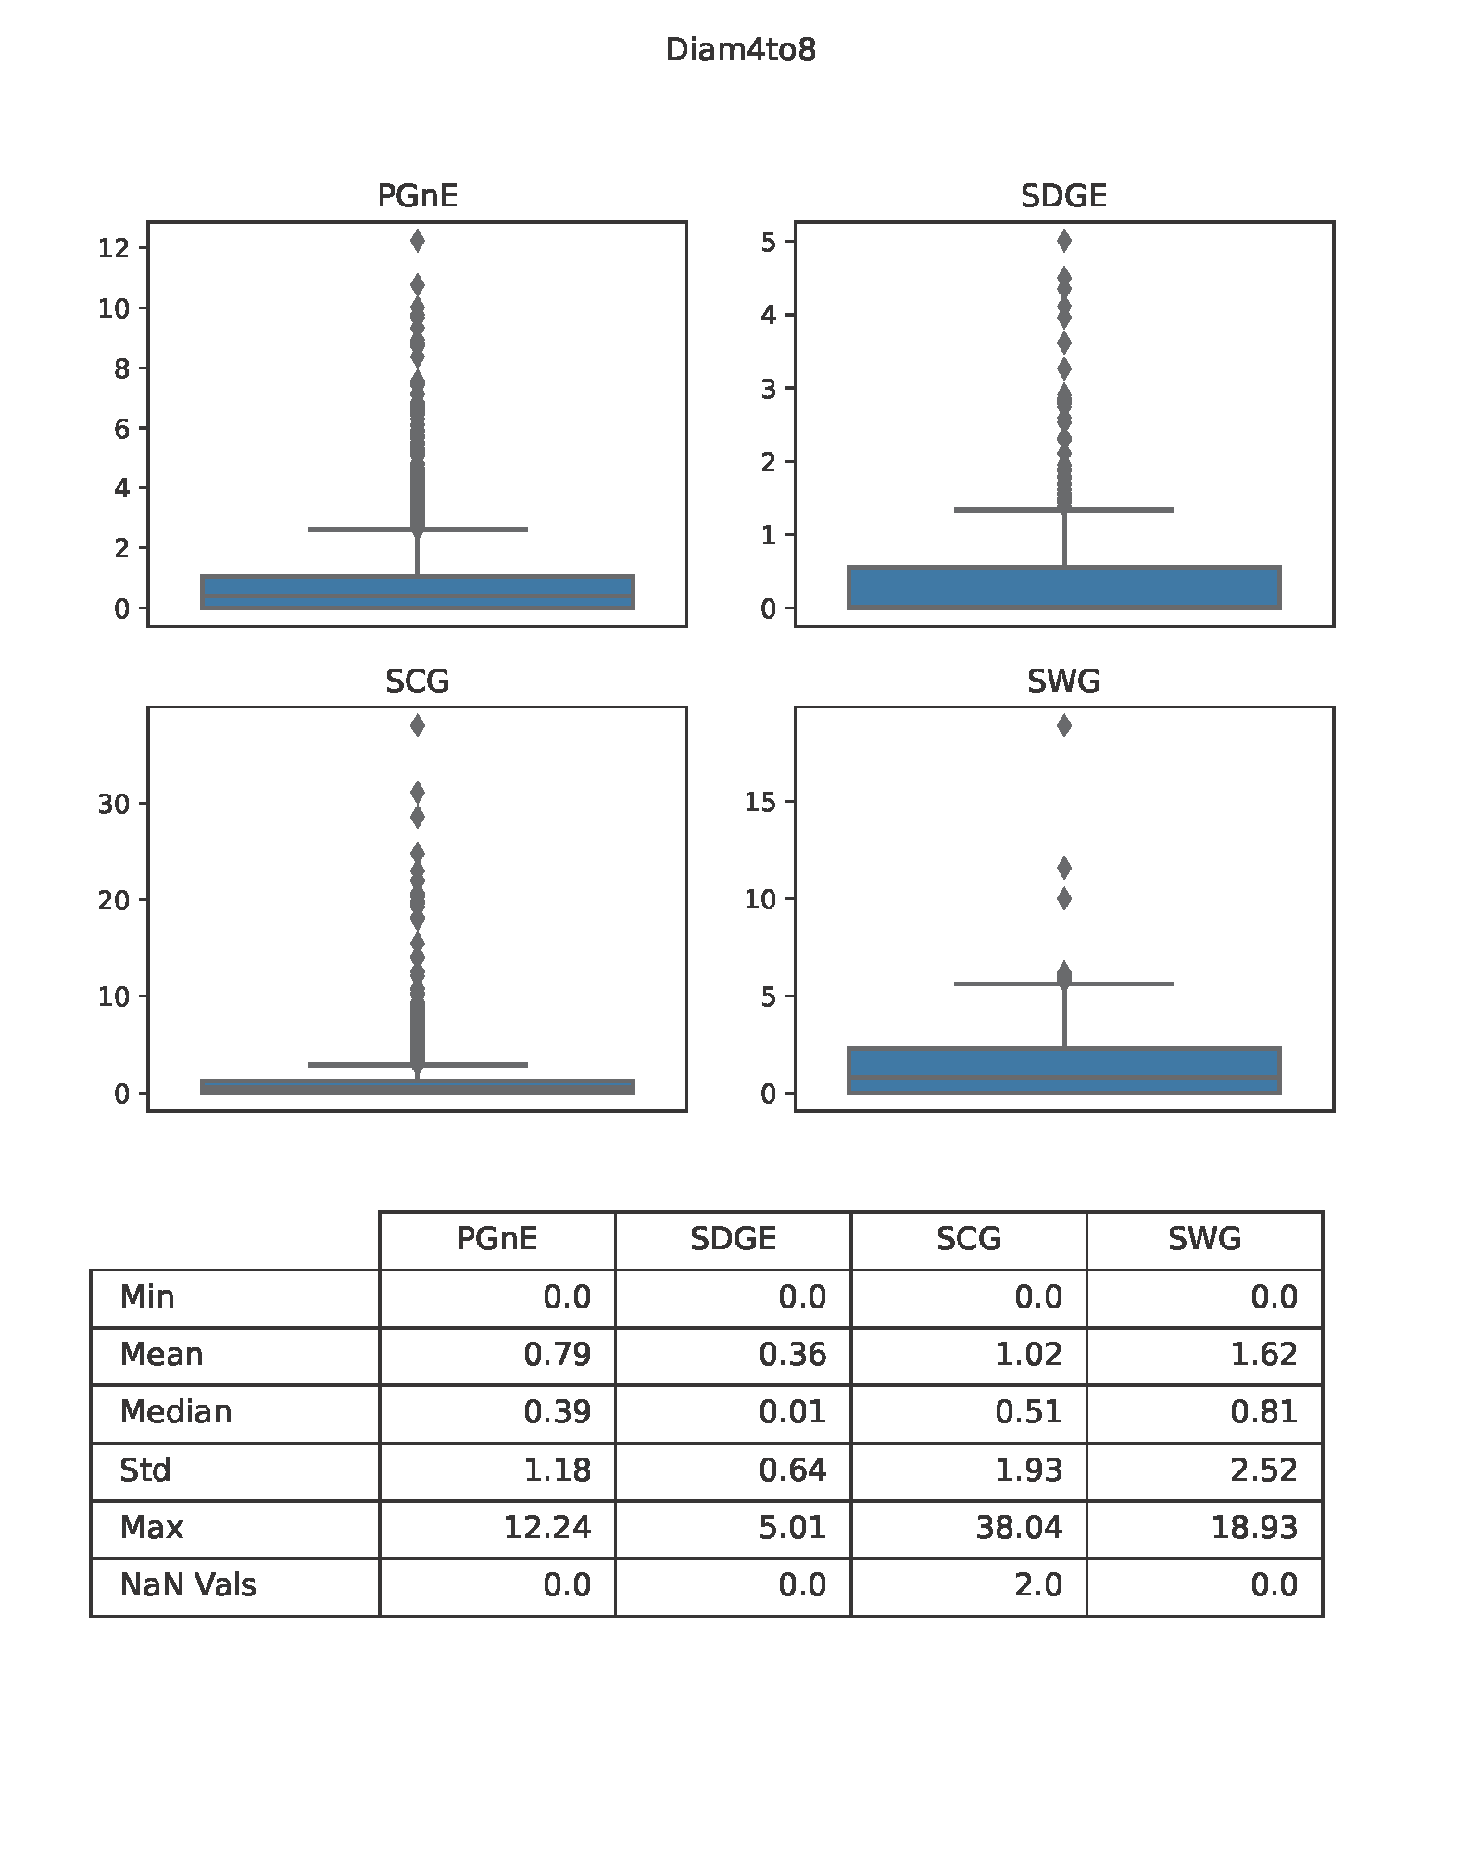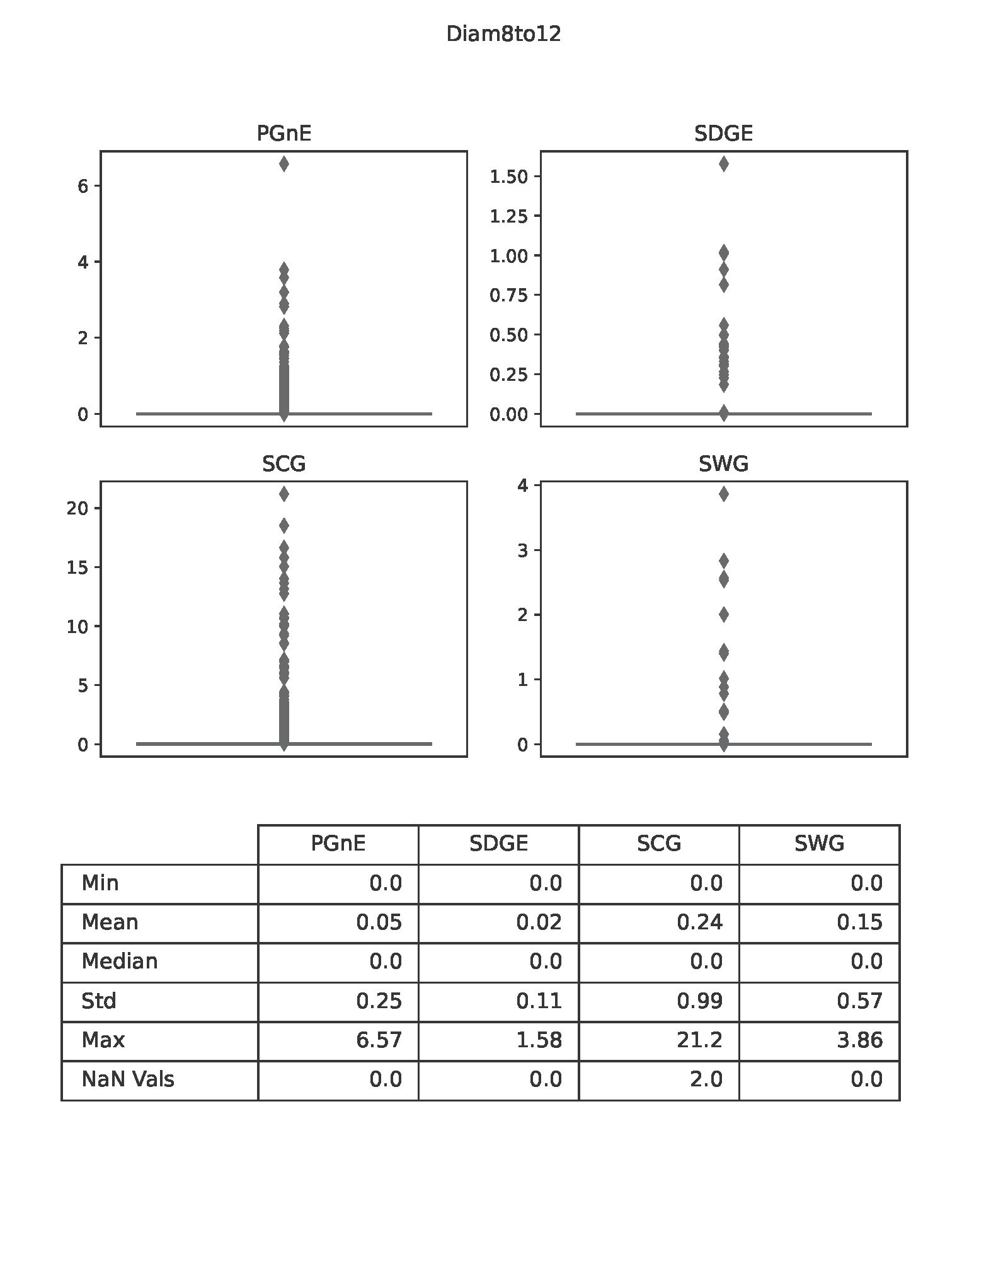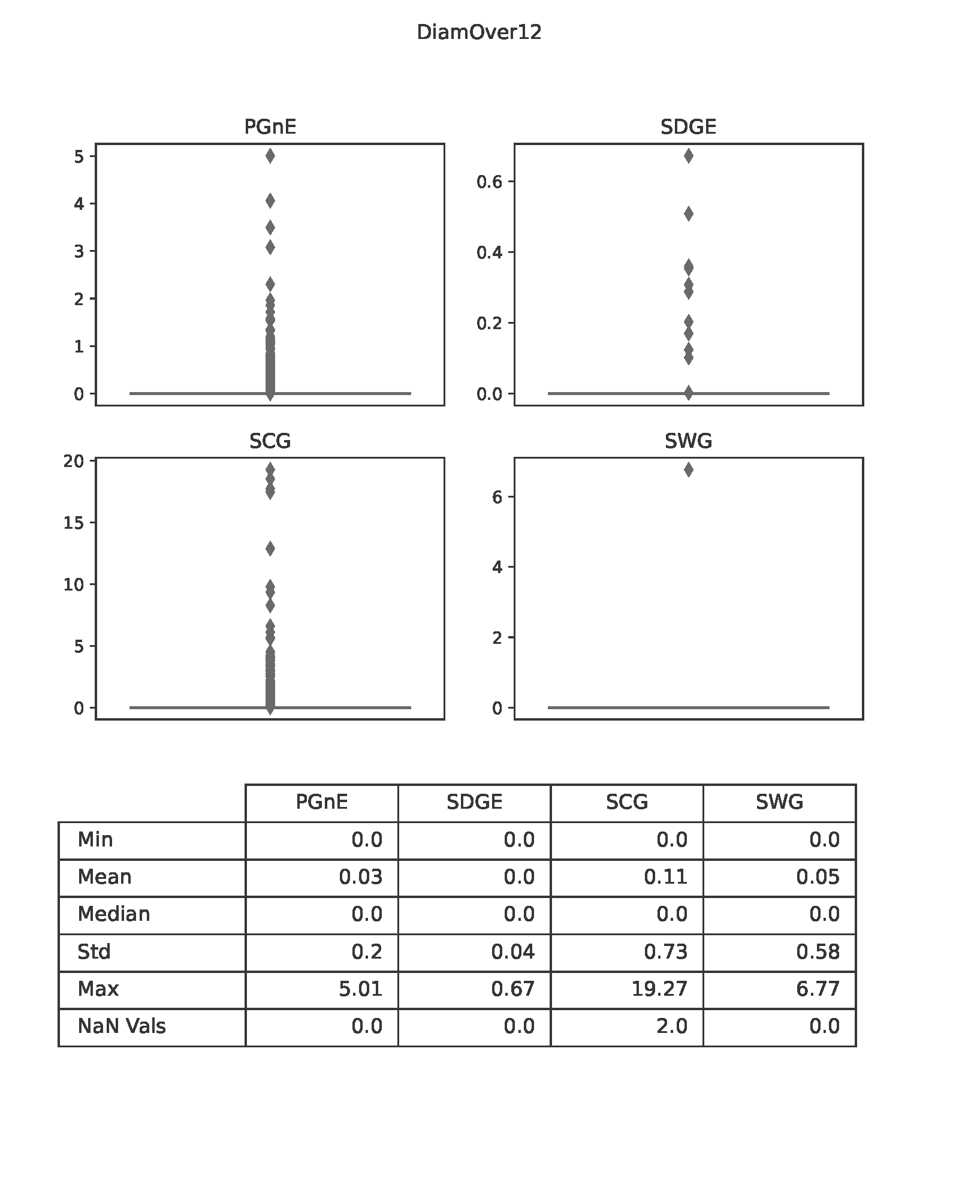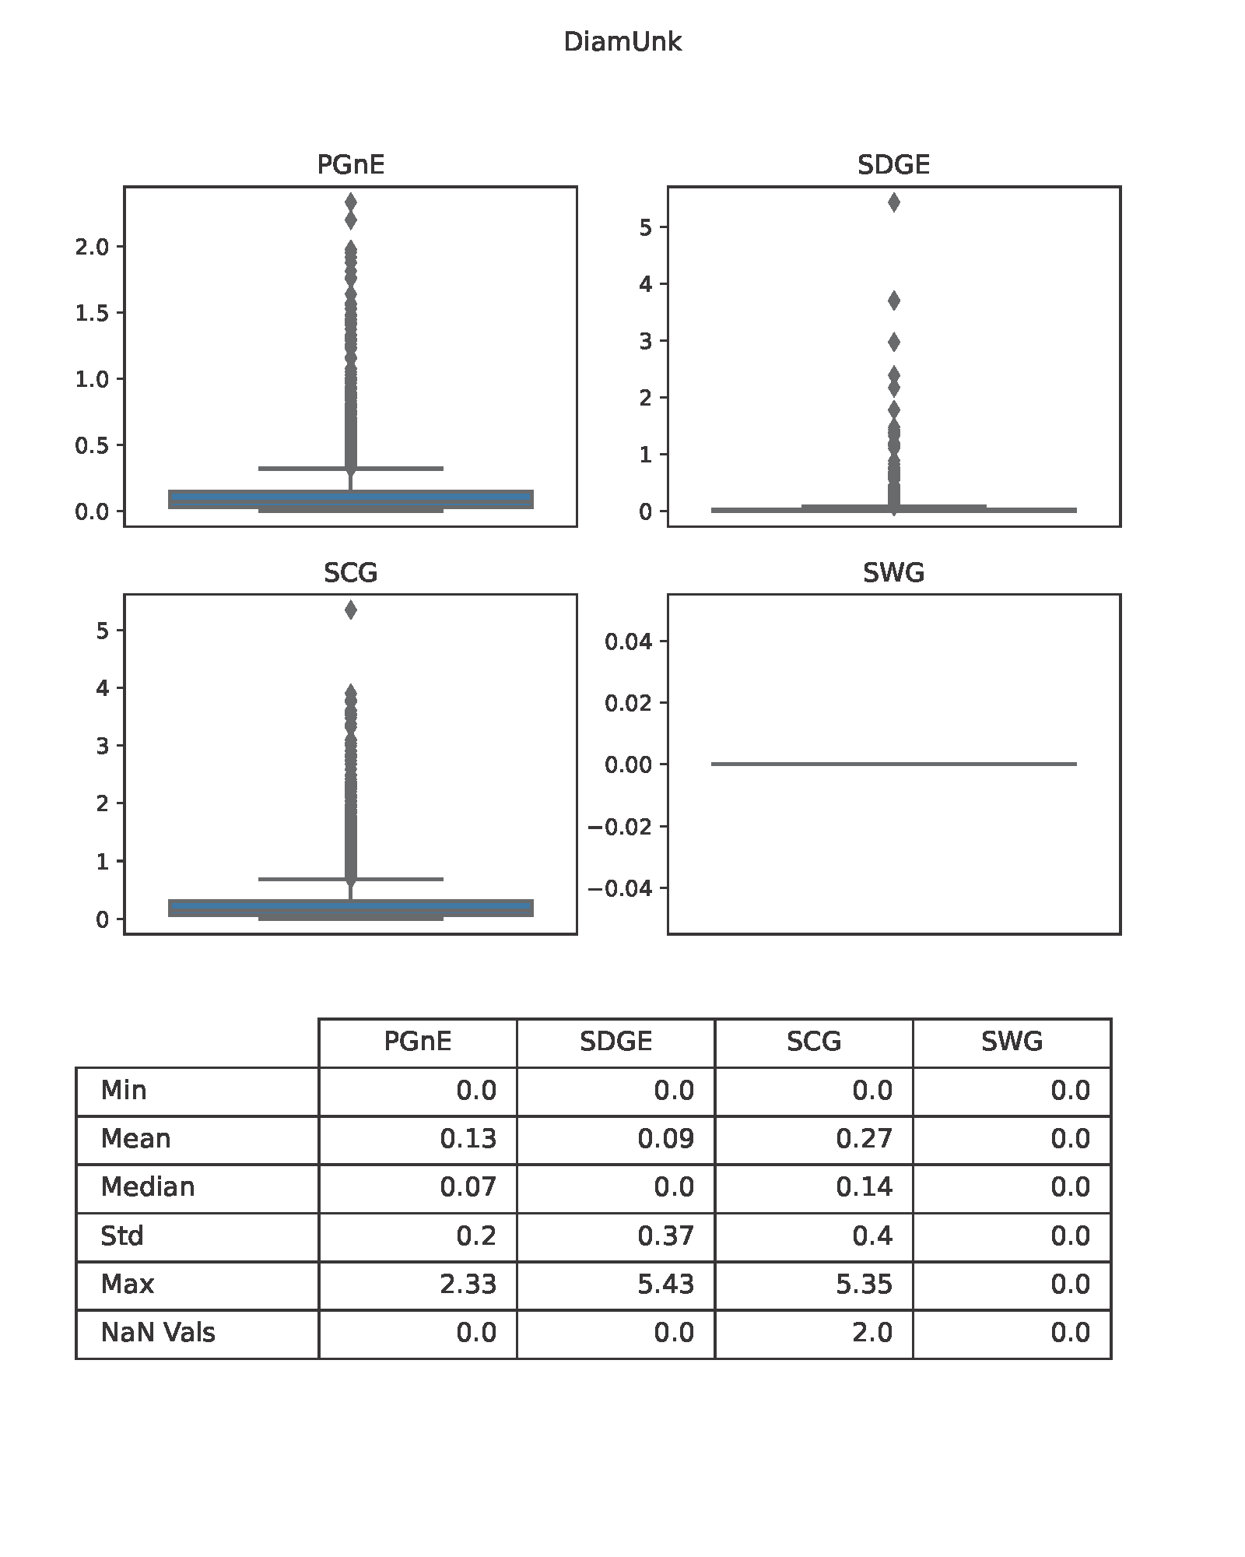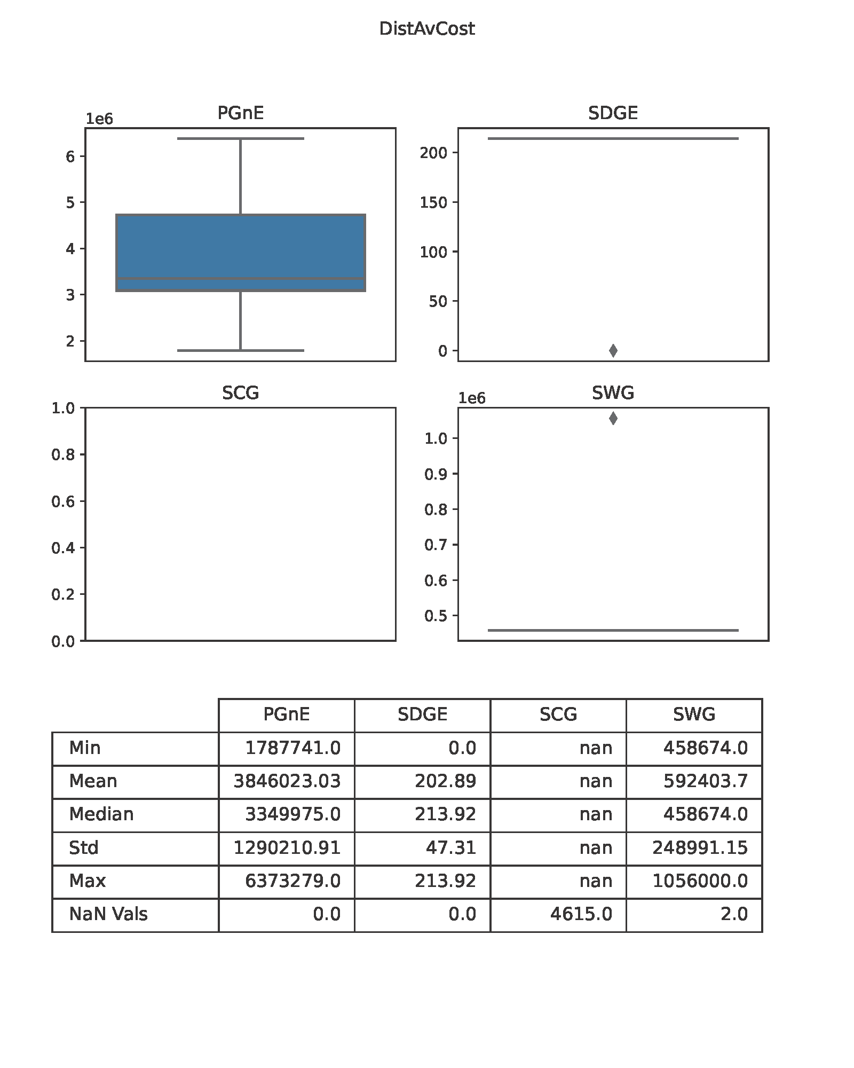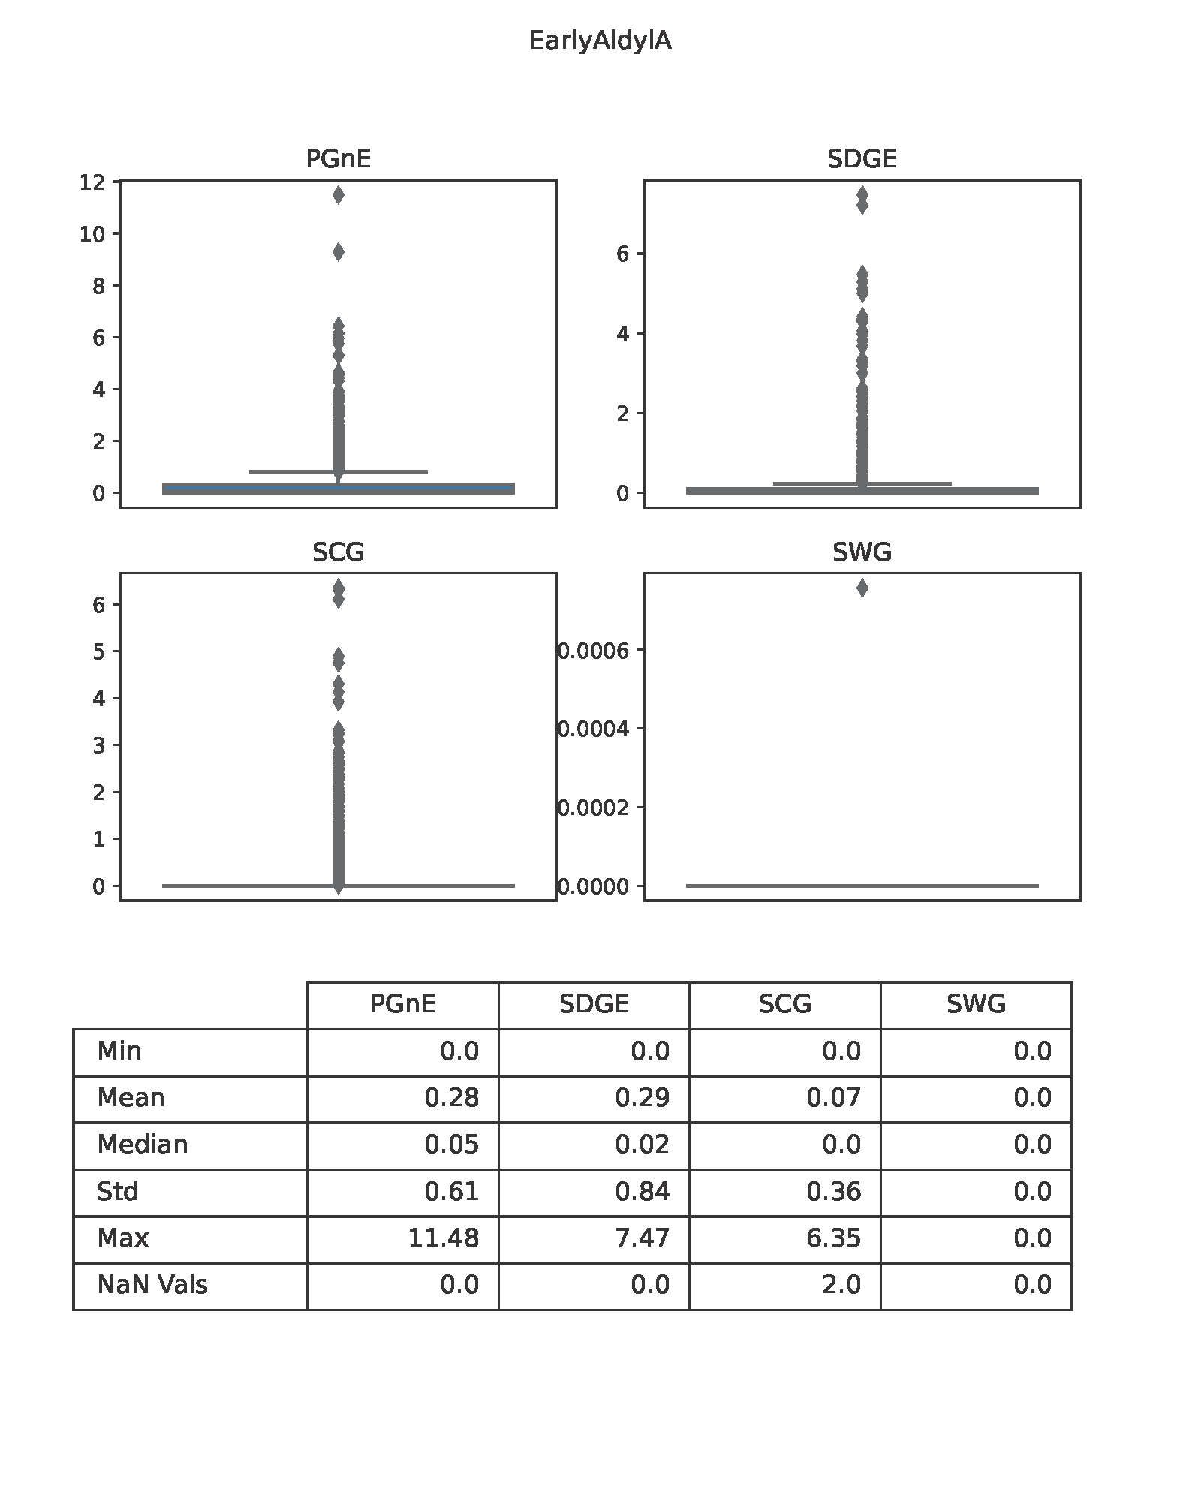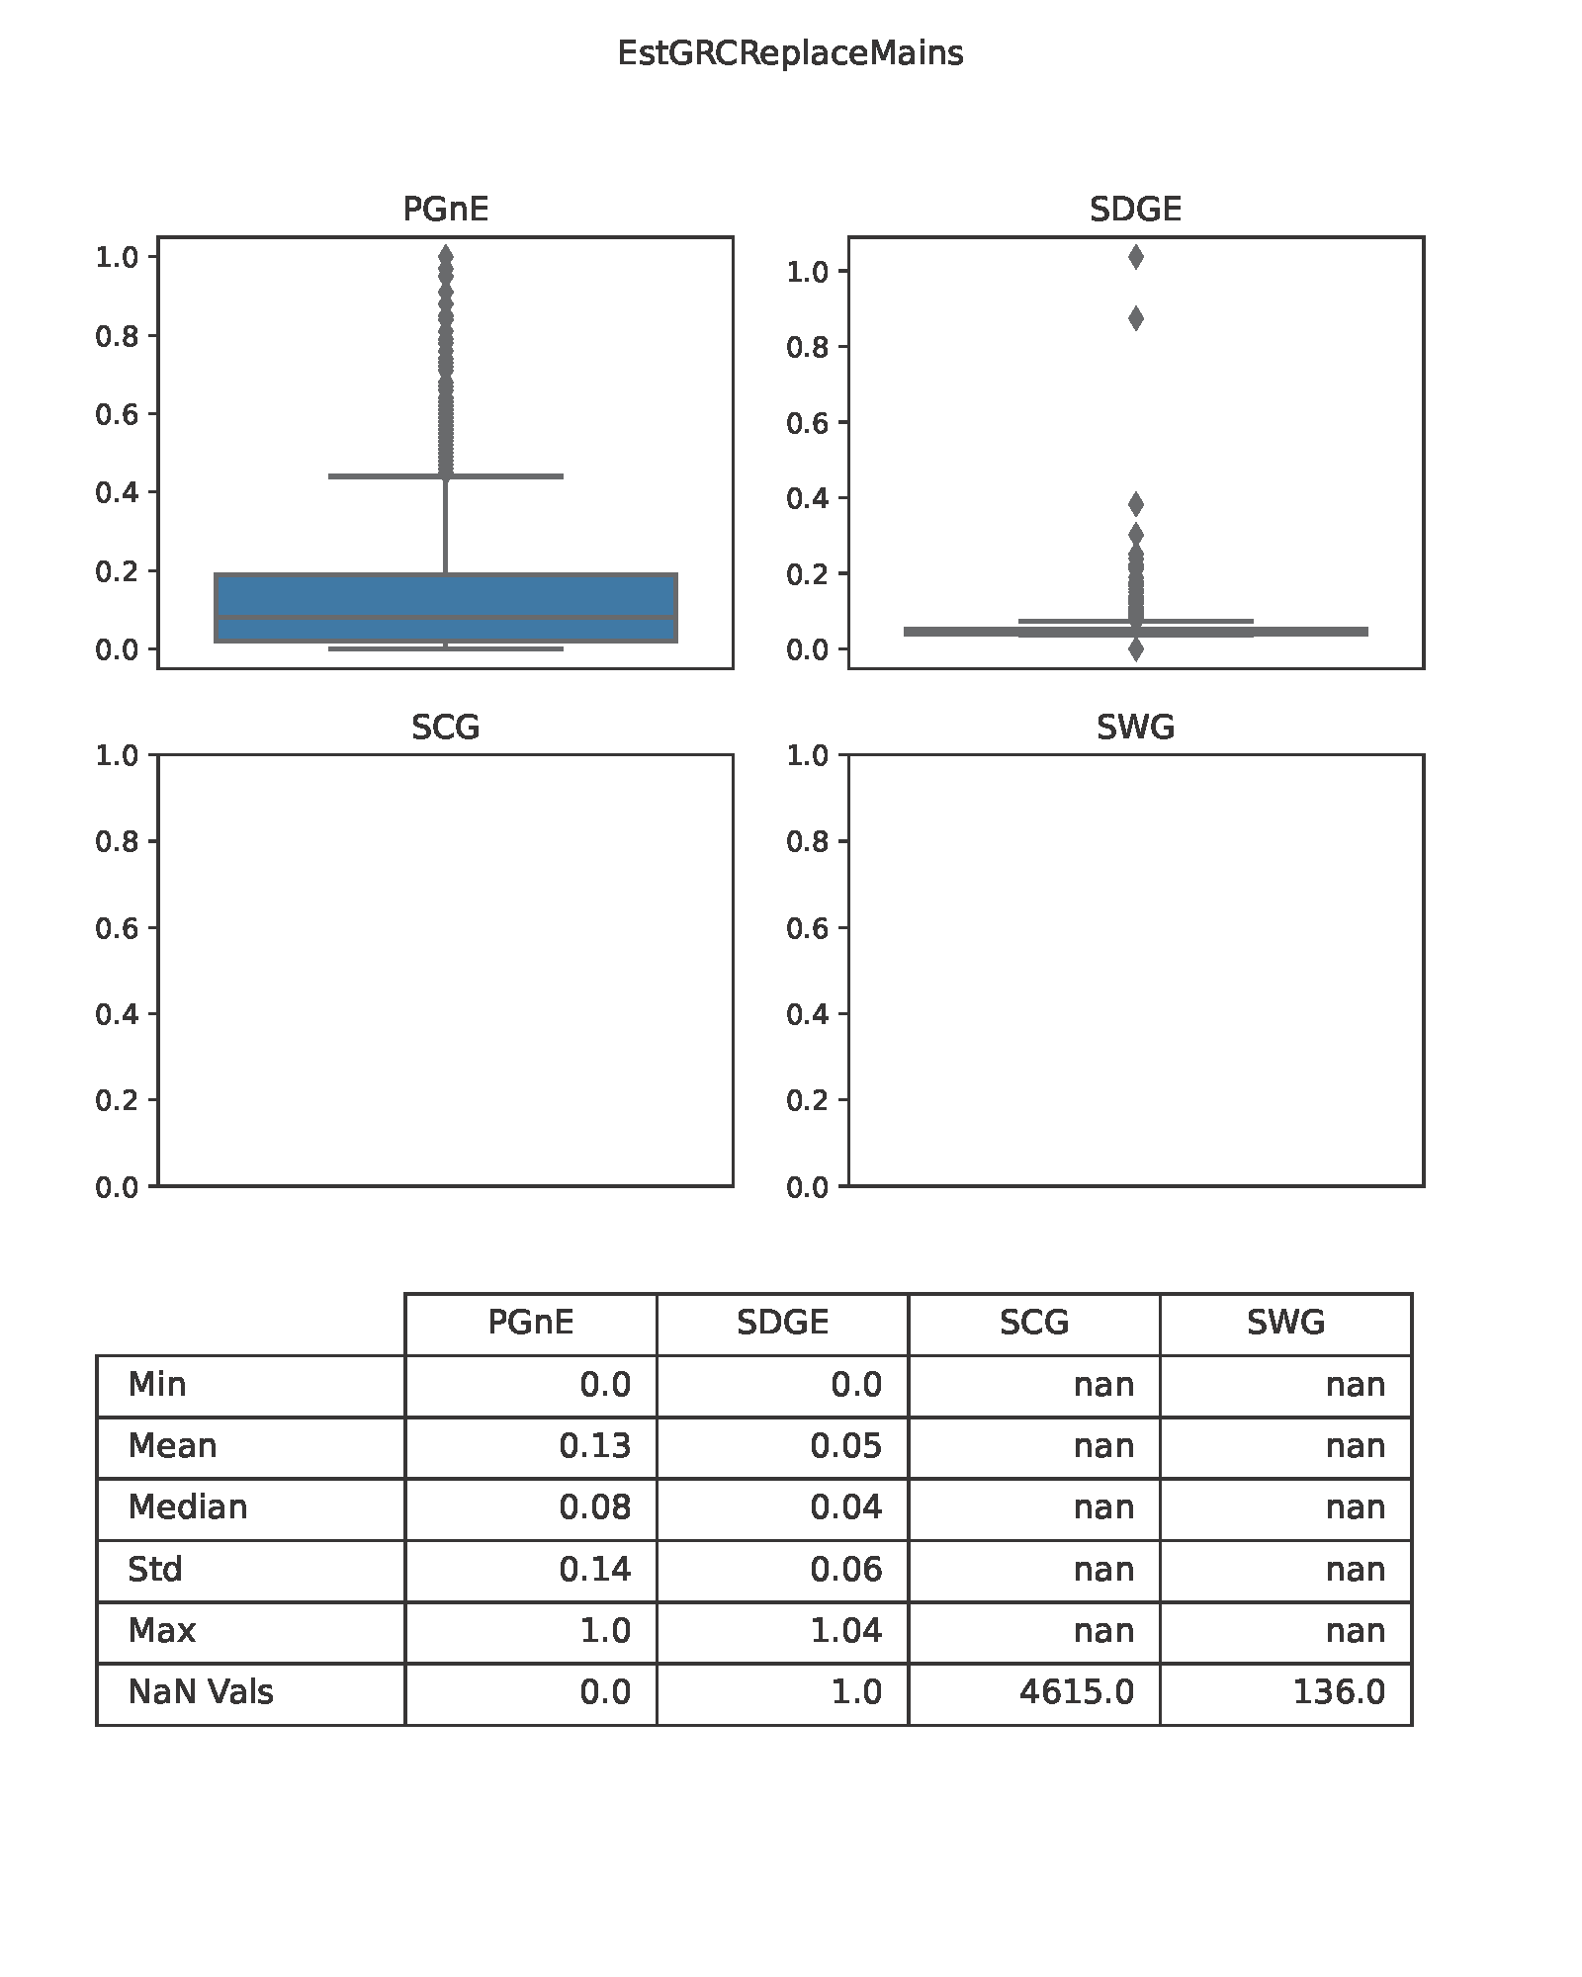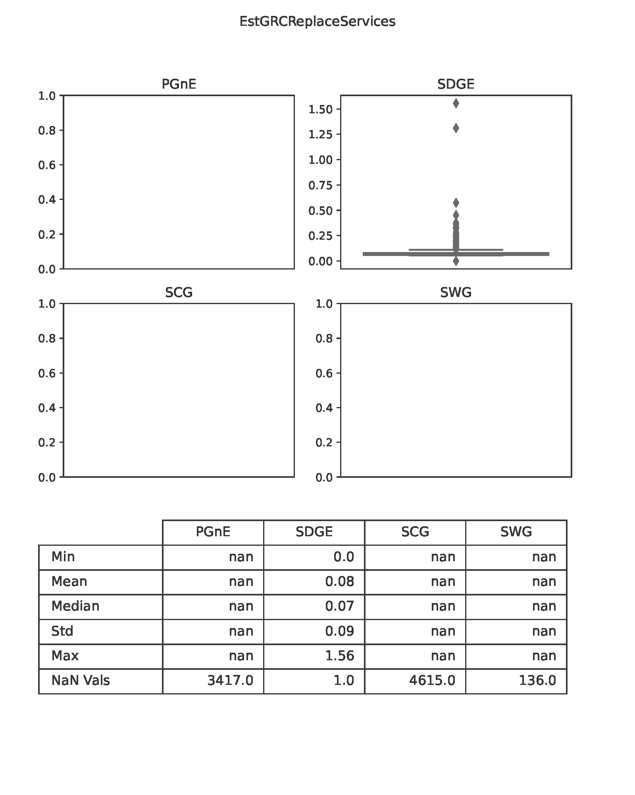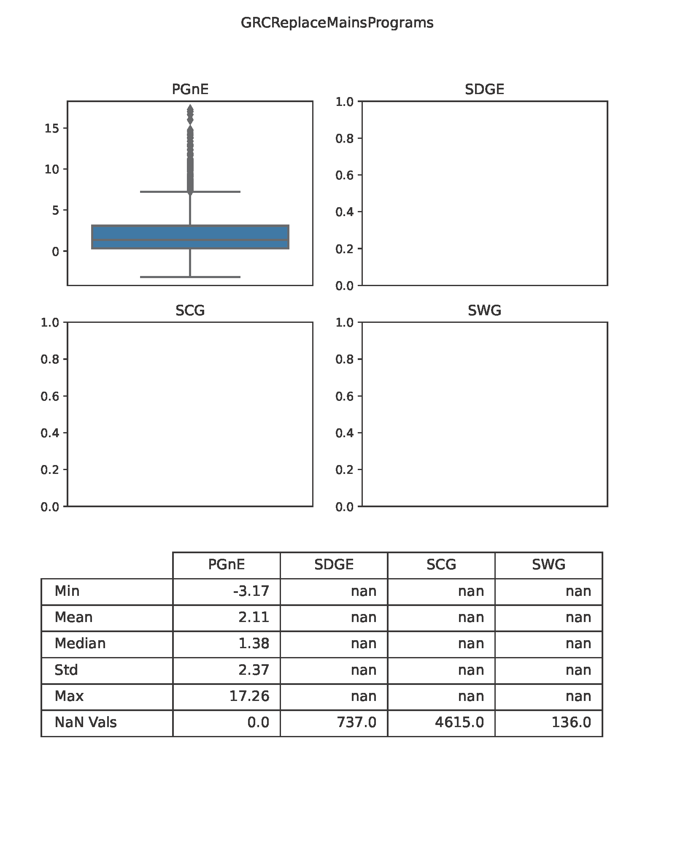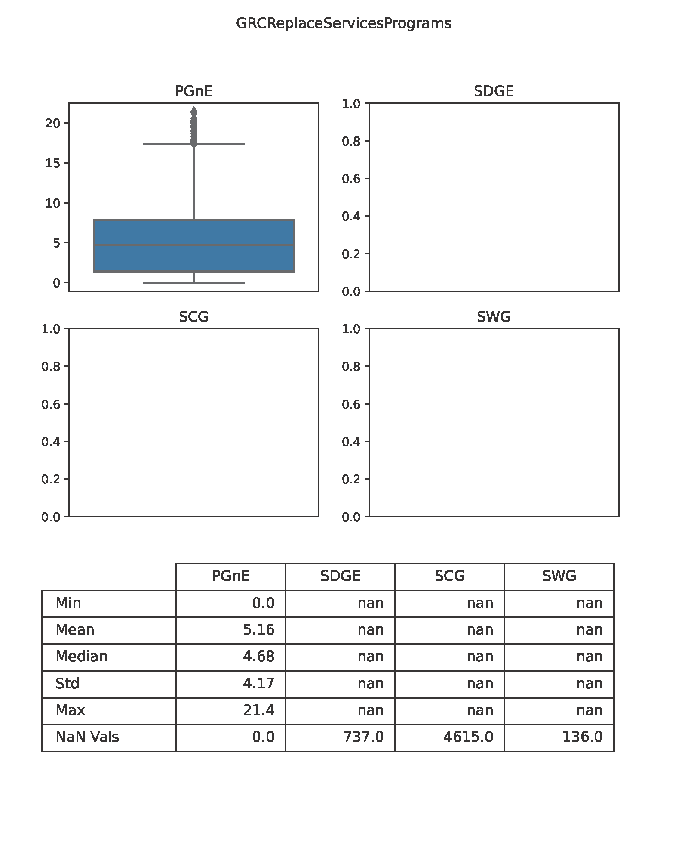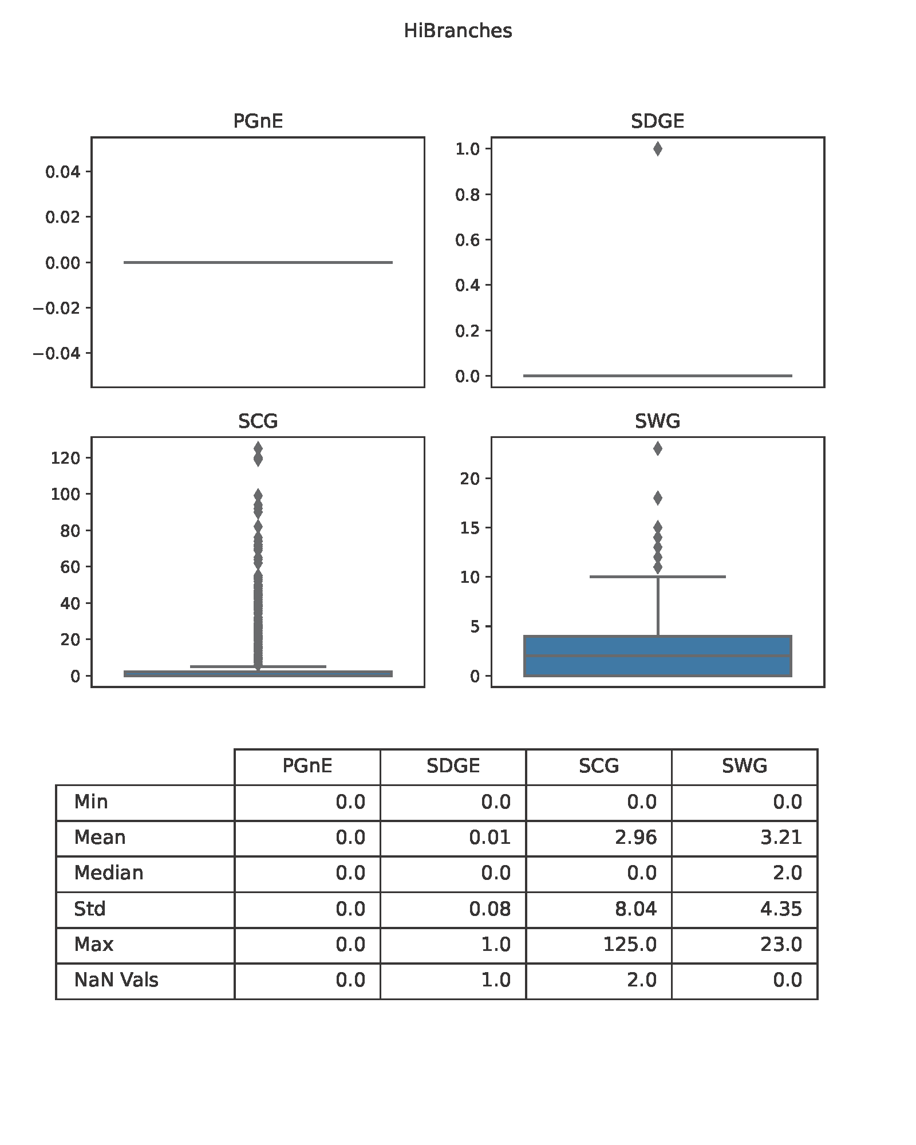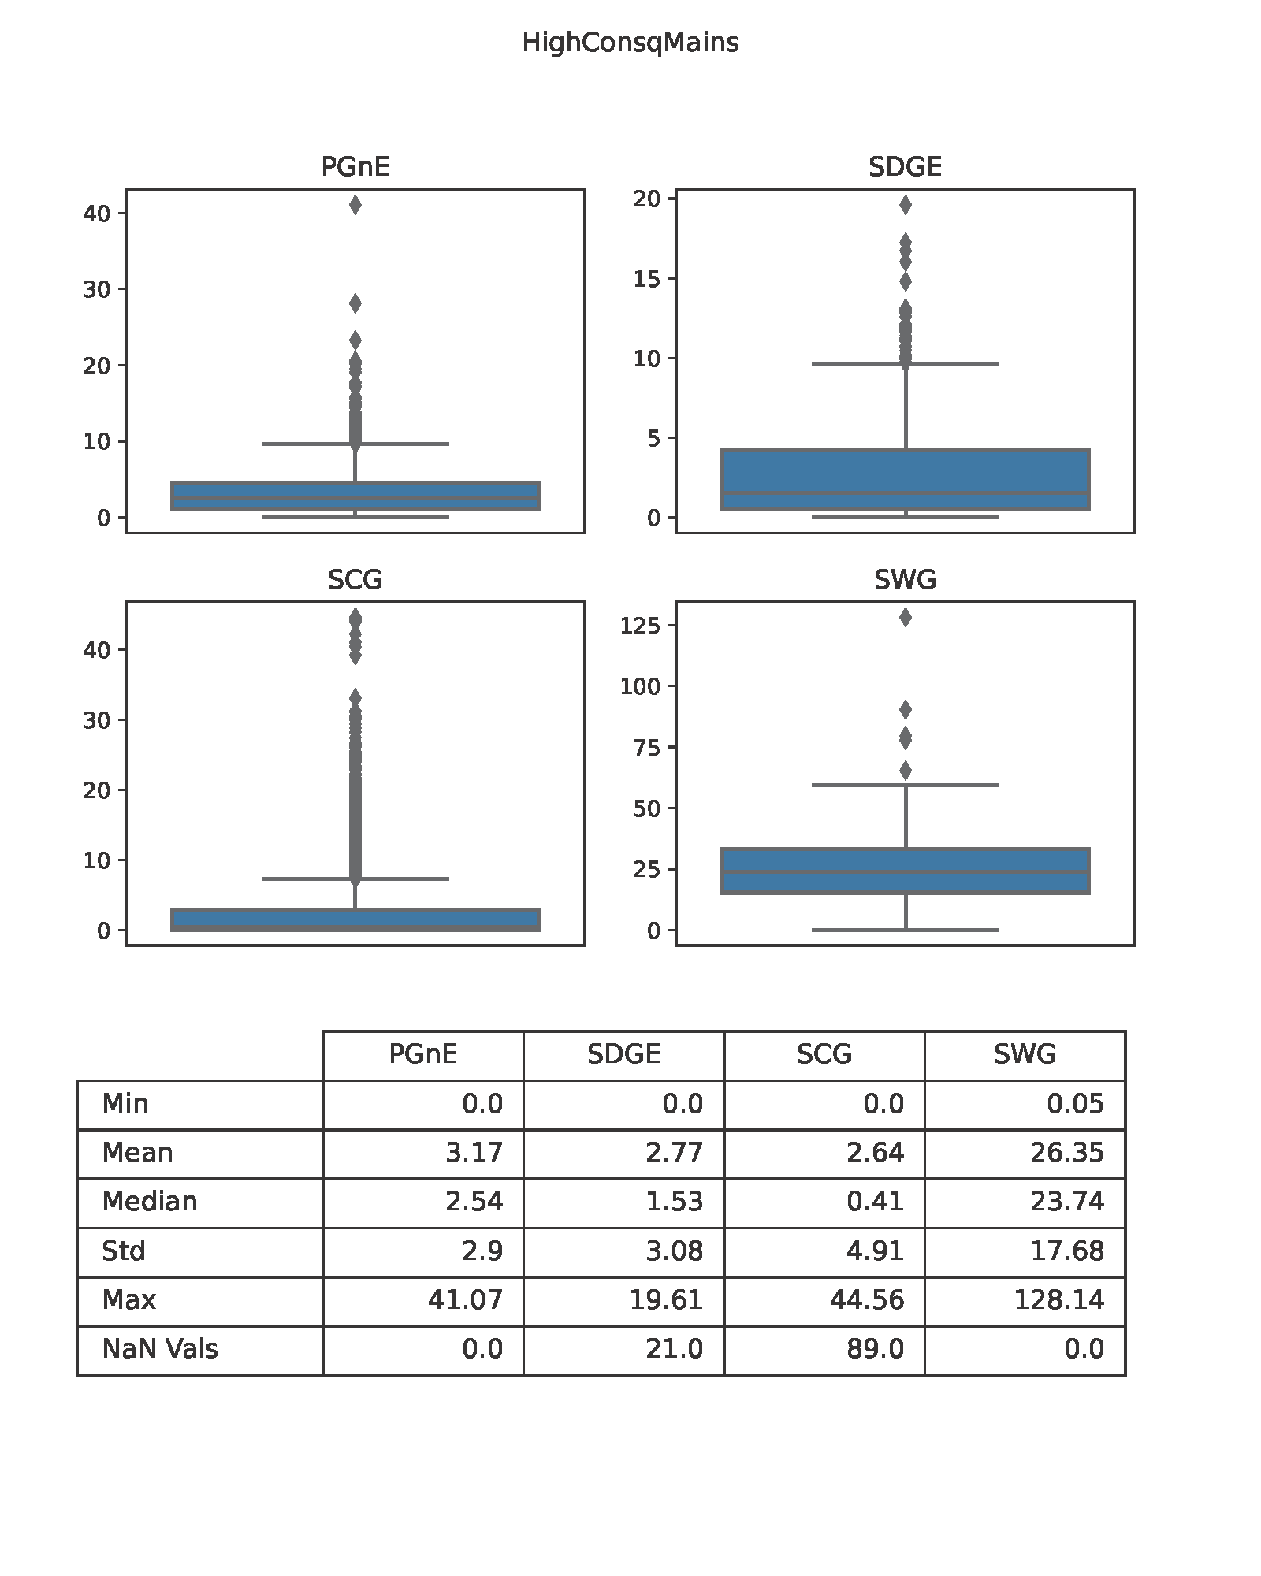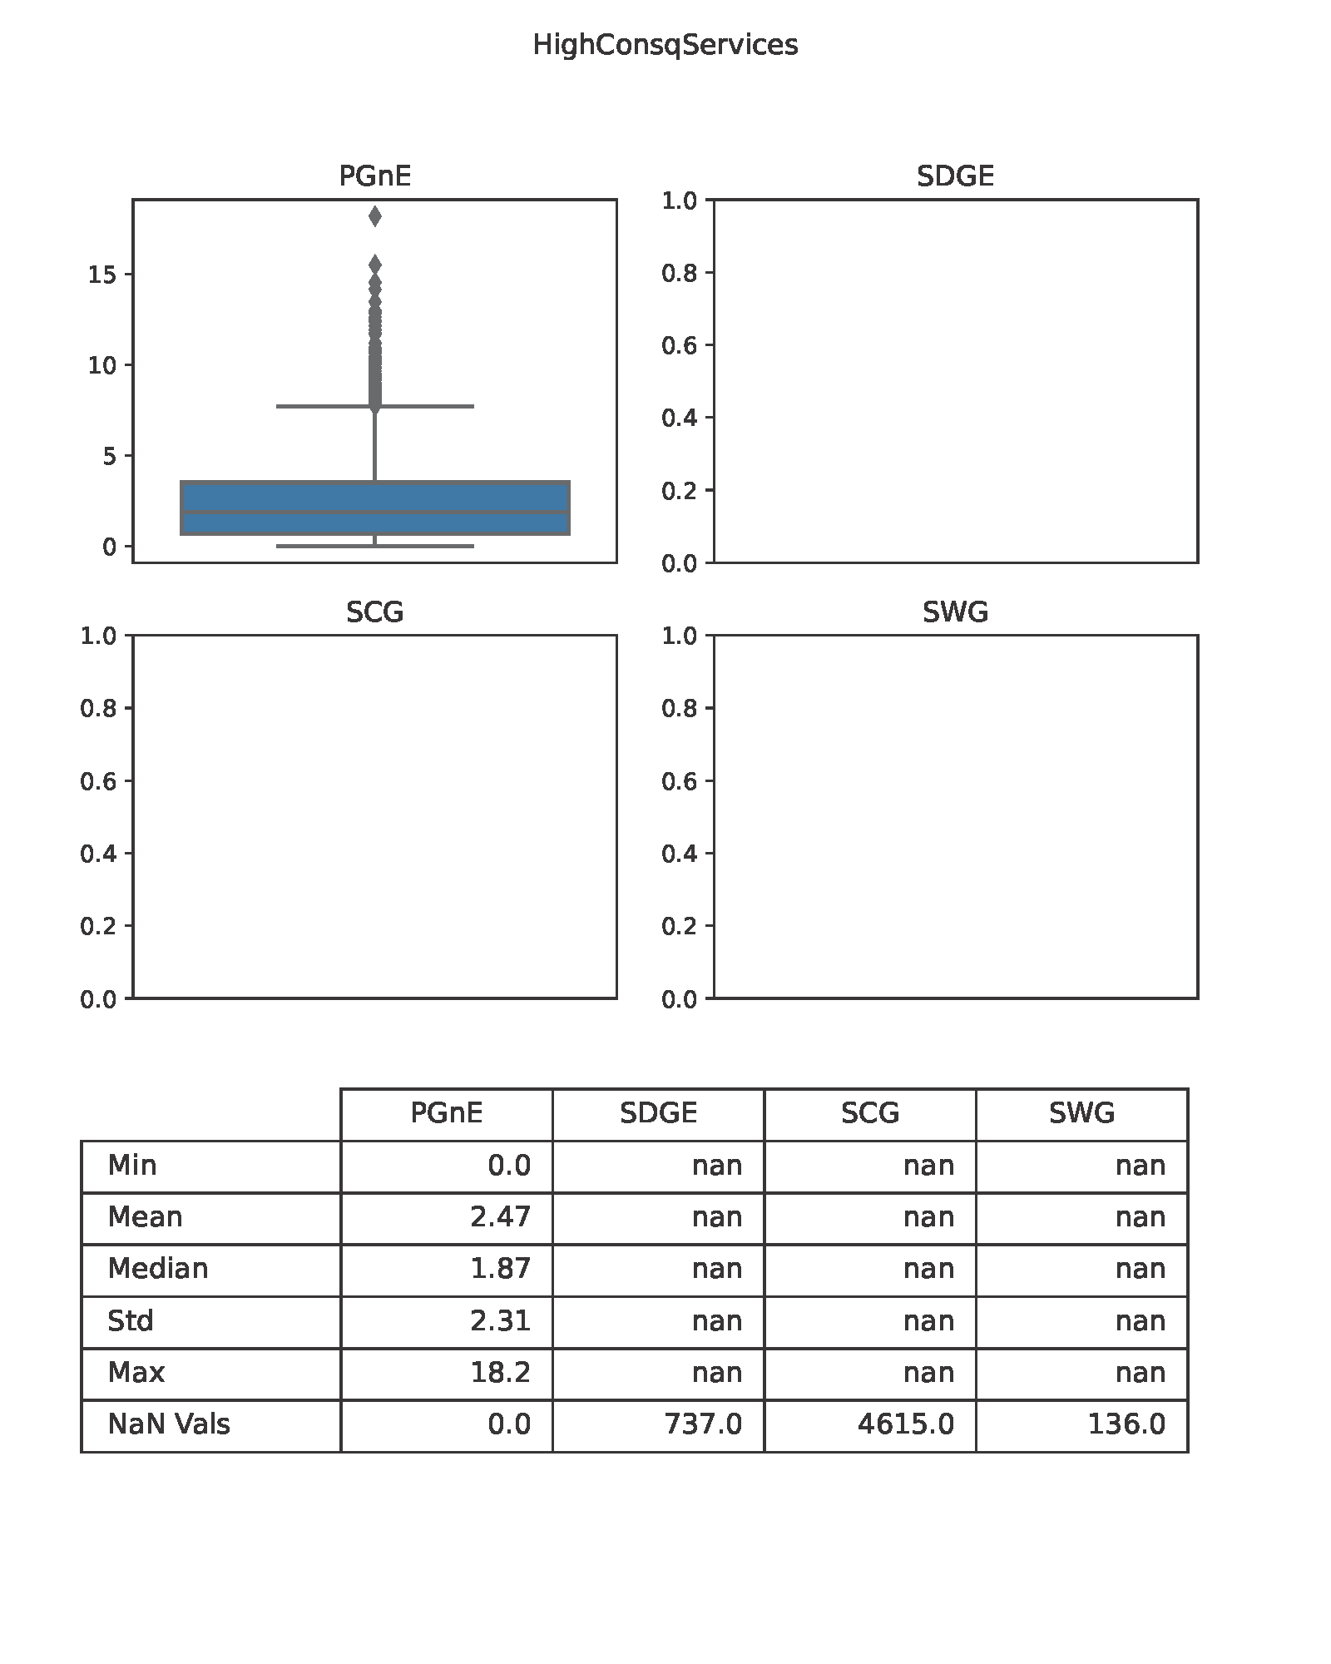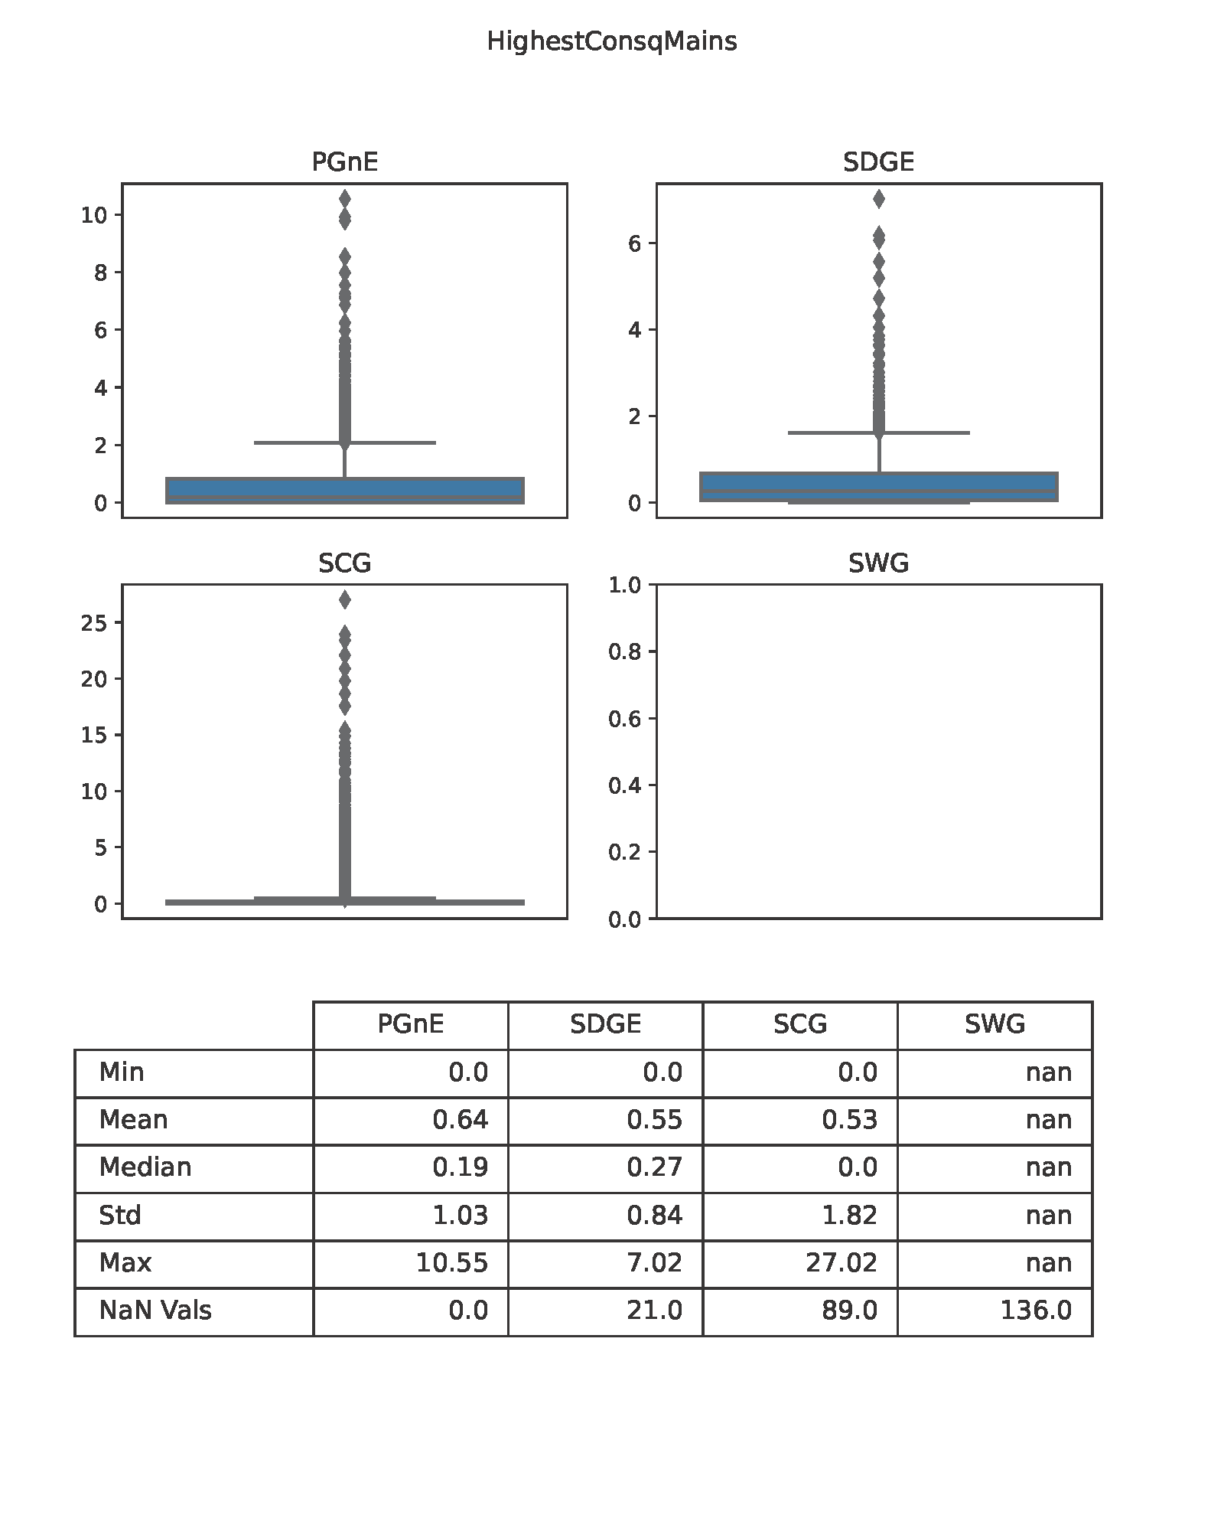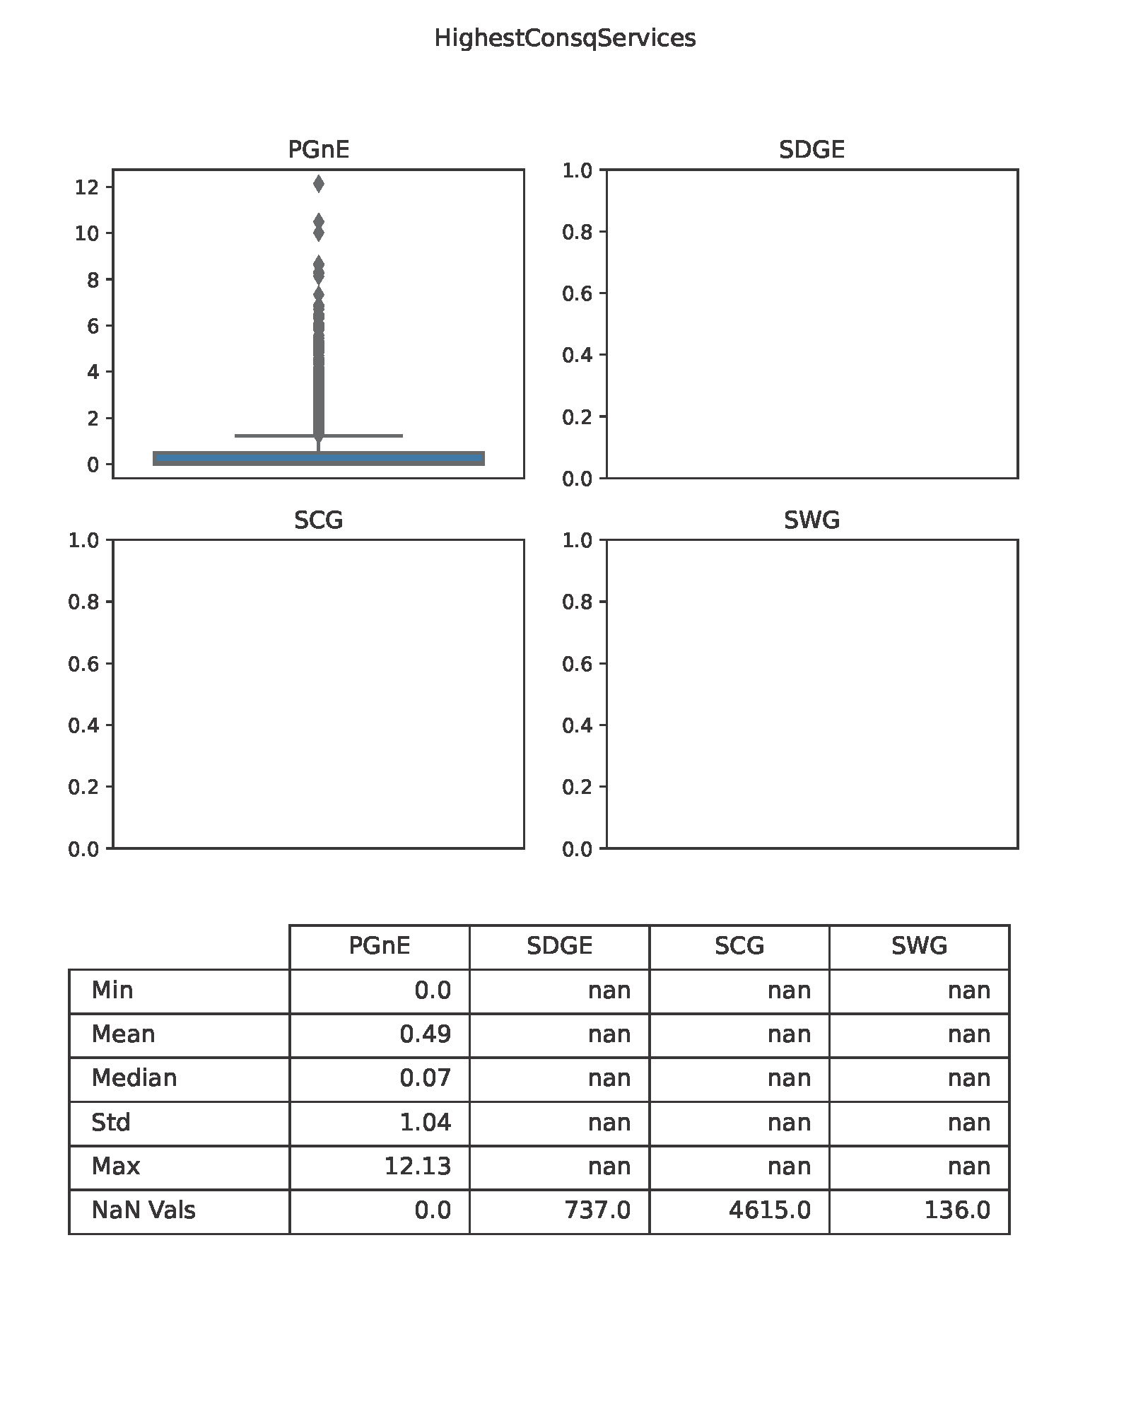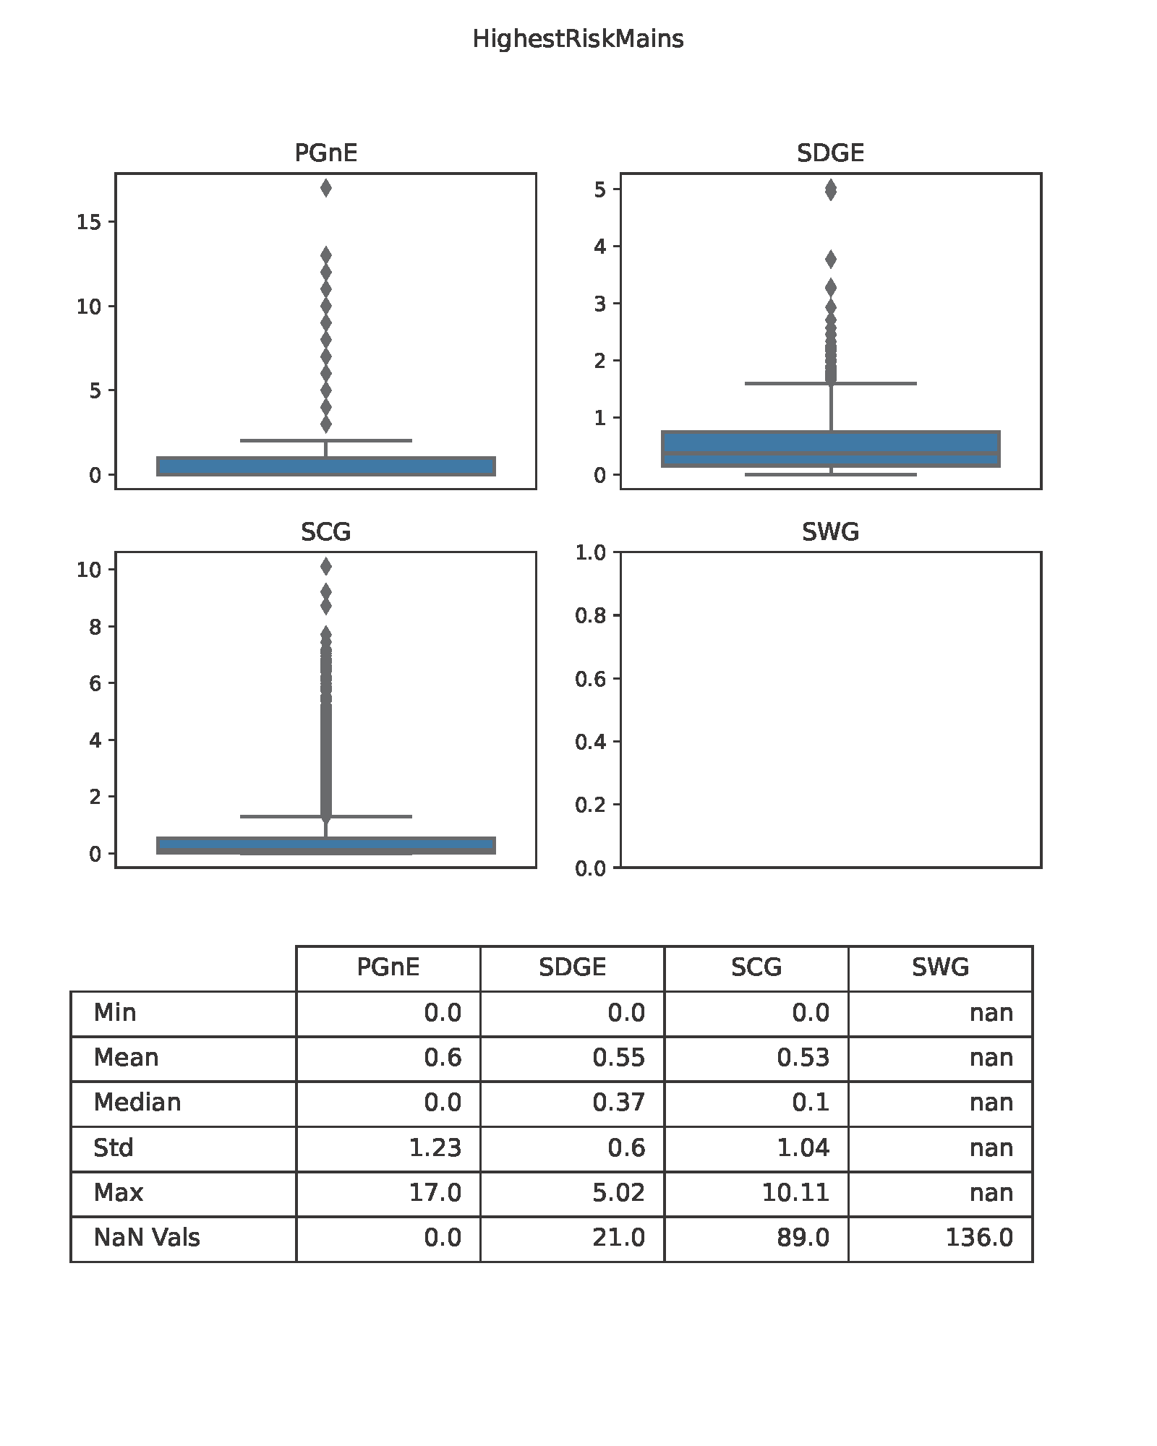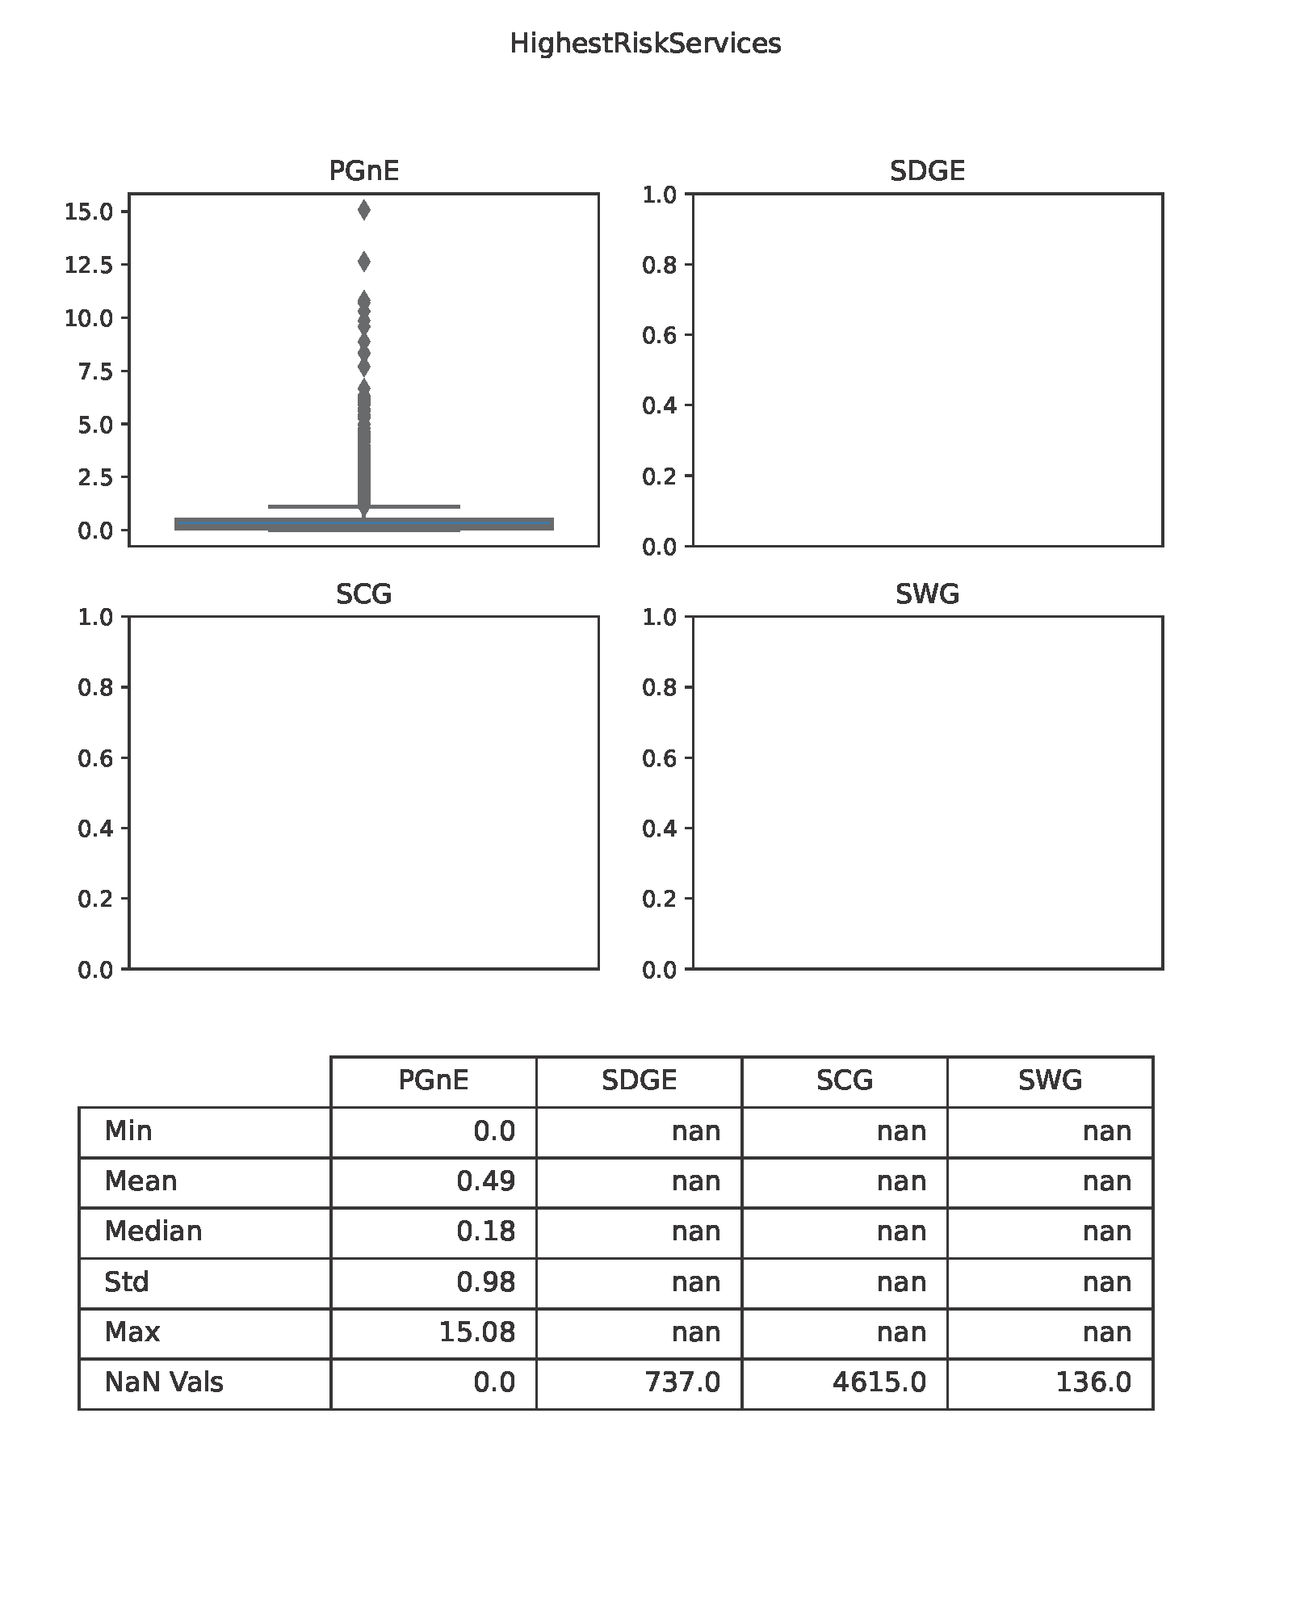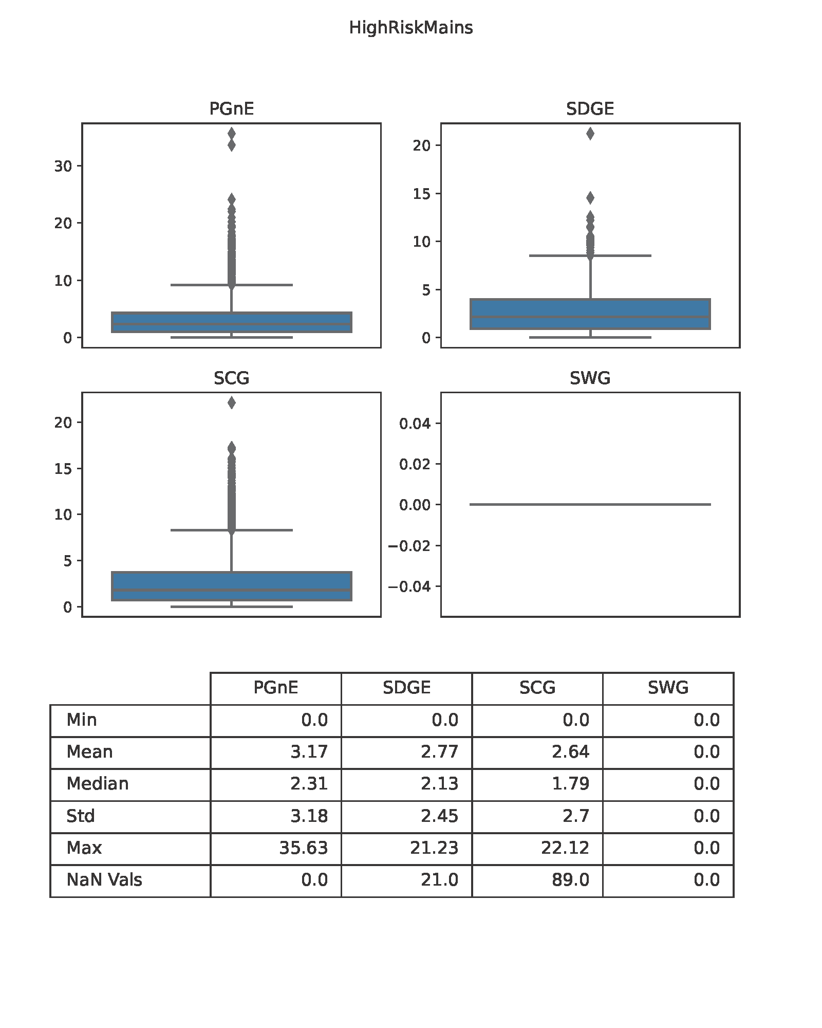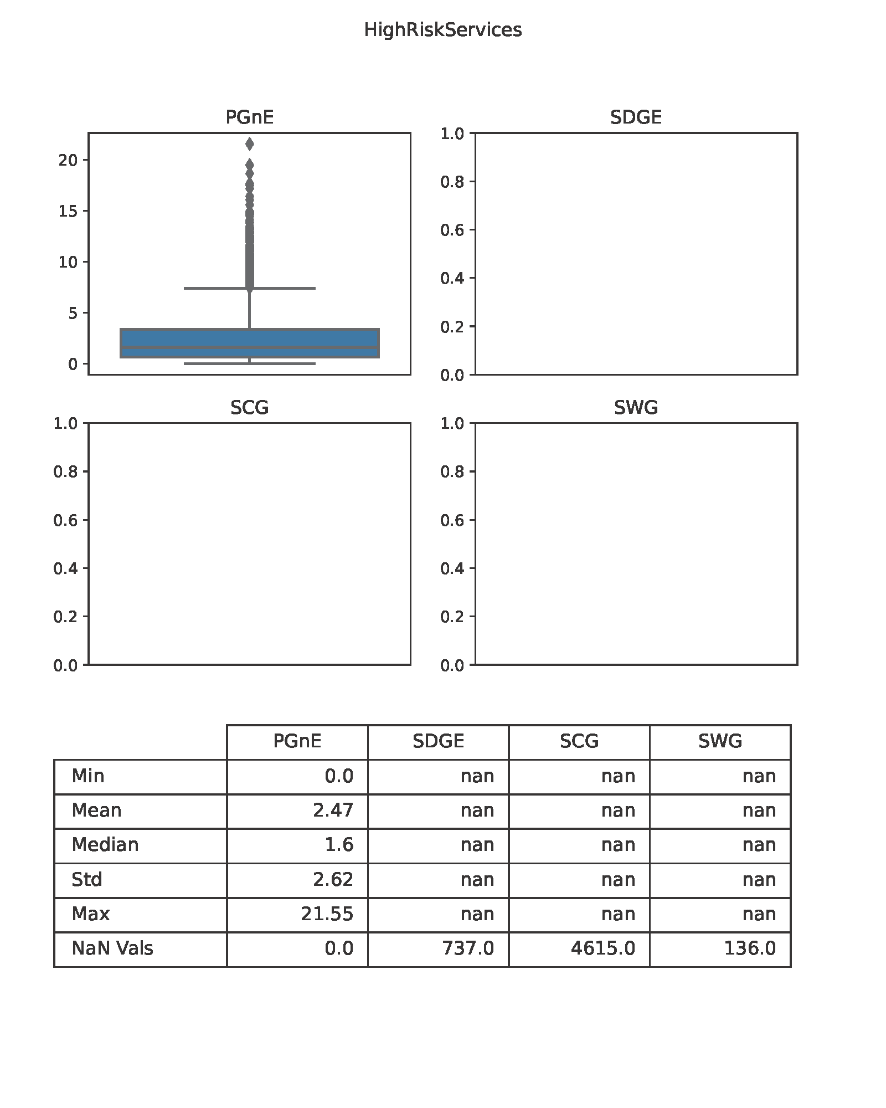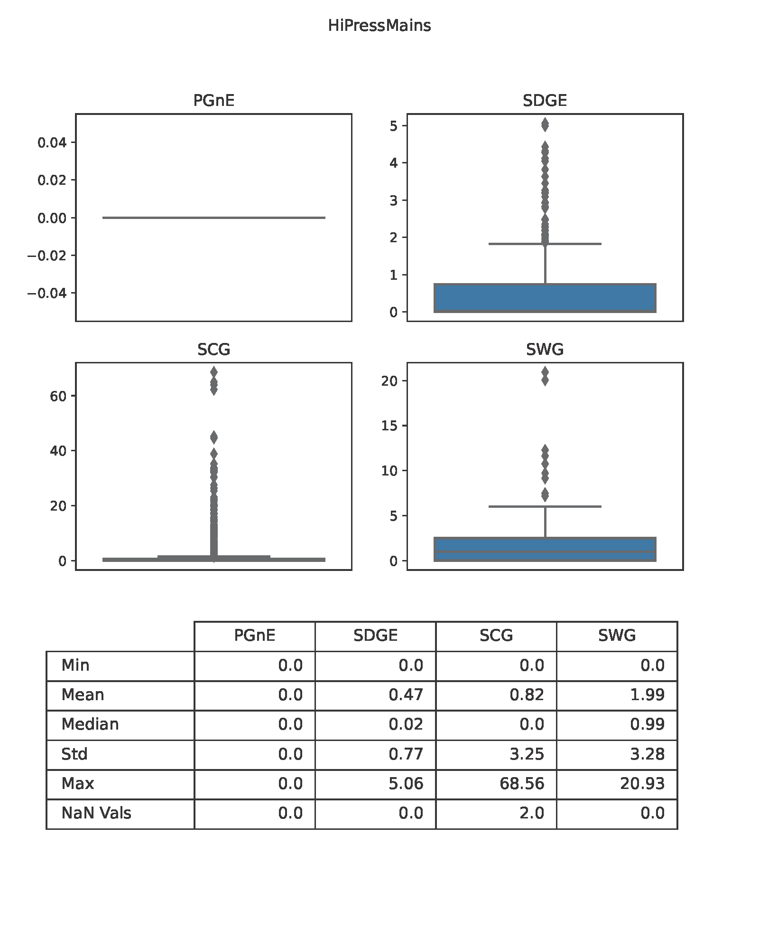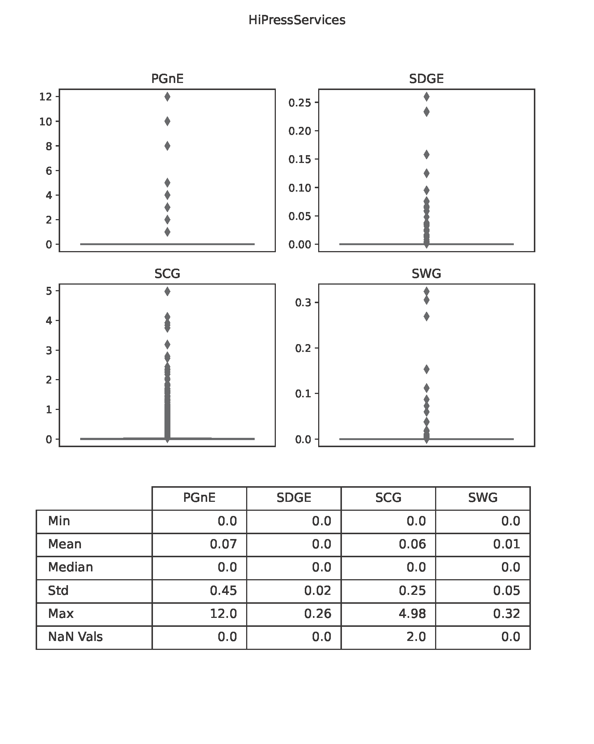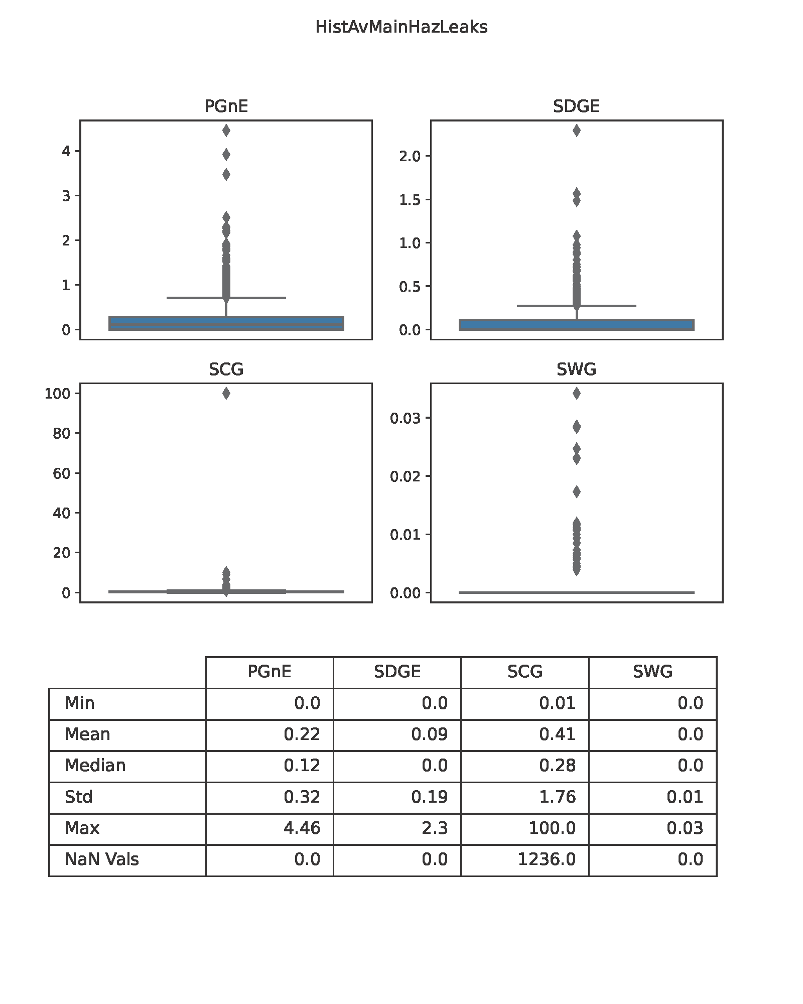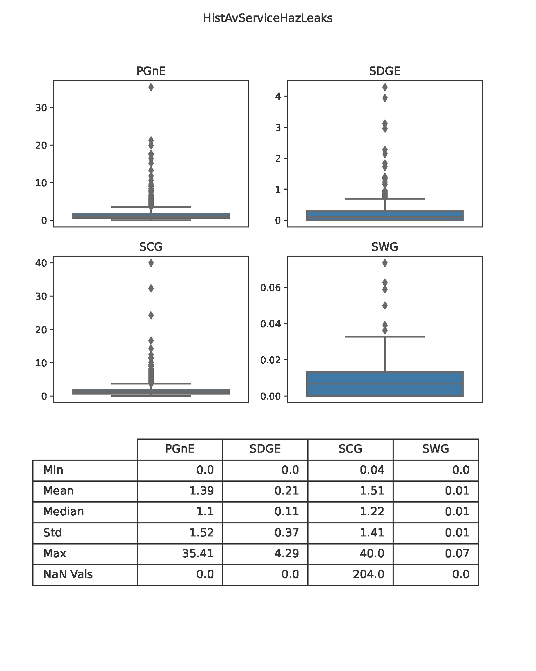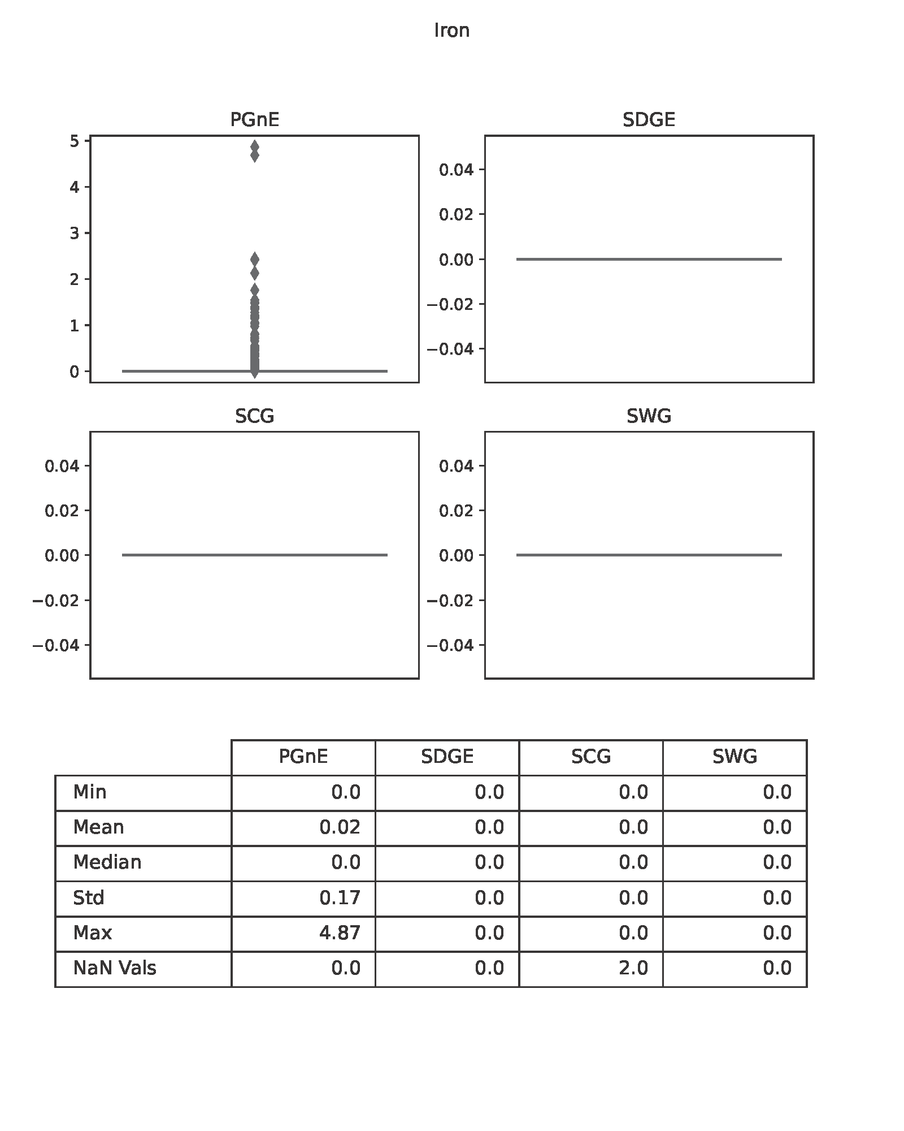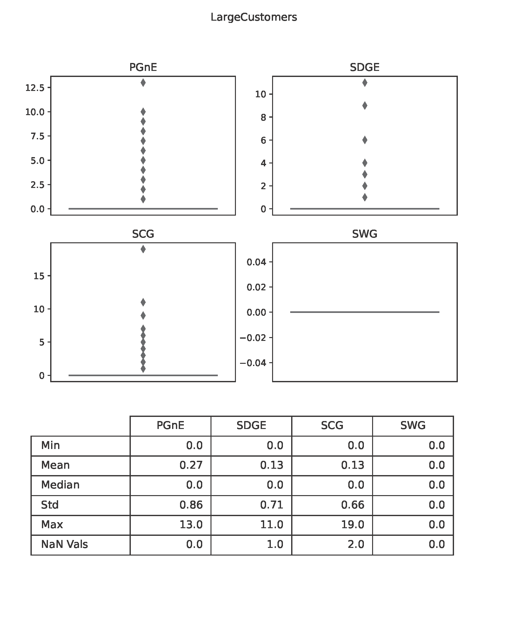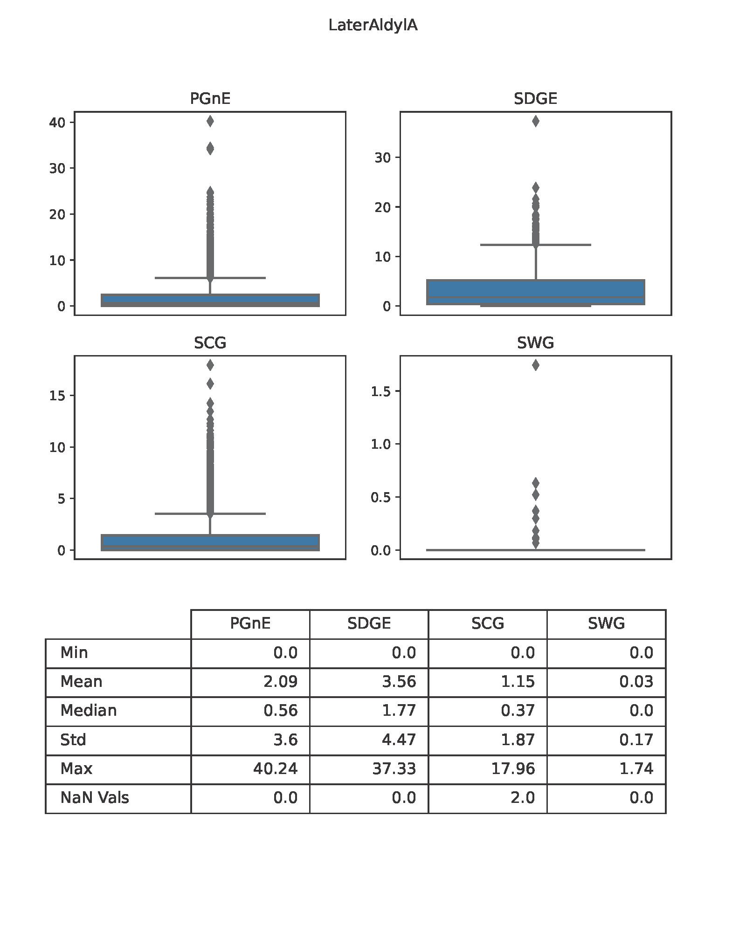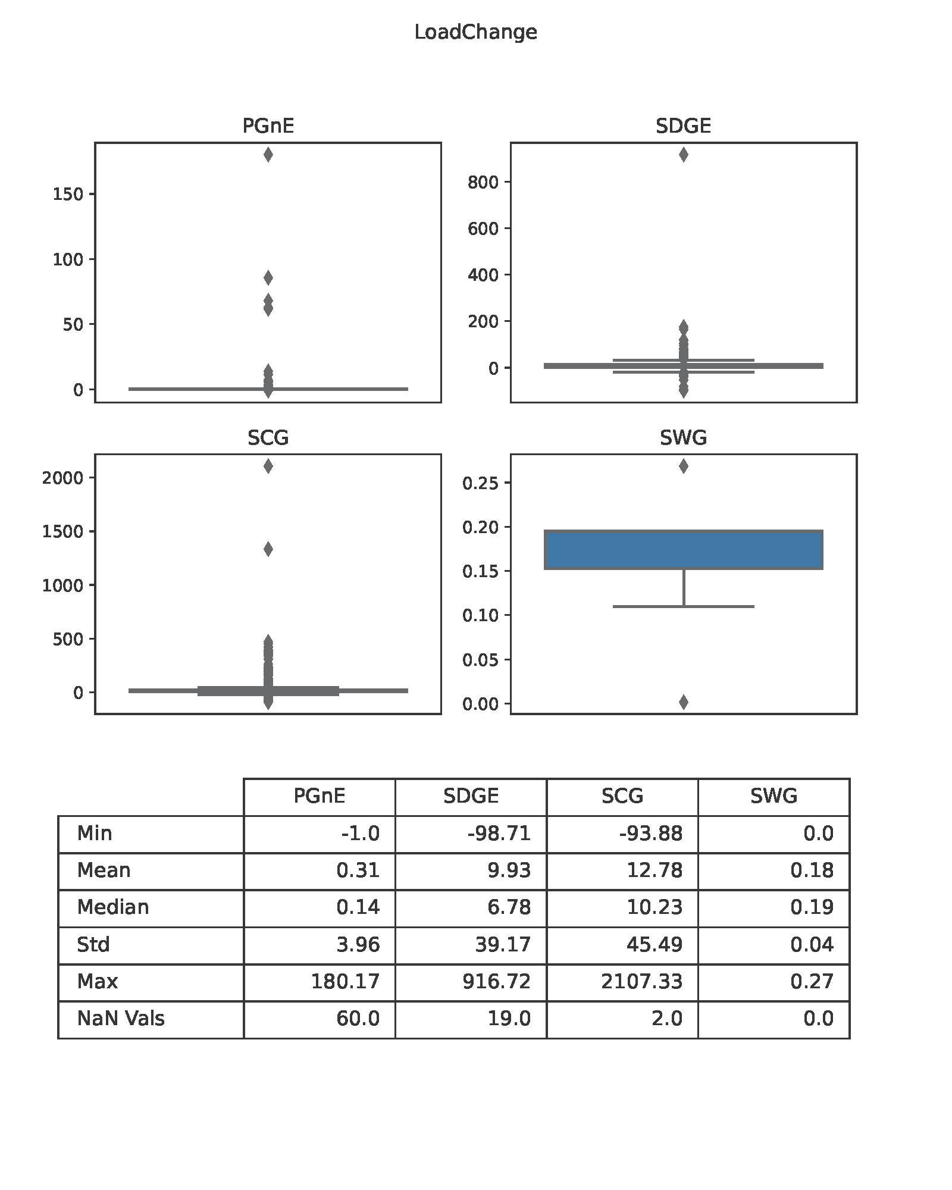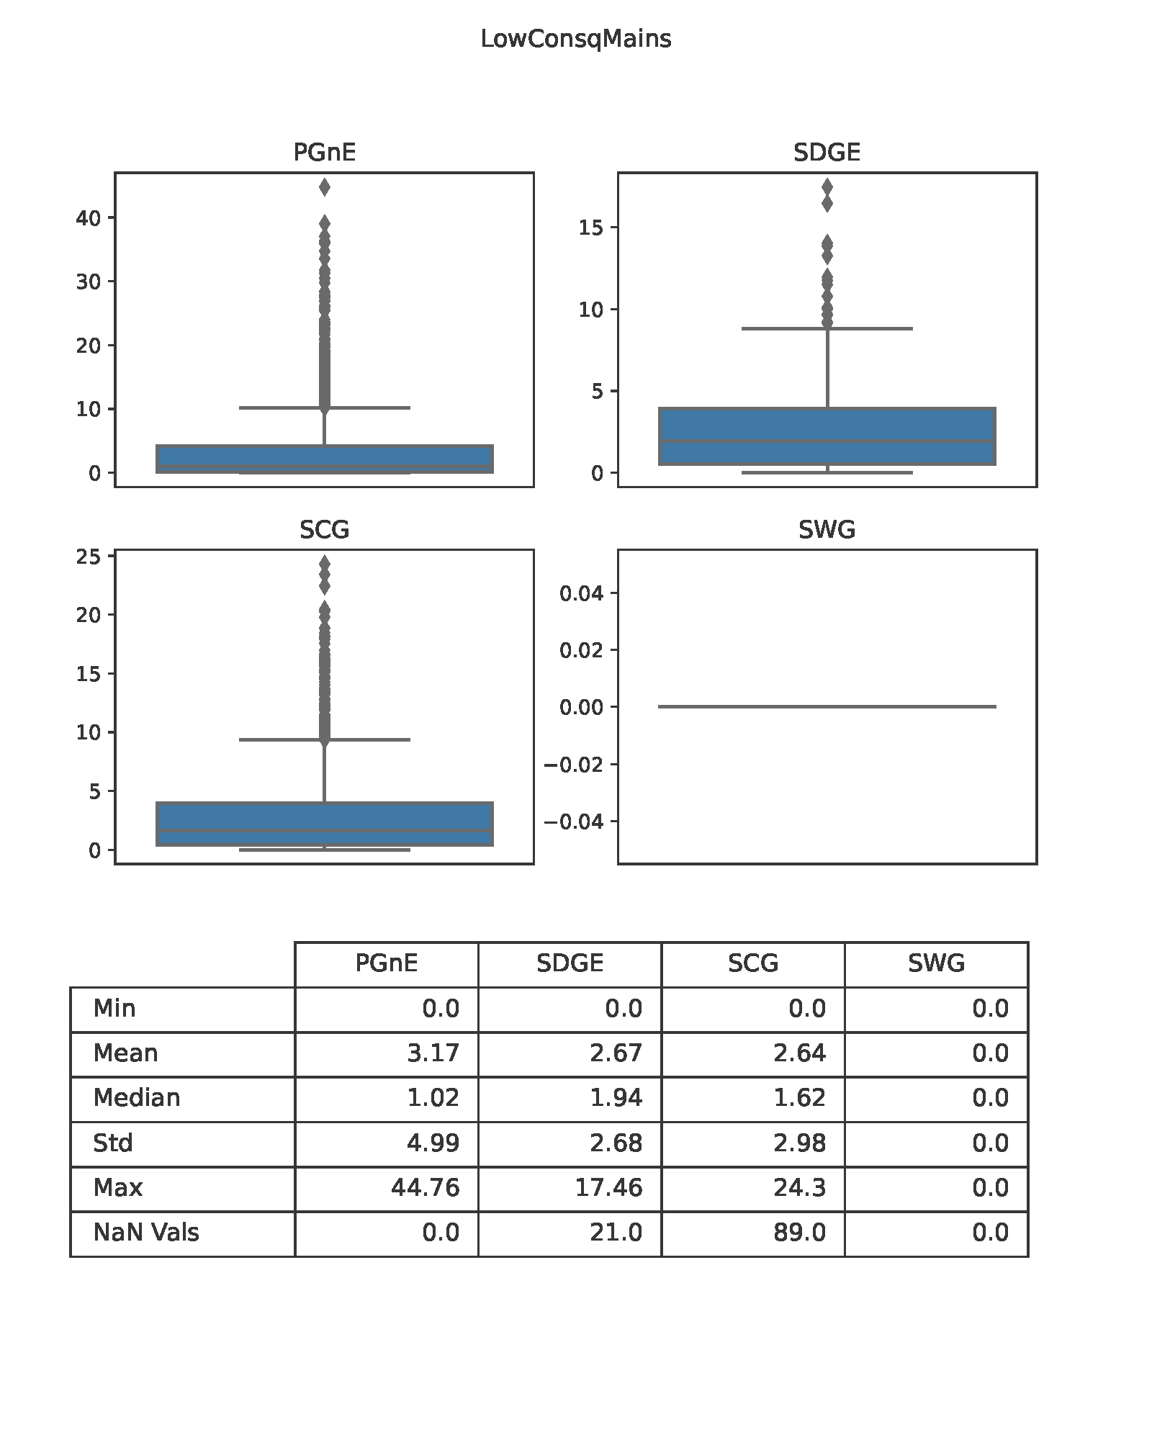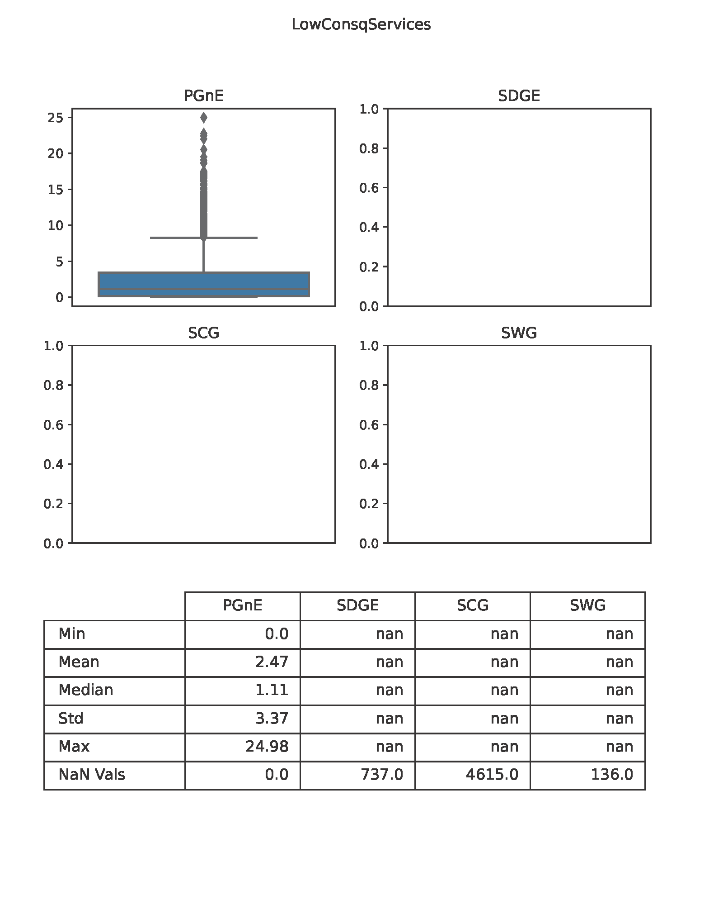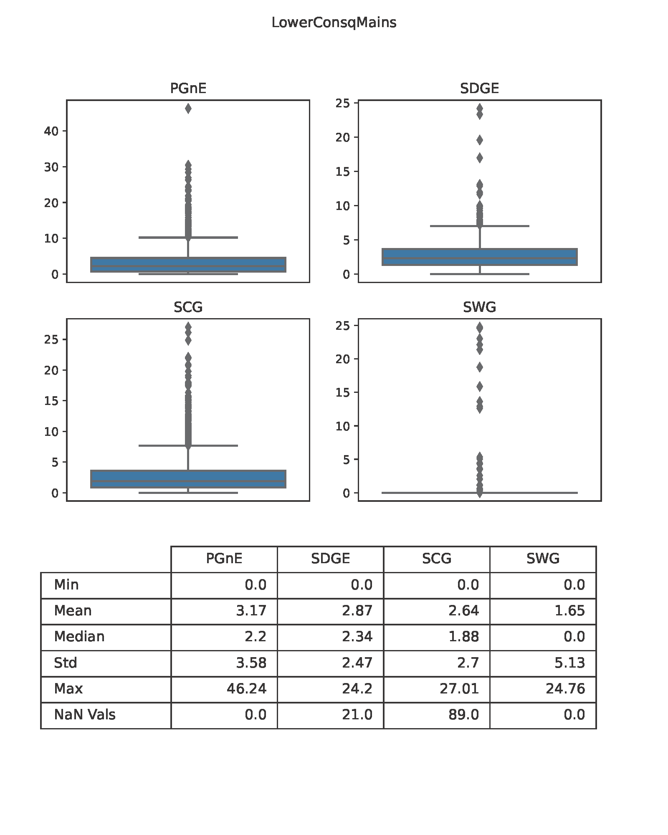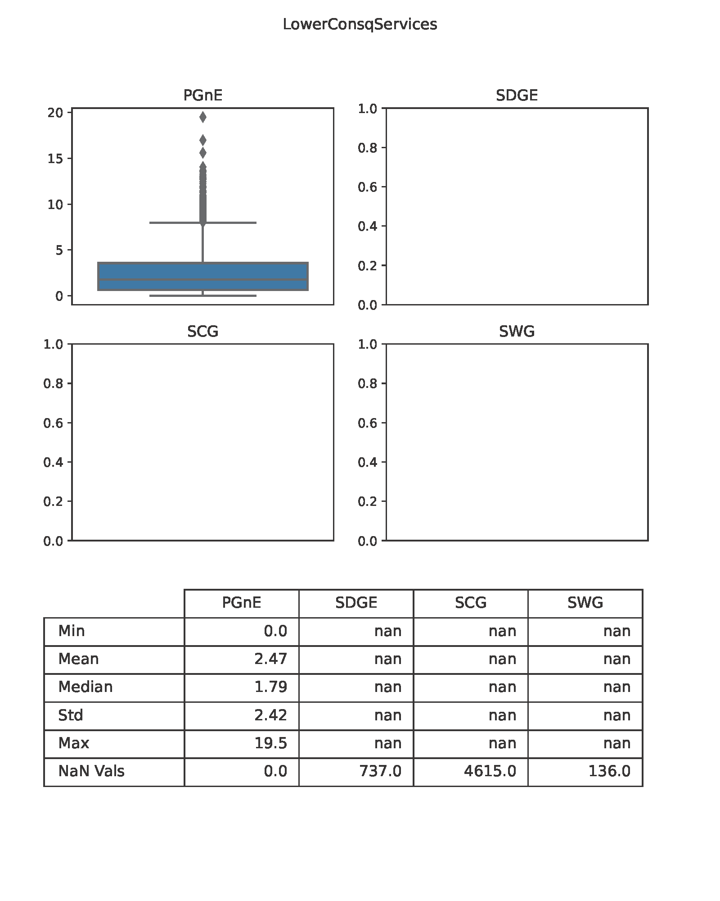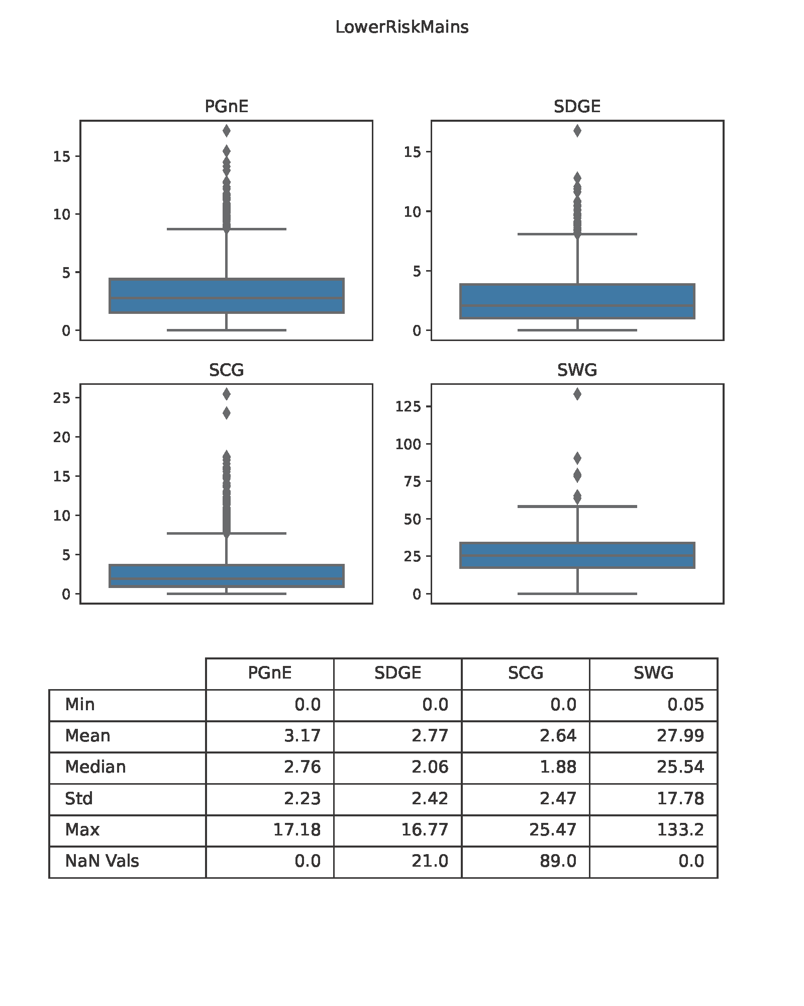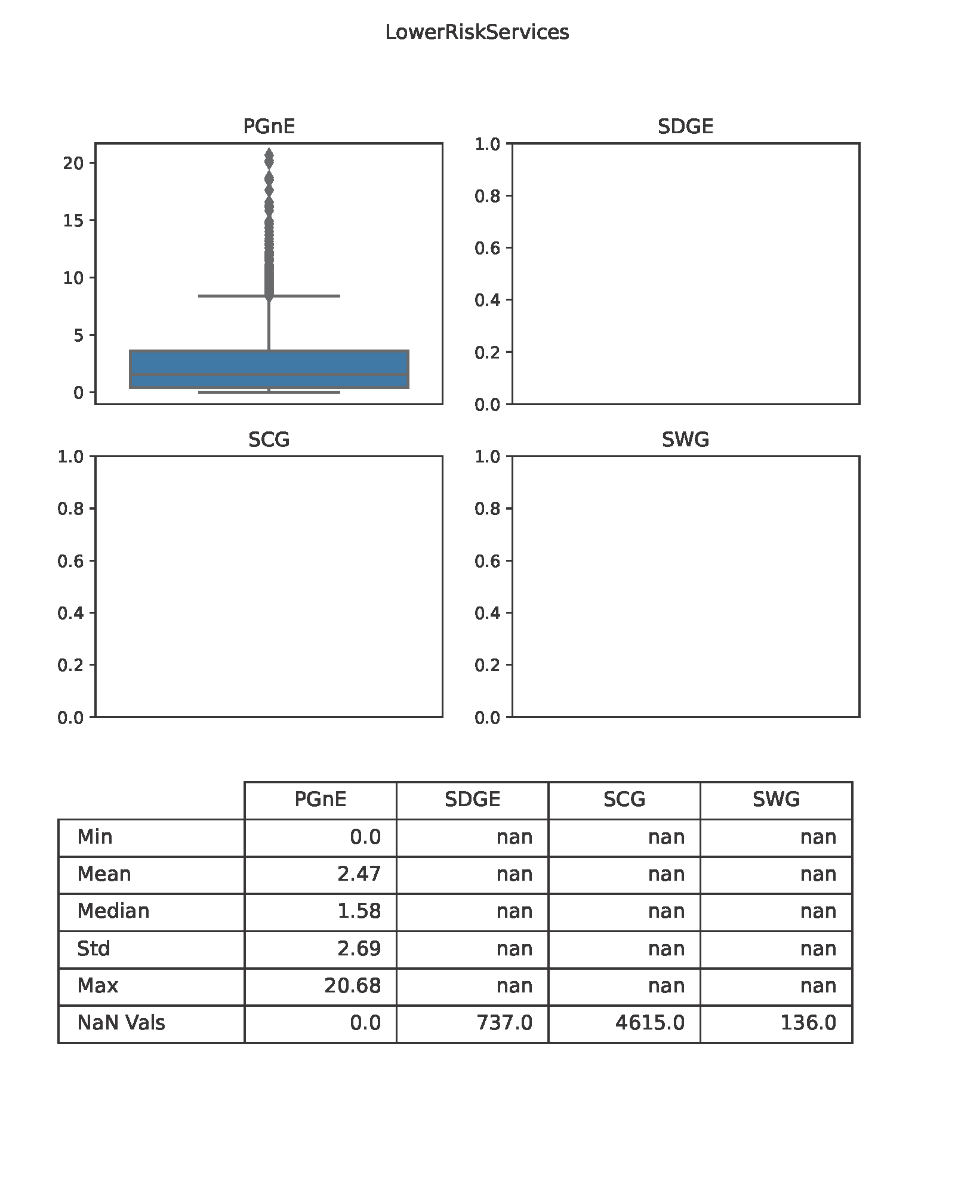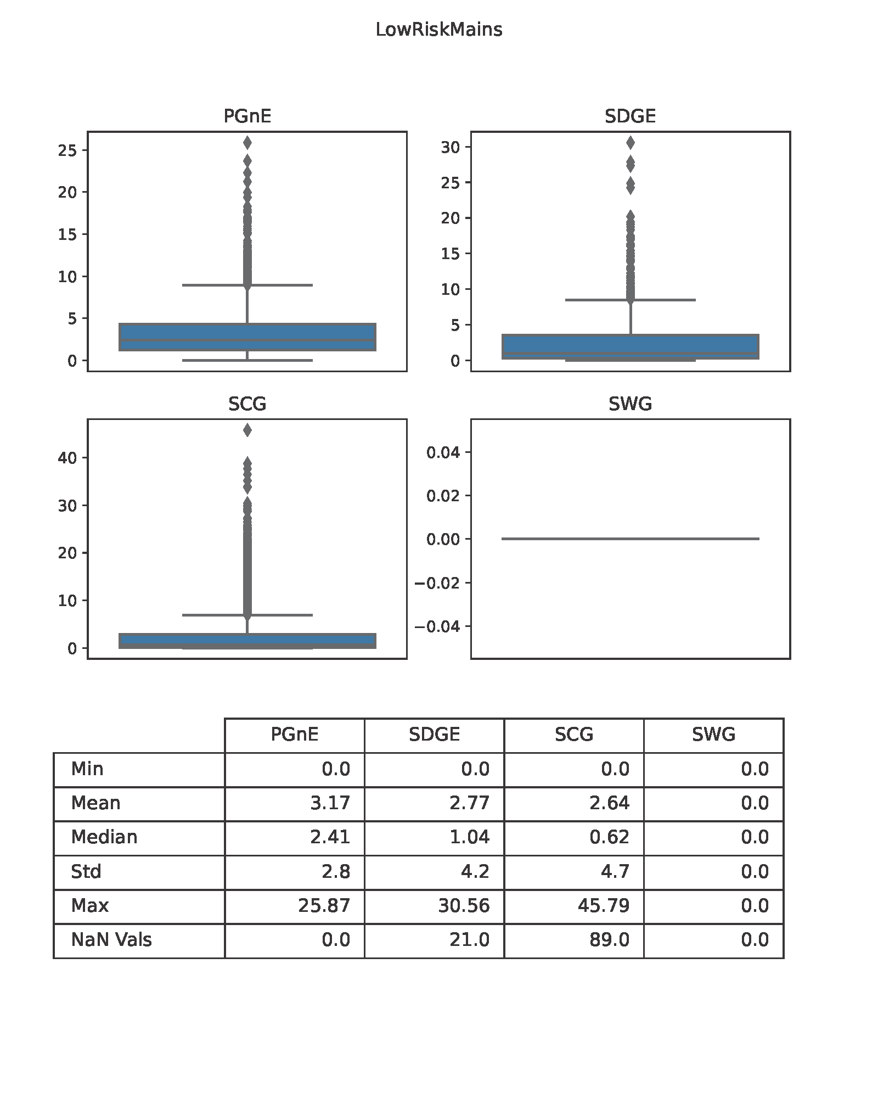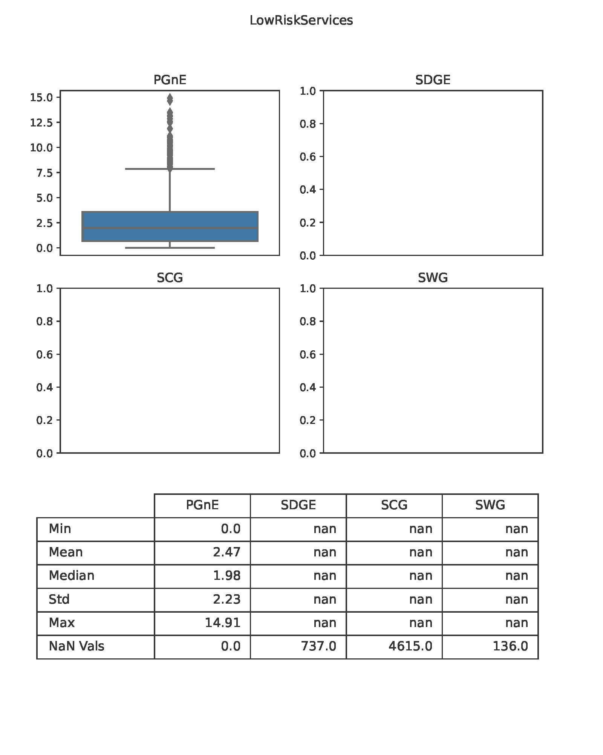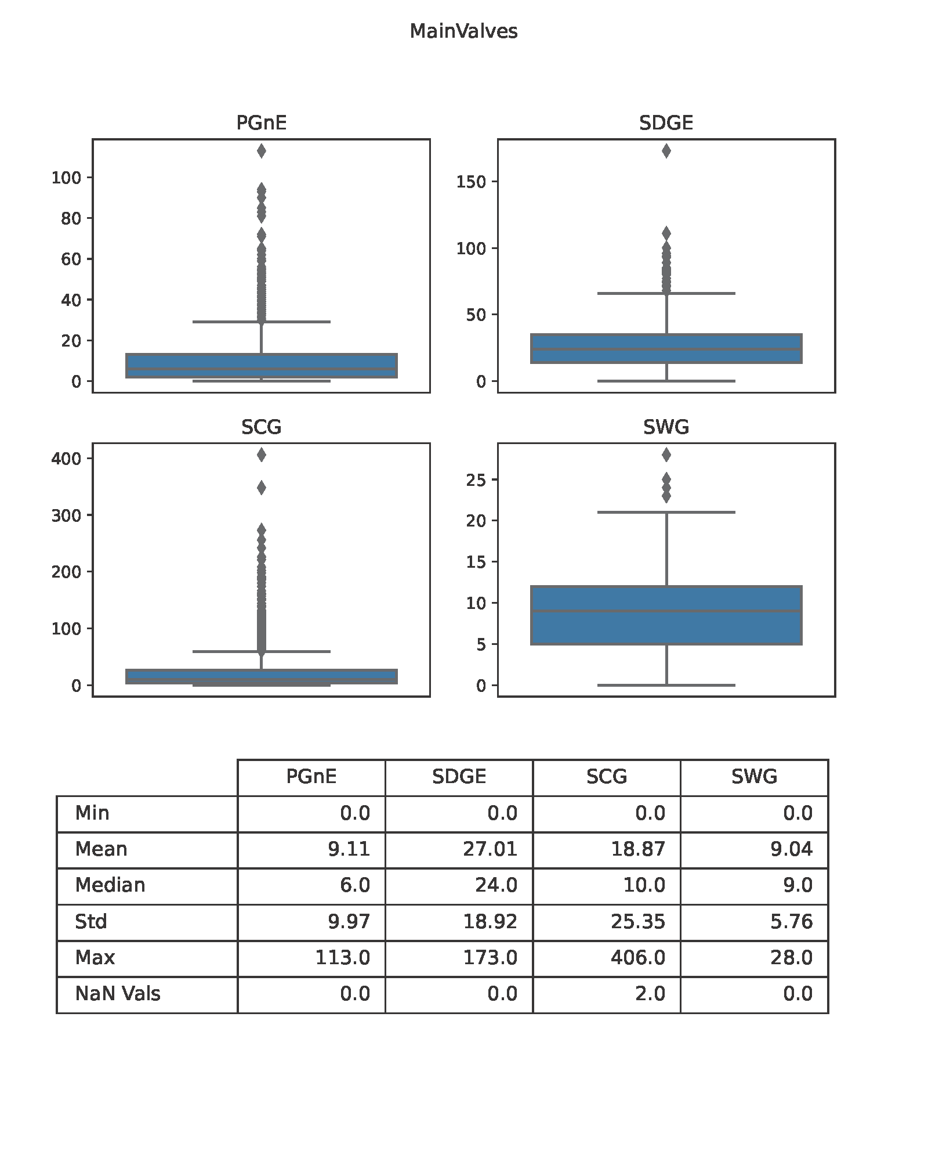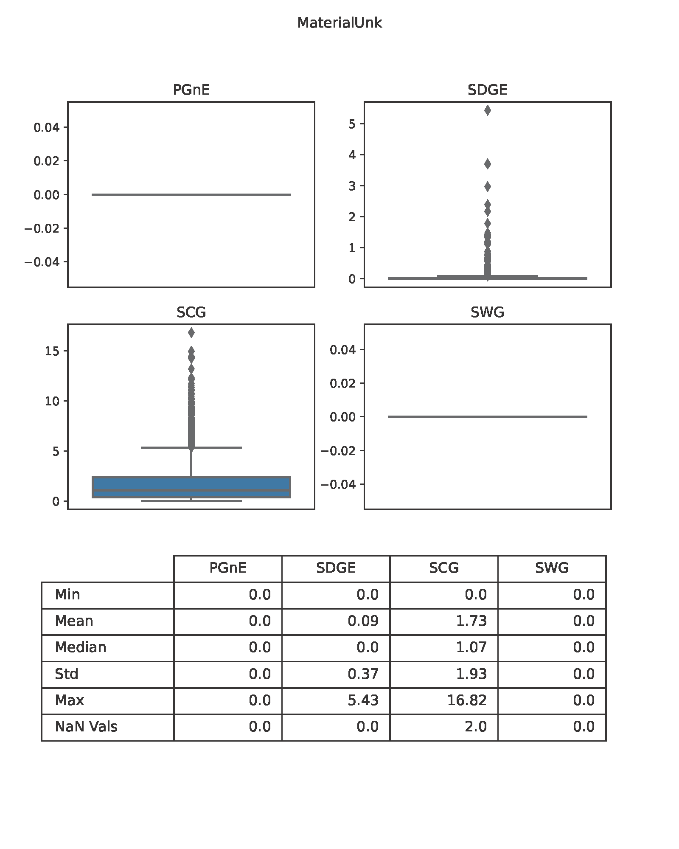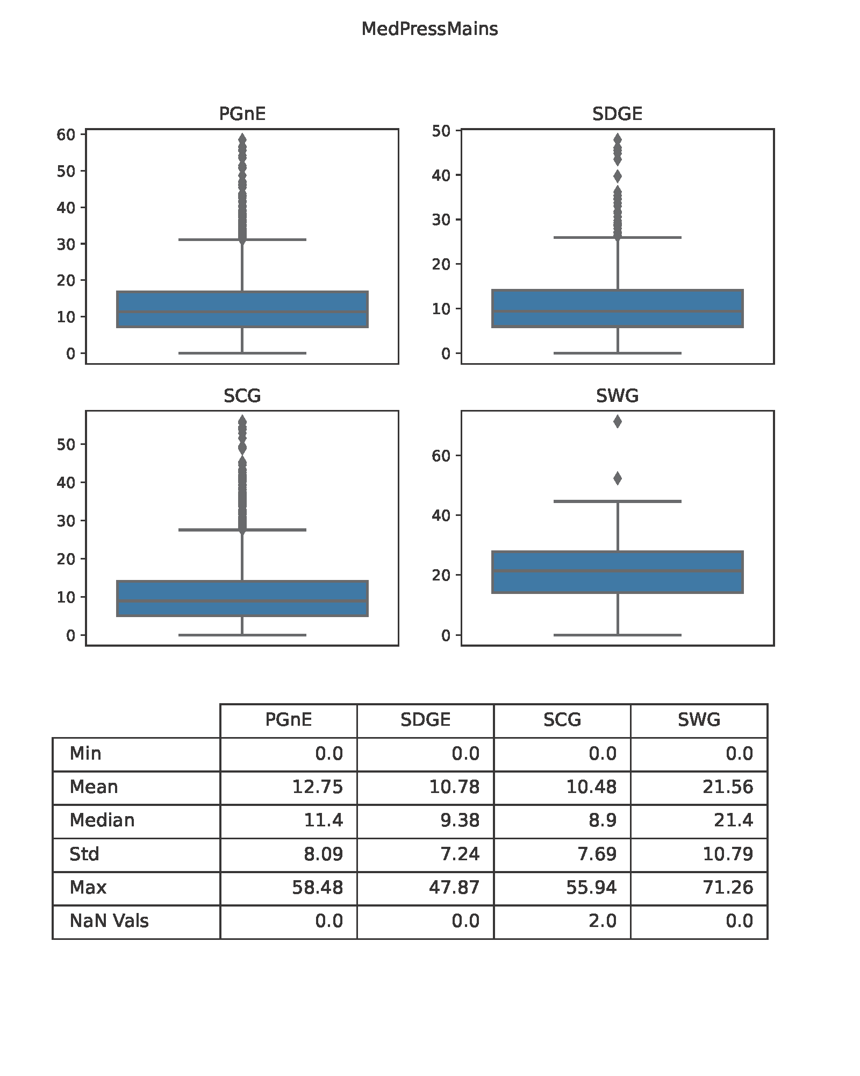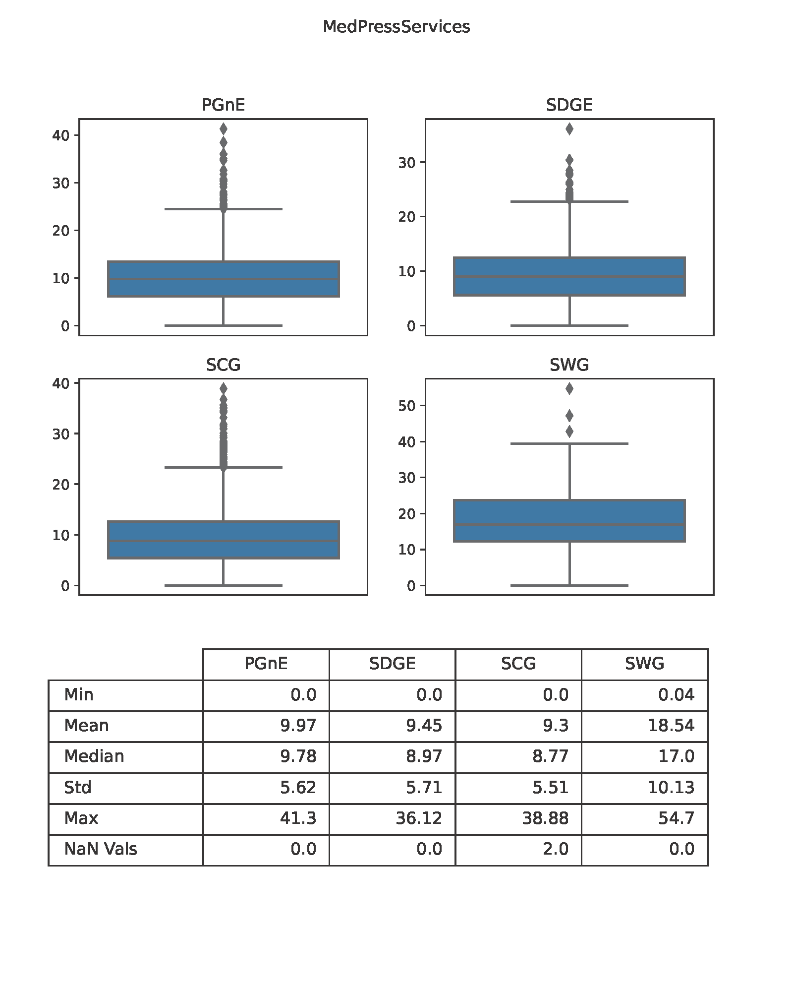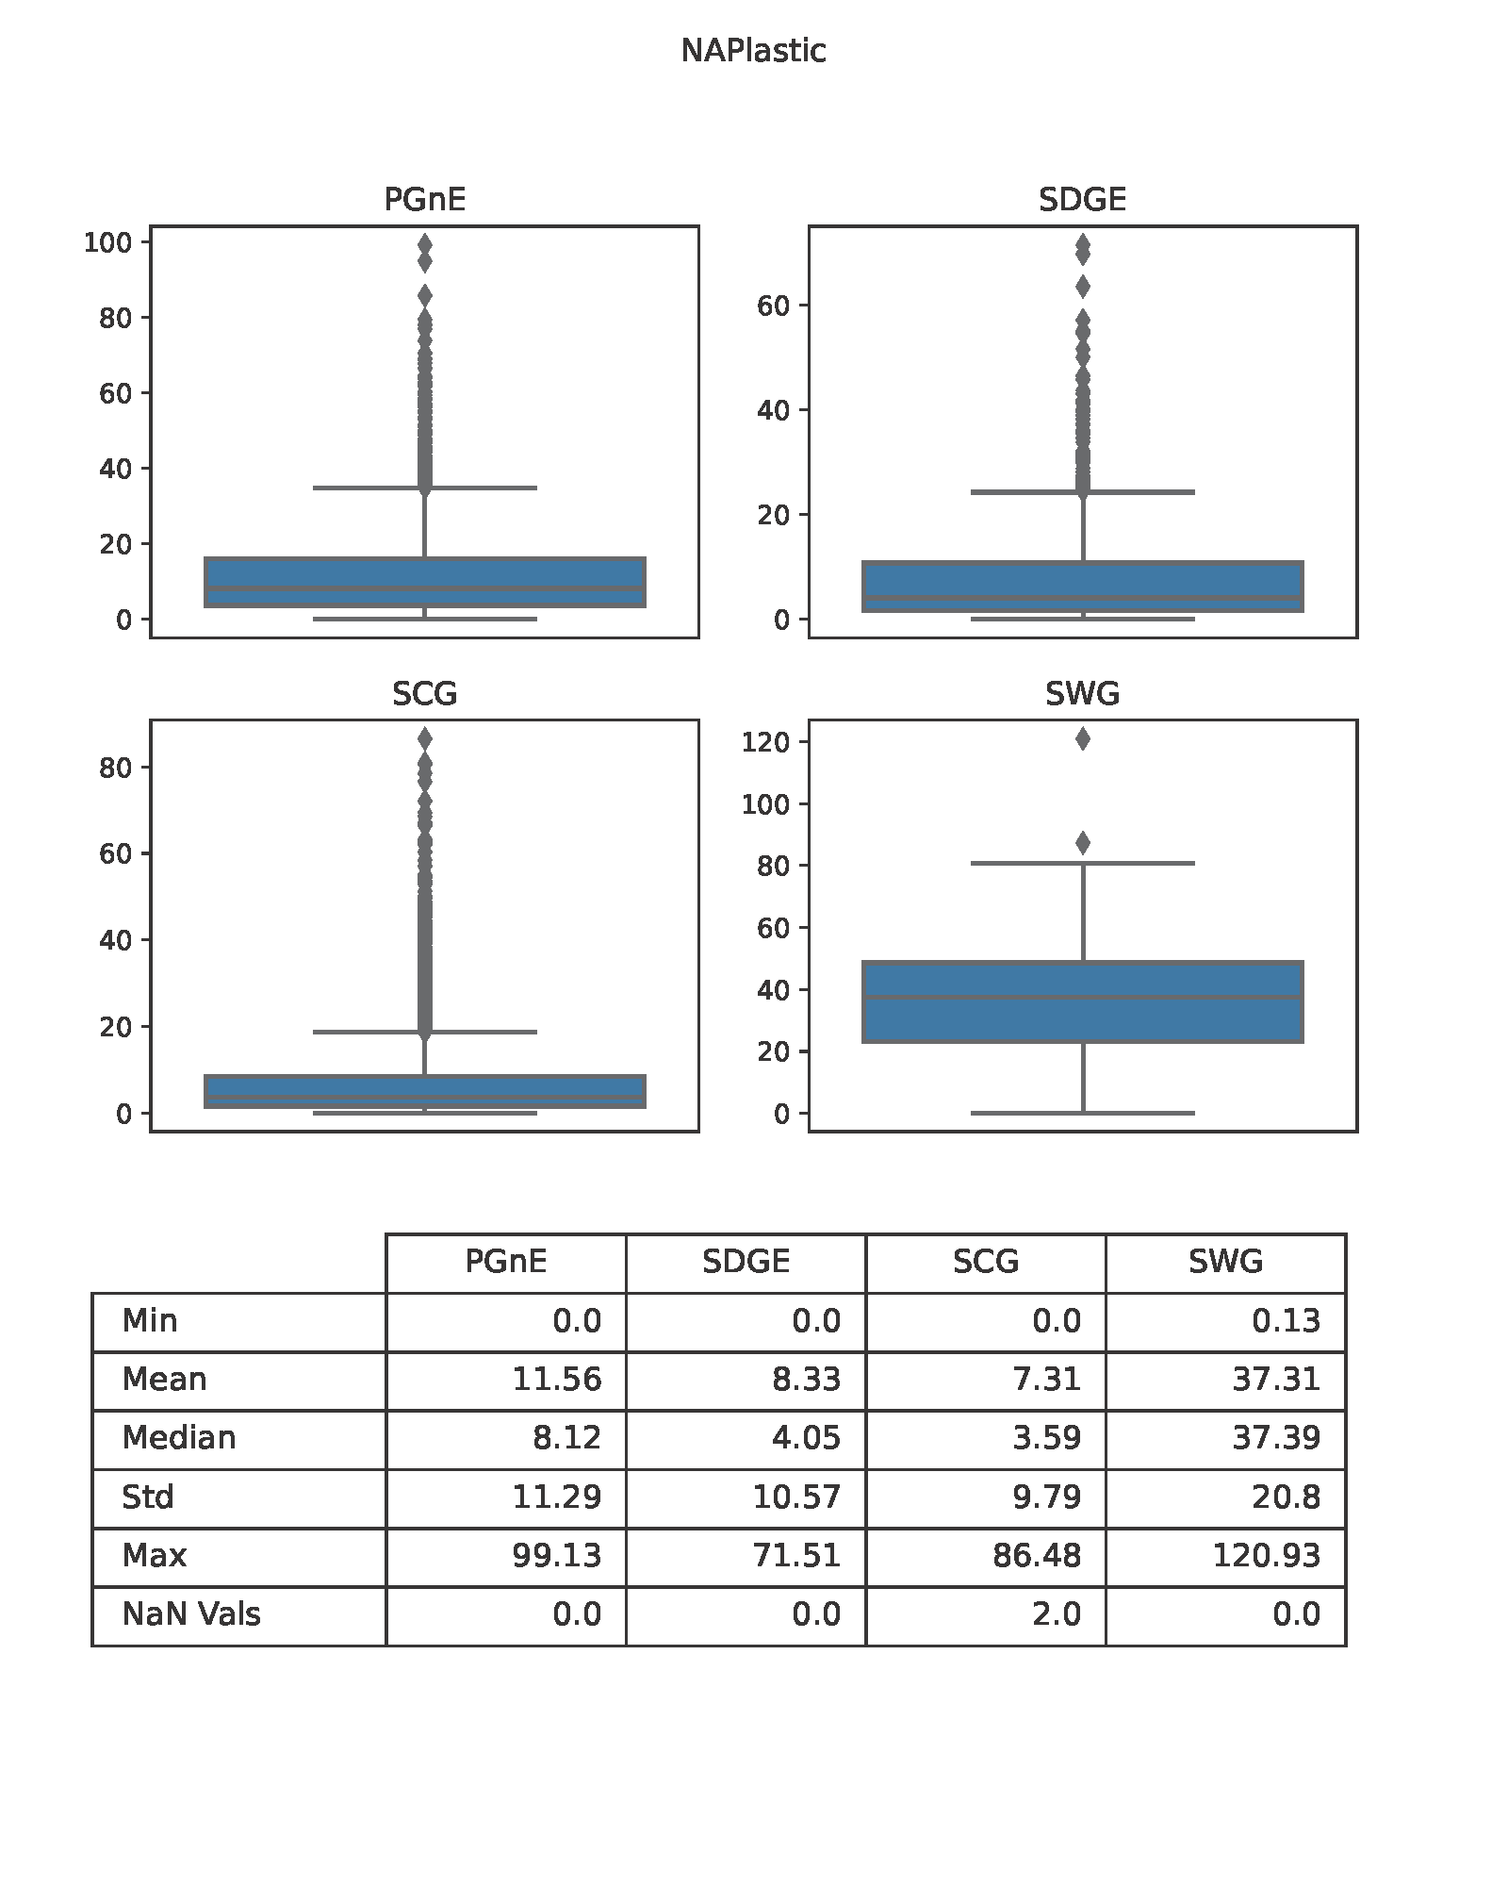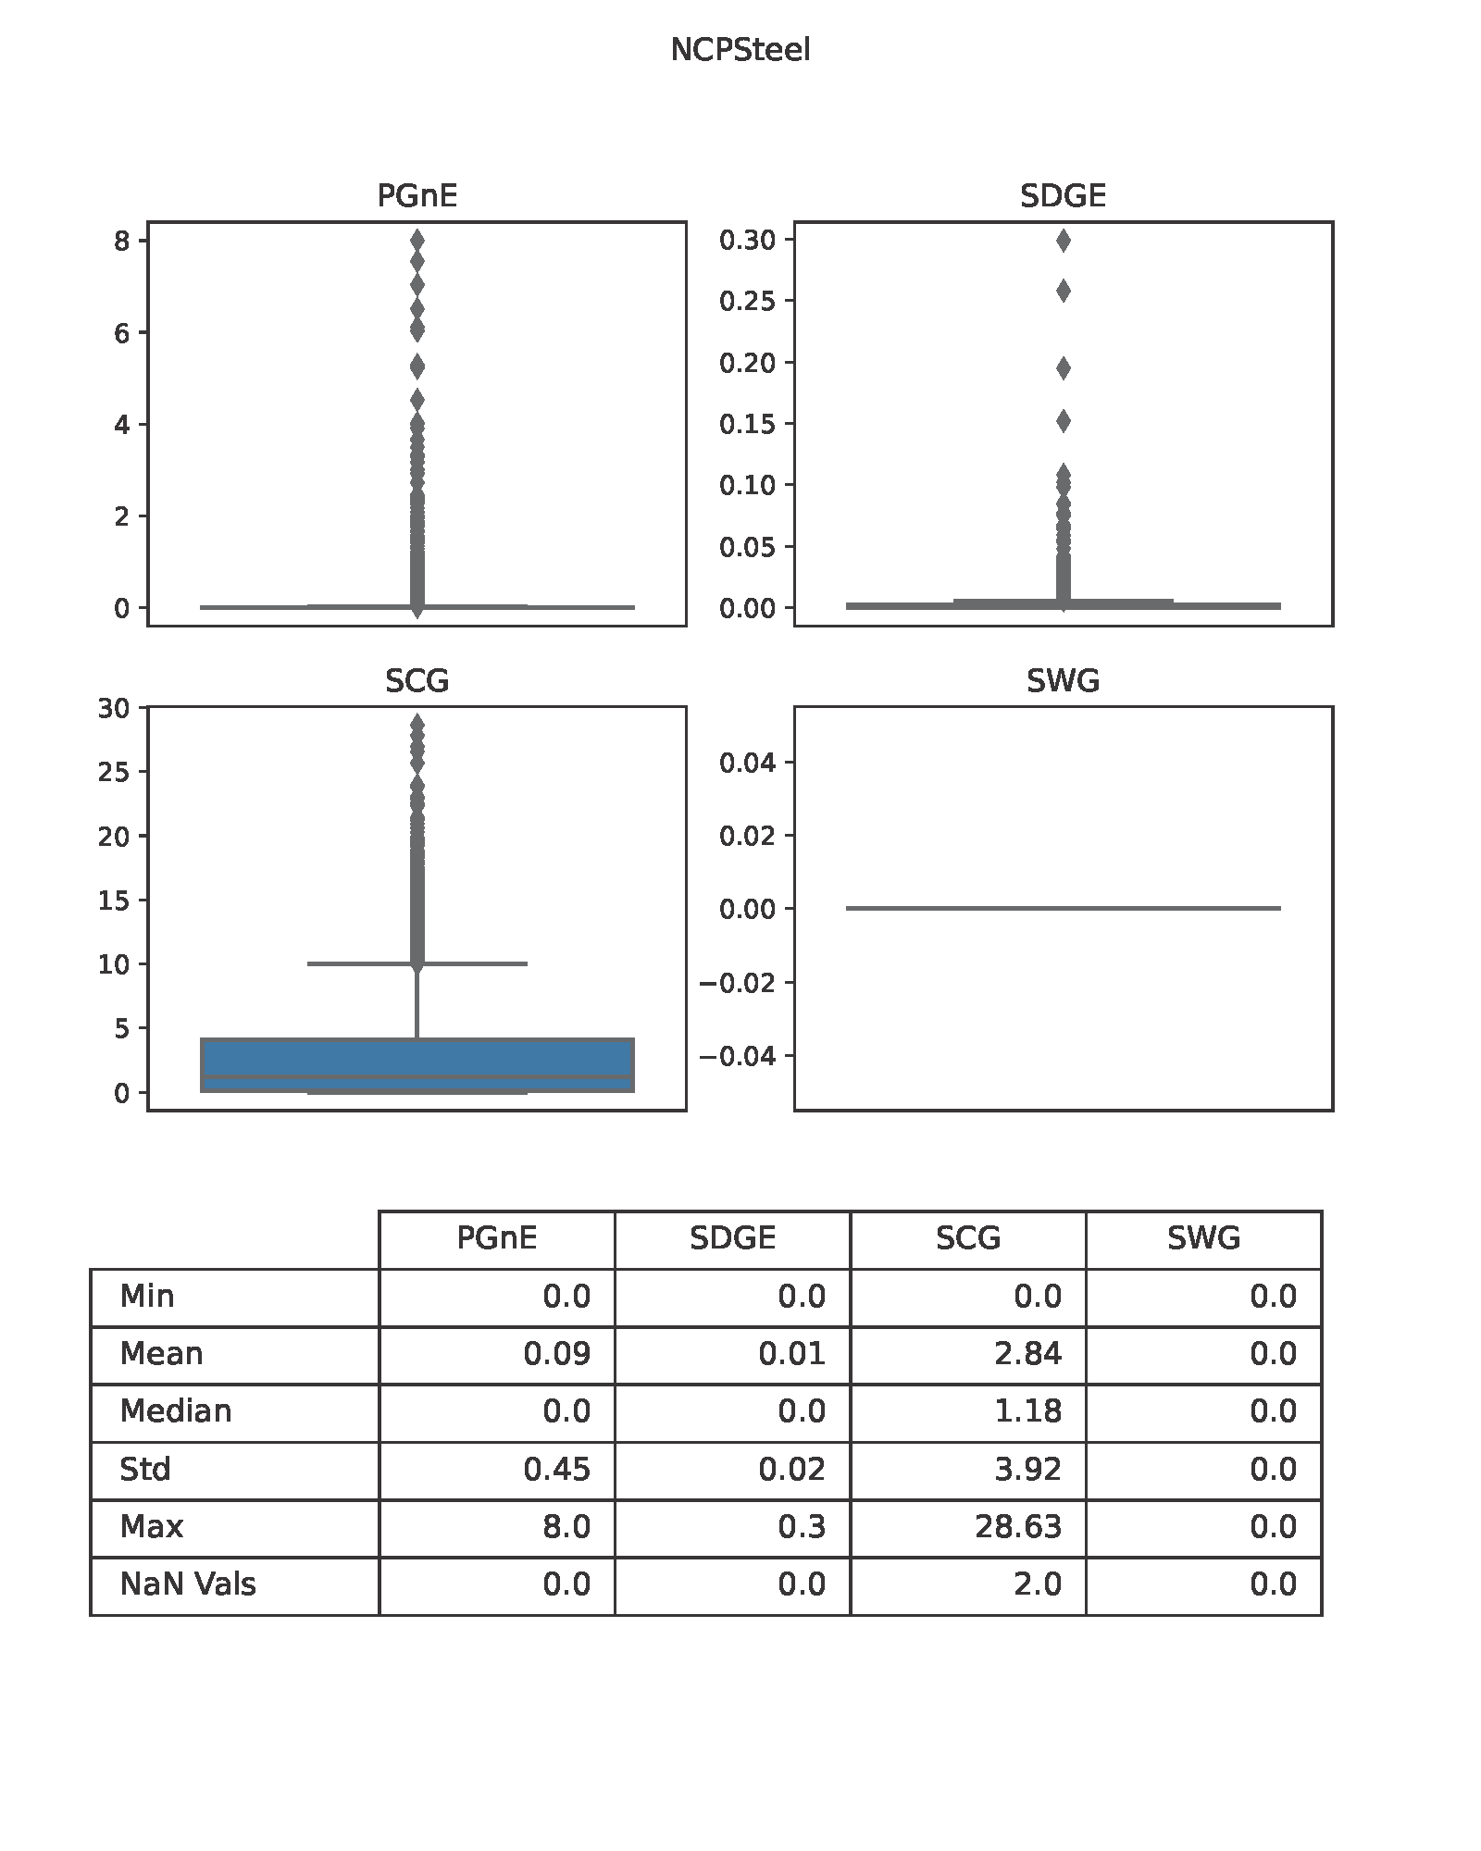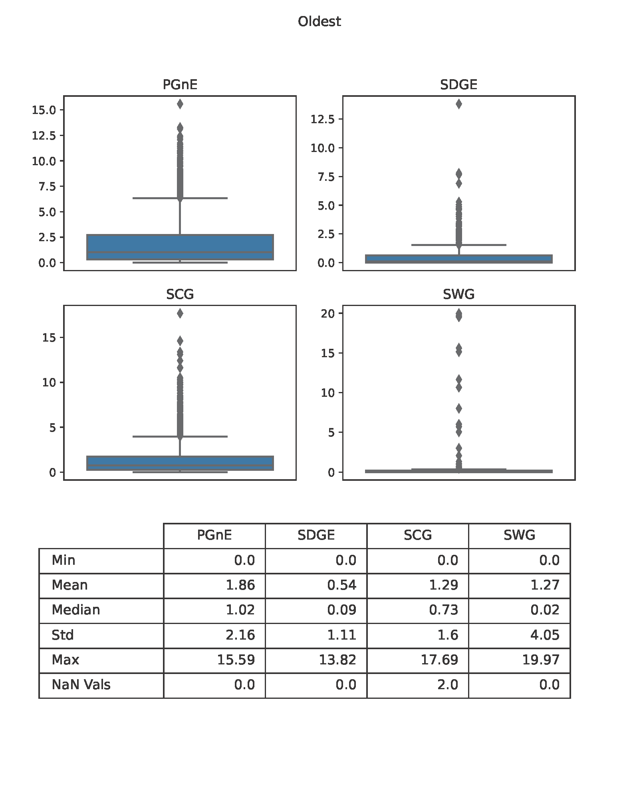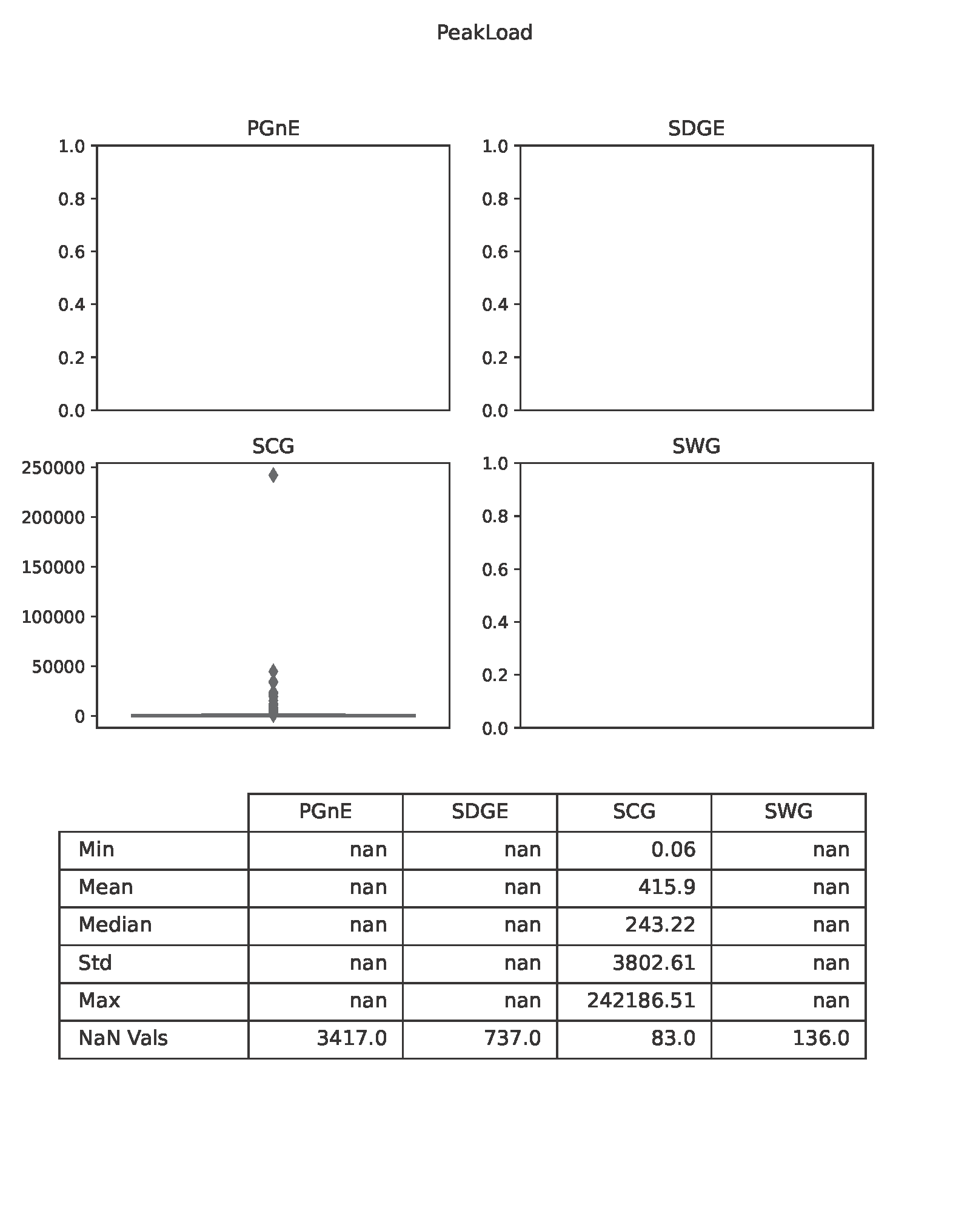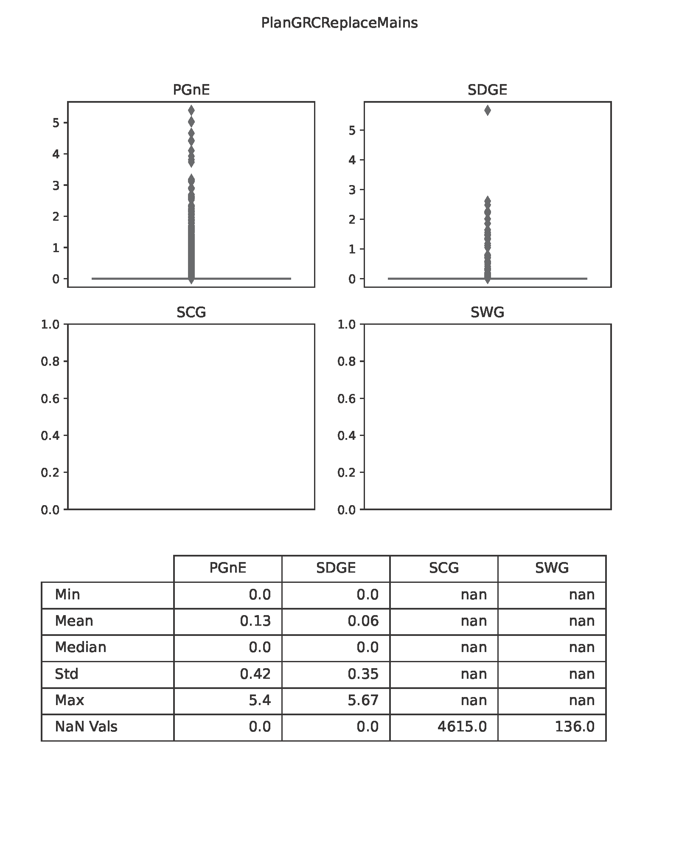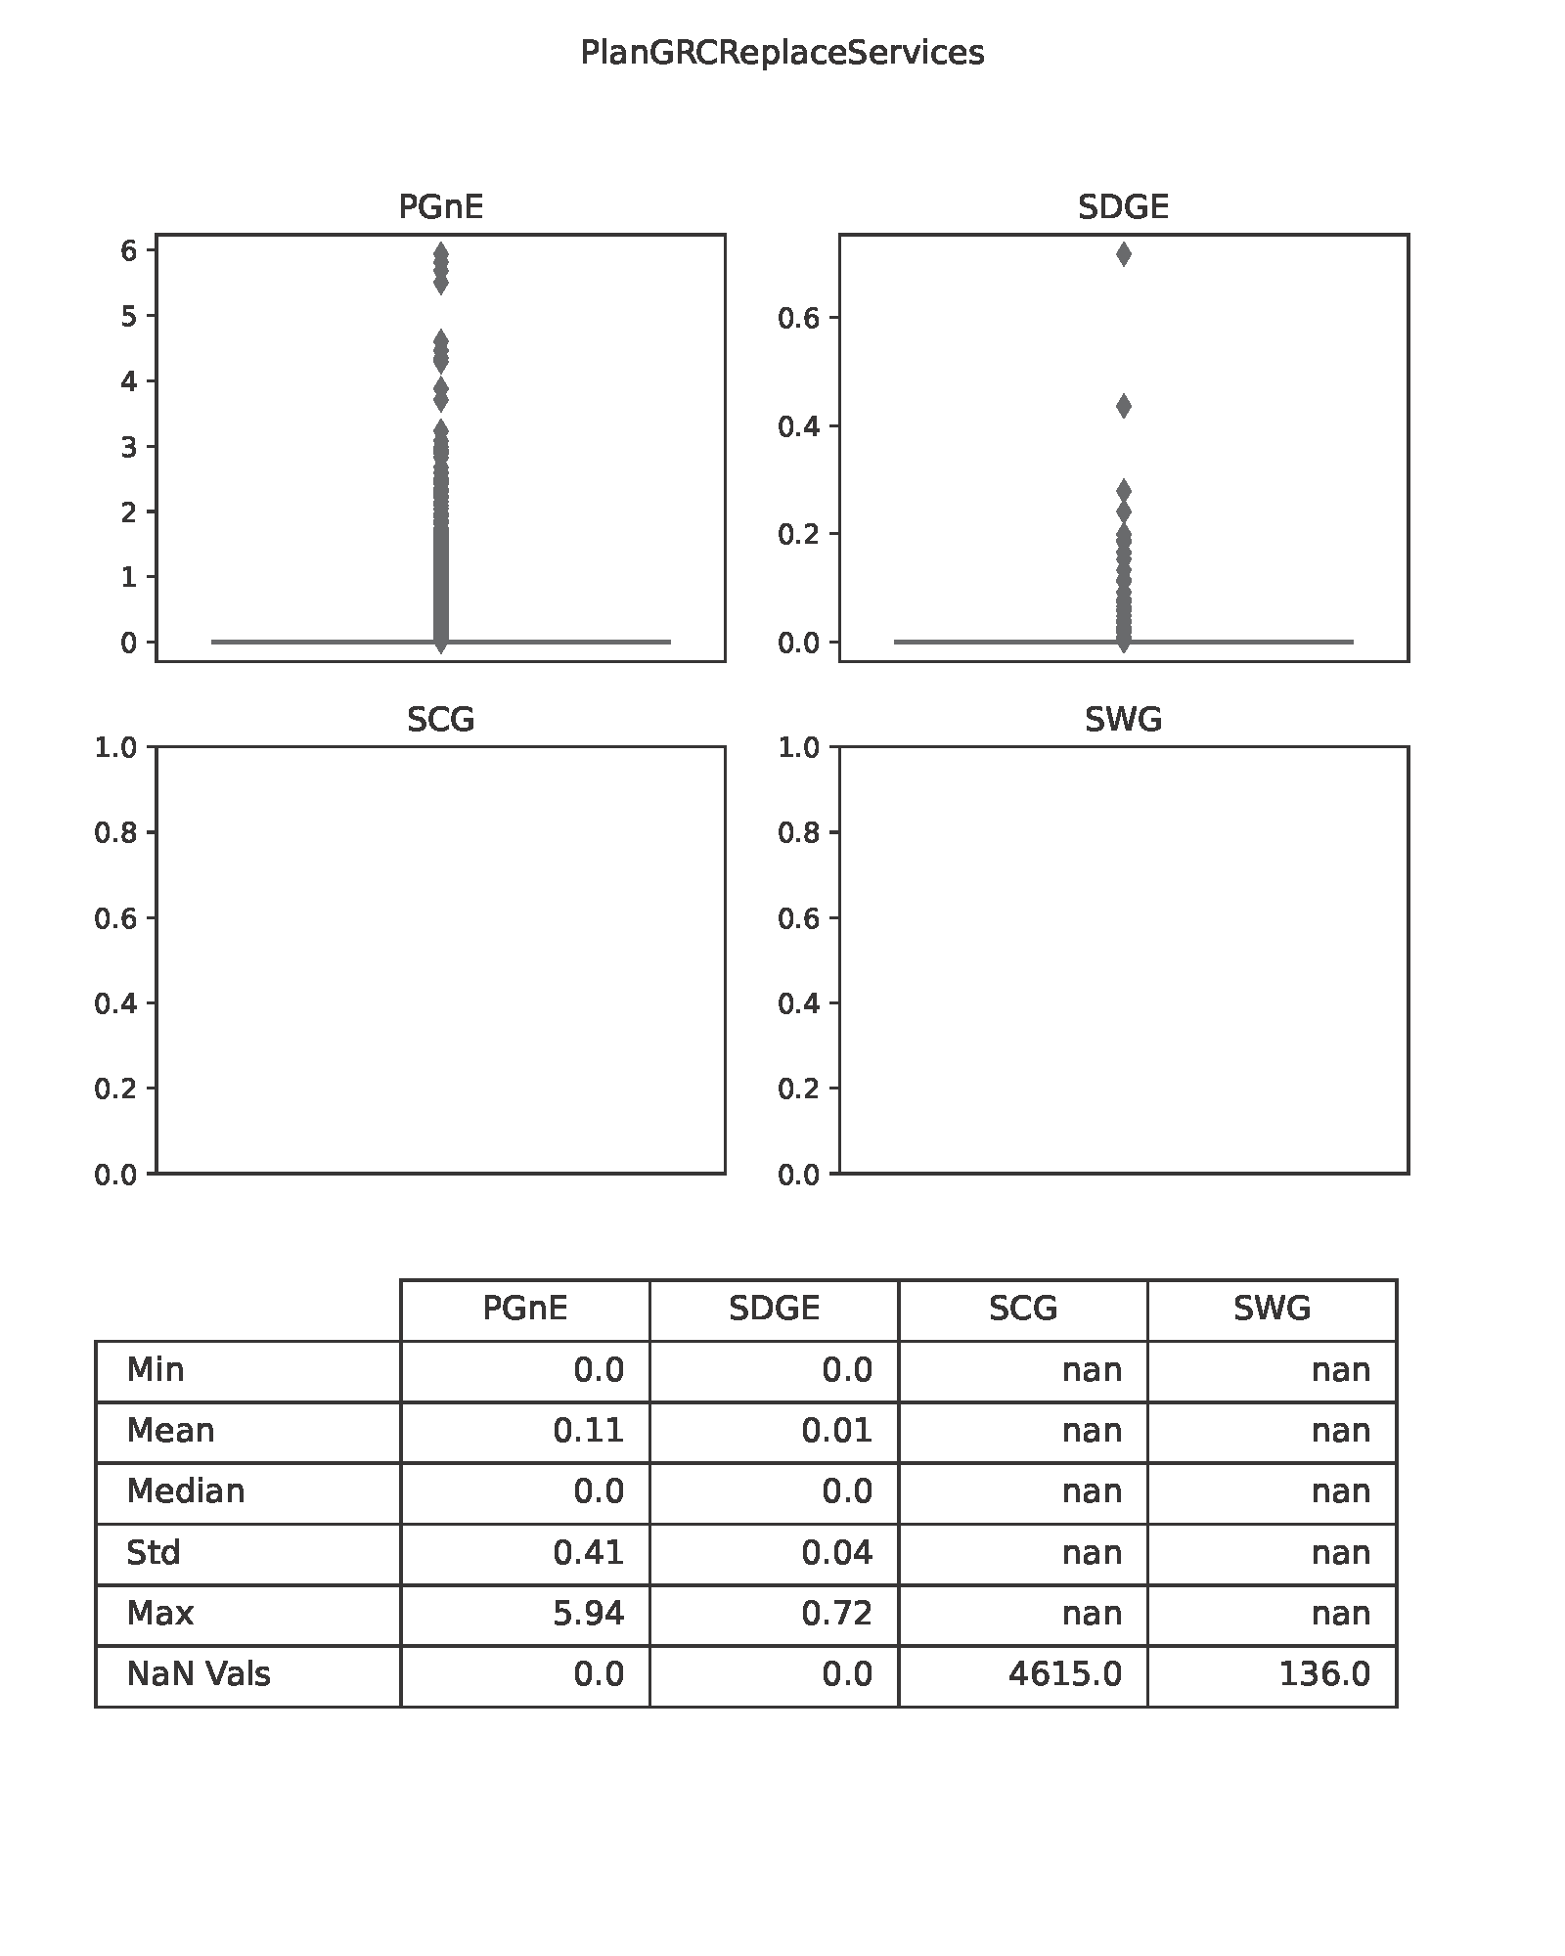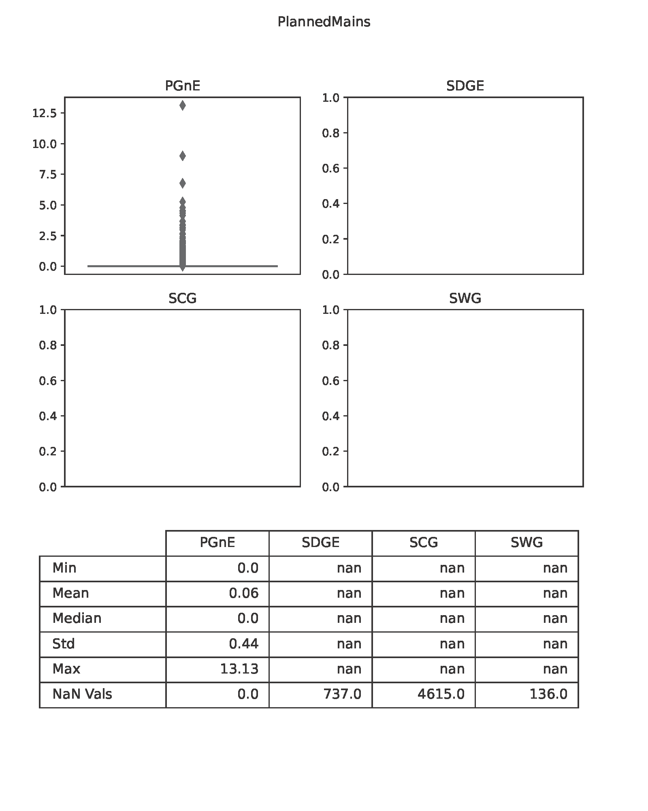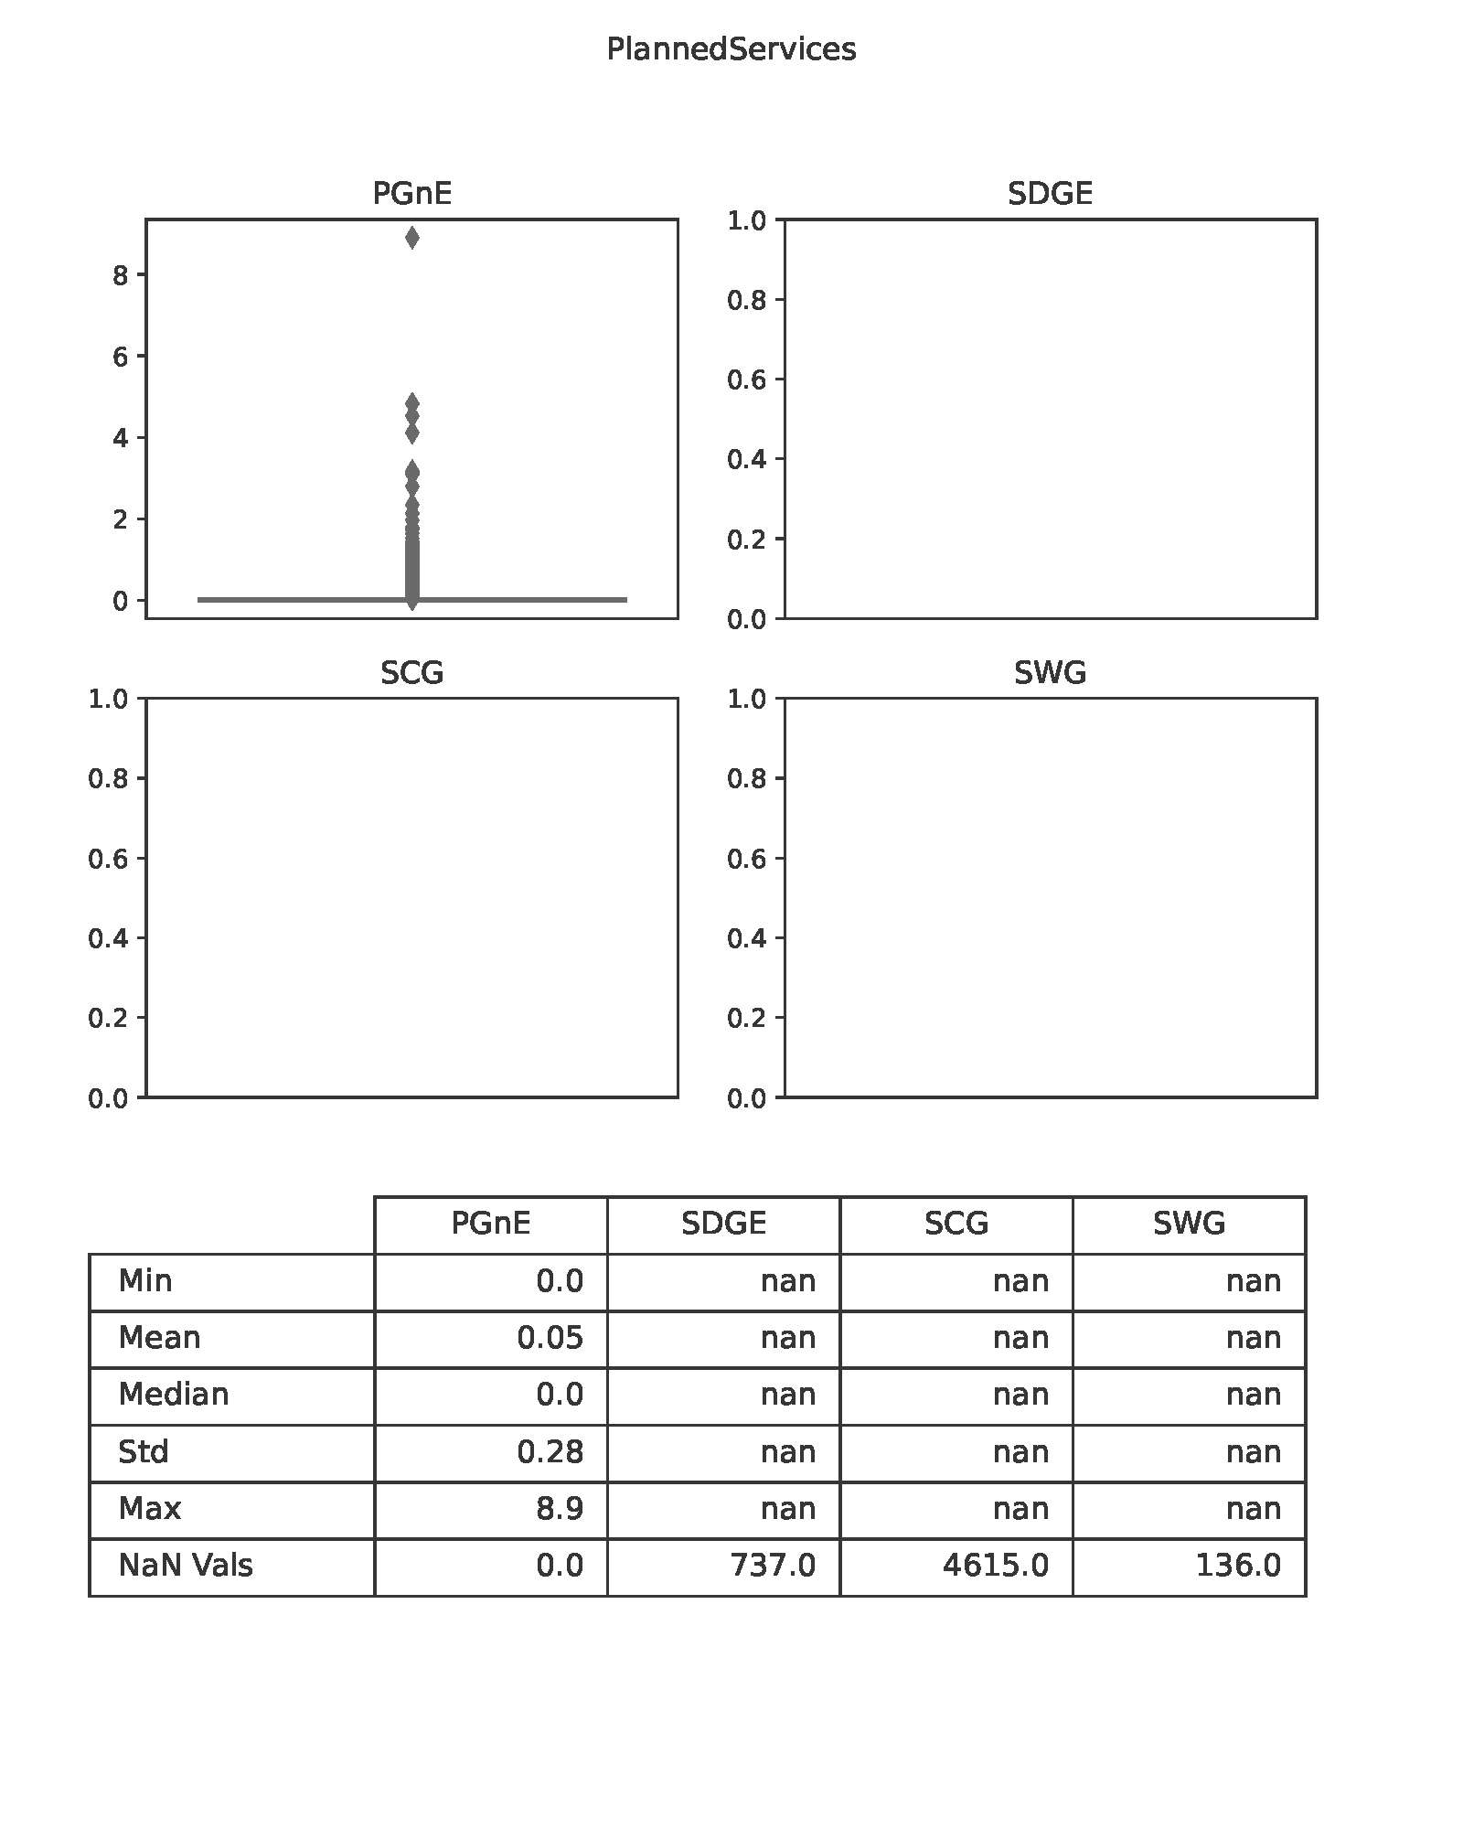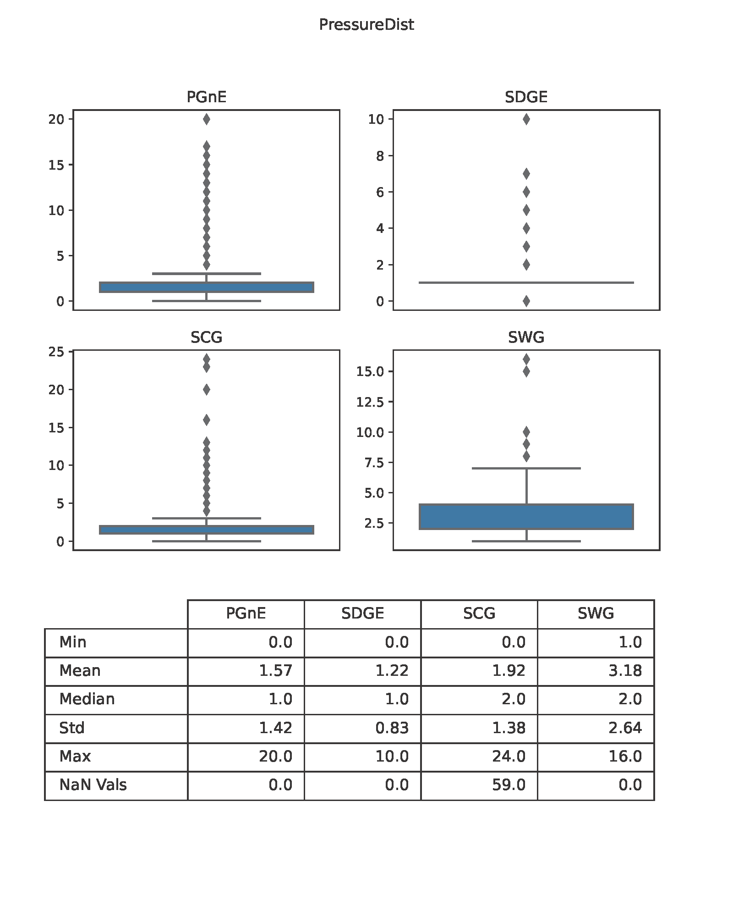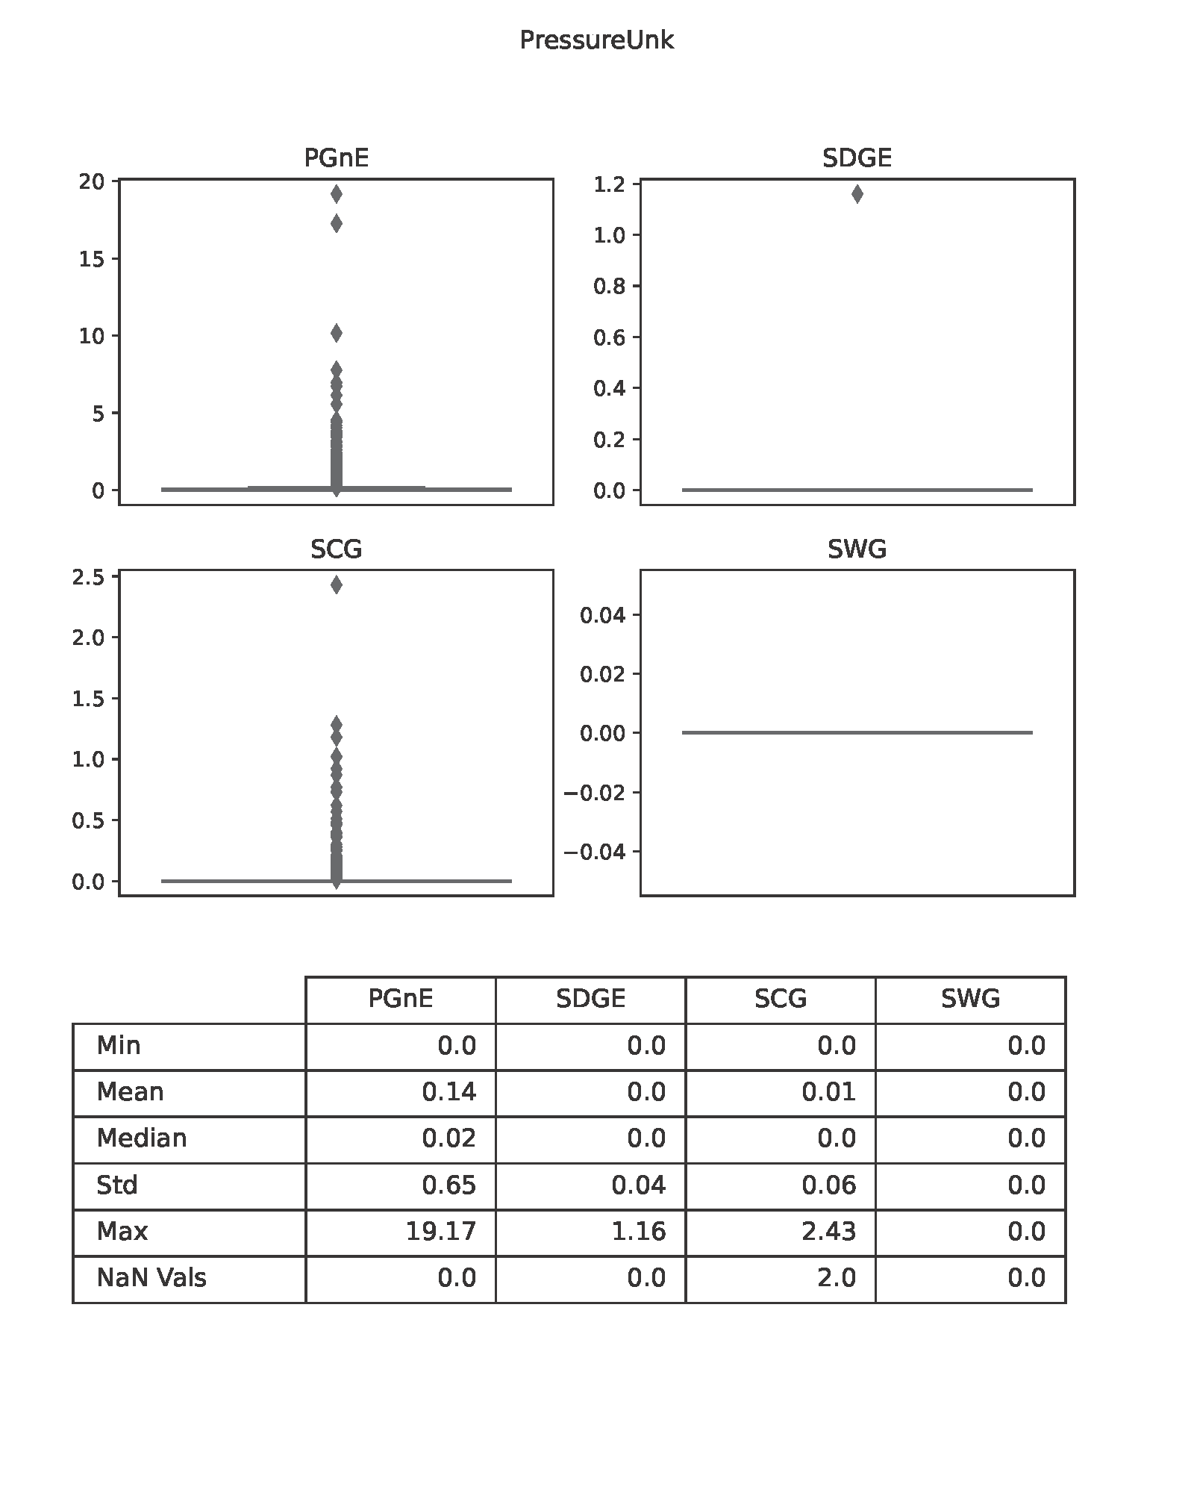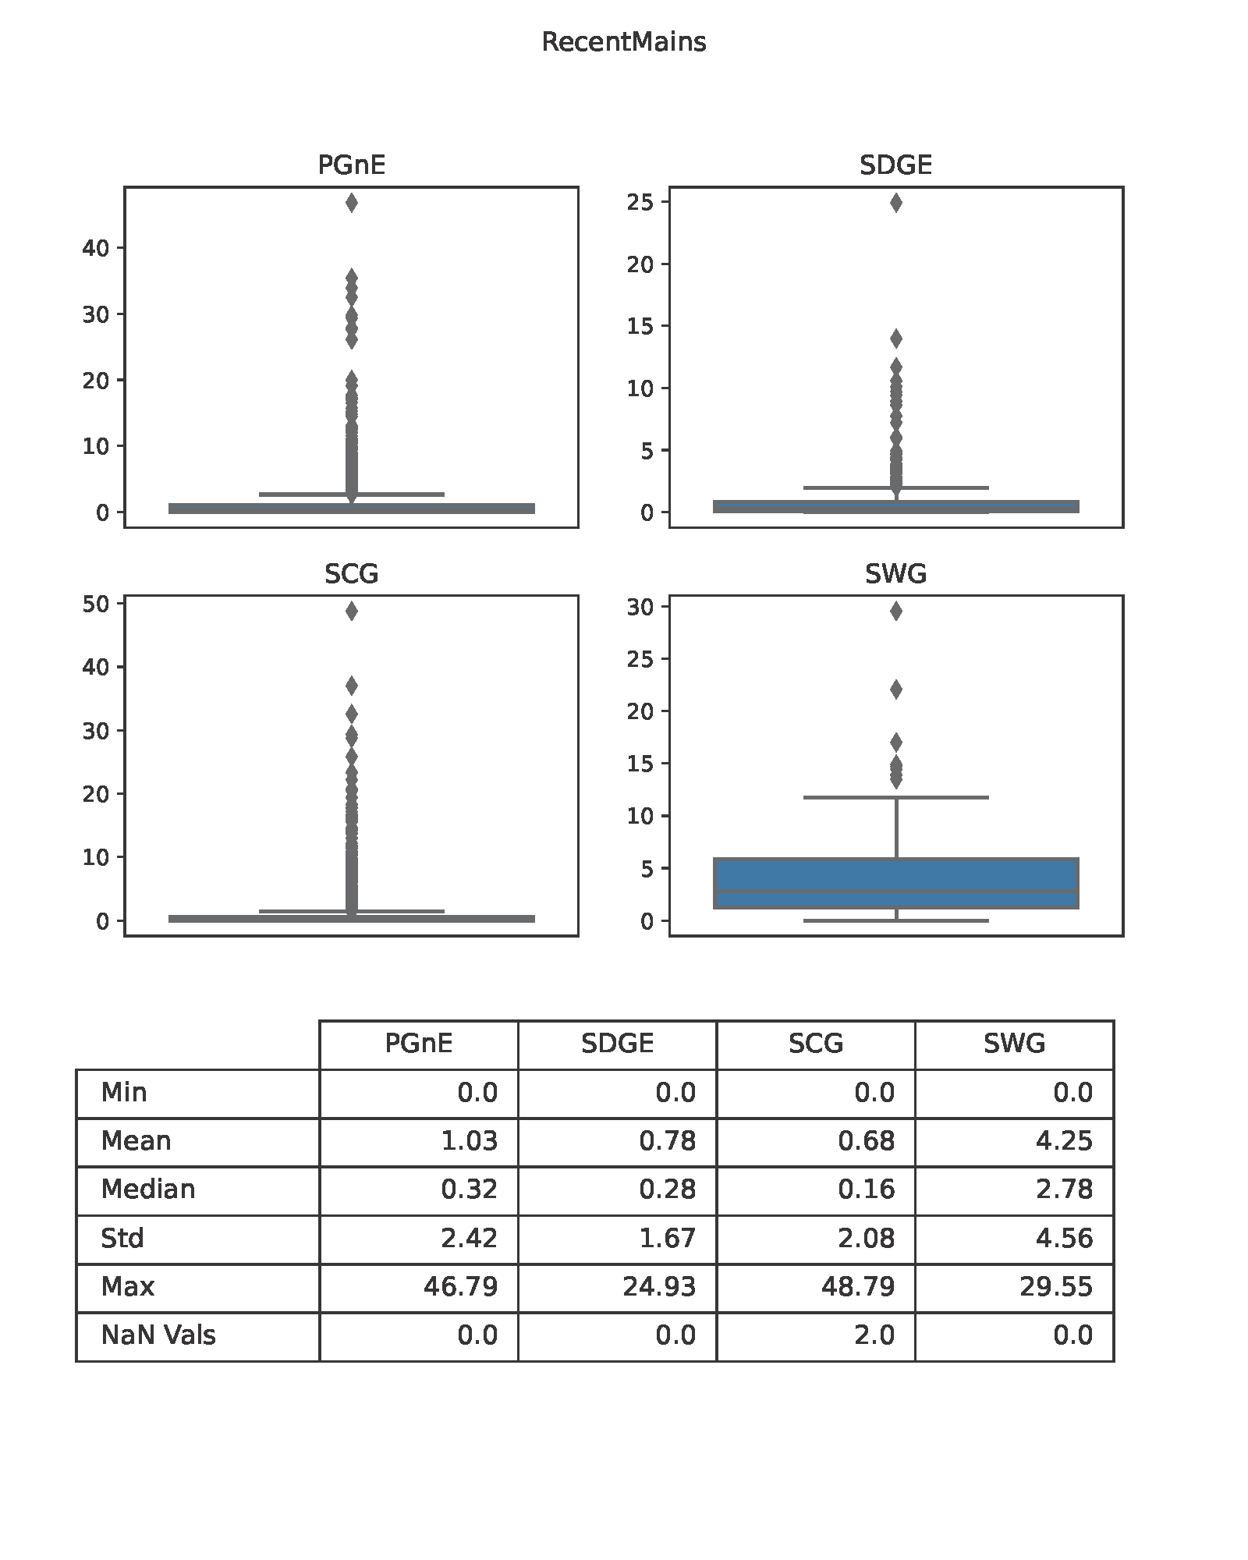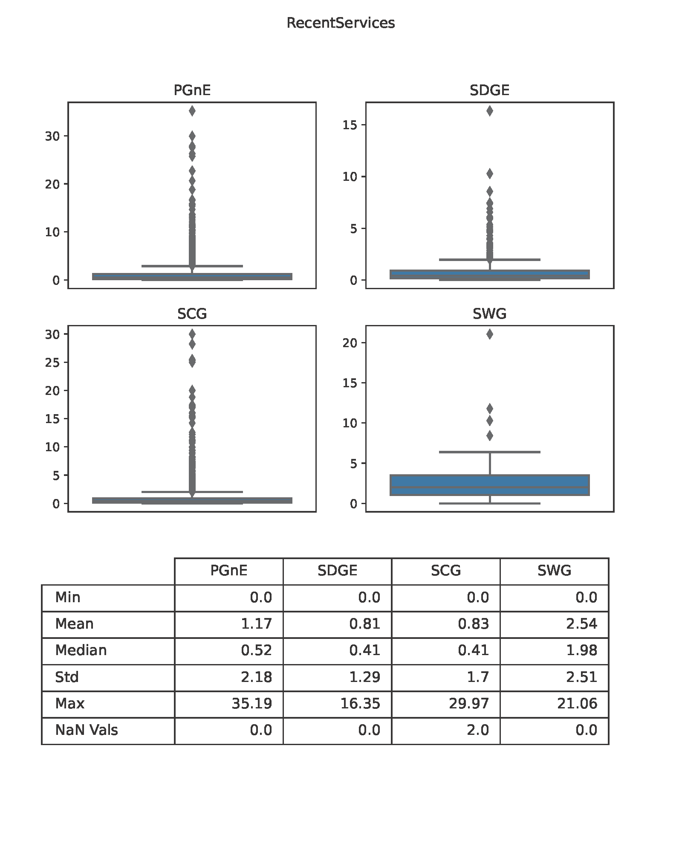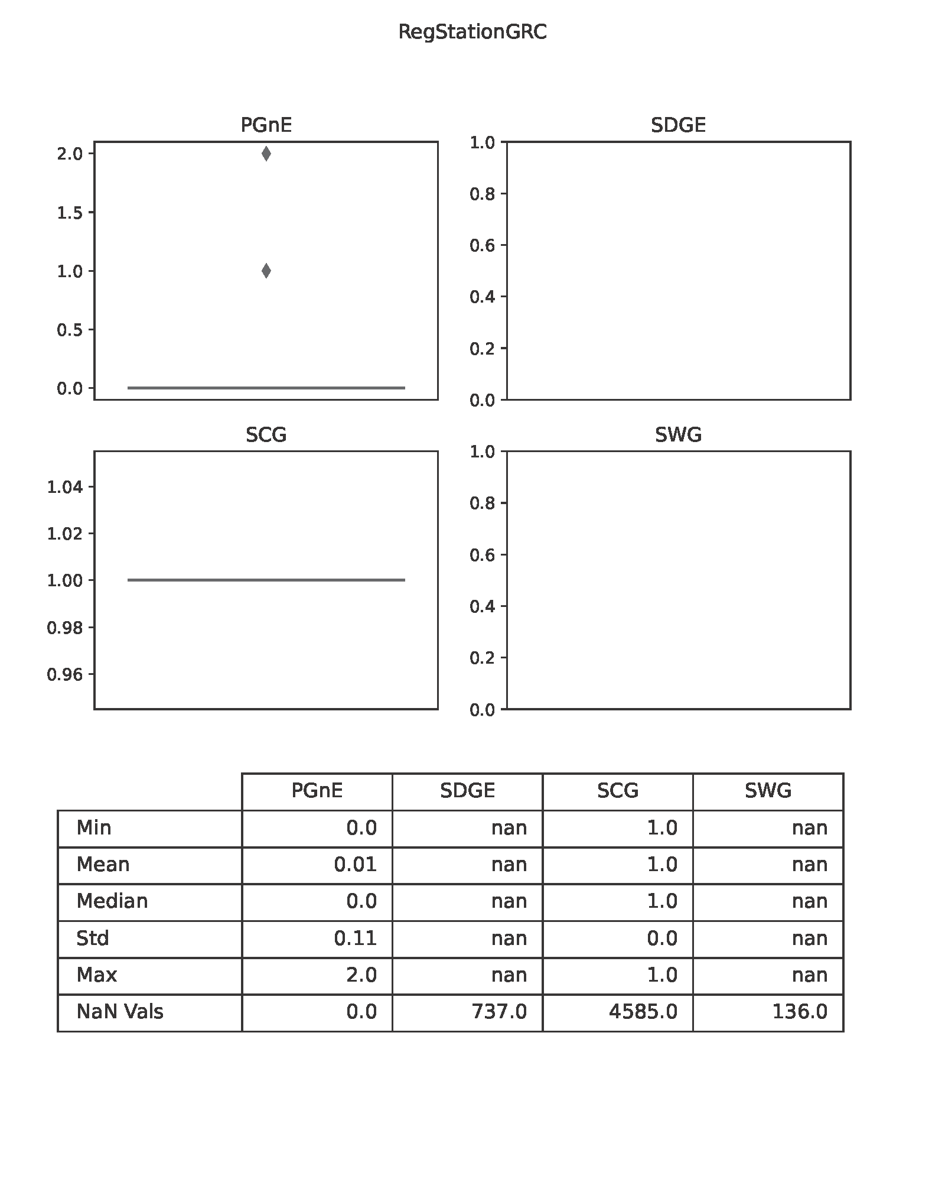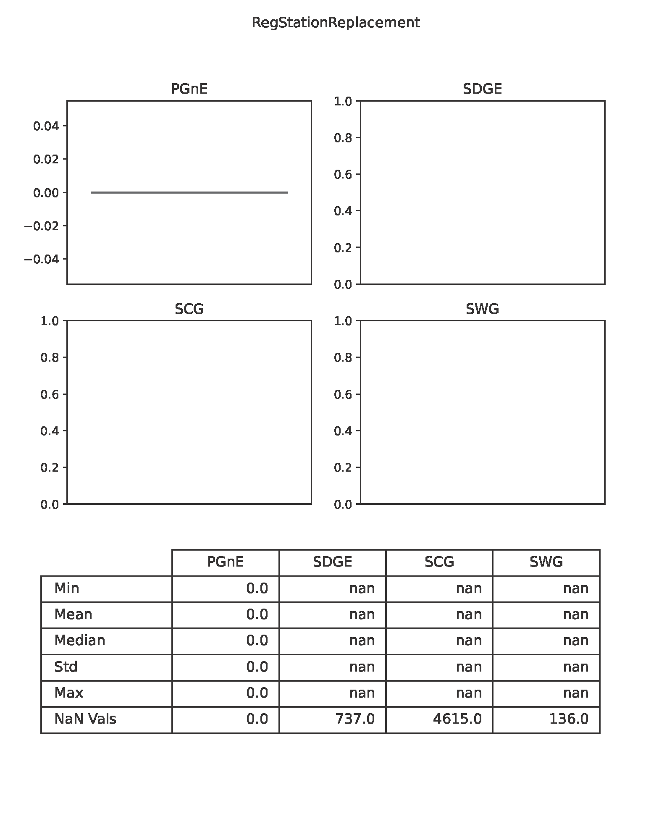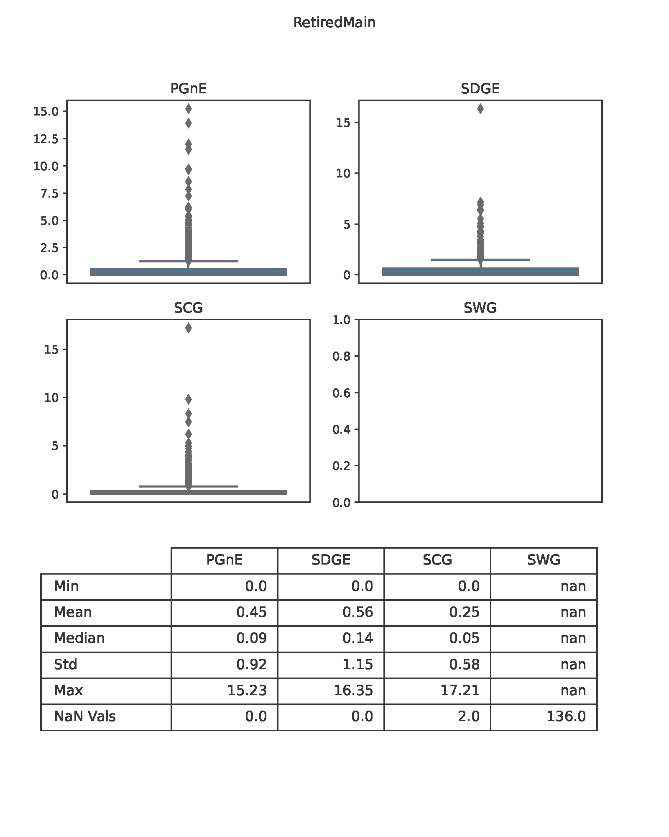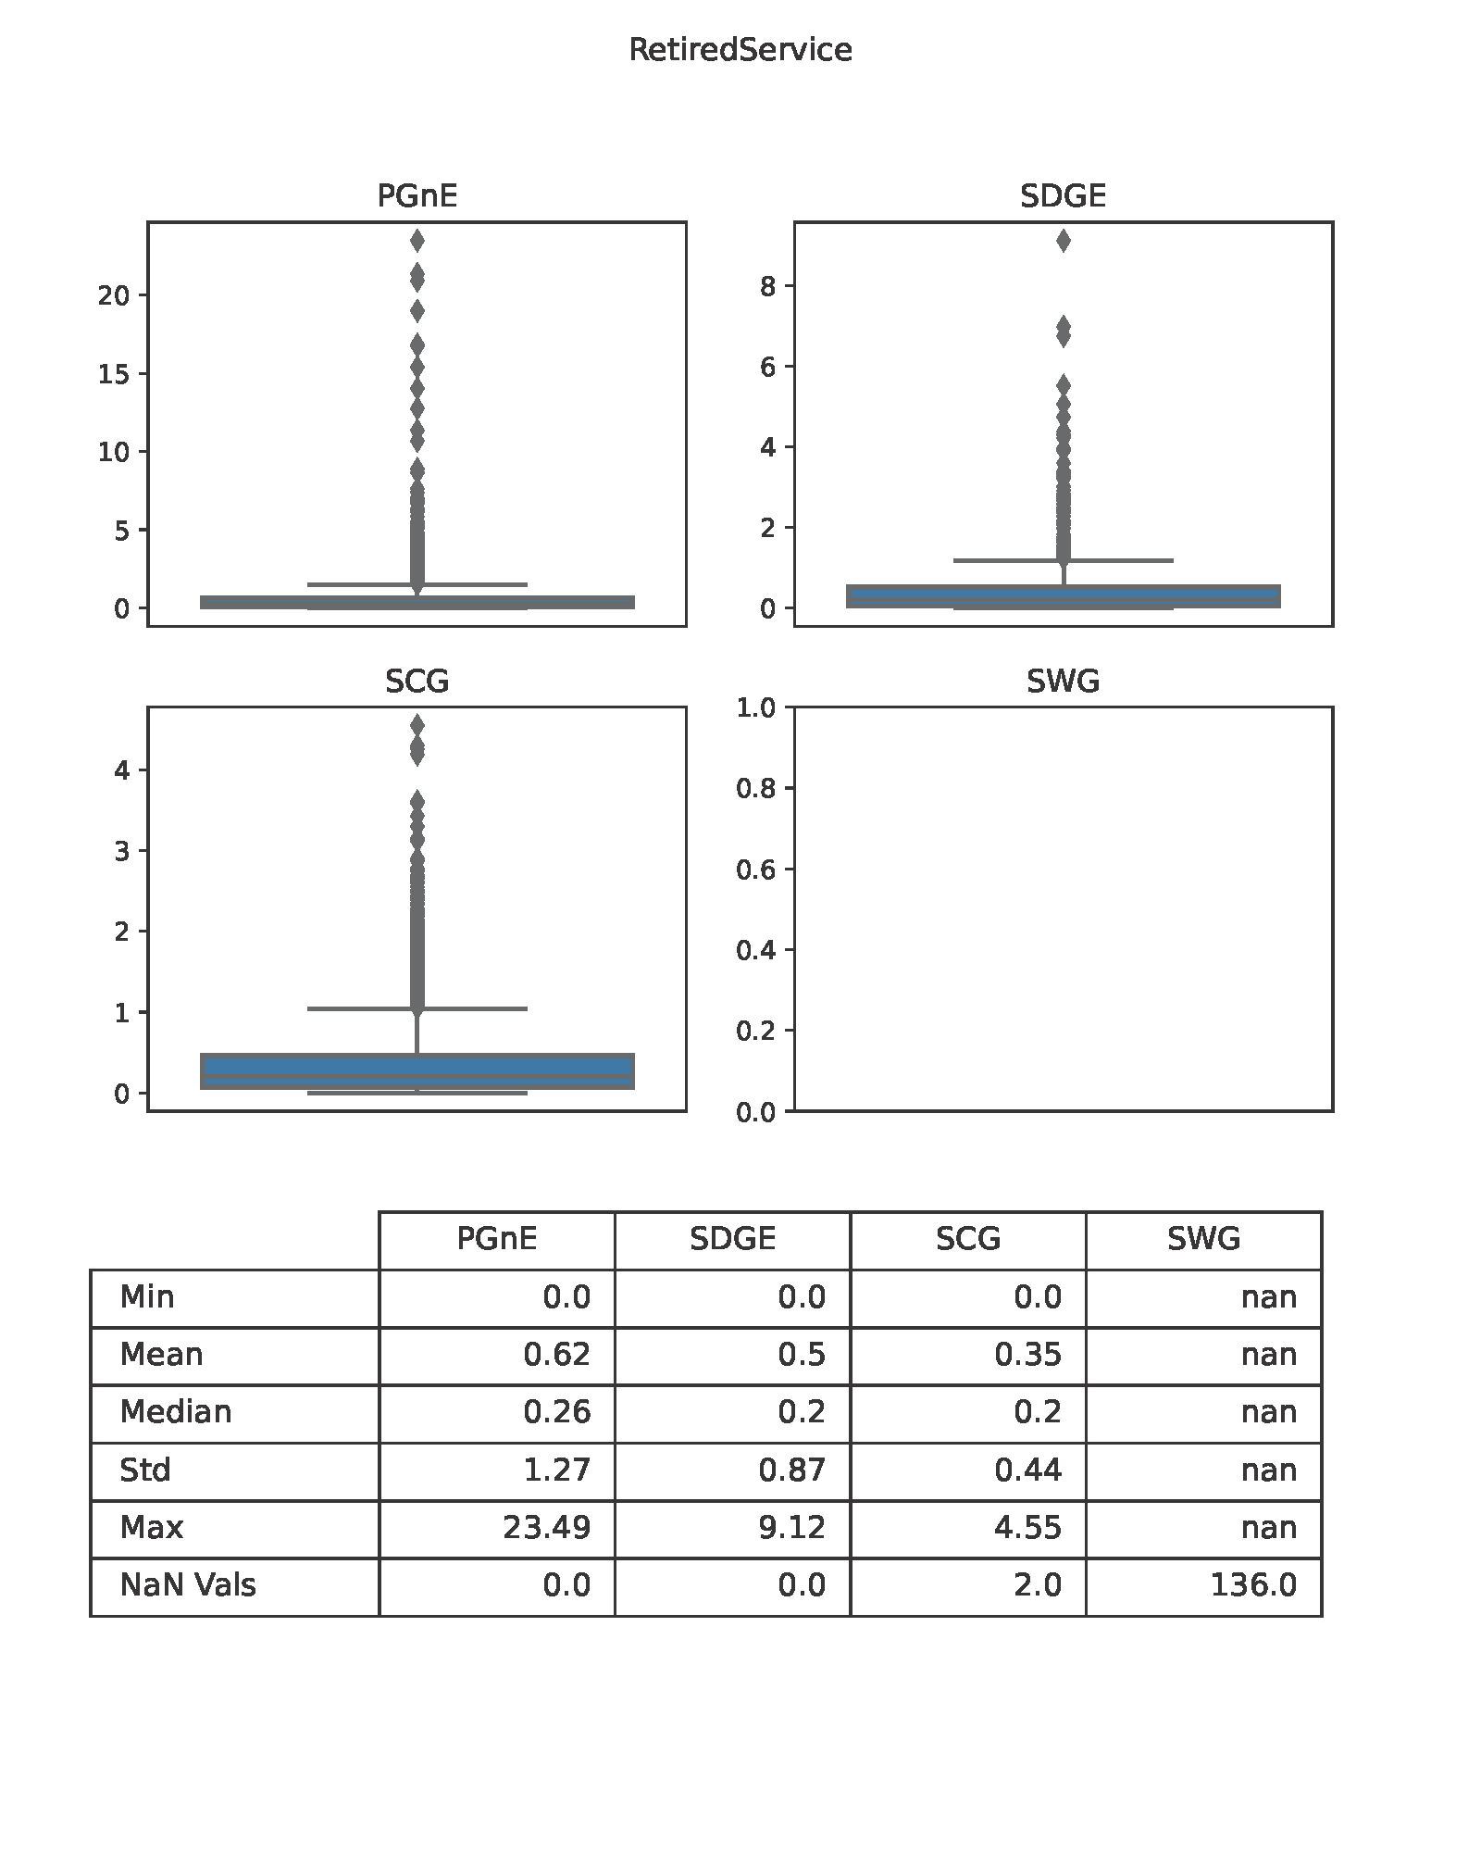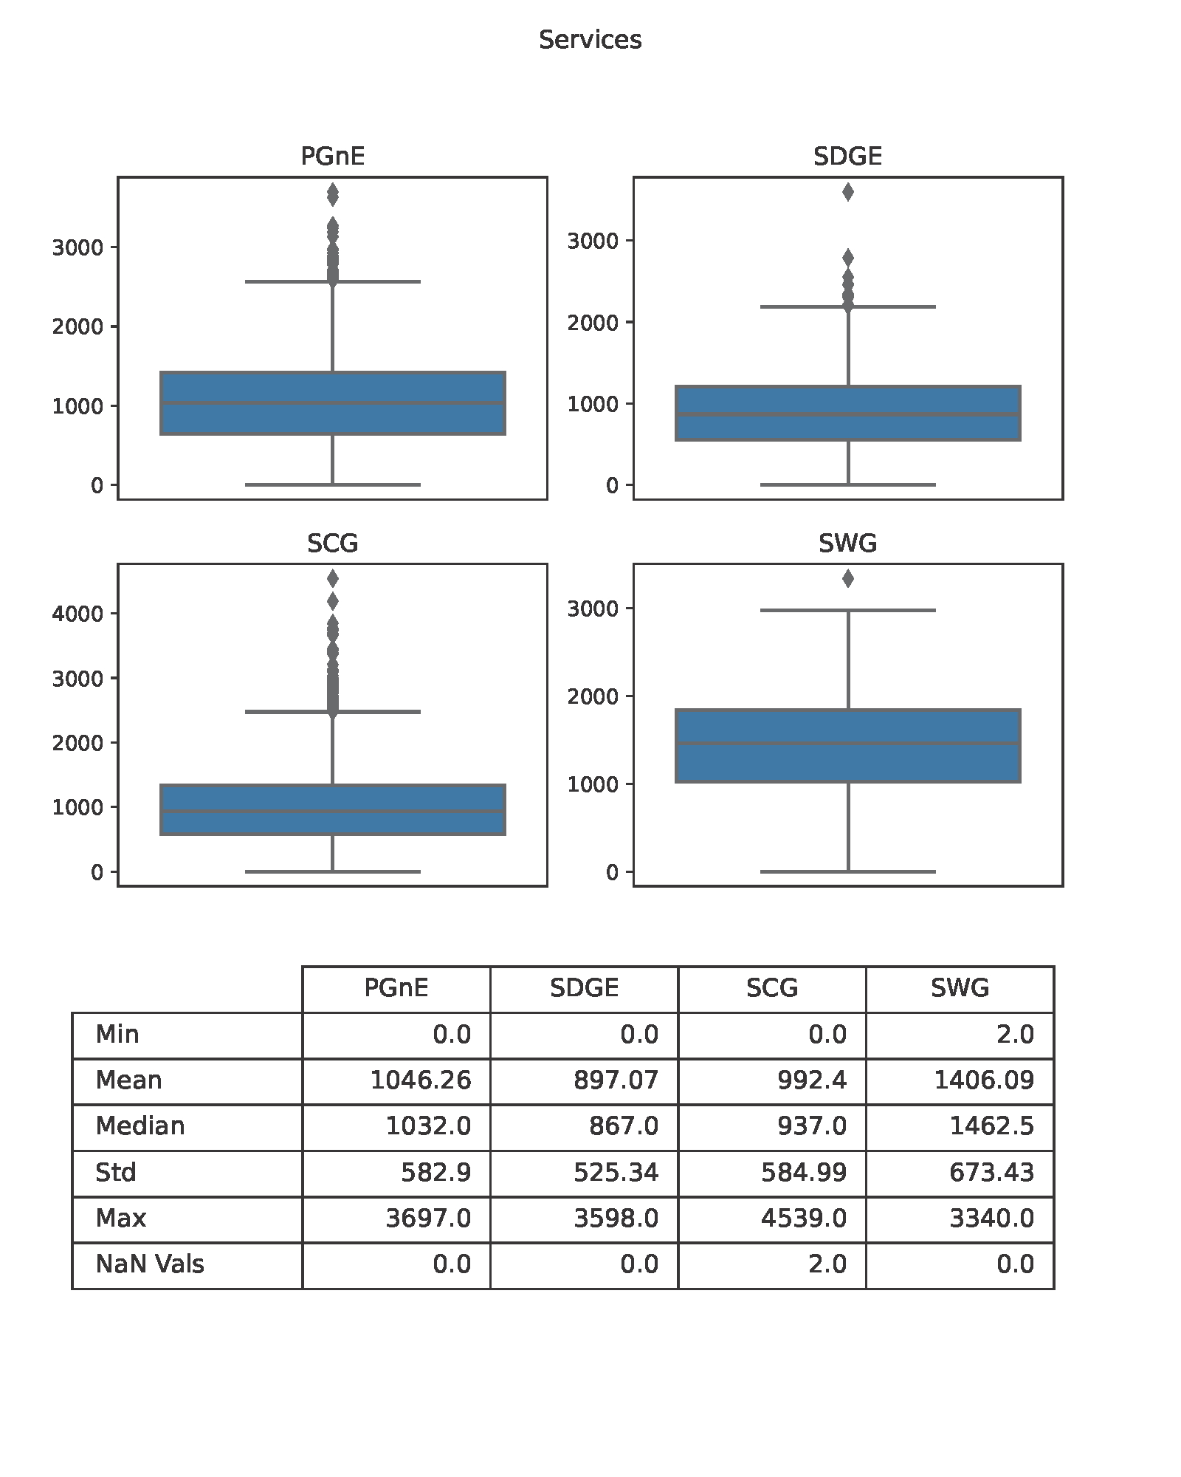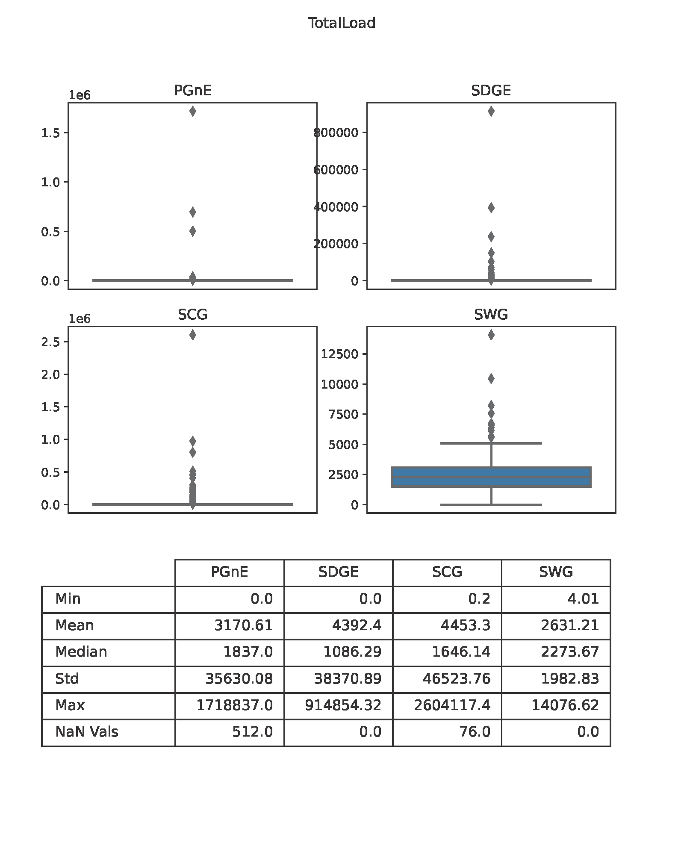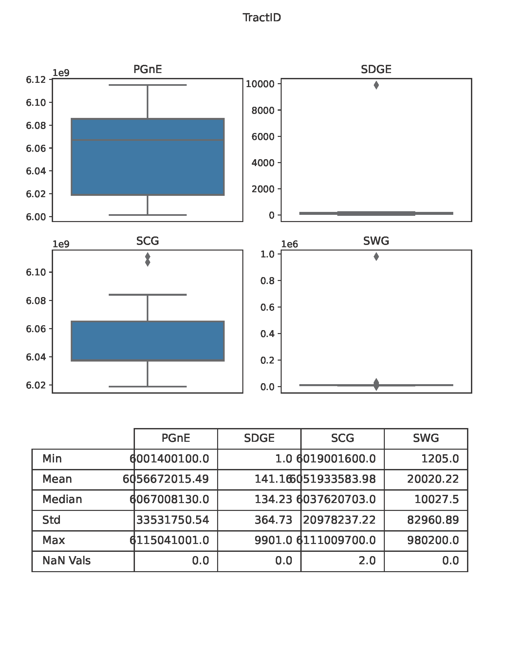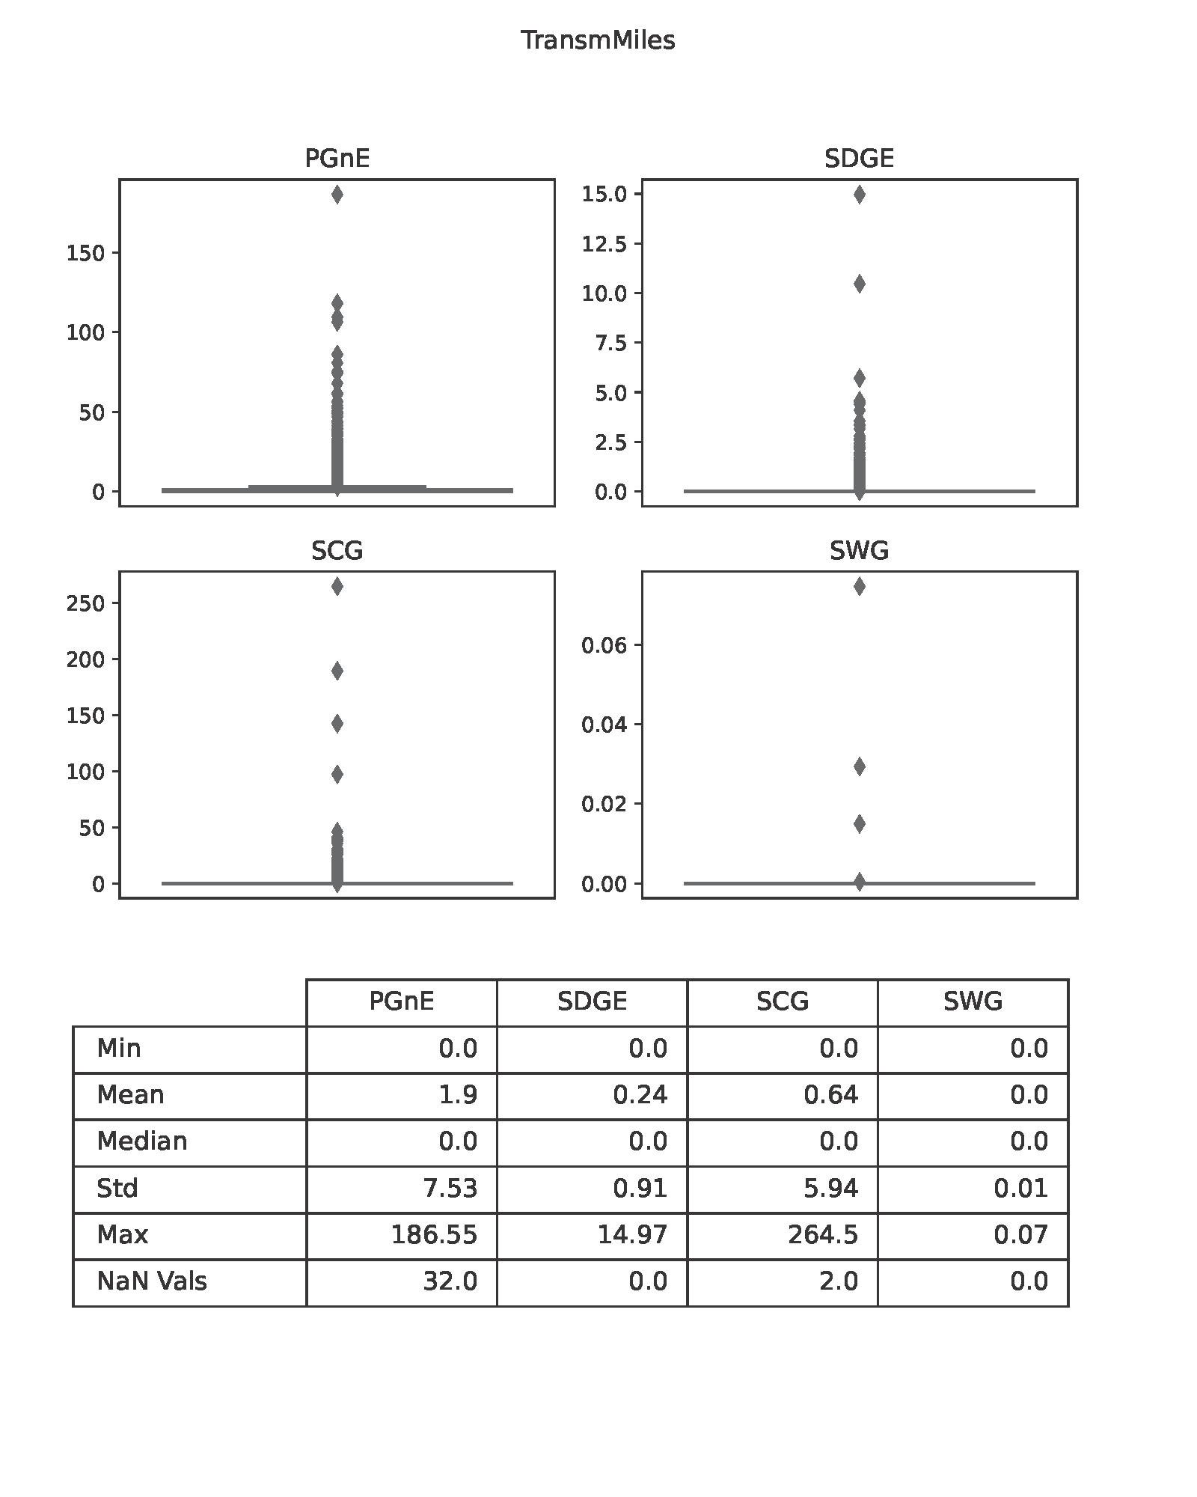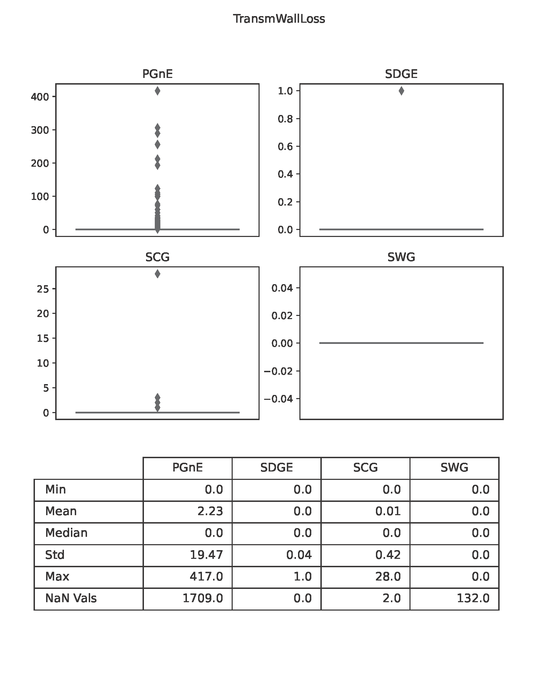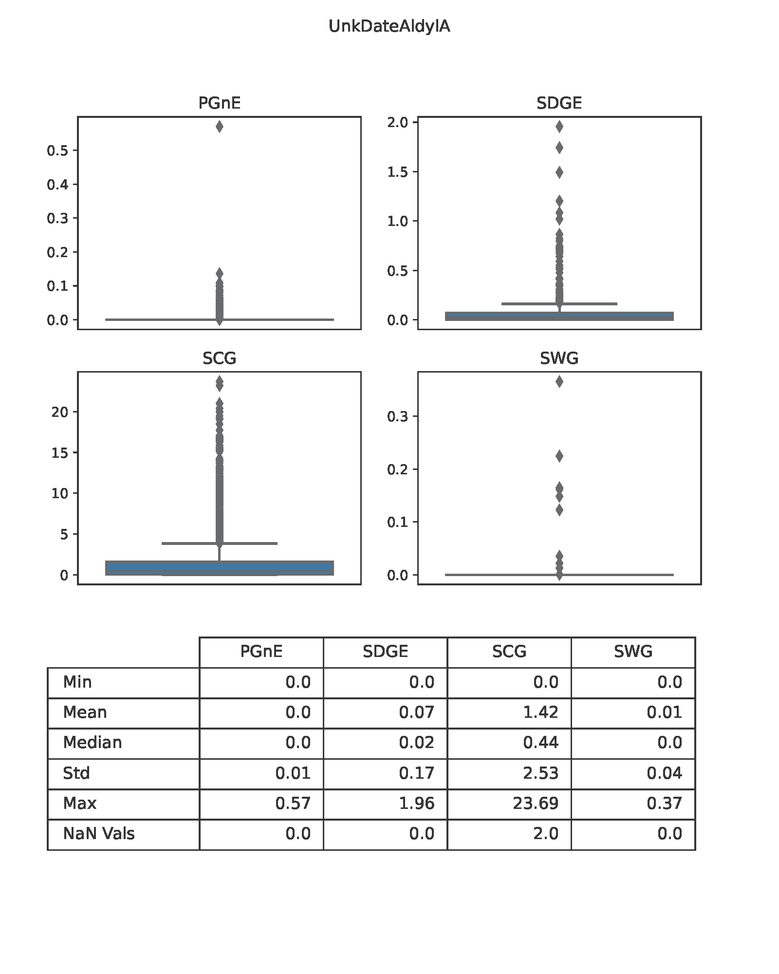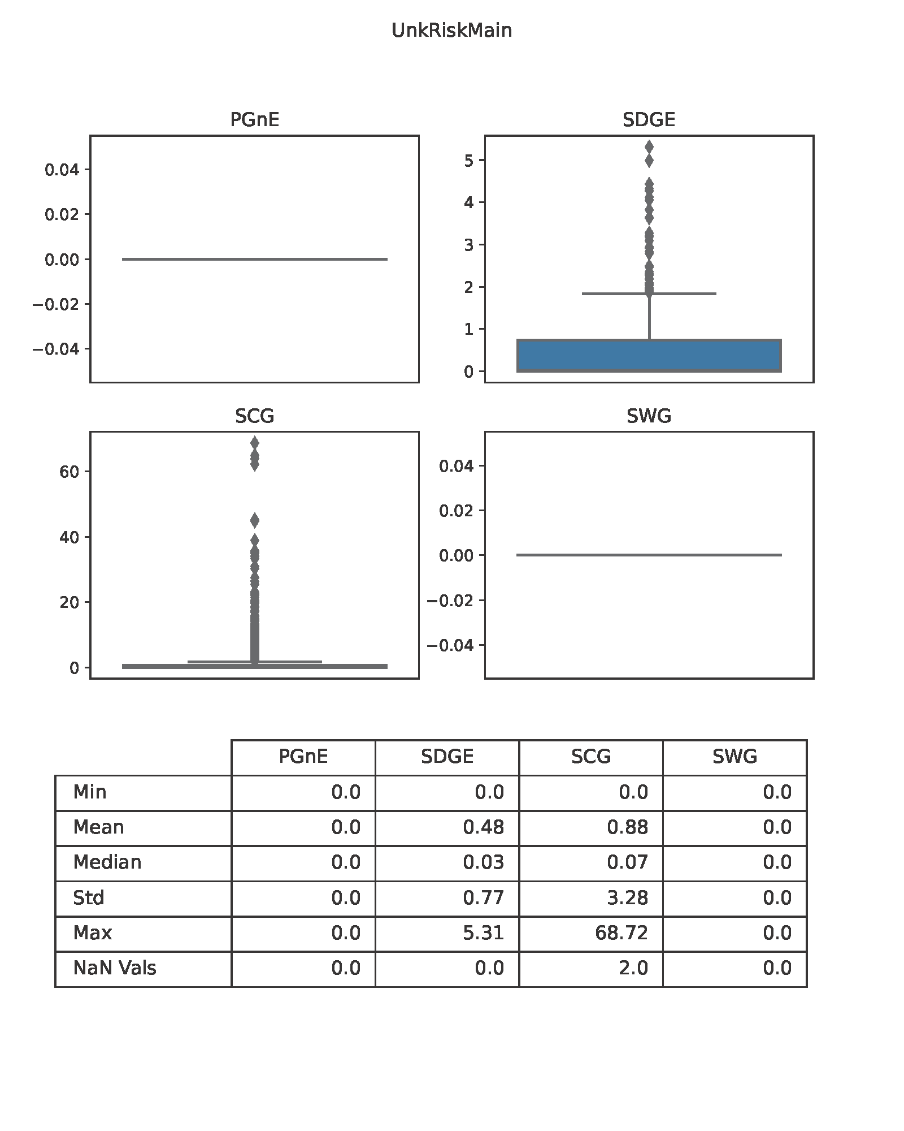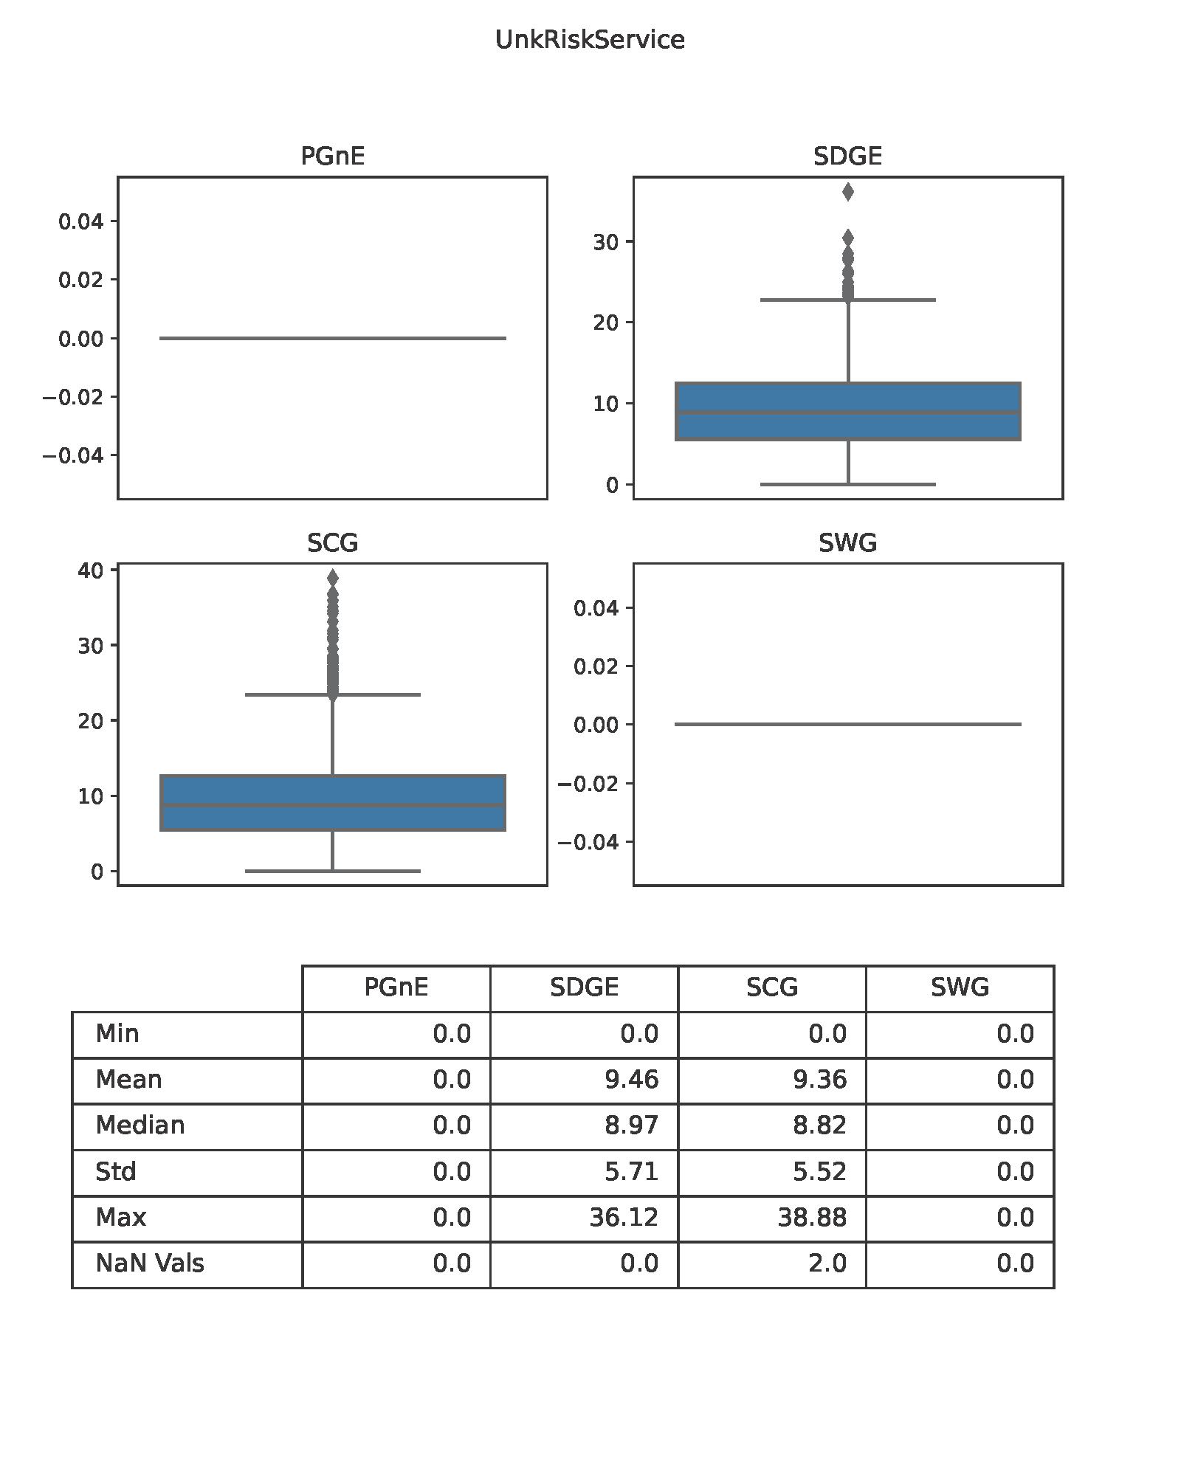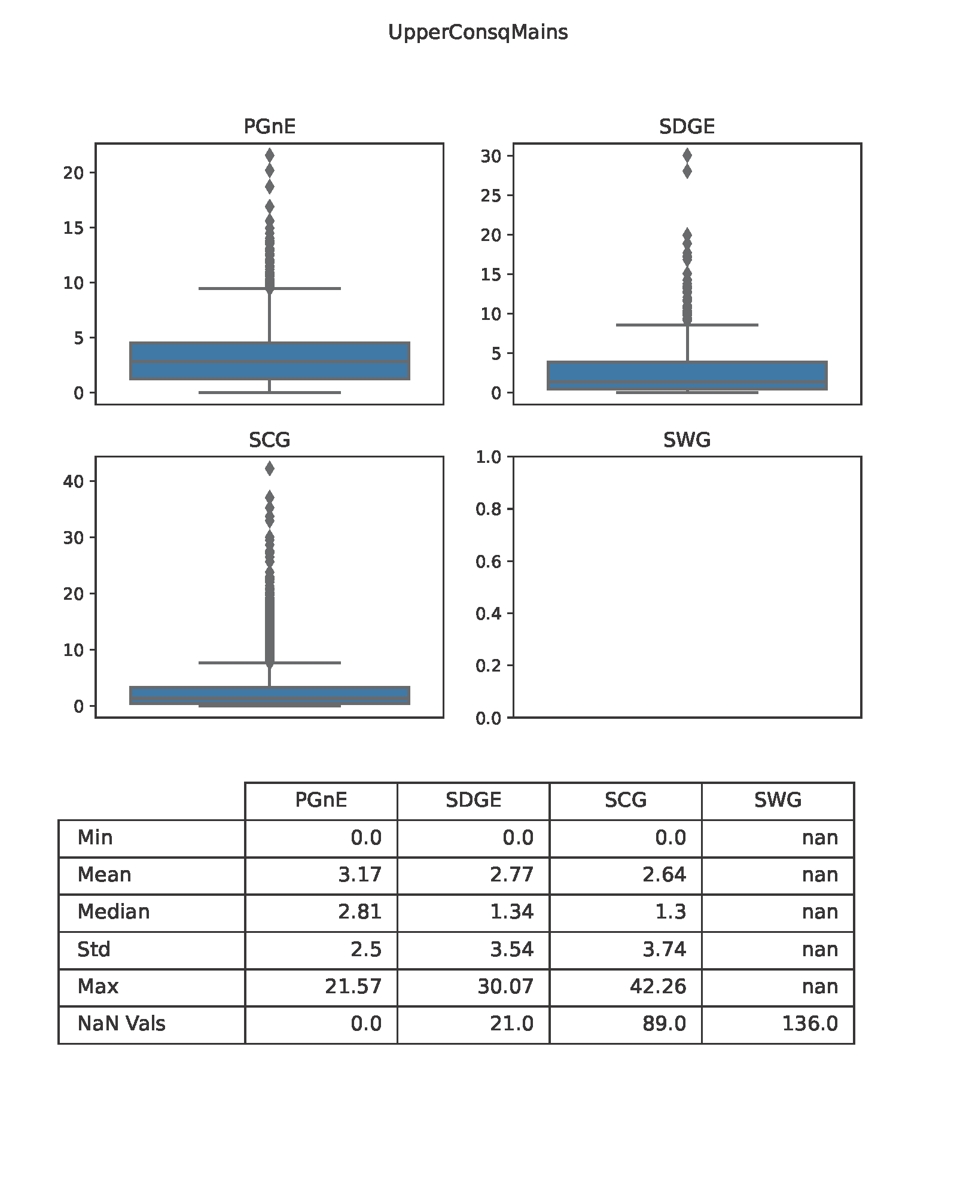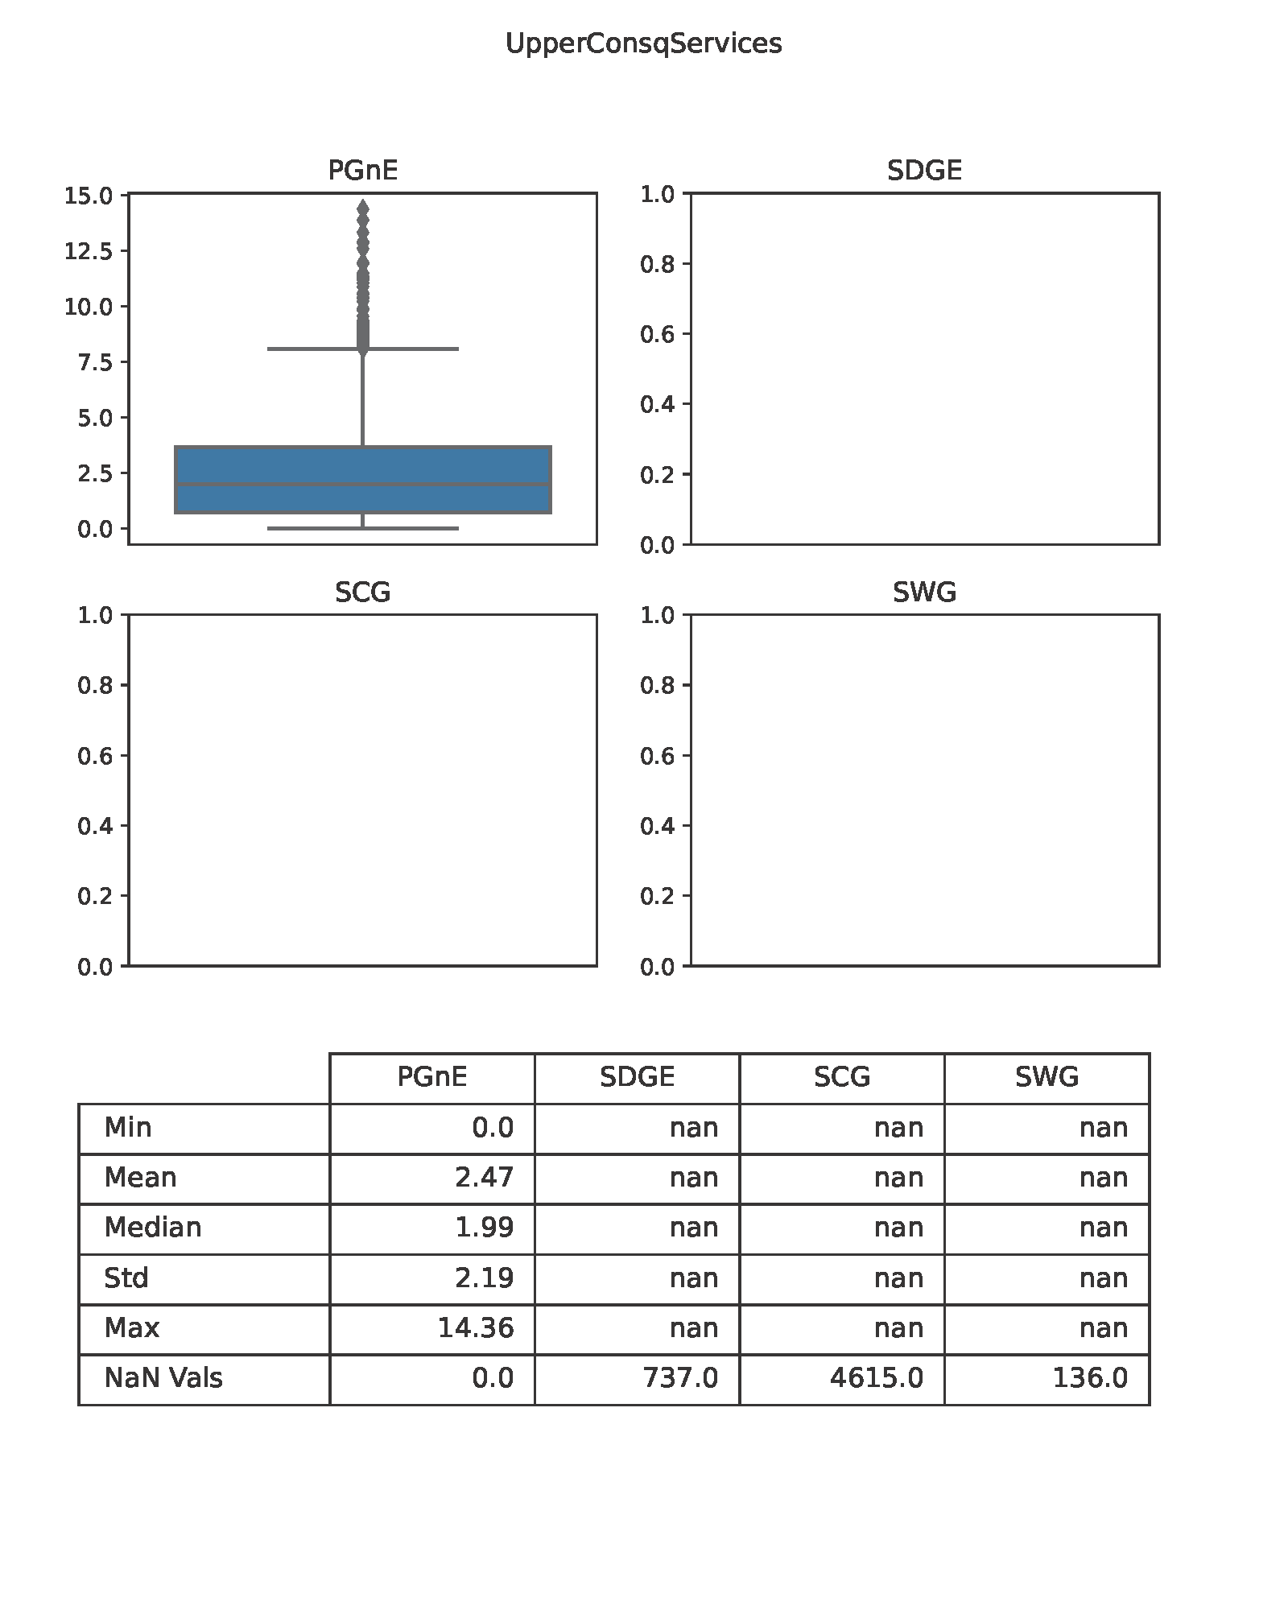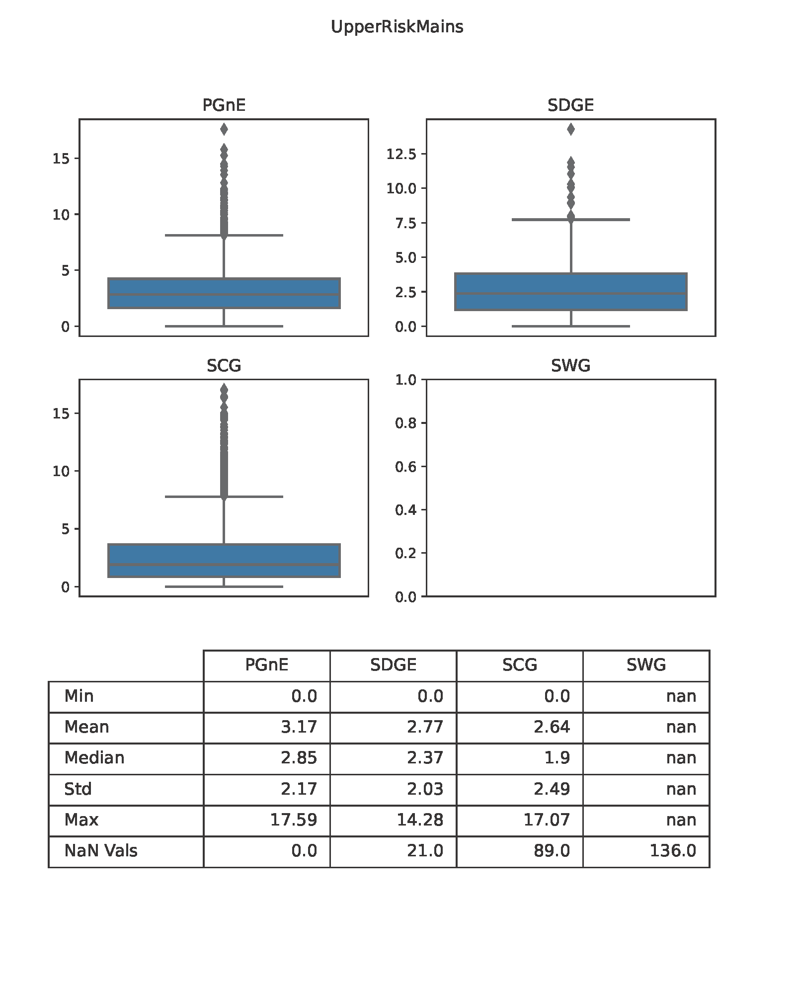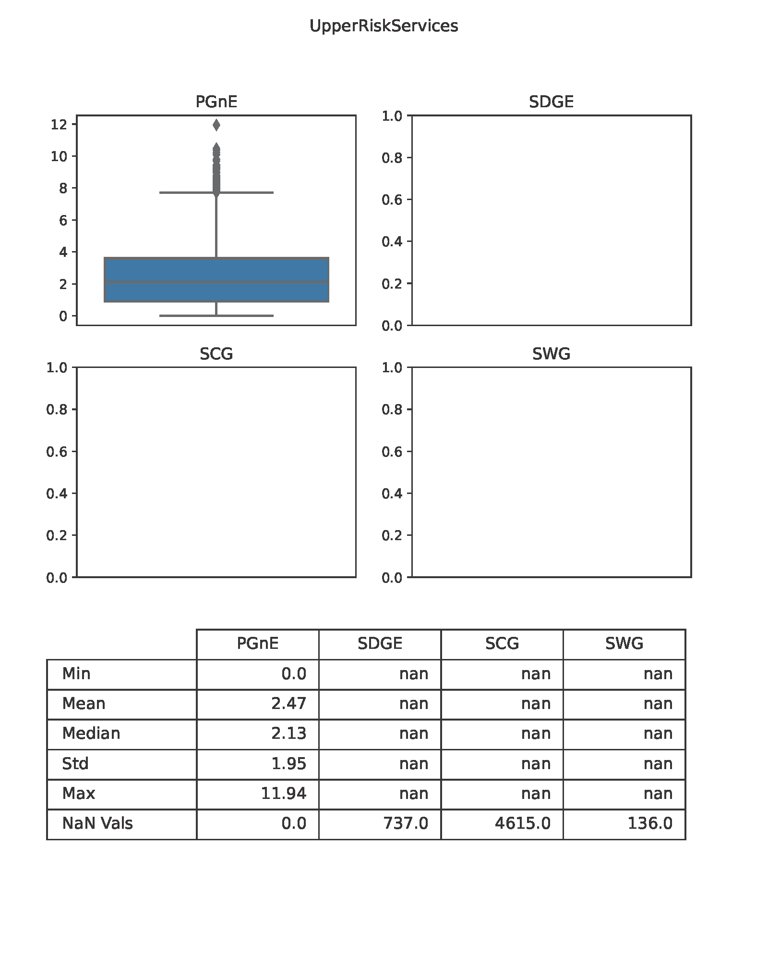

https://www.cpuc.ca.gov/industries-and-topics/natural-gas/long-term-gas-planning-rulemaking-closed
https://www.cpuc.ca.gov/industries-and-topics/natural-gas/long-term-gas-planning-rulemaking
https://www.cpuc.ca.gov/industries-and-topics/natural-gas/sb-1221-implementation
Pipeline Simulation Interest Group, Paper No. 2220 (2022). https://www.onepetro.org/
Energy and Environmental Economics (E3), November 2022. https://gridworks.org/wp-content/uploads/2023/06/Evaluation-Framework-for-Strategic-Gas-Decommissioning-in-Northern-California-Interim-Report-for-CEC-PIR-20-009.pdf
RAND Corporation, September 2022. (Deliverable available upon request by submitting an email to pubs@energy.ca.gov.
https://canadacommons.ca/artifacts/22084926/pipeline-abandonment-assumptions/22985048/
https://www.cer-rec.gc.ca/en/applications-hearings/pipeline-abandonment/pipeline-abandonment-discussion-paper-technical-environmental-issues.html
https://docs2.cer-rec.gc.ca/ll-eng/llisapi.dll/fetch/2000/90463/782060/782061/795792/804521/850212/C8-5-13_-_Attachment_11_-_Pipeline_Abandonment_Scoping_Study_-_A2Y0S9_.pdf?nodeid=850222&vernum=-2
https://www.acer.europa.eu/sites/default/files/documents/Media/News/Documents/Future%20Regulation%20of%20Natural%20Gas%20Networks%20-%20Final%20Report%20DNV.pdf
https://www.cpuc.ca.gov/industries-and-topics/natural-gas/long-term-gas-planning-rulemaking-closed
https://www.cpuc.ca.gov/-/media/cpuc-website/divisions/energy-division/documents/natural-gas/long-term-gas-planning-oir/rulings/revisedgassystemdataruling09212022.pdf
https://www.cpuc.ca.gov/-/media/cpuc-website/divisions/energy-division/documents/natural-gas/long-term-gas-planning-oir/rulings/gassystemdataruling03012022.pdf
https://www.cpuc.ca.gov/-/media/cpuc-website/divisions/energy-division/documents/natural-gas/long-term-gas-planning-oir/rulings/revisedgassystemdataruling09212022.pdf
Staff Proposal on Gas Distribution Infrastructure Decommissioning Framework in Support of Climate Goals California Public Utilities Commission Staff December 21, 2022, Filed 12/22/22 in Rulemaking R-20-01-007. Retrieved from: framework-staff-proposal.pdf
https://www.cpuc.ca.gov/-/media/cpuc-website/divisions/energy-division/documents/natural-gas/long-term-gas-planning-oir/rulings/gassystemdataruling03012022.pdf
https://www.cpuc.ca.gov/-/media/cpuc-website/divisions/energy-division/documents/natural-gas/long-term-gas-planning-oir/rulings/revisedgassystemdataruling09212022.pdf

