Decommissioning Readiness Assessment Memorandum

December 2025

- This research is funded by the California Energy Commission (CEC) through the Gas Research and Development Program, which invests in innovations to support the gas sector transition and cost-effective achievement of the state’s clean energy and climate goals.
- The research project, PIR-22-002, aims to provide state agencies, local governments, investor-owned utilities (IOUs), and other stakeholders with a data-driven approach to screen for promising sites for decommissioning specific segments of California’s gas system through a map-based tool that leverages gas system data and publicly available community data.
- This memo and data here within are being shared to support transparent and timely consideration of interim deliverables that are relevant for energy stakeholders and all those interested in California’s public interest gas decommissioning research.

This interim deliverable is submitted to the CEC by DNV GL USA, Inc. The memo meets deliverable requirements under Task 3 of the California Energy Commission’s Project PIR-22-002: Mindful Decommissioning - Development of a Data-Driven Tool to Support Strategic and Equitable Decommissioning of Gas Infrastructure.

Table of contents
1 Introduction 1
1.1 Background 1
1.2 Purpose 1
2 Approach and Methodology 2
2.1 Data Identification 2
2.2 Data Collection 3
2.3 Additional Data Sources to be Leveraged 5
3 Stakeholder Engagement 6
3.1 List of Stakeholders Involved 6
4 Results and Lessons Learned 8
4.1 Residential Customer Decommissioning Readiness Index 8
4.2 Residential Customer Decommissioning Readiness Factors 9
4.3 Non-Residential Customer Decommissioning Readiness Factors 12

Figures

Figure 4-1. Residential Gas Decommissioning Hot Spot Analysis, Northern/Central California Region 9
Figure 4-2. Residential Gas Decommissioning Hot Spot Analysis, Southern California Region 9
Figure 4-3: Residential Decommissioning Readiness Index’s Housing Stock Sub-Index Component Values 11
Figure 4-4: Residential Decommissioning Readiness Index’s Household Gas Dependence Sub-Index Component Values 11
Figure 4-5. Residential Decommissioning Readiness Index’s Household Financial Security Sub-Index Component Values 12
Figure 4-6. Non-Residential Gas Decommissioning Hot Spot Analysis, Northern/Central California Region 13
Figure 4-7. Non-Residential Gas Decommissioning Hot Spot Analysis, Southern California Region 13
Figure 4-8. Schools Non-Residential Decommissioning Readiness Sub-Index Component Values 16
Figure 4-9. Retail Non-Residential Decommissioning Readiness Sub-Index Component Values 17
Figure 4-10. Restaurant Non-Residential Decommissioning Readiness Sub-Index Component Values 17
Figure 4-11. Refrigerated Warehouse Non-Residential Decommissioning Readiness Sub-Index Component Values 18
Figure 4-12. Office Non-Residential Decommissioning Readiness Sub-Index Component Values 18
Figure 4-13. Warehouses Non-Residential Decommissioning Readiness Sub-Index Component Values 19
Figure 4-14. Miscellaneous Non-Residential Decommissioning Readiness Sub-Index Component Values 19
Figure 4-15. Hotel Non-Residential Decommissioning Readiness Sub-Index Component Values 20
Figure 4-16. Healthcare Non-Residential Decommissioning Readiness Sub-Index Component Values 20
Figure 4-17. Food Store Non-Residential Decommissioning Readiness Sub-Index Component Values 21
Figure 4-18. Durable Goods Manufacturing Non-Residential Decommissioning Readiness Sub-Index Component Values 21
Figure 4-19. Non-Durable Goods Manufacturing Non-Residential Decommissioning Readiness Sub-Index Component Values 22
Figure 4-20. College Non-Residential Decommissioning Readiness Sub-Index Component Values 22

Tables

Table 4-1. Correlation coefficients computed for census tract level residential decommissioning readiness sub-index values 10
Table 4-2. Correlation Coefficients Computed for Census Tract Level Non-Residential Decommissioning Readiness Sub-Index Values 15

Introduction
The Gas Distribution System Decommissioning Screening Tool’s (the Tool’s) Decommissioning Readiness indices were developed with the intention of capturing the comprehensive set of challenges or barriers related to the adoption of gas substitute end-use technologies among different types of customers. The final iteration of the Tool settled upon an approach that quantifies these types of concerns differently for residential versus non-residential customers. This decision reflected importance differences between the types of barriers that are most likely to be consequential for residential versus non-residential customers seeking to participate in decommissioning projects.

Background
The research team’s initial development of the decommissioning readiness concept focused on the experience of non-residential gas customers facing the termination of gas service as the result of gas distribution system infrastructure decommissioning projects. The justification for this approach was grounded in the knowledge that these types of customers typically use much larger volumes of gas (on an individual basis) to supply end-uses which may be more difficult to substitute with alternative technologies. Consequently, our proposed method for quantifying non-residential customer decommissioning readiness involved the development of sub-indices that incorporated information about (1) the total volume of gas use among different non-residential customer sectors, (2) the breakdown of that gas use by end-use category within each sub-sector, and (3) the current state of technical readiness in terms of the available gas substitute technologies within each end-use category.
As the team developed the initial versions of this Non-residential Decommissioning Readiness Index, the feedback received from the project’s Technical Advisory Committee (TAC) as well as local community-based organizations included in the project’s community engagement work, was generally positive. However, these stakeholders also expressed concerns that a similar Decommissioning Readiness Index must be created for residential customers as well. This is because residential customers make up the bulk of the gas system’s rate base and would play an essential role in determining the feasibility of most proposed gas decommissioning projects.
Reflecting on this feedback, the team decided to develop a corresponding Residential Gas Decommissioning Readiness Index using a significantly different methodology from its non-residential counterpart. This decision was made on the basis of the fact that for all domestic end-uses of gas, the technical readiness of substitute technologies, which are primarily electrical, should be considered as high. As such, the principal barriers within the residential sector likely stem from other types of concerns including the capacity of households and property owners to absorb the financial burdens of purchasing, installing, and operating gas substitute equipment as well as the physical readiness of the properties to integrate these technologies without significant retrofit effort, such as for upgrading electrical infrastructure, for example.

Purpose
The extent to which customers’ readiness to move away from the use of gas as a fuel source must be considered as a criterion for assessing the relative promise of candidate sites for gas decommissioning projects depends upon one’s conception of how such projects are most likely to proceed, in real world practice. While it is technically possible that the choice of sites for pursuing gas decommissioning projects could be based solely on the characteristics of gas infrastructure assets, with impacted customers only being notified about their impending termination of service after the fact. It is highly unlikely that such projects would be able to proceed to completion without encountering significant customer opposition. This is because, in the absence of significant financial support, customers facing termination of their gas service would be responsible for significant expenses related to procuring, installing, and (potentially) operating gas substitute end-use equipment. The purpose of the Residential and Non-Residential Decommissioning Readiness Indices, therefore, is to function as a proxy for the extent to which gas decommissioning project proposals are likely to encounter such local customer opposition due to the burdens, financial and otherwise, which those customers would likely have to bear as a result of their participation.

Approach and Methodology

Data Identification

Expected Quality and Sources of the Data Sets That Will Populate the Data-Driven Tool
The research team obtained nearly all the primary data sources which were assembled for use in the Decommissioning Readiness Indices from official providers operating the state or national level. These data providers are documented more comprehensively in the project’s Indices Design and Development Memorandum (Secondary and Tertiary Metrics Report). However, at a high level, they included the U.S. Census Bureau, the National Renewable Energy Laboratory (NREL), the U.S. Energy Information Administration (EIA), the CEC, and California’s investor-owned utilities (IOUs). The only instance where novel research had to be conducted to develop a primary input variable was in the case of determining the relative state of technical and commercial maturity of gas substitute technologies relative to different combinations of end-use energy service categories and different non-residential sub-sectors. This is an area where the team needed to conduct a literature review of published studies in both the peer reviewed academic literature as well as in grey literature reports and trade publications to establish relative scores (low = 1, medium = 2, or high 3) for technical readiness. This is an instance where this, and future, projects would have benefitted from the availability of a more officially established set of technical readiness evaluation results. This is something that could alternatively be taken up by California state agencies or even one of the National Laboratories as a topic of future research.
Despite using many official, high quality, primary data sources for this analysis, there are expected to be long term challenges associated with the reproducibility of the study’s methods, using similar, but updated data. This is due to challenges related to the accessibility of granular energy consumption data for these types of analyses as well as inconsistencies in the update cadence and methodologies used to produce some other key data sources. In the latter case, the CEC’s Commercial End-Use Survey (CEUS) provides a good illustration of the problem. The results of this survey were useful for establishing the distribution of gas consumption by different end-use categories among different classes of non-residential gas consumers. Unfortunately, however, despite efforts to update this study on an ongoing basis, only two published versions currently exist (2006, and 2018-2020) which each have subtle, but important, distinctions in terms of the methods used both for collecting primary data from survey respondents and analysing/aggregating that data for the reporting of results. Consequently, without significant future changes, this type of data source probably cannot be relied upon to be updated on a consistent basis, and using consistent methods, to support derivative uses such as those reported on in this study.
Regarding the availability of disaggregated energy consumption data, current data access and privacy aggregation guidelines that have been put into place by the California Public Utilities Commission (CPUC) for the purposes of protecting IOU customer privacy are quite restrictive in terms of the ability of researchers to access historical consumption data and appropriately contextualize them for use in this type of analysis. Several of the key primary input variables which were used to support this analysis, which relate to customer gas and electricity use, required significant post-processing and contextual enhancement effort on behalf of the UCLA research team. This was an effort which itself was at least equal to or greater in scope than this scale of this entire project. Moreover, this effort was funded using a collection of parallel research grant and contracts assembled from various sources over a period of multiple years. The continued nonachievement of the state to improve the state of granular usage data accessibility and usability through updates to both data access pathways and required privacy protection measures will present a long-term challenge to the reproducibility of this and similar analyses.

Data Collection

IOU Customer Metered Gas and Electricity Usage Data
Both the Residential and Non-Residential Decommissioning Readiness Indices relied heavily upon a large, confidential database of historical metered gas usage data for non-residential customers served by the state’s three largest IOU gas utility service providers: PG&E, SDG&E, and SoCalGas. This database has been assembled by the UCLA research team based upon raw bill data provided, under non-disclosure agreement, by the CPUC’s Energy Division for the most recently available complete data year, 2021.
For the Non-Residential Decommissioning Index, whose focus is on the volume of customer demand and the proportion of that demand that is used to supply hard to substitute end-uses, customer usage data were aggregated by six-digit North American Industrial Classification System (NAICS) code designation. These NAICS codes were self-reported by individual non-residential customers to their local IOU gas service providers. The mapping of each individual six-digit NAICS code to one of 13 CEUS sub-sectors was performed using definitions reported in the official NAICS code documentation hosted by the US Census. For the Residential Decommissioning Index, customer data were aggregated according to single-family or multi-family housing type designation, as determined by tax-assessor database property use-type designations for the parcels associated with individual utility customer premises.

Residential Household Socio-Economic Attribute Data
Data on the current socio-economic characteristics of residential populations within California were obtained from the US Census Bureau’s American Community Survey. Specifically, 5-year estimates for the year 2022 were accessed via API. A list of the relevant primary source variables with justifications for their use in quantifying residential decommissioning readiness is provided below:
- Median household income: The assumption relative to this variable is that census tracts with higher median household incomes will have greater access to financial resources necessary to facilitate the up-front purchase of gas substitute equipment, as well as to make any necessary property renovations/retrofits necessary to accommodate their installation.
- Percentage renter housing units: The assumption relative to this variable is that census tracts with a higher percentage of renter housing units will have greater challenges in terms of initiating and completing gas-appliance substitution projects, due to the split-incentives between property owners and renters in terms of these types of building energy system alteration projects.
- Median gross rent as a percentage of household income: The assumption relative to this variable is that census tracts with higher median gross rents as a percentage of household income will have a larger population facing financial constraints in terms of the cost of implementing the types of fuel-substitution measures that would likely be required to participate in a decommissioning project.
- Homeowners with mortgage housing costs that are greater than 50% of their household income: The assumption relative to this variable is that census tracts with a larger number of homeowners whose housing costs are greater than 50% of their household income will be more financially constrained in terms of initiating the types of fuel-substitution measures that would likely be required to participate in a decommissioning project.
- Homeowners without mortgage housing costs that are greater than 50% of their household income: The assumption relative to this variable mirrors that of the previous, except as applied to homeowners who may be similarly burdened by non-mortgage related housing costs.
Renter housing costs greater than 50% of their household income: The assumption relative to this variable mirrors that of the previous, except as applied to renters who may be similarly burdened by housing costs. (NOTE: This variable somewhat overlaps with the median gross rent as a percentage of household income, introduced previously. However, the team observed that renters are not the principal agents responsible making property modification decisions. Thus, the team determined that it would be appropriate to include both variables in this sub-index as a way of amplifying these concerns relative to census tracts with larger populations of housing cost burdened renter household considered as having a lower measure of financial stability relative to the potential needs of decommissioning project participation.)

Residential Building Stock Attribute Data
Data on the characteristics of the residential building stock and some categories of installed end-use energy equipment were sourced from the US Census Bureau’s American Community Survey (ACS). Specifically, 5-year estimates for the year 2022 were accessed via API. A list of the relevant primary source variables with justifications for their use in quantifying residential decommissioning readiness is provided below:
- Percentage of total housing units that are in 4+ unit multi-family buildings: The assumption relative to this variable is that census tracts with a larger proportion of inhabitants living within larger multi-family buildings should be considered less ready for gas decommissioning as these types of properties are structurally more difficult to electrify and must content with split incentives (between owners and occupants) in terms of the costs and benefits from doing so.
- Percentage of total housing units that were built prior to 1978: The assumption relative to this variable is that census tracts with a higher proportion of total housing units built before to 1978 (prior to the introduction of California's statewide Title-24 building energy codes) are likely to have been constructed with smaller capacity electrical service panels that are less ready to integrate new electrical appliance loads without the need for costly capacity upgrades or other panel size optimization strategies.
Median home value: The assumption relative to this variable is that census tracts with higher median home values are likely to have received more extensive and more recent building retrofit measures resulting in the improved thermal shell efficiency, end-use energy appliance efficiency, as well as higher-capacity building electrical system components (service panels, wiring, outlet receptacles, etc.) reducing the effective barriers to gas-substitute end-use electrical appliance integration.

Non-Residential Sub-sector Gas End-Use Distribution Data
In addition to the detailed account-level metered gas and electricity usage data, our methodology for constructing the Non-Residential Decommissioning Readiness Index additionally required information about the distribution of gas end-uses by non-residential sub-sector and the relative difficulty of substituting gas for each combination of end-use and sub-sector. For the former, the research team turned to published results from the CEC’s CEUS for 2006. At the time the analysis was conducted, updated results from the 2018-2022 version of the CEUS had not yet been published. Additionally, following the publication of the 2018-2022 results, which occurred midway through this project’s completion, the research team found that there were significant changes to the methodology that as used between 2006 and 2018-2022 versions. Most significantly, the 2018-2022 version of the CEUS no-longer reports detailed breakdowns of end-use gas consumption for different commercial sub-sectors. These breakdowns are central to the project’s proposed methodology for quantifying the readiness of non-residential customers to implement the types of fuel substitution measures that will be required to participate in gas decommissioning projects.

Additional Data Sources to be Leveraged
There are several additional data sources that could be leveraged to support this type of analysis in the future. Principle among them are data that reflect the existing and anticipated future capacity constraints of the electrical distribution infrastructure in different areas throughout the state. In most residential contexts, as well as in many non-residential contexts, the most likely fuel source that will be used to substitute for the use of gas resulting from an infrastructure decommissioning project will be electricity. Consequently, it is natural to inquire as to whether electrical distribution infrastructure capacity constraints may be a limiting factor in terms of the scale or speed with which gas distribution infrastructure decommissioning projects may proceed. To ensure consistency with the scope of the research originally outlined in the GFO, the decision was made to exclude these considerations from the analysis. However, over the long term, concerns related to the capacity of the electrical system, or indeed any other primary fuel system, to provide for increased demand resulting from decommissioning related end-use fuel substitution efforts should be considered.

Stakeholder Engagement

List of Stakeholders Involved
Because gas system decommissioning is still an emerging and technically complex field, the project team designed a rigorous, step-by-step process to build the Tool’s decommissioning readiness framework. Central to this process was ensuring that the underlying data—particularly the indicators used to assess decommissioning readiness across California communities—accurately reflected on-the-ground conditions and local priorities. To do so, the team carried out a statewide, multi-layer engagement effort involving state agencies, IOUs, municipal leaders, community-based organizations (CBOs), and other partners (see Final Report APPENDIX D Attendee Lists, forthcoming). These conversations and engagement informed both the data architecture of the Tool and the co-development of case studies in selected communities. Engagement around Tool development and refinement did not center on decommissioning readiness but instead focused on all four Tool indices. However, all community engagement activities provided TAC members and community partners with the opportunity to review and provide feedback on the decommissioning readiness indices.
The TAC played an essential role early in the process of developing the Tool’s indices. Engaged early, the TAC provided structured feedback through meetings, presentations, and targeted surveys that helped shape decisions about which datasets to include, how indicators should be constructed, and how analytical methods should be applied. Their insights ensured that the Tool’s decommissioning readiness measures remained technically sound while also aligned with the practical needs of regulators, utilities, and community partners.
Case studies were co-developed with local partners to help validate the team’s data, elevate critical factors to include in the Tool, fill in knowledge/data gaps and incorporate diverse perspectives on the costs, risks, benefits, and community impacts. This statewide collaborative approach strengthened the accuracy and relevance of the decommissioning readiness data. Stakeholder input helped surface missing information, clarify local constraints, elevate community-defined risks and benefits, and refine assumptions about costs and implementation feasibility.
An important goal of the Tool is to help equitably identify and prioritize potential pipeline segments or areas for decommissioning statewide. Achieving this required validating the decommissioning readiness metrics through multiple engagement channels, including workshops, a public webinar, and—most critically—case study sessions with community partners. Additional feedback was collected through direct outreach to affinity groups, an online Resource Hub, and the TAC, where appropriate. These groups are listed in the following sections.

TAC Members
The following is a list of the TAC members who supported the project team in validating data types and sources and advised us on the development of the Tool’s Decommissioning Readiness Indices. Community engagement with the TAC is described in more detail in Section 3.2.3 of the Final Report (forthcoming), and included the following organizations:
- Natural Resources Defense Council
- Energy Coalition
- Stanford University
- Energy+Environmental Economics (E3)
- RAND
- California Public Utilities Commission
California Energy Commission

Community Partners
The following is a list of community partners who participated in validating the Decommissioning Readiness Indices as part of the case study process. Case study engagement involved a detailed review of all four indices rather than a sole focus on the decommissioning readiness indices alone. However, the case study engagement process provided an opportunity to receive feedback on the Tool’s ability to assess local level commercial and residential decommissioning readiness. Development of the case studies is described in more detail in Section 3.2.4 of the Final Report (forthcoming) and included engagement with 10 different communities. The following gave permission to have their participation listed publicly:
- Blue Lake Rancheria, North Coast/Humboldt
- Central California Asthma Collaborative, Central Valley
- Climate Resilient Communities, North Fair Oaks
- Climate Ready North Fair Oaks
- Staff and community leaders at Climate First: Replacing Oil & Gas (CFROG), Oxnard
- Restore the Delta, Stockton
Self-Help Enterprises, San Joaquin Valley
For a complete list of all stakeholders engaged during public webinars and workshops, reference Appendix D of the Final Report (forthcoming).

Results and Lessons Learned

Residential Customer Decommissioning Readiness Index
One useful way of evaluating the distribution of Residential Decommissioning Readiness Index values is by making use of the in-built “hot spot” identification feature that is accessible via the Tool’s “Analyze” page. This section includes results that were generated by running this “hot spot” identification tool, which involves the computation of a geospatial statistic that is used to assess the degree of local spatial autocorrelation in a geographic dataset (Getis-Ord Statistic, G_{i}*). For a given neighborhood buffer distance, this statistic helps to identify contiguous areas with anomalously low or high values for a given attribute at defined confidence intervals.
Figure 4-1 and Figure 4-2 depict the results of a hot spot analysis which were generated for the residential decommissioning readiness index relative to the Northern/Central and Southern California regions using a 2-mile buffer distance parameter setting. In these figures, which both depict the same output results layer, a perceptually divergent color scheme has been applied to illustrate areas with high concentrations of census tracts that should be considered promising (red) and unpromising (blue) for gas distribution system decommissioning projects, relative to residential readiness concerns.
Readers who are familiar with the local demographic and housing characteristics of either, or both, of these regions will likely identify the blue-colored areas as being representative of communities with larger populations of low income, renter households, living in older, predominantly multi-family properties, that are more heavily reliant upon gas for key end-use energy services. By contrast, the red areas generally are inhabited by higher-income, single-family homeowners, whose properties have been more recently built and are less reliant upon gas for key energy services.
As has been previously discussed, the residential decommissioning readiness index is comprised of three separate sub-index components. By default, each of these three components contribute equally to the residential decommissioning readiness index. However, the relative weighting of these sub-indices' contributions can be customized using the “Custom Index Weighting” feature that is also available in the Tool’s “Analyze” page. This feature allows for the creation of custom indices and sub-indices by:
- Using all, or only a sub-set, of the provided sub-index values
- Assigning unique weights to each sub-index component selected
- Choosing the directionality applied to each sub-index component selected
Setting a custom output score range for the newly created outputs
Figure 4-1 provides a graphical illustration of the outputs of a “hot spot” analysis for the Residential Gas Decommissioning Index layer with a distance buffer setting of 2 miles for the Northern/Central California region. Figure 4-2 includes a graphical illustration of the same hot spot analysis results, except for the Southern California region.

Figure 4-1. Residential Gas Decommissioning Hot Spot Analysis, Northern/Central California Region
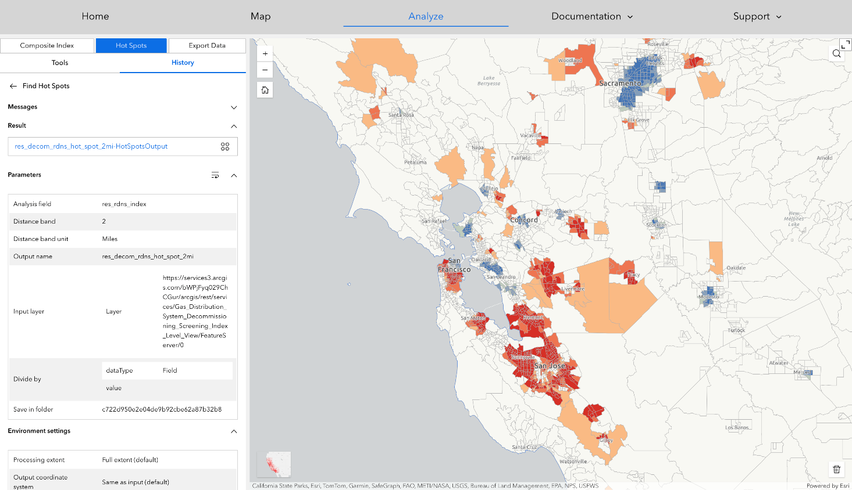
Figure 4-2. Residential Gas Decommissioning Hot Spot Analysis, Southern California Region
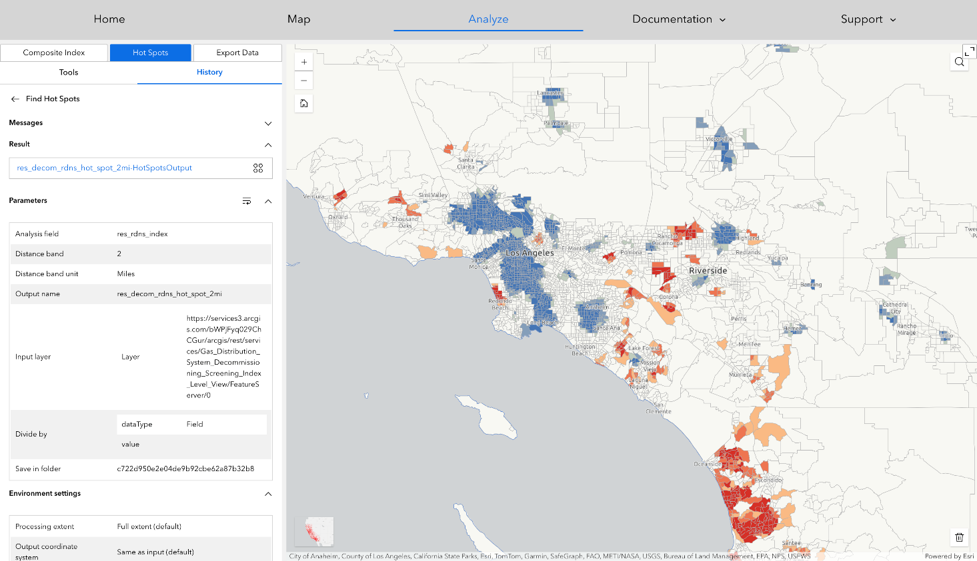

Residential Customer Decommissioning Readiness Factors
Figure 4-3 through Figure 4-5 have been generated for each of the three residential decommissioning sub-indices. Each figure includes a statewide map of the corresponding sub-index values that has been generated using a perceptually uniform color scale as well as a histogram plot showing the count frequency distribution of values across the sub-index's 1-10 ordinal range. An important feature, which is shared across all the three residential decommissioning readiness sub-indices, is the roughly normal distribution of values across this original range. As discussed further in Section 4.3, this is in stark contrast to the distribution of values for both the Non-Residential Decommissioning Readiness Index and sub-indices, which are all strongly left skewed.
Table 4-1 shows a set of correlation coefficients computed for each pairwise combination of the three, census tract level, residential decommissioning readiness sub-indices. These correlations indicate the degree to which tracts which are identified as promising relative to one sub-index, are likely to be similarly identified by the other sub-indices. Interestingly, the Household Gas Dependence sub-index was not found to be strongly correlated with either the Household Financial Stability sub-index (corr-coeff = -0.06395) or Housing Stock Condition sub-index (corr-coeff = -0.05903). This indicates that the degree to which homes rely upon gas is largely independent of their physical condition or the wealth/income status of the communities in which they are located. Alternatively, and perhaps as is to be expected, a much stronger correlation was observed between the Household Financial Stability and the Housing Stock Condition sub-indices (coff-coef = 0.32190). This reflects the positive relationship between indicators of wealth, income, and home ownership status and those related to the quality and condition of the housing stock.
Table 4-1. Correlation coefficients computed for census tract level residential decommissioning readiness sub-index values
Correlation Coefficients | Household Financial Stability | Household Gas Dependence | Housing Stock Condition
Household financial stability | 1
Household gas dependence | -0.06395 | 1
Housing stock condition | 0.32190 | -0.05903 | 1
Figure 4-3 through Figure 4-5 show a series of map panels and corresponding count frequency histograms illustrating the distribution of Residential Decommissioning Readiness Index’s Housing Stock Condition (Figure 4-3), Household Gas Dependence (Figure 4-4), and Household Financial Stability (Figure 4-5) sub-index values.
Figure 4-3: Residential Decommissioning Readiness Index’s Housing Stock Sub-Index Component Values
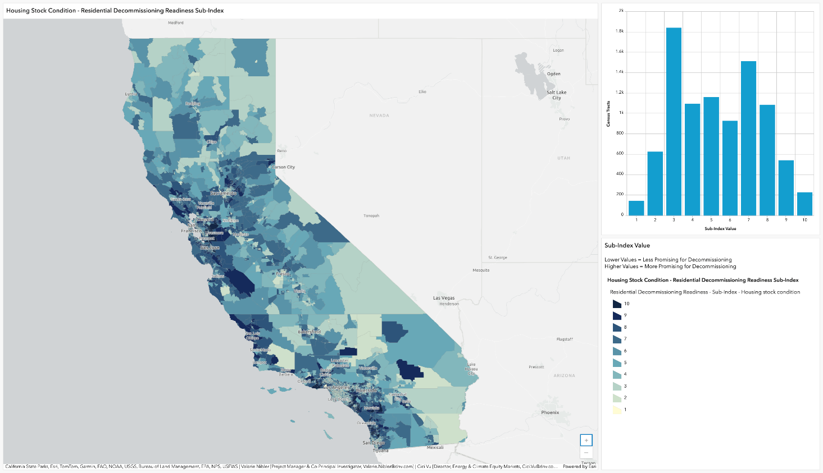
Figure 4-4: Residential Decommissioning Readiness Index’s Household Gas Dependence Sub-Index Component Values
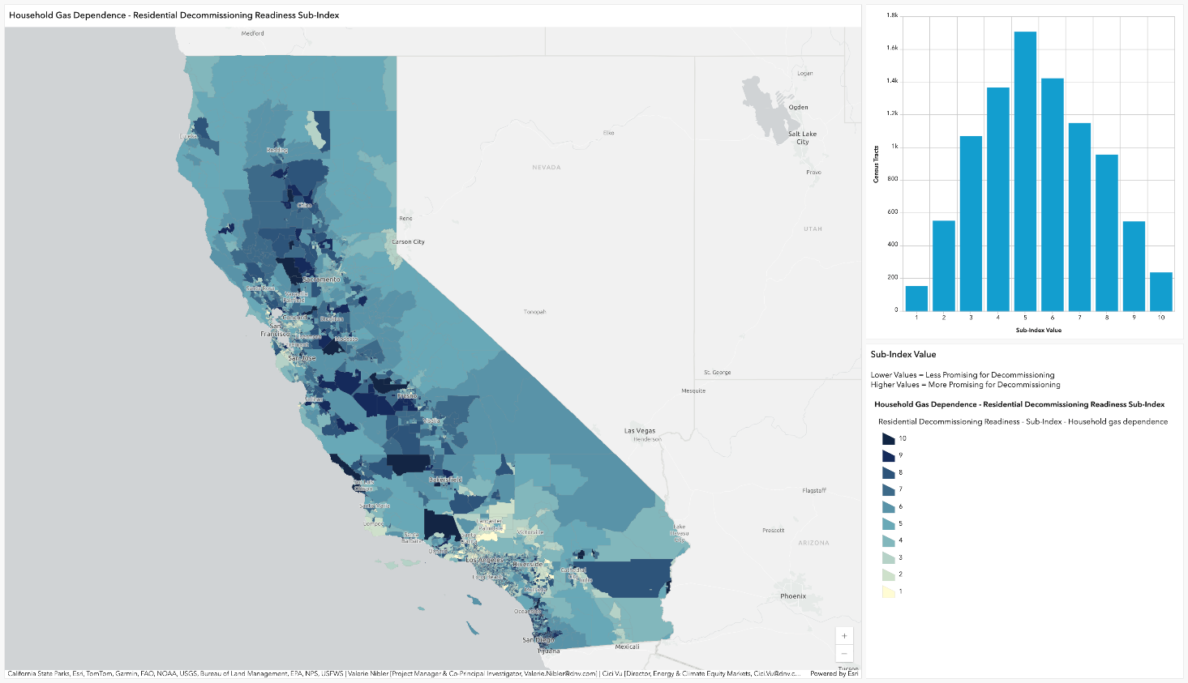
Figure 4-5. Residential Decommissioning Readiness Index’s Household Financial Security Sub-Index Component Values
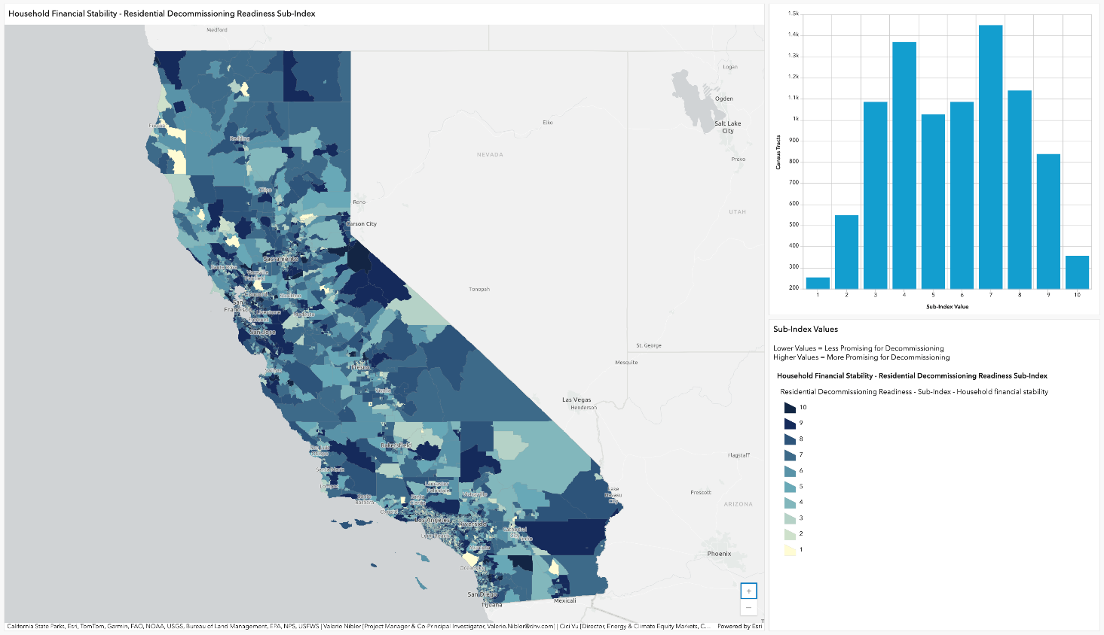

Non-Residential Customer Decommissioning Readiness Factors

Figure 4-6 and Figure 4-7 provide similar views for the results of a “hot spot” analysis conducted for the Non-Residential Decommissioning Readiness Index values developed as part of this study. The blue-colored areas depict “cool spots”—concentrations of census tracts considered less promising for decommissioning based upon the Non-Residential Decommissioning Readiness Index values. Conversely, the red-colored areas depict “hot spots”—concentrations of census tracts considered more promising for decommissioning based upon the characteristics of non-residential gas facilities and end-use consumption. Based on these results, there appear to be a larger number of concentrated areas with intensive non-residential gas consumption that would be considered less promising for gas decommissioning projects, in the state’s Northern/Central region as compared to the Southern Region.

Figure 4-6. Non-Residential Gas Decommissioning Hot Spot Analysis, Northern/Central California Region
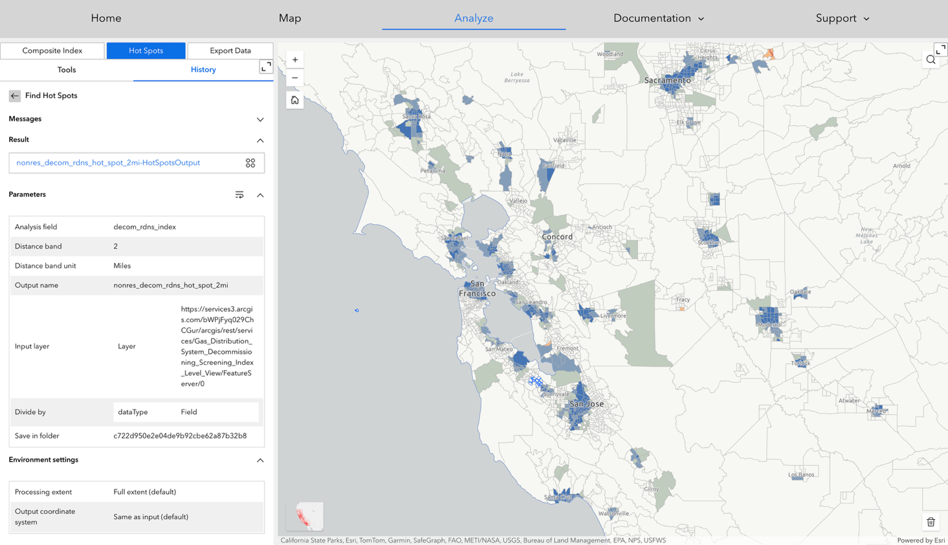
Figure 4-7. Non-Residential Gas Decommissioning Hot Spot Analysis, Southern California Region
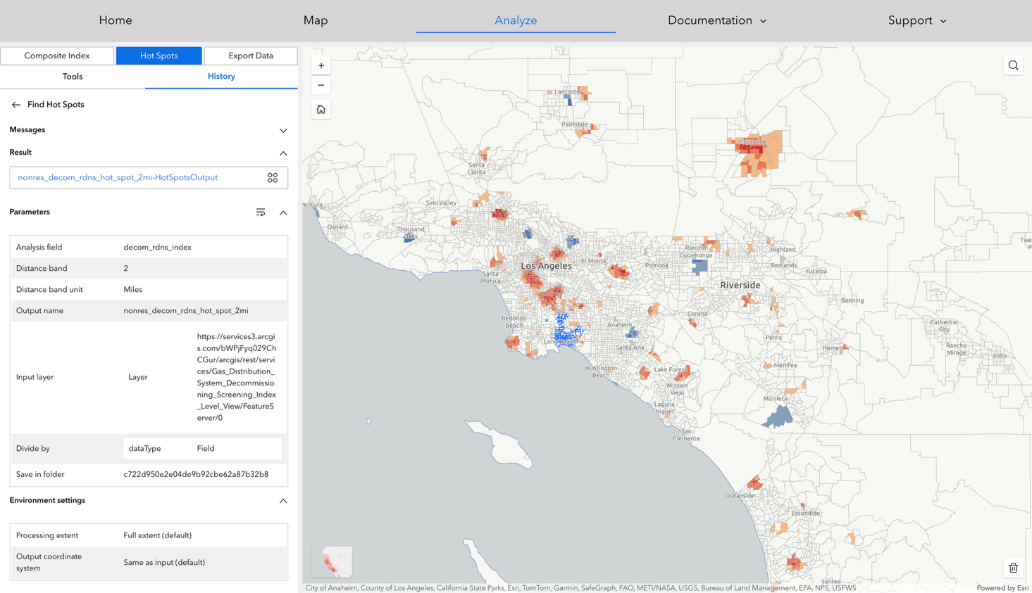
Table 4-2. below shows a set of pairwise correlation coefficients generated for the thirteen, census tract level, non-residential decommissioning readiness sub-index values. Based upon the way that these sub-indices were constructed, these correlation coefficients can essentially be interpreted as communicating the degree to which there is a coincident presence of facilities, and corresponding gas consumption, among these different non-residential sub-sectors throughout the state. Calling out some examples of significant findings, the research team saw that the sub-index values for Offices, Retail, and Restaurants all have high pairwise correlation coefficients. This reflects the degree to which these types of activities tend to be co-located with one another, geographically. Alternatively, the team saw that the Refrigerated Warehouses and Schools sub-indices have a slightly negative correlation coefficient, indicating that these types of facilities are far less likely to be located together within the same census tract. Here again, it is important to remember that the classification of facilities into these various sub-sectors was performed using six-digit NAICS codes self-reported by individual non-residential utility customers to their local gas utility provider.
Table 4-2. Correlation Coefficients Computed for Census Tract Level Non-Residential Decommissioning Readiness Sub-Index Values

Correlation Coefficients | College | Durable Goods Manufacturing | Food Store | Healthcare | Hotel | Misc. | Non-durable Goods Manufacturing | Offices | Refrigeration  Warehouse | Restaurant | Retail | School | Warehouse
College | 1
Durable Goods Manufacturing | 0.29019 | 1
Food Store | 0.18425 | 0.19651 | 1
Healthcare | 0.27738 | 0.18665 | 0.18788 | 1
Hotel | 0.24384 | 0.20783 | 0.19218 | 0.21872 | 1
Misc. | 0.44637 | 0.45411 | 0.37433 | 0.41089 | 0.36879 | 1
Non-durable Goods Manufacturing | 0.27070 | 0.61549 | 0.26009 | 0.18625 | 0.21687 | 0.44602 | 1
Office | 0.50172 | 0.48730 | 0.33915 | 0.53304 | 0.39265 | 0.78835 | 0.44910 | 1
Refrigeration Warehouse | 0.11455 | 0.38737 | 0.10663 | 0.07362 | 0.11806 | 0.21991 | 0.35703 | 0.21295 | 1
Restaurant | 0.36583 | 0.28447 | 0.35359 | 0.34066 | 0.35229 | 0.66873 | 0.34645 | 0.63579 | 0.14421 | 1
Retail | 0.41189 | 0.49959 | 0.35773 | 0.39092 | 0.33015 | 0.70503 | 0.47310 | 0.71715 | 0.22296 | 0.61896 | 1
School | 0.16577 | 0.10033 | 0.13543 | 0.16105 | 0.03030 | 0.26541 | 0.12441 | 0.26433 | -0.00456 | 0.24797 | 0.23337 | 1
Warehouse | 0.32935 | 0.76105 | 0.25054 | 0.24997 | 0.24823 | 0.55307 | 0.59466 | 0.56514 | 0.37383 | 0.39336 | 0.61160 | 0.15714 | 1

Figure 4-8 through Figure 4-20 show a series of map panels and corresponding count frequency histograms illustrating the distribution of each sub-indices that constitute the non-residential decommissioning readiness Index. These provide a useful point of comparison relative to the previous set of maps and histograms provided for the residential decommissioning readiness sub-indices. Specifically of note, is the fact that the skewed distributions for these sub-indices reflect both the comparative geographic sparsity of these various types of non-residential facilities as well as the comparatively wide range (min-max) of annual gas consumption levels among individual facilities both within and between the different non-residential sub-sectors.
Figure 4-8. Schools Non-Residential Decommissioning Readiness Sub-Index Component Values
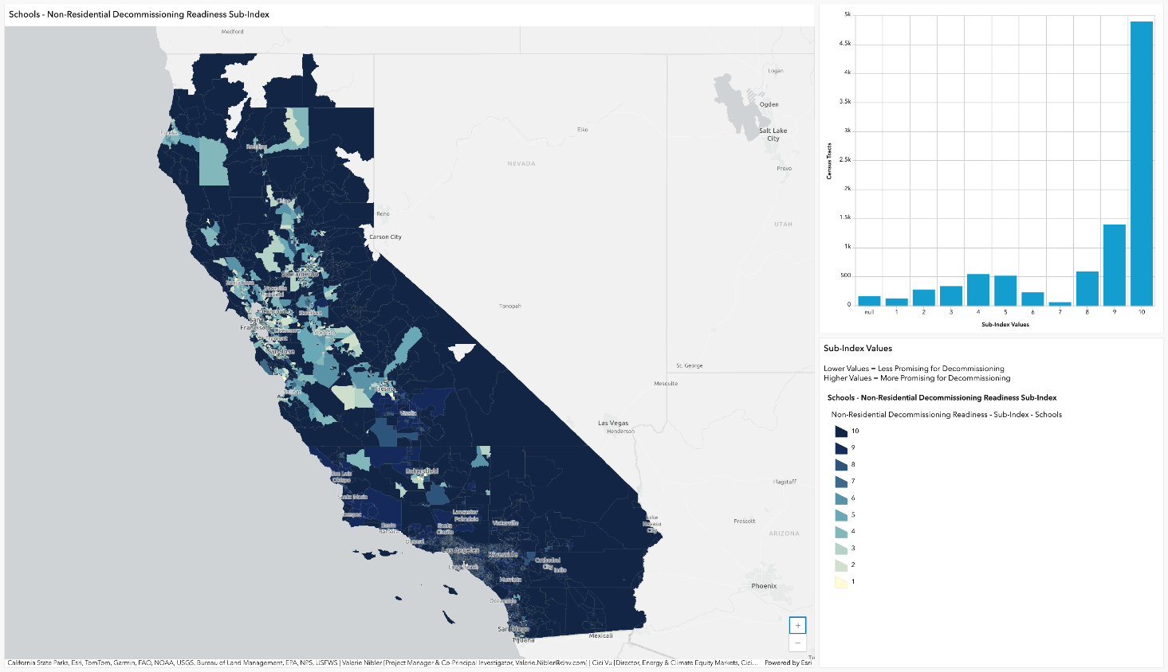
Figure 4-9. Retail Non-Residential Decommissioning Readiness Sub-Index Component Values
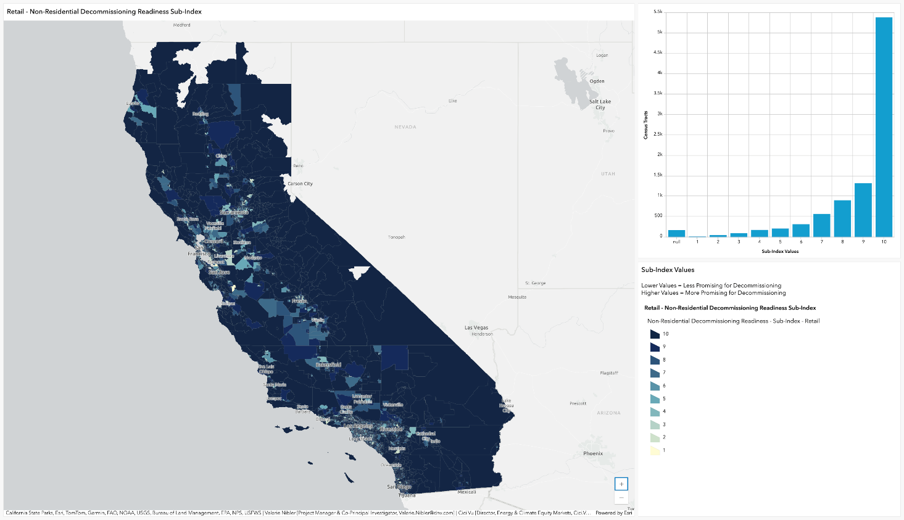
Figure 4-10. Restaurant Non-Residential Decommissioning Readiness Sub-Index Component Values
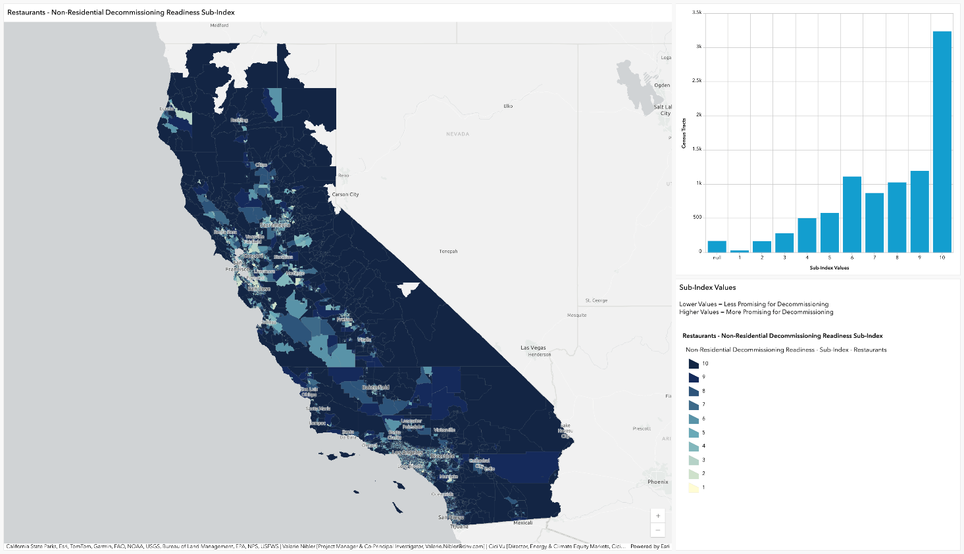
Figure 4-11. Refrigerated Warehouse Non-Residential Decommissioning Readiness Sub-Index Component Values
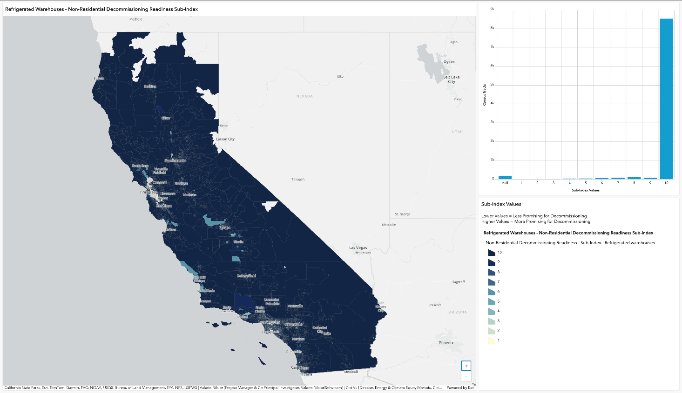
Figure 4-12. Office Non-Residential Decommissioning Readiness Sub-Index Component Values
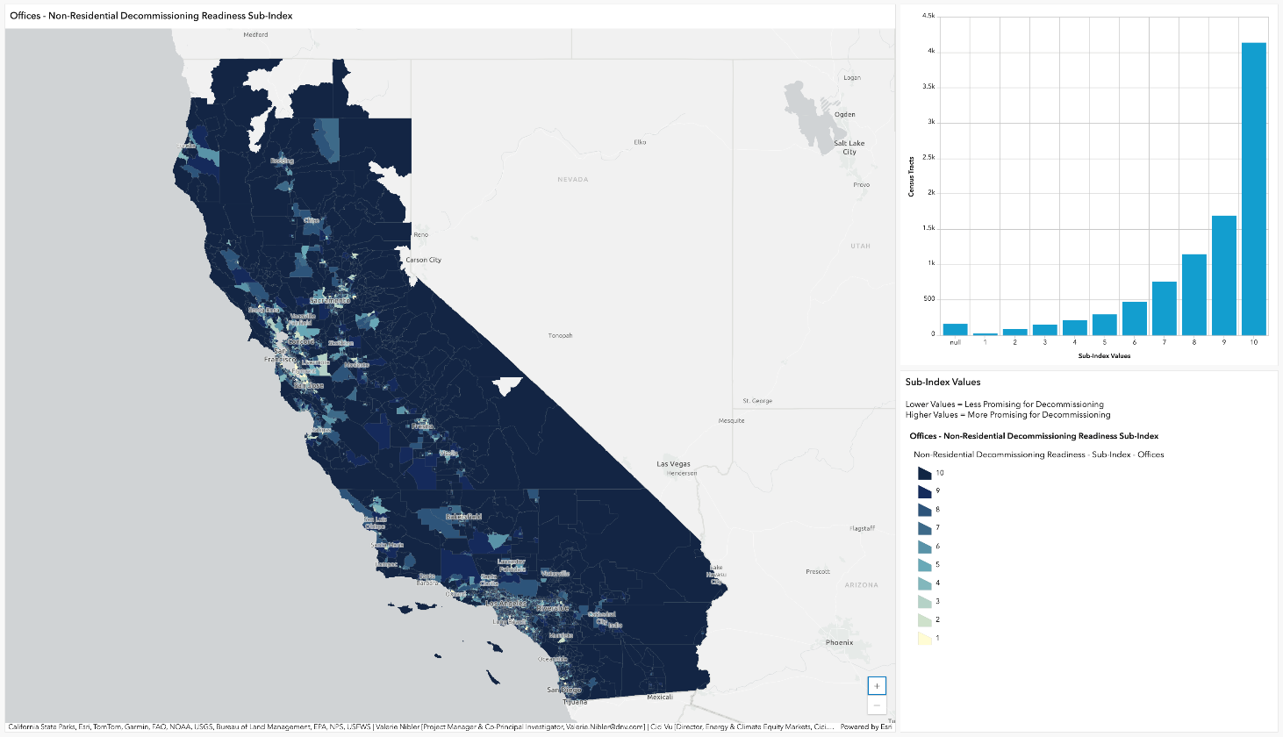
Figure 4-13. Warehouses Non-Residential Decommissioning Readiness Sub-Index Component Values
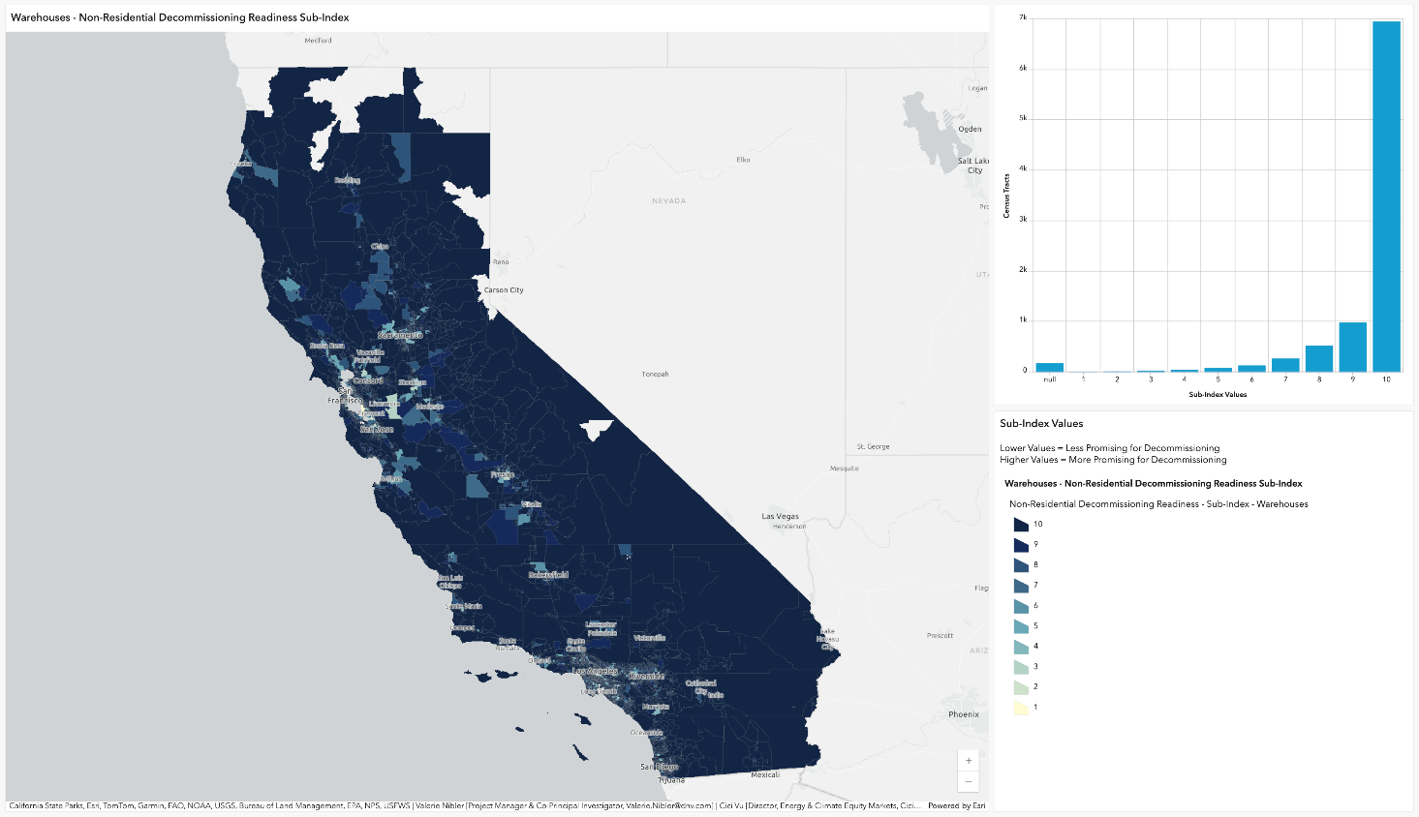
Figure 4-14. Miscellaneous Non-Residential Decommissioning Readiness Sub-Index Component Values
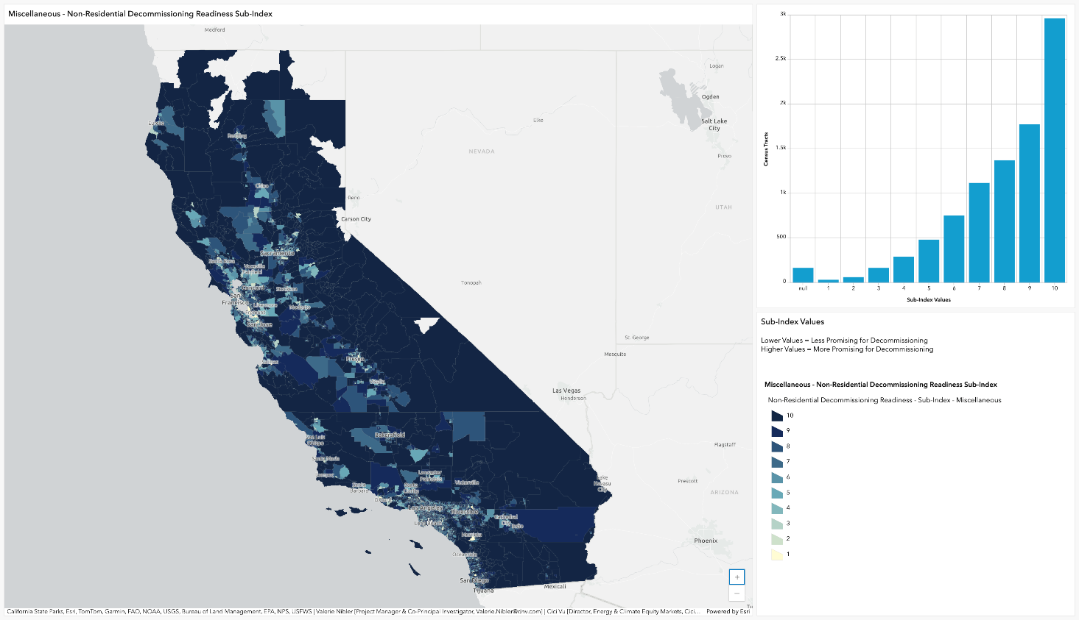
Figure 4-15. Hotel Non-Residential Decommissioning Readiness Sub-Index Component Values
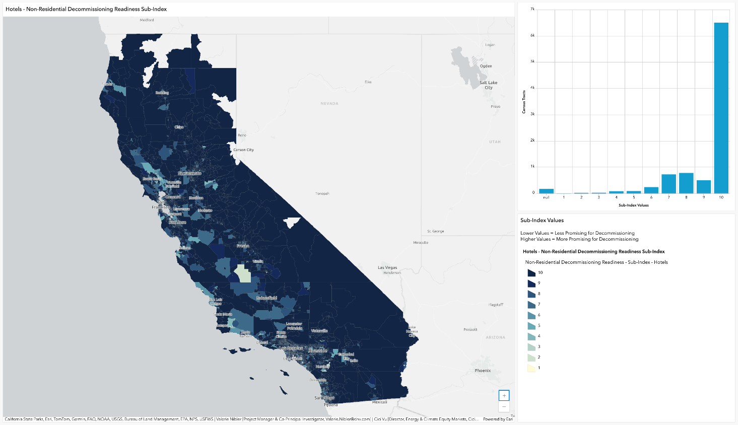
Figure 4-16. Healthcare Non-Residential Decommissioning Readiness Sub-Index Component Values
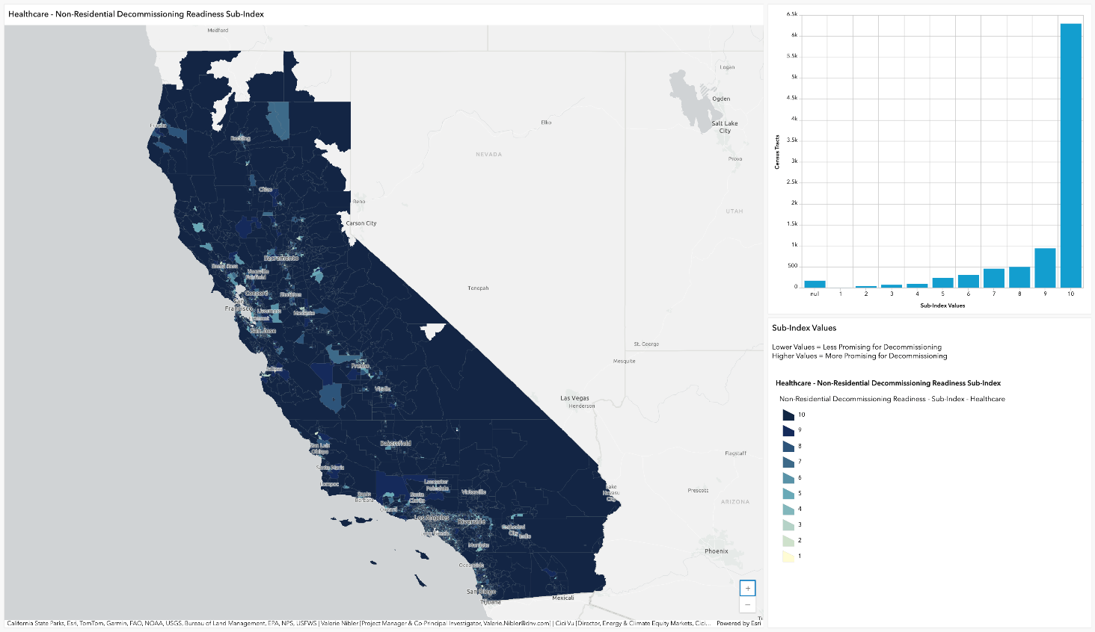
Figure 4-17. Food Store Non-Residential Decommissioning Readiness Sub-Index Component Values
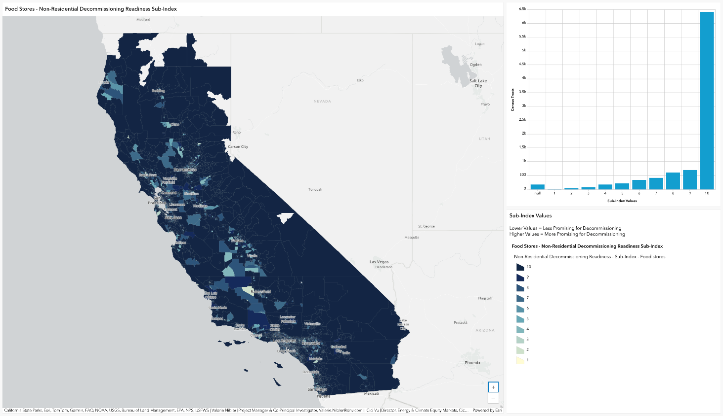
Figure 4-18. Durable Goods Manufacturing Non-Residential Decommissioning Readiness Sub-Index Component Values
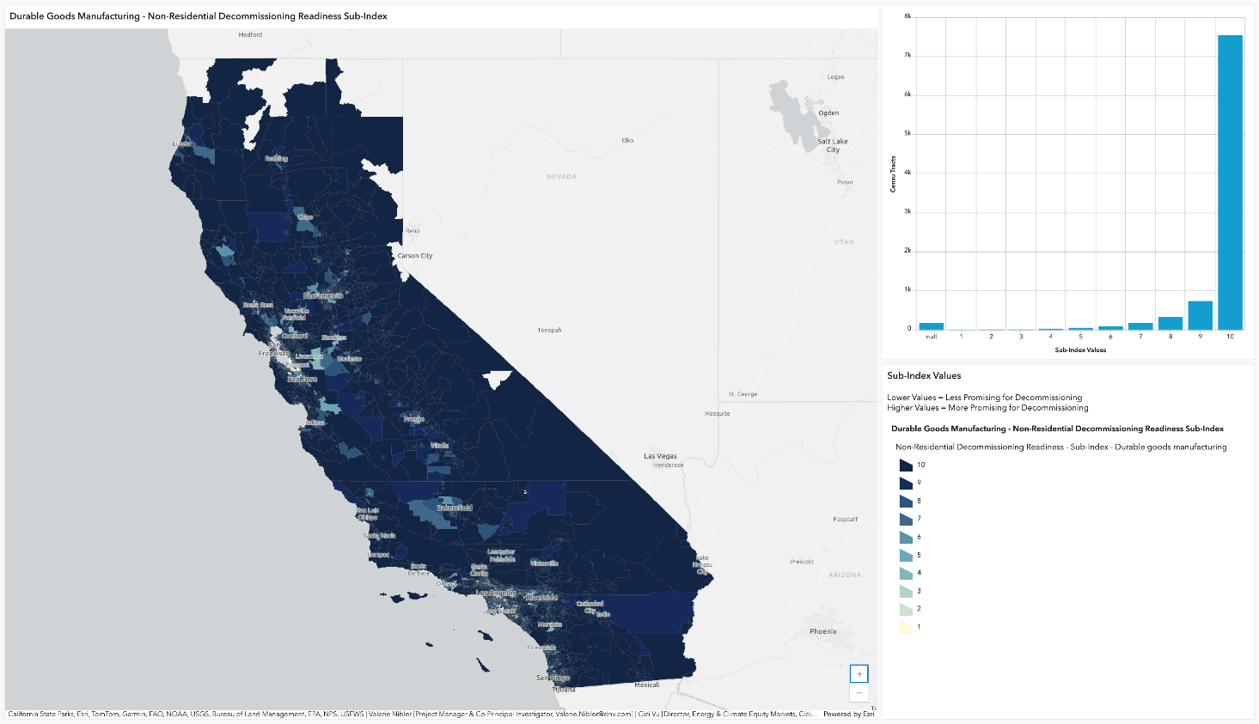
Figure 4-19. Non-Durable Goods Manufacturing Non-Residential Decommissioning Readiness Sub-Index Component Values
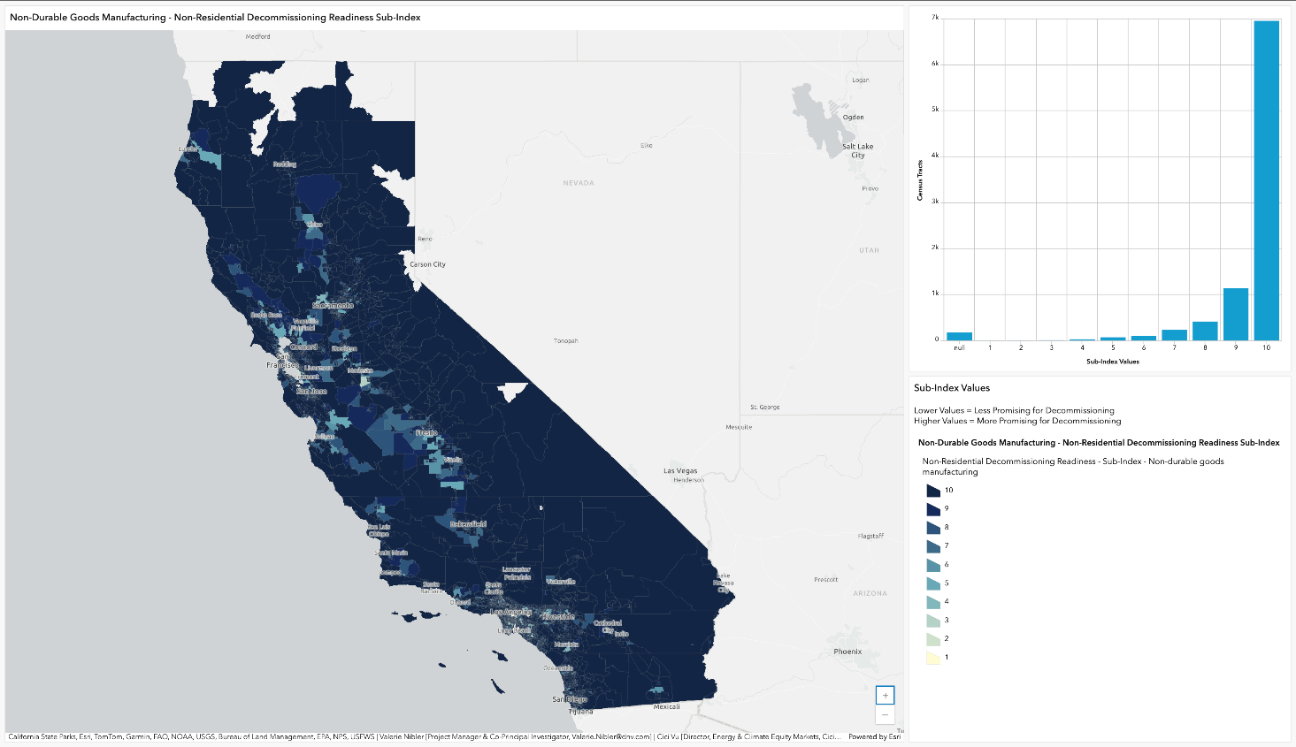
Figure 4-20. College Non-Residential Decommissioning Readiness Sub-Index Component Values
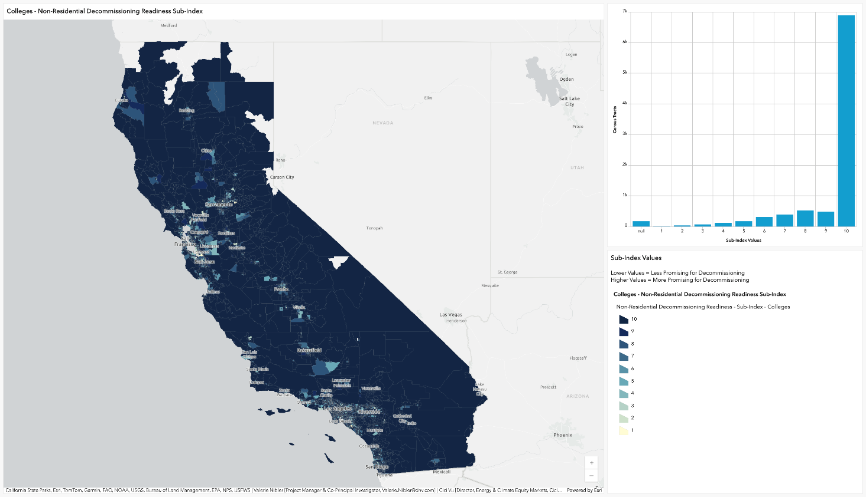

Refers to research and information produced outside of traditional academic or commercial publishing channels. It typically includes materials that are not formally published or peer-reviewed.
https://www.energy.ca.gov/data-reports/surveys/california-commercial-end-use-survey
https://www.energy.ca.gov/data-reports/surveys/2006-california-commercial-end-use-survey-ceus
https://www.energy.ca.gov/publications/2023/2022-california-commercial-end-use-survey-ceus-final-report
https://www.census.gov/naics/
https://data.census.gov/table?g=040XX00US06$1400000&y=2022&d=ACS+5-Year+Estimates+Data+Profiles
ESRI. “How Hot Spot Analysis (Getis-Ord Gi*) works.” Accessed: 10-28-2025. https://pro.arcgis.com/en/pro-app/latest/tool-reference/spatial-statistics/h-how-hot-spot-analysis-getis-ord-gi-spatial-stati.htm
The Miscellaneous category included numerous commercial entities that are not included in the other categories referenced above, ranging from performing arts companies, museums, and courts to testing laboratories, amusement parks, and gasoline stations.
The categorization of commercial businesses is copied from mapping of NAICS codes to the Restaurant CEUS subsectors

