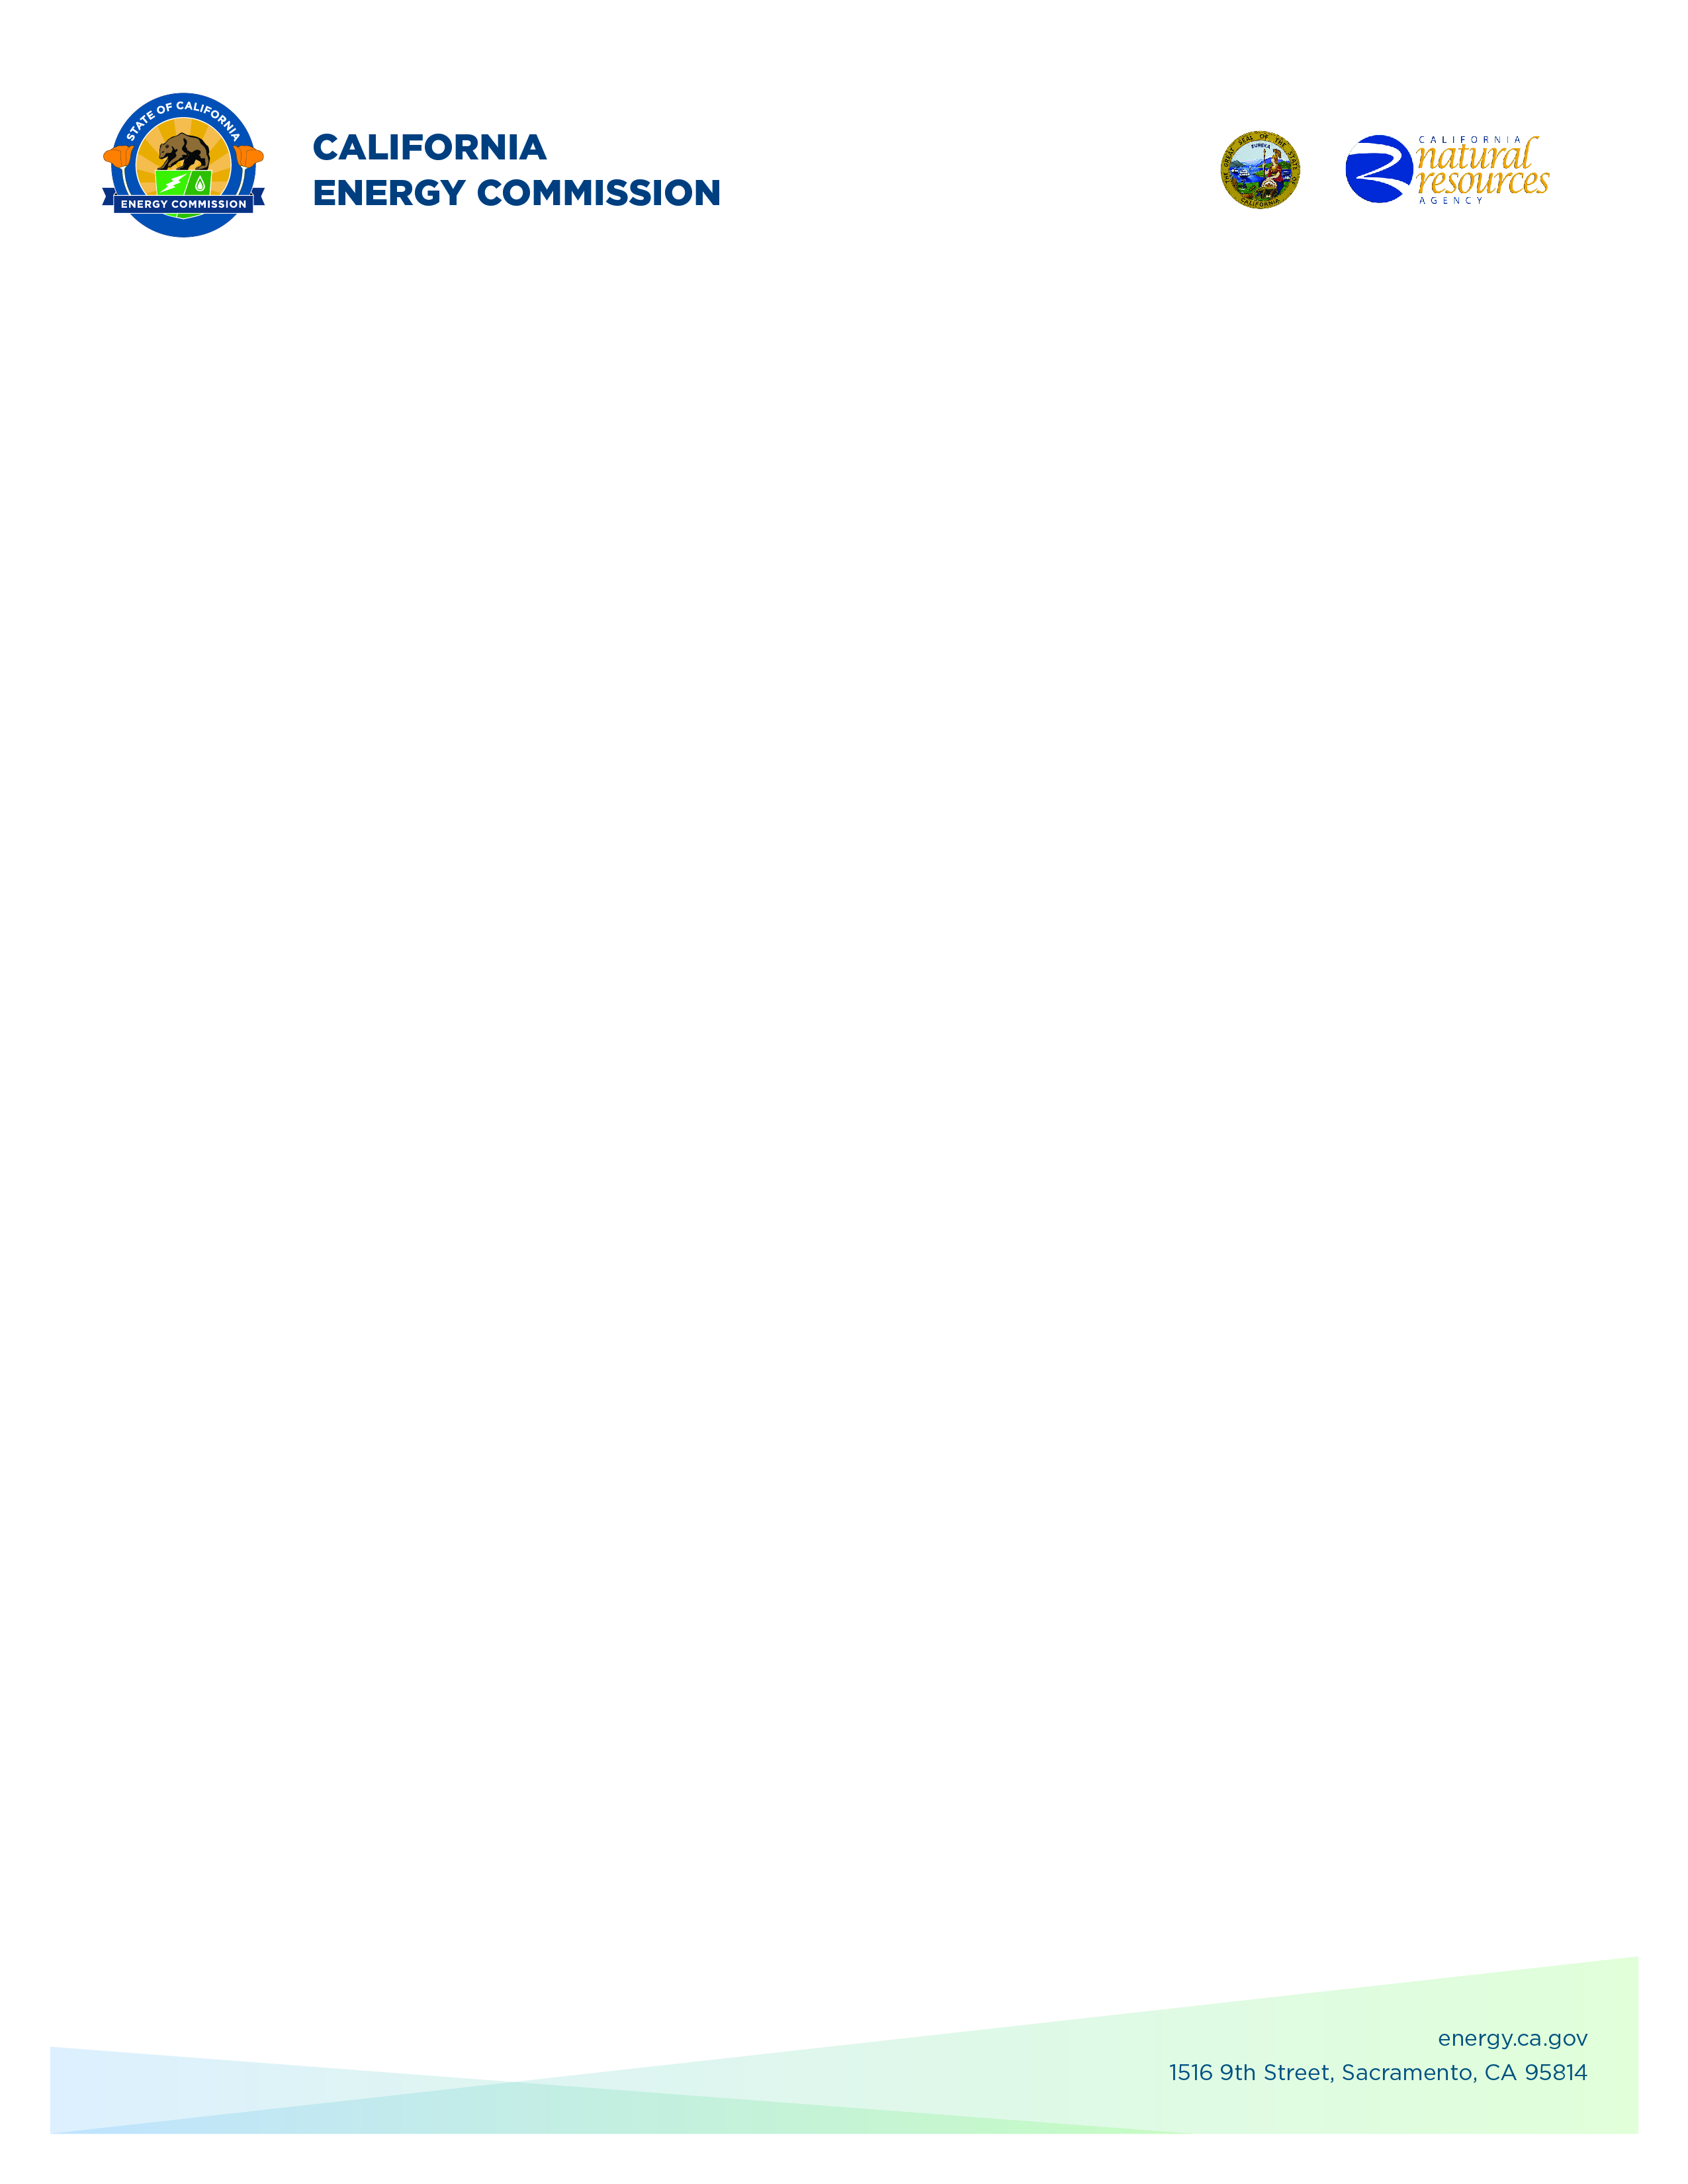
GFO-22-301
Commercializing industrial Decarbonization (2022 CID Program)
Addendum 8
February 13, 2026

The purpose of this addendum is to notify potential applicants of changes that have been made to GFO-22-301.

GFO-22-301 had at most three funding rounds, per the GFO manual, notice is hereby given on the opening for Round 3 funding.

The addendum includes the following revisions to the Solicitation Manual and Questions and Answers document. Added language appears in bold underline, and deleted language appears in [strikethrough] and within square brackets.

Solicitation Manual
- GFO manual cover page
- Section I.A Purpose of Solicitation – Group 3 removed.
- Section I.C.2 Group 2: Energy Efficiency and Decarbonization of Concrete Manufacturing – Note on page 11 is updated to reflect Round 3.
- Section I.C.3 Group 3: Energy Efficient Separation Processes – is removed.
- Section I.D Funding – Amount available and minimum/maximum funding amounts for solicitation and groups 1 and 2 are updated, group 3 removed.
- Section I.E “Key Activities Schedule”
  - Added Round 3 release date.
  - Removed Pre-Application Workshop, Deadline for Round 2 Written Questions, Anticipated Distribution of Round 2 Questions and Answers.
  - Added 3rd Round Deadline to Submit Applications.
  - Added 3rd Round Notice of Proposed Awards Posting Date.
  - Added Anticipated Energy Commission Business Meeting Date (Round 3).

Crystal Willis,
Commission Agreement Officer

