RFP-25-803
Improvements to Modeling Climate Data in Demand Forecasting

Addendum 02
April 2, 2026

Note: Added language appears in bold underline, and deleted language appears in strikethrough and within square brackets.

The purpose of this addendum is to make the following revisions to the Application Manual.

- Page 1 of the solicitation manual
ACTIVITY | ACTION DATE
RFP Release | February 23, 2026
Deadline for Written Questions by 5:00 p.m. * | [March 4, 2026]  March 24, 2026
Pre-Bid Conference * | March 4, 2026
Distribute Questions/Answers and Addenda (if any) to RFP | March 11, 2026
Distribute Revised Questions/Answers to RFP | [March 27, 2026]  April 2, 2026
Deadline to Submit Proposals by 11:59 p.m. * | [March 25, 2026]  April 1, 2026
Deadline to Submit Revisions to Proposals by 11:59 p.m. | April 6, 2026
Notice of Proposed Award | [April 8, 2026]  [April 15, 2026]  April 17, 2026
Commission Business Meeting | June 22, 2026
Contract Start Date | July 1, 2026
Contract Termination Date | June 30, 2028
- Attachment 7a is updated to include G&A in calculating the Loaded Hourly Rate

[O2 = +B2+E2+H2+N2]
O2 = +B2+E2+H2+K2+N2
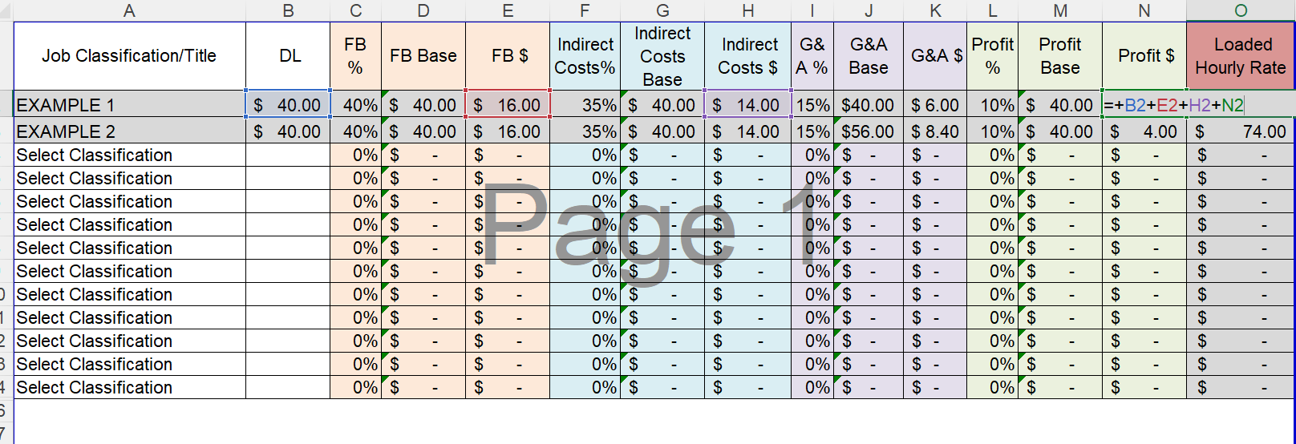
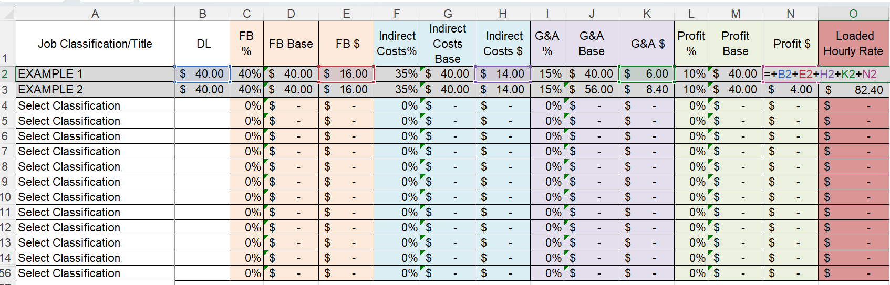

- Page 21 of application manual is updated to reflect the addition of G&A in calculating the total expected labor cost
[Step 1
Calculate each Individual’s Loaded Hourly Rate = DL + FB + Indirect + Profit (Separately for the Prime and each Subcontractor). This is documented on Attachment 7a in each workbook.]

Step 1
Calculate each Individual’s Loaded Hourly Rate = DL + FB + Indirect + G&A + Profit (Separately for the Prime and each Subcontractor). This is documented on Attachment 7a in each workbook. This is mandatory and failure to provide revised workbooks by the new deadline will result in disqualification.

- CEC will accept clarifications to proposals submitted by the April 1, 2026 deadline. Clarifications are strictly limited to those that address the edits to the solicitation described above, including the updated budget form and in revised Q&A, questions #52-71. Clarifications must be submitted by April 6, 2026 by 11:59 p.m.

