GFO-25-305
Addendum 2
July 9, 2026

Non-Energy Impacts of Integrated Energy Retrofit Packages from the Equitable Building Decarbonization Program

Disclaimer: Added language appears in bold underline, and deleted language appears in [strikethrough] and within square brackets.

The purpose of this addendum is to make the following revisions:

- Change in the budget template attachment.

In the “Fringe Benefits” tab, the Direct Labor Costs ($) column was incorrectly indicated as percentages (% data type) instead of dollars. The Direct Labor Costs ($) column has been adjusted so that it indicates cost in dollars.

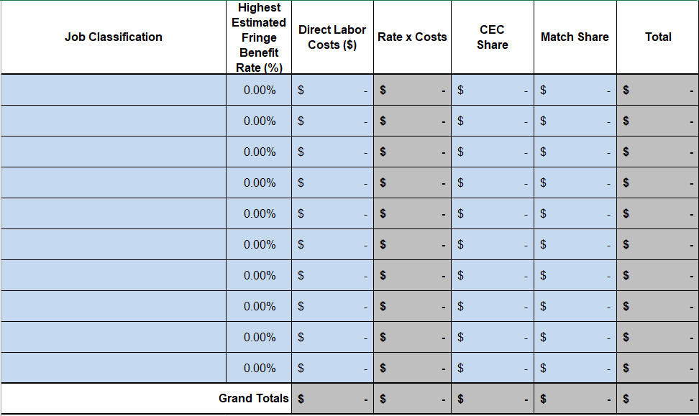

- Page 10 of the Solicitation Manual, Section I.E., Key Activities Schedule:

The deadline to submit applications has been extended to July 17, 2026.

Key activities, dates, and times for this solicitation and for agreements resulting from this solicitation are presented below. An addendum will be released if the dates change for activities that appear in bold.

ACTIVITY | DATE | TIME¹²
Solicitation Release | April 9, 2026
Pre-Application Workshop | April 24, 2026 | 9:00 a.m.-11 a.m.
Deadline for Written Questions¹³ | May 8, 2026 | 5:00 p.m.
Anticipated Distribution of Questions and Answers | Week of May 25, 2026
Support for Application Submission in ECAMS | [July 10, 2026] July 17, 2026 | 5:00 p.m.¹⁴
Deadline to Submit Applications | [July 10, 2026] July 17, 2026 | 11:59 p.m.
Anticipated Notice of Proposed Award Posting Date | Week of Sep. 21, 2026
Anticipated Energy Commission Business Meeting Date | Dec. 9, 2026
Anticipated Agreement Start Date | February 1, 2027
Anticipated Agreement End Date | March 31, 2030

